Targeted Metabolomic Profiles of Serum Amino Acids and Acylcarnitines Related to Gastric Cancer

Running title: Metabolomic Profiles in Gastric Cancer

Dehong Li1,2, Yan Lu2, Fenghui Zhao3, Li Yan2, Xingwen Yang2, Lianhua Wei2, Xiaoyan Yang2, Xiumei Yuan2, Kehu Yang1*

1Evidence Based Medicine Center, School of Basic Medical Sciences, Lanzhou University, Lanzhou 730000, China

2Department of Clinical laboratory, Gansu Provincial Hospital, Lanzhou 730000, China

3Department of Pathology, Gansu Provincial Hospital, Lanzhou 730000, China

*Correspondence:

Kehu Yang

Evidence Based Medicine Center, School of Basic Medical Sciences,Lanzhou University, Lanzhou, 730000, China, Tel: +86-13893117077; Email: [yangkh-ebm@lzu.edu.cn](mailto:yangkh-ebm@lzu.edu.cn)

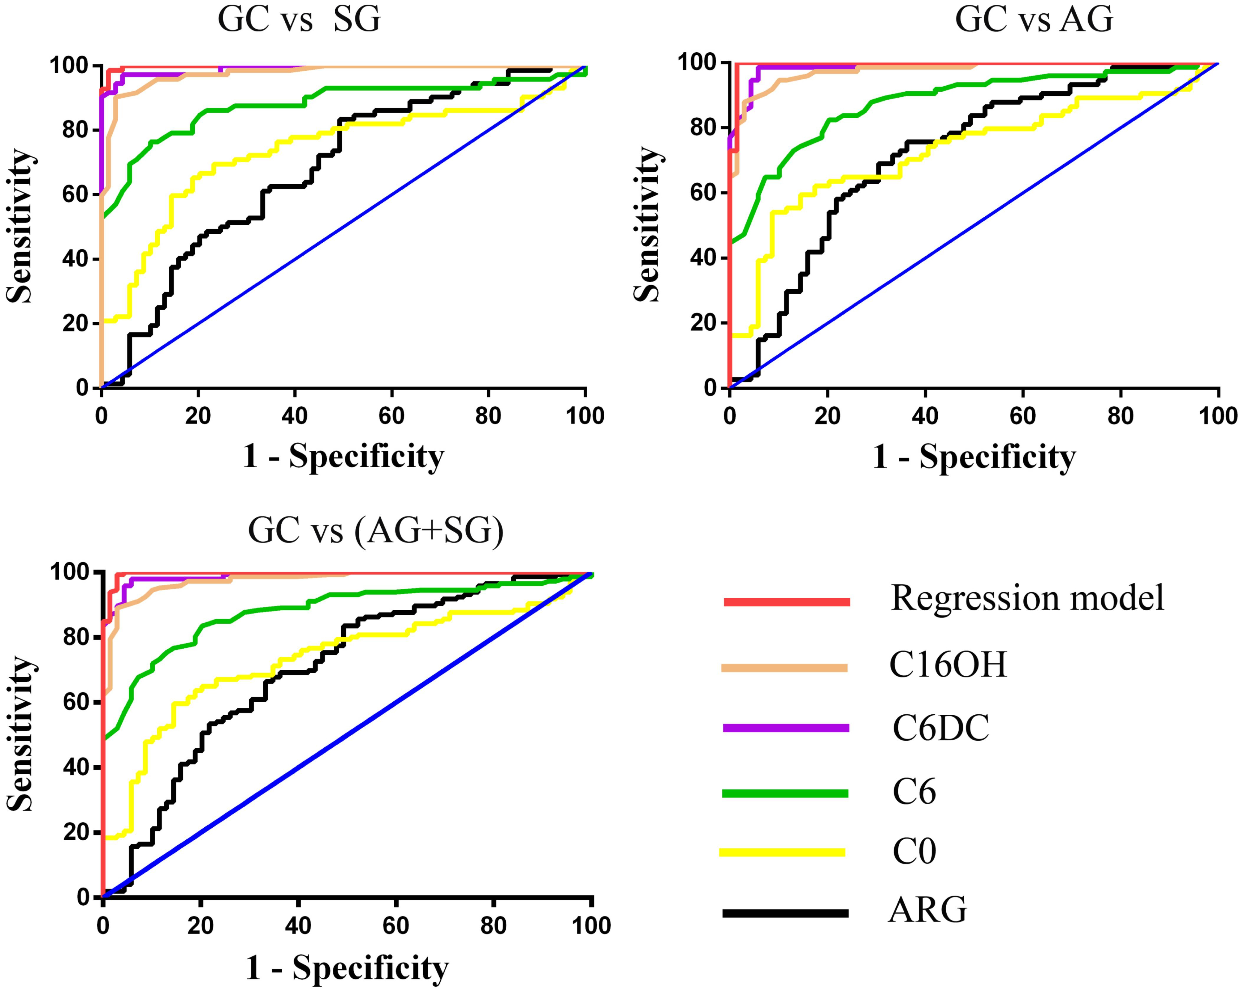

**Figure.S1.**Receiver operating characteristic (ROC) curves for five metabolites and the regression model. AUC, area under the curve.

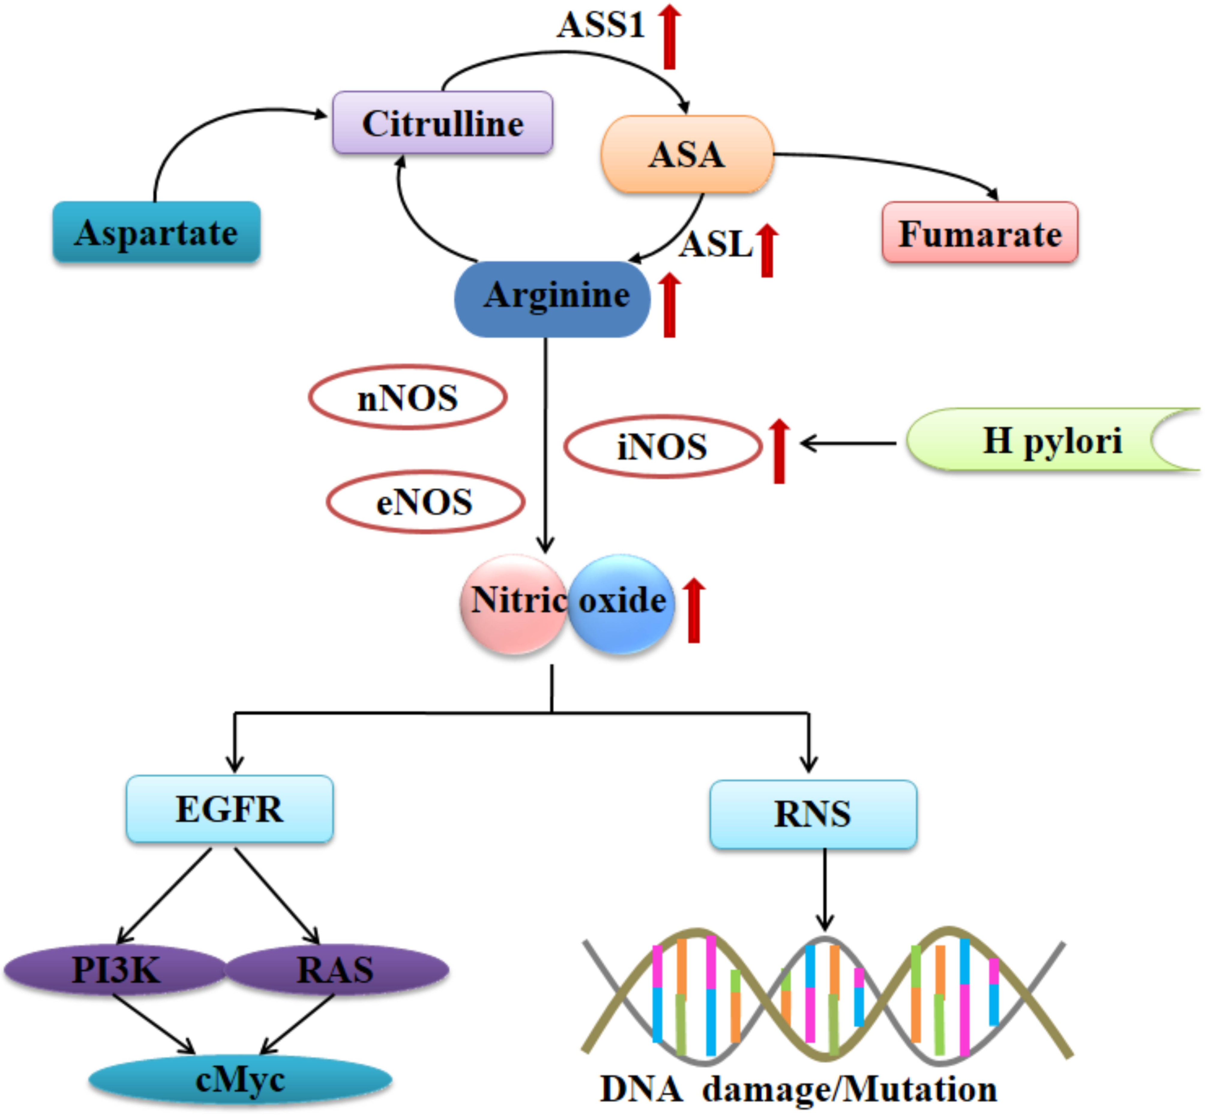

**Figure.S2.Molecular mechanisms of arginine involvement in gastric cancer**. Red arrows denote cancer-related upregulation of proteins contributing to arginine metabolism, causing a net increase in nitric oxide (NO) synthesis. Cancer cells showed enhanced NO amounts by upregulating iNOS, ASS1 and ASL, which increase arginine availability for nitric oxide synthesis.

ASA, argininosuccinic acid; ASL,argininosuccinatelyase; ASS1, argininosuccinate synthase 1; NOS:nitricoxide synthase;RNS:reactive nitrogen species

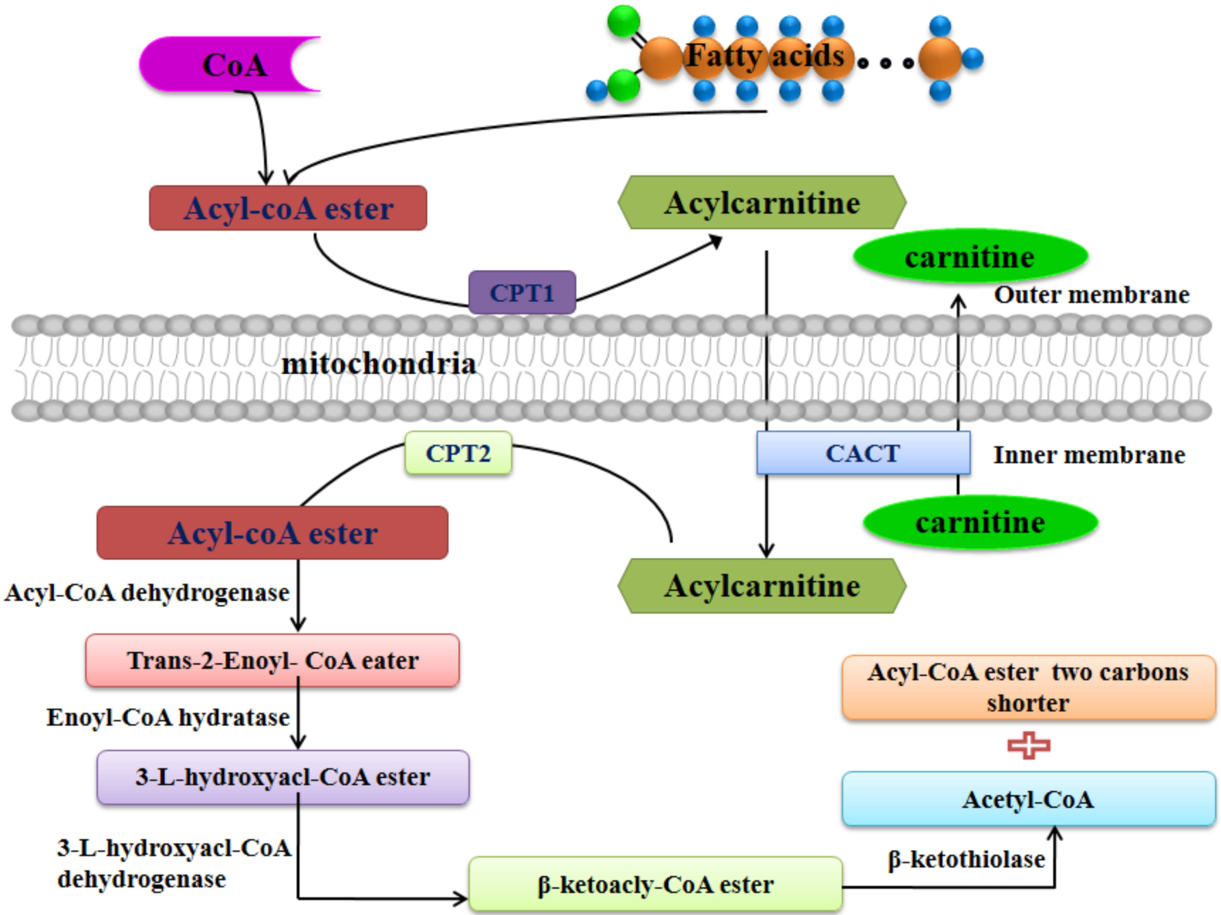

**Figure.S3.Mitochondrial fatty acid β-oxidation.** Upon transport across the cytosolic membrane, fatty acids are transformed into acyl-CoAs in the cytosol. CPT1 transforms acyl-CoAs into respective acylcarnitines, which are then transported across the mitochondrial membrane by CACT. CPT2 converts the seacylcarnitines back into acyl-CoAs, which are degraded into acetyl-CoAs via an inducible set of enzymes.

CPT:carnitinepalmitoyltransferase; CACT: carnitine-acylcarnitinetranslocase