Supplementary Material. Binny et al (2022). Real-time estimation of the effective reproduction number in Aotearoa New Zealand.

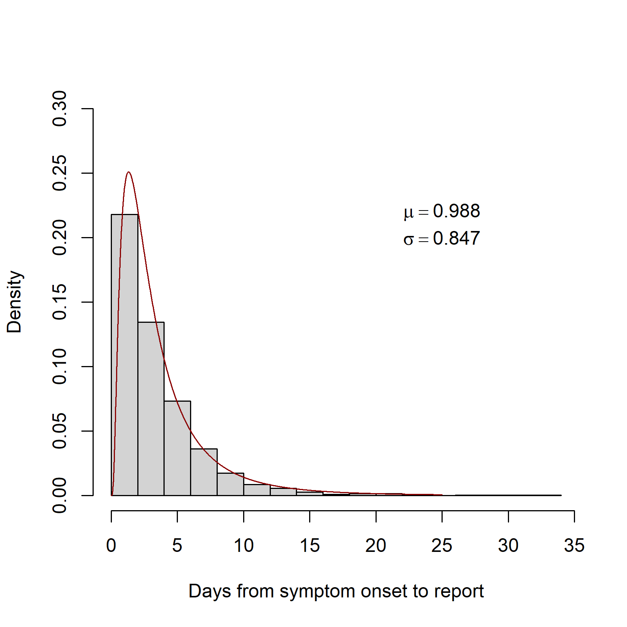
Figure S1. Distribution of delays from the date of symptom onset to date of report. For input to the model, a report delay distribution was estimated using EpiNow2’s estimate_delay function (Abbott et al, 2020b). A log-normal distribution (red curve) was fitted to 100 subsampled bootstraps of the onset-to-report delays from 3208 cases reported between 17 August 2021 and 18 January 2022 (excluding 9 cases with delays greater than 60 days), taking (with replacement) 250 samples from these delays in each bootstrap. Using the posterior samples, the parameters of the log-normal distribution were estimated to be μ = 0.988 (SD = 0.088) and σ = 0.847 (SD = 0.063).

Table S2. Parameters (μ and σ) of the log-normal distribution fitted to onset-to-report delays for each month independently from 17 August 2021 – 18 January 2022.
Month of report | μ | σ
17/08/2021 – 16-09/2021 | 0.979 (SD 0.084) | 0.854 (SD 0.067)
17/09/2021 – 16-10/2021 | 0.904 (SD 0.086) | 0.898 (SD 0.072)
17/10/2021 – 16/11/2021 | 0.988 (SD 0.077) | 0.799 (SD 0.068)
17/11/2021 – 16/12/2021 | 1.010 (SD 0.085) | 0.876 (SD 0.067)
17/12/2021 – 18/01/2022 | 1.071 (SD 0.076) | 0.806 (SD 0.059)

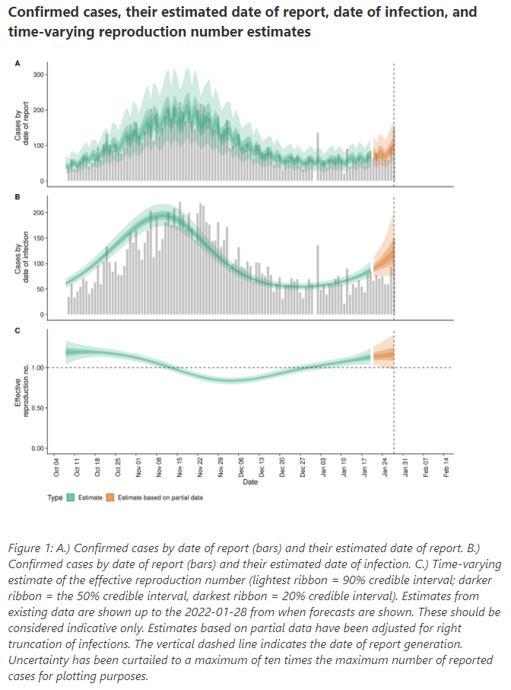
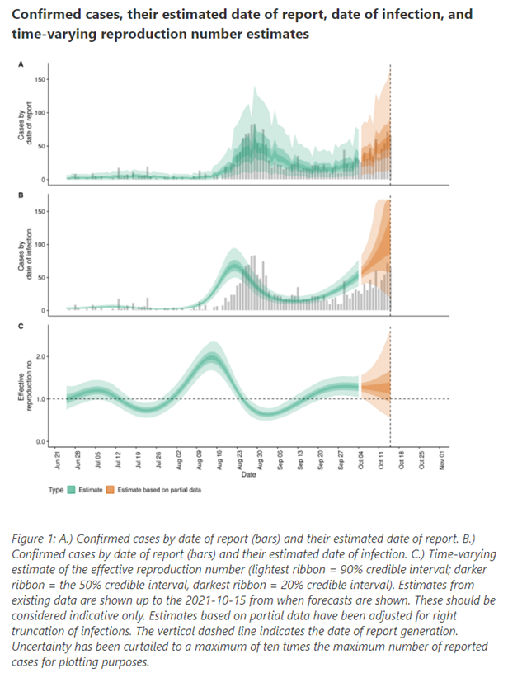
Figure S2. Figure (available under Creative Commons Attribution CC BY 4.0) reproduced from EpiForecasts (Abbott et al, 2020a,b, accessed from https://epiforecasts.io/covid/posts/national/new-zealand/ on 19 October 2021 (left) and on 1 February 2022 (right). New cases by date of report (A), date of infection (B) and effective reproduction number (C) over 16-week periods up to 15 October 2021 (left) and up to 28 January 2022 (right).
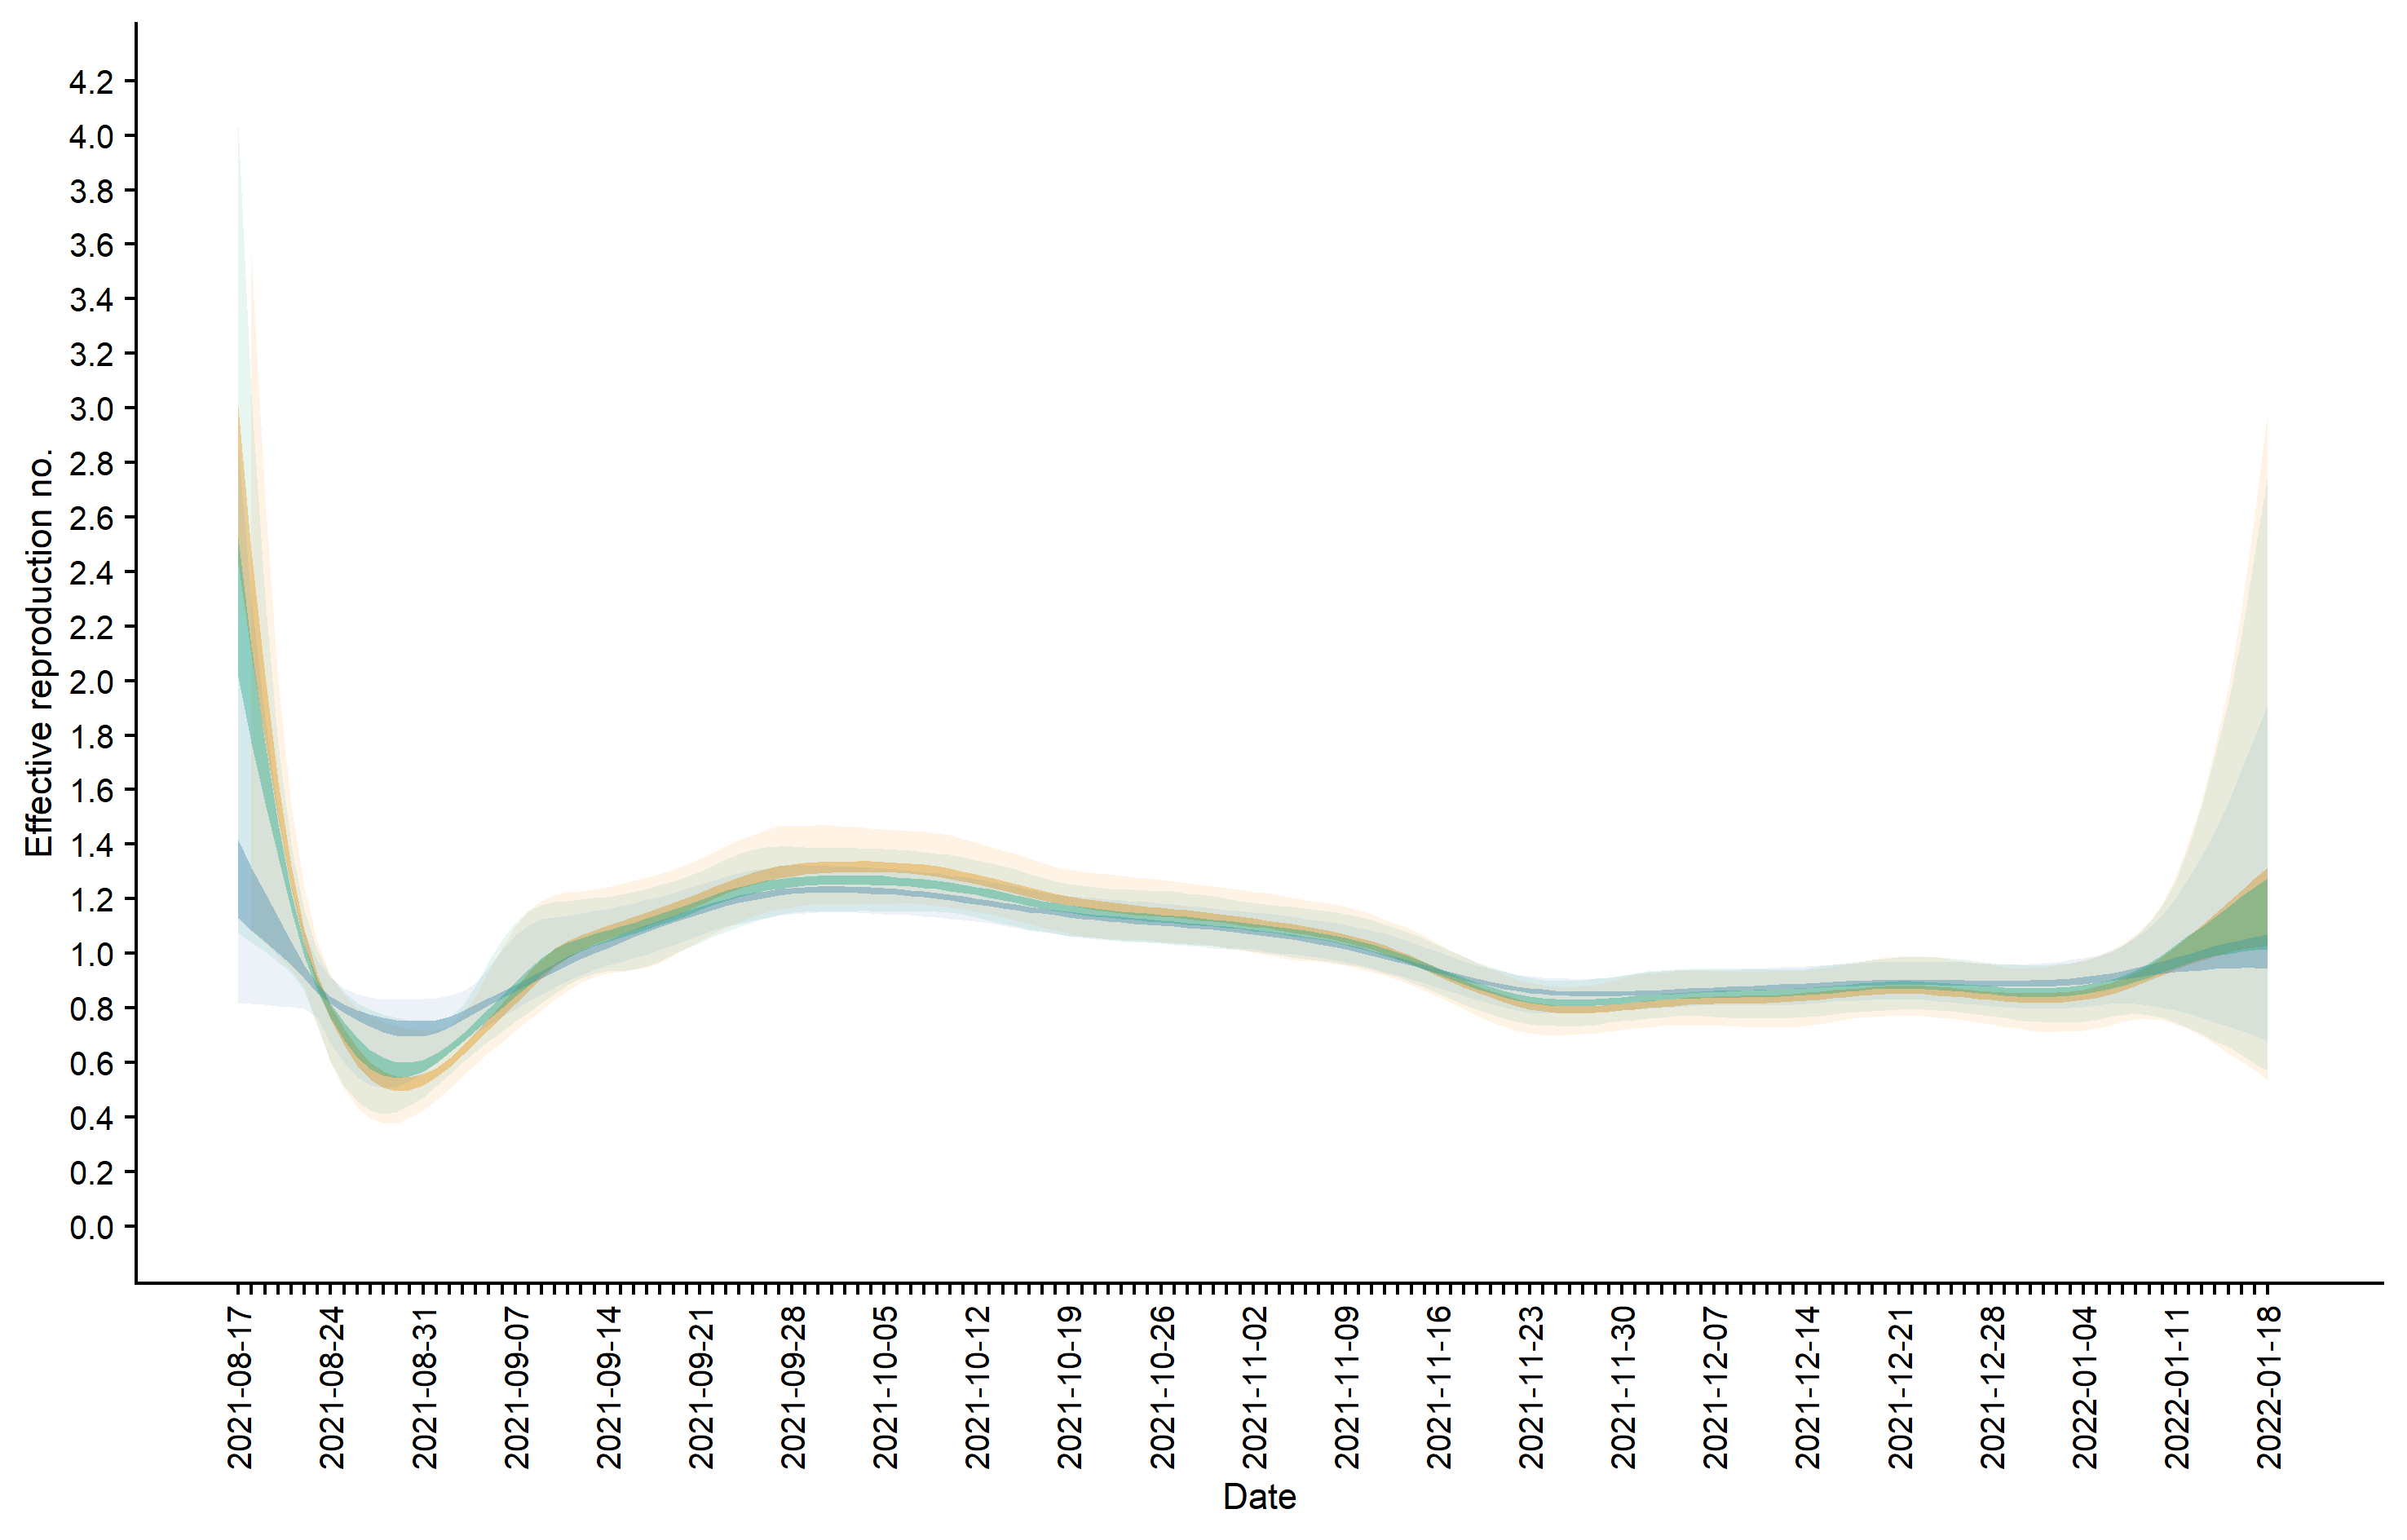
Figure S3: Estimated effective reproduction number, R_{t}, over time (light ribbon = 90% credible interval [CrI]; dark ribbon = 20% CrI) using a gamma-distributed generation time with mean of 3.6 days and SD of 3.1 days (green); a shorter mean 3.2 days and SD 2.4 days (blue); and a longer mean 4.6 days and SD 3.1 days (orange). Estimates up to 9 January 2022 are based on full data; estimates from 10 January to 18 January are based on partial data and have been adjusted for right truncation of infections.

