SUPPLEMENTARY

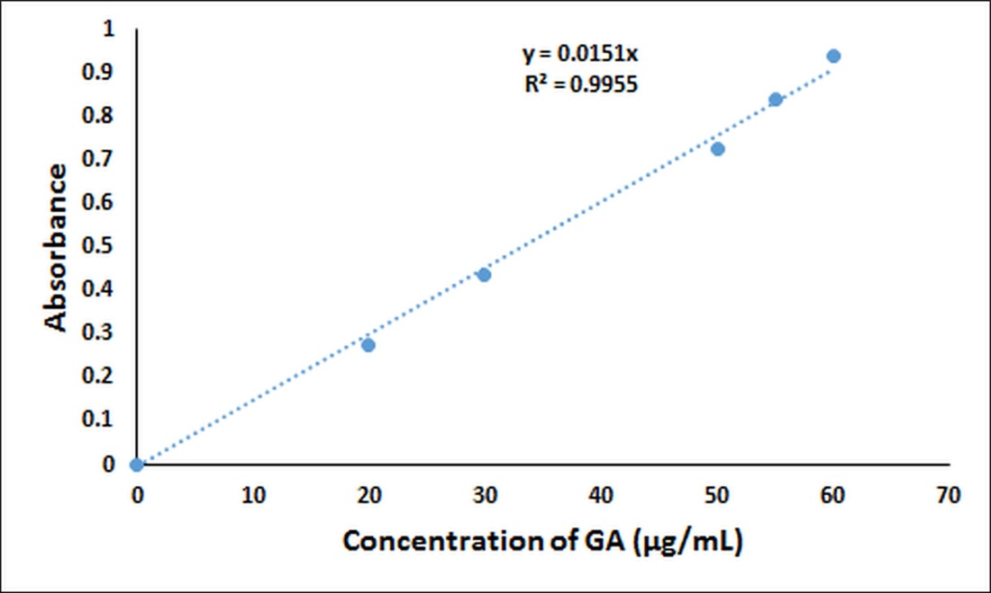
Figure S1. The calibration curve of GA

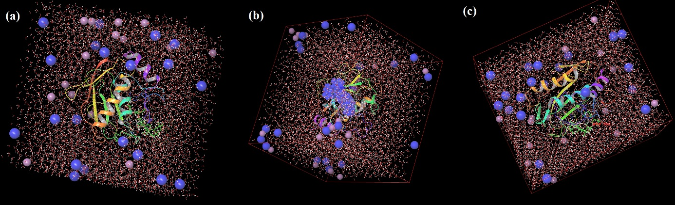
Figure S2. MD system of GA in complex with MMP-1(PDB ID: 966C) (a), MMP-3(PDB ID: 2JT6) (b), MMP-9(PDB ID: 5CUH) (c)

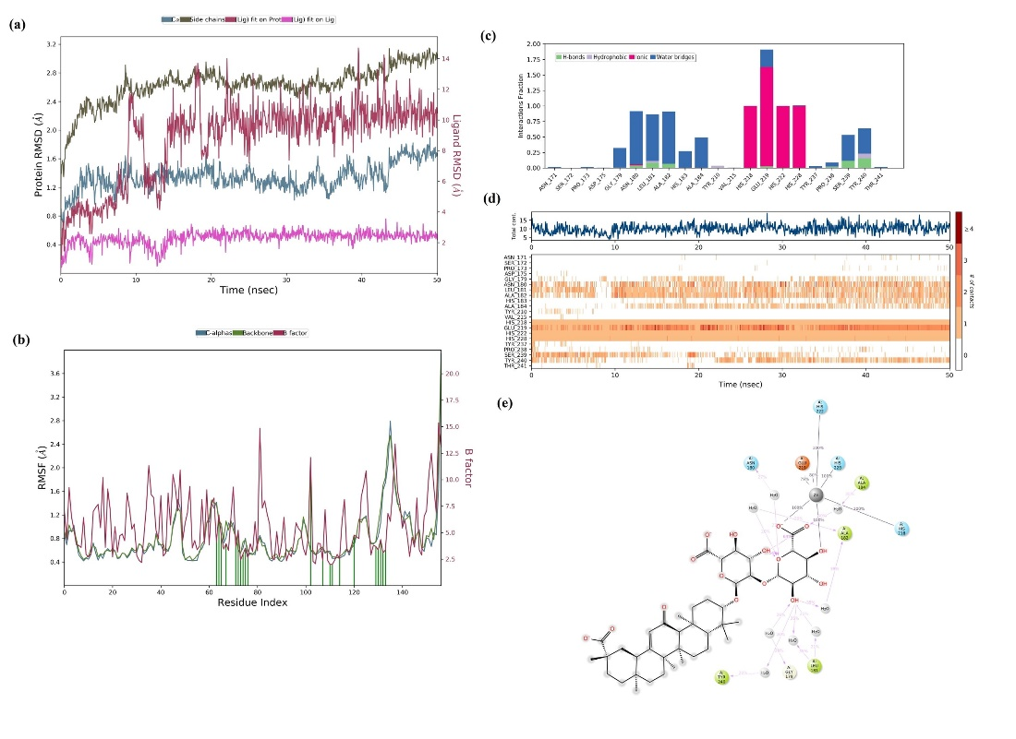
Figure S3. MD simulation analysis of GA in complex with MMP-1(PDB ID: 966C). RMSD of GA-966C complex (Protein Cα-atoms RMSD is shown in green while RMSD of GA with respect to protein are shown in purple (a), Protein amino acids RMSF (b), Protein–ligand contact diagram (c), timeline representation of the interactions and contacts (d), ligand 2D interaction histogram obtained from MD trajectory (e).

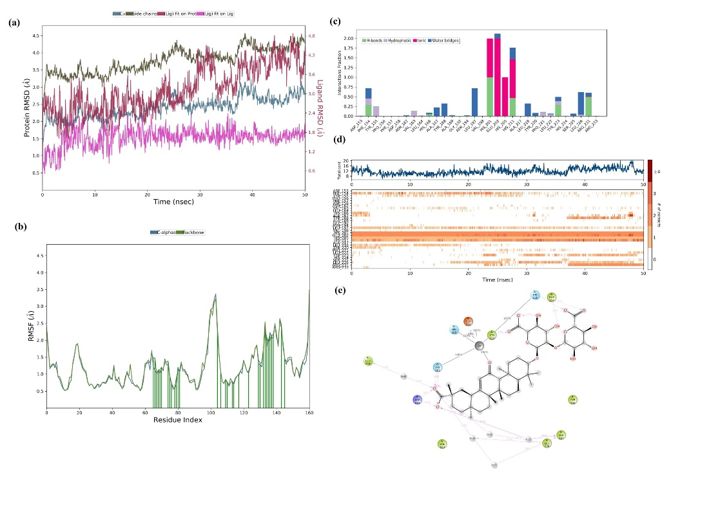
Figure S4. MD simulation analysis of GA in complex with MMP-3(PDB ID: 2JT6). RMSD of GA-2JT6 complex (Protein Cα-atoms RMSD is shown in green while RMSD of GA with respect to protein are shown in purple (a), Protein amino acids RMSF (b), Protein–ligand contact diagram (c), timeline representation of the interactions and contacts (d), ligand 2D interaction histogram obtained from MD trajectory (e).

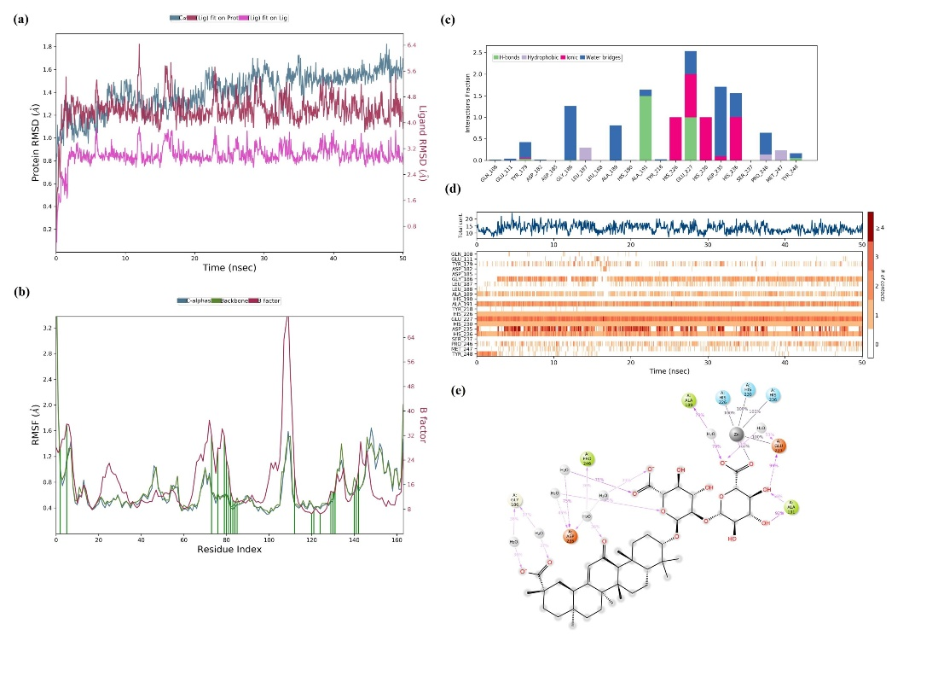
Figure S5. MD simulation analysis of GA in complex with MMP-9(PDB ID: 5CUH). RMSD of GA-5CUH complex (Protein Cα-atoms RMSD is shown in green while RMSD of GA with respect to protein are shown in purple (a), Protein amino acids RMSF (b), Protein–ligand contact diagram (c), timeline representation of the interactions and contacts (d), ligand 2D interaction histogram obtained from MD trajectory (e).

