**WB images in figure 2B**

A549 SPC21

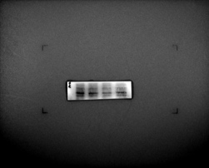

A549 𝝱-Actin

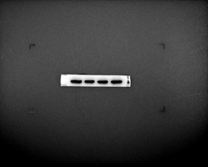

NCI-H1299 SPC21

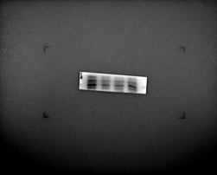

NCI-H1299 𝝱-Actin

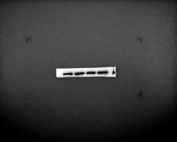

**WB images in figure 3A**

A549 PTEN

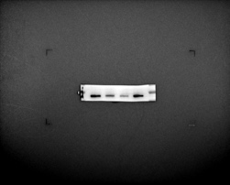

NCI-H1299 PTEN

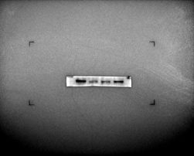

A549-p-Akt

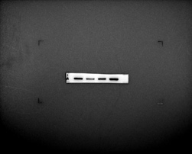

NCI-H1299 p-Akt

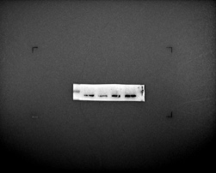

A549 Akt

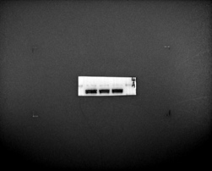

NCI-H1299 Akt

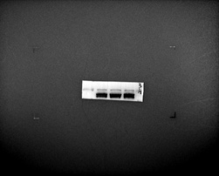

A549 𝝱-Actin

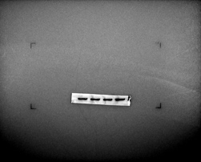

NCI-H1299 𝝱-Actin

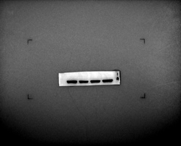

**WB images in figure 3B**

NCI-H1299+MK SPC21

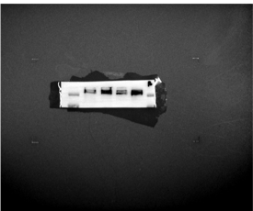

NCI-H1299+MK PTEN

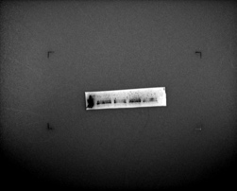

NCI-H1299+MK p-Akt

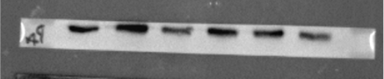

NCI-H1299+MK Akt

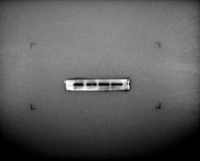

NCI-H1299+MK 𝝱-Actin

