Supplementary file A1

Study sites

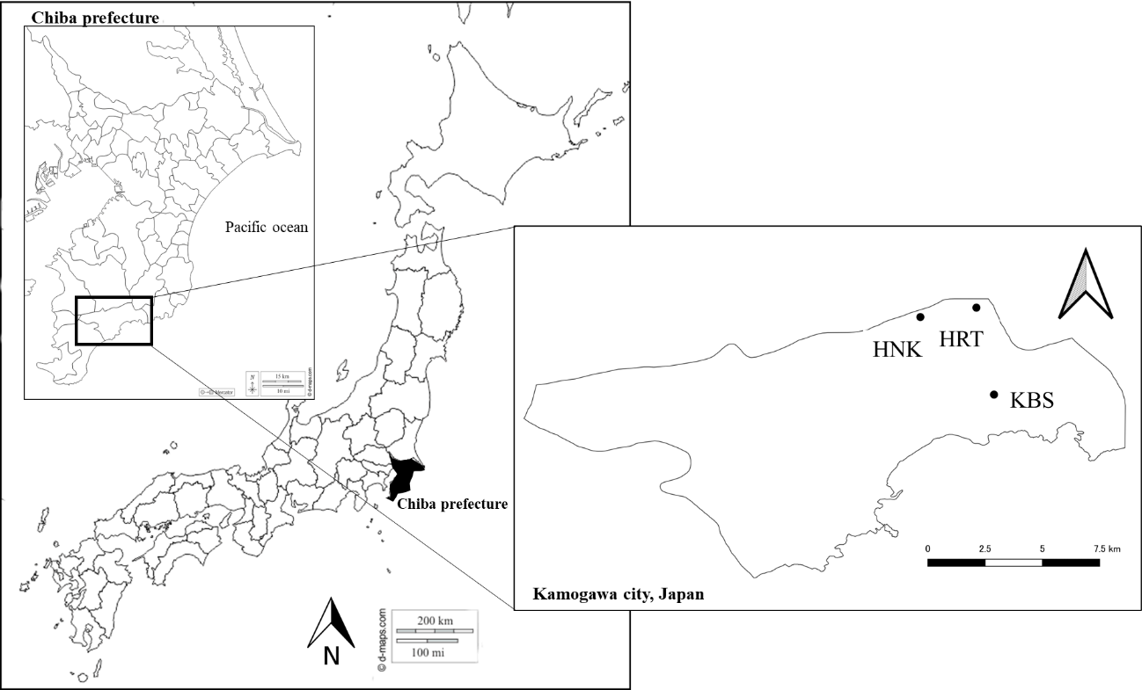

**B**

Experimental Design

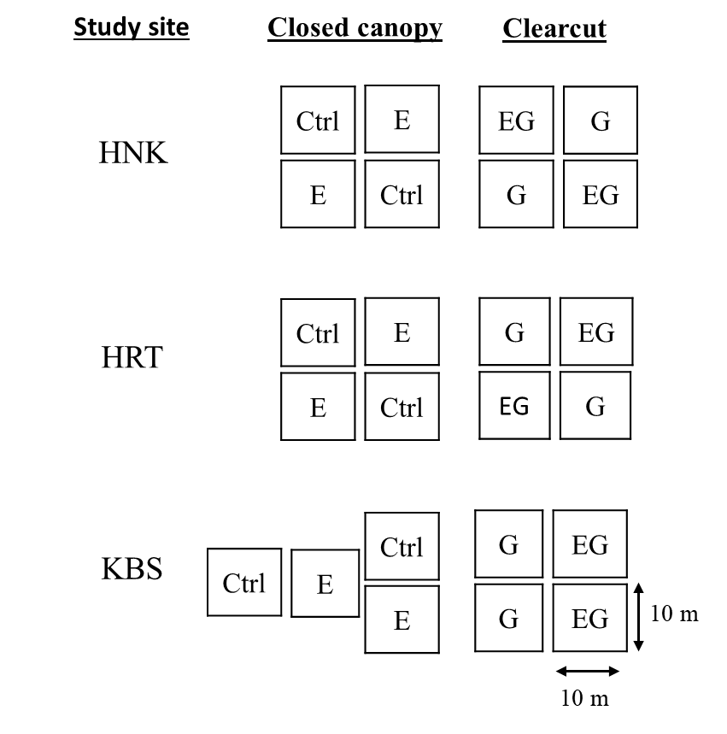

**C.**

Vegetation and Sapling surveys

