Table S2 The secondary and tertiary structures of CnSBP gene family. Blue presents alpha helix; Green presents beta turn; Red presents extended strand; Pink presents random coil.
Protein | Alpha helix (%) | Beta turn (%) | Random coli (%) | Extended strand (%) | Distribution of secondary structure elements | Tertiary structure prediction
CnSBP1 | 34.71 | 4.71 | 46.47 | 14.12 | 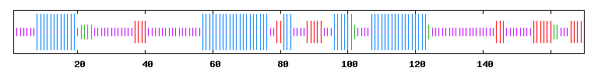 | 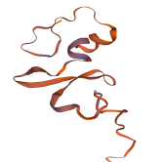
CnSBP2 | 21.47 | 9.2 | 44.17 | 25.15 | 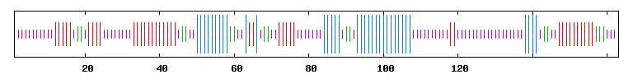 | 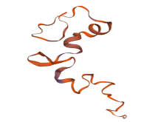
CnSBP3 | 32.95 | 7.36 | 33.33 | 26.36 | 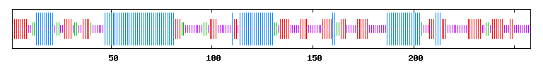 | 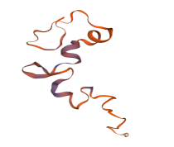
CnSBP4 | 26.81 | 3.83 | 56.25 | 13.1 | 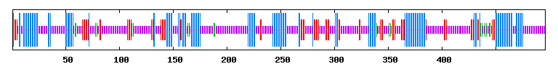
CnSBP5 | 14.9 | 3.37 | 69.23 | 12.5 | 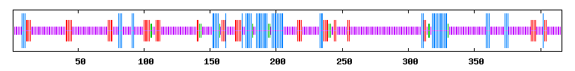
CnSBP6 | 20.6 | 4.65 | 59.47 | 15.28 | 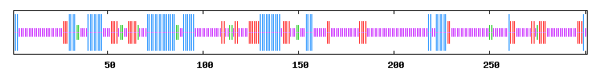 | 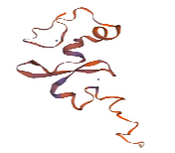  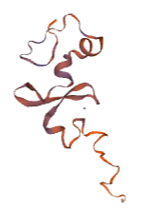
CnSBP7 | 19.21 | 6.62 | 58.94 | 15.23 | 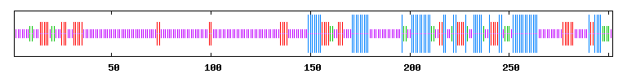
CnSBP8 | 35.85 | 4.40 | 47.90 | 11.84 | 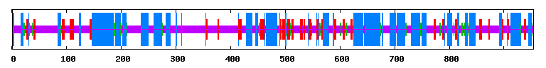 | 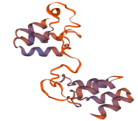
CnSBP9 | 17.87 | 3.09 | 67.35 | 11.68 | 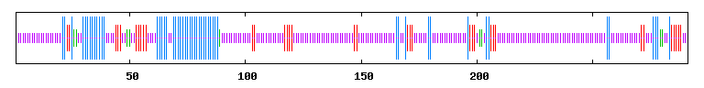 | 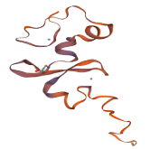
CnSBP10 | 24.91 | 3.97 | 60.65 | 10.47 | 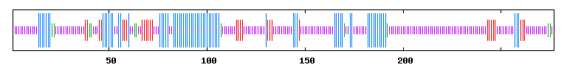 | 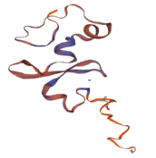  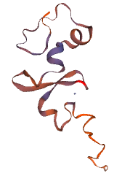
CnSBP11 | 19.08 | 5.34 | 58.78 | 16.79 | 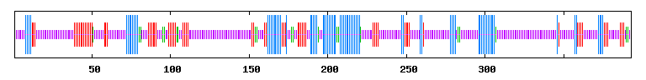
CnSBP12 | 23.18 | 6.01 | 50.21 | 20.60 | 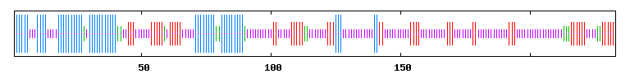 | 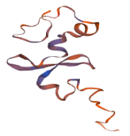
CnSBP13 | 25.89 | 5.08 | 56.85 | 12.18 | 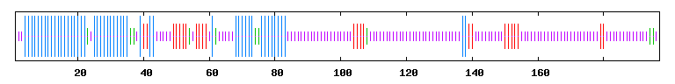 | 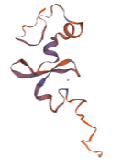
CnSBP14 | 35.00 | 5.11 | 39.67 | 20.22 | 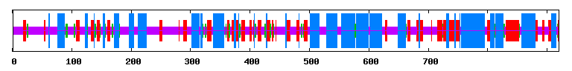
CnSBP15 | 44.29 | 5.71 | 41.90 | 8.10 | 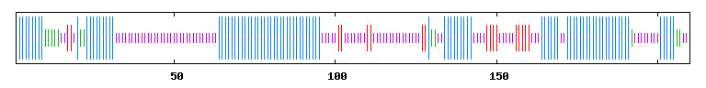
CnSBP16 | 38.51 | 6.76 | 42.57 | 12.16 | 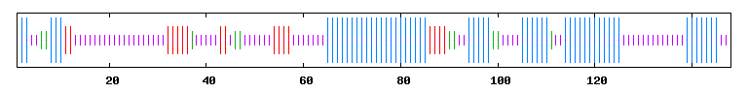 | 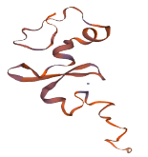
CnSBP17 | 25.81 | 2.90 | 51.94 | 19.35 | 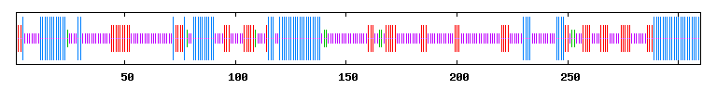 | 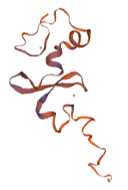
CnSBP18 | 16.46 | 3.29 | 64.56 | 15.70 | 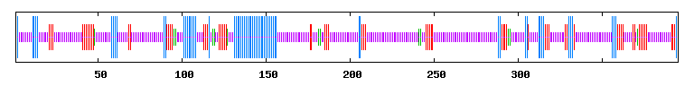 | 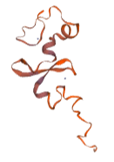
CnSBP19 | 23.35 | 7.61 | 56.85 | 12.18 | 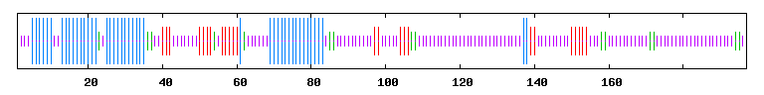 | 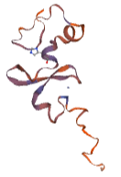
CnSBP20 | 19.63 | 4.44 | 60.05 | 15.89 | 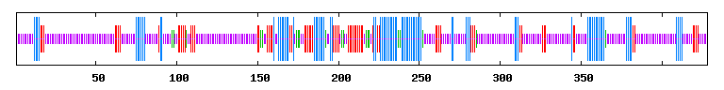 | 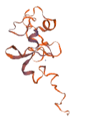
CnSBP21 | 40.85 | 4.23 | 45.77 | 9.15 | 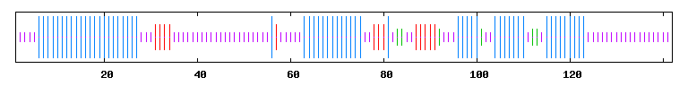 | 