Supplementary material

1. Experimental design

Control
250µg/L
750µg/L
2200µg/L
Pot containing 10 shoots
Filter and aerator pump

Figure A.1 Experimental design consisting of 18 water tanks, each containing two pots planted with 10 shoots of Zostera capensis each. The water tanks are placed in two connected water baths to equalise temperature and assigned to treatments or control via a randomised block design.

2.Calculating glyphosate exposure during the experimental period
Table A.1 Measured glyphosate concentration in treatment groups at 24 hr.
Treatment | Control | 250 µg/L | 750 µg/L | 2200 µg/L | Tank
Concentration | 0 | 158 | 369 | 1802 | 1
 | 0 | 144 | 436 | 1530 | 2
 | 0 | 182 | 580 | 1232 | 3
 | 0 | 107 | 749 | 767 | 4
Mean concentration | 0 | 148 | 534 | 1333

Table A.2 Calculated time weighted average (TWA) concentration of glyphosate in µg/L, over the three-week experimental period, based on nominal concentrations administered. Time weighted average glyphosate concentrations were calculated using a 20% loss per week due to water changes, and assuming no further degradation or adsorption, with the possibility that overall exposure levels were even lower than these calculated values.
Treatment | Week 1 | Week2 | Week 3 | TWA/group
Control | 0 | 0 | 0 | 0
250µg/L | 250 | 200 | 160 | 203
750µg/L | 750 | 600 | 480 | 610
2200µg/L | 2200 | 1760 | 1408 | 1789

Table A.3 Calculated time weighted average concentration of glyphosate over the three -week experimental period, based on measured glyphosate concentrations at 24 hr.
Treatment | Week 1 | Week2 | Week 3 | TWA per tank | TWA per group
Control | 0 | 0 | 0 | 0 | 0
250µg/L | 158 | 127 | 101 | 129 | 120
250µg/L | 144 | 115 | 92 | 117
250µg/L | 182 | 145 | 116 | 148
250µg/L | 107 | 85 | 68 | 87
750µg/L | 369 | 295 | 236 | 300 | 434
750µg/L | 436 | 349 | 279 | 355
750µg/L | 580 | 464 | 371 | 471
750µg/L | 749 | 599 | 480 | 609
2200µg/L | 1802 | 1441 | 1153 | 1465 | 1084
2200µg/L | 1530 | 1224 | 979 | 1245
2200µg/L | 1232 | 986 | 789 | 1002
2200µg/L | 767 | 614 | 491 | 624

3. Morphological analysis on full dataset
3.1 Boxplots of untransformed data
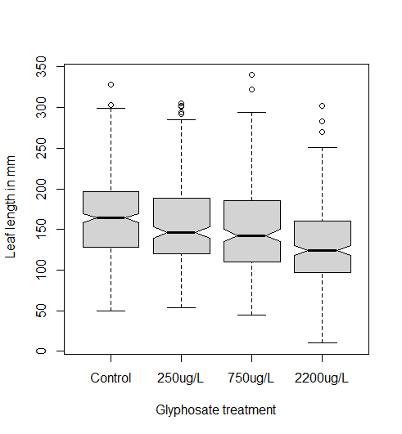
Figure B.1 Notched boxplot showing medians and interquartile range of untransformed data (full dataset), showing the decrease in leaf length (mm) with increasing glyphosate concentration (µg/L). Notches that do no overlap give a strong indication that medians are significantly different.
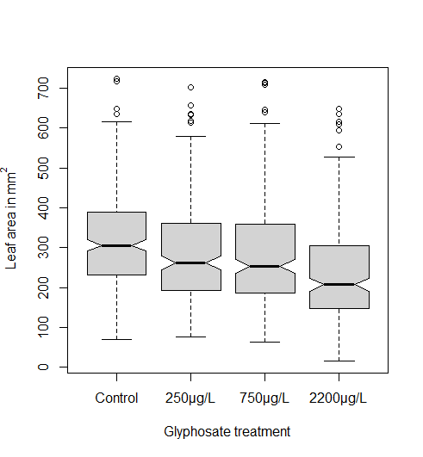
Figure B.2: Notched boxplot showing medians and interquartile range of untransformed data (full dataset), showing the decrease in leaf area (mm²) with increasing glyphosate concentration (µg/L ). Notches that do no overlap give a strong indication that medians are significantly different.
2.2 ANOVA on full morphometric dataset
Analysis was run on the full dataset, with n equal to 360 for the control group and 240 for the each treatment group. Glyphosate concentration had a strong, statistically significant negative effect on leaf area (F value 29.041, p <0.001), although an interaction between water baths and glyphosate treatment was also detected (F value 12.864, p <0.001), as well as a batch effect for bath alone (F value 9.0908, p =0.002). The same was true for leaf length (F value 25.5771, p<0.001), which also had an interaction with water bath (F value =15.0030, p= <0.001) (Type III ANOVA), as well a batch effect for bath alone(F value =7.9118, p= 0.002).
ANOVA was performed on leaf width data. Glyphosate concentration had a strong, statistically significant negative effect on leaf width (F value 27.5642, p<0.001), although an interaction between the two water baths and the glyphosate treatment was also detected (F value 7.7551, p <0.001) (Type III ANOVA) as well a batch effect for bath alone (F value = 7.1952, p= 0.007).

3. Photosynthetic pigments analysis
Table B.1
Calculations used for chlorophyll and carotenoid determination
Chlorophyll a (µg/g fw) = 12.25(A663.5)-2.55(A646.5)
Chlorophyll b (µg/g fw) = 20.31 (A646.5) – 4.91(663.5)
Carotenoids (µg/g fw) = (1000A470 – 3.27[chlorophyll a] – 104[chlorophyll b])/227
Total chlorophyll = 17.76(A646.5)+ 7.34(A663.5)
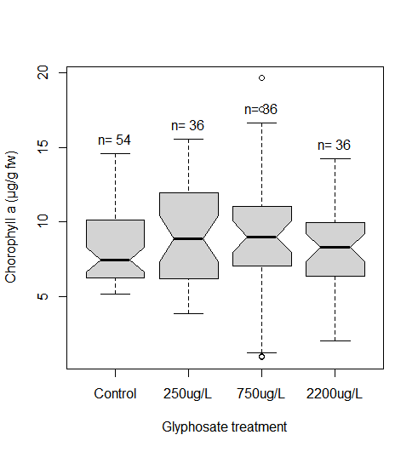
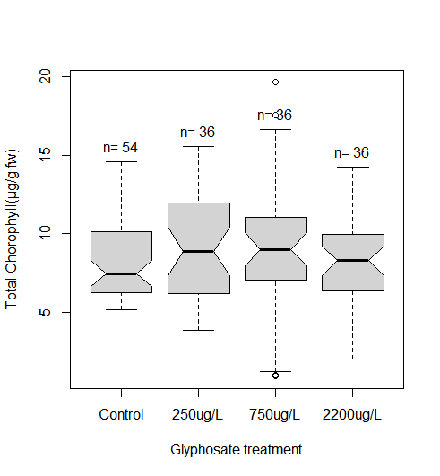
Data did not conform to the requirements for normality, therefore a Kruskal-Wallis rank sum test was performed. The results are given in Table B.2 below, and the median and data spread in Figure C.1.
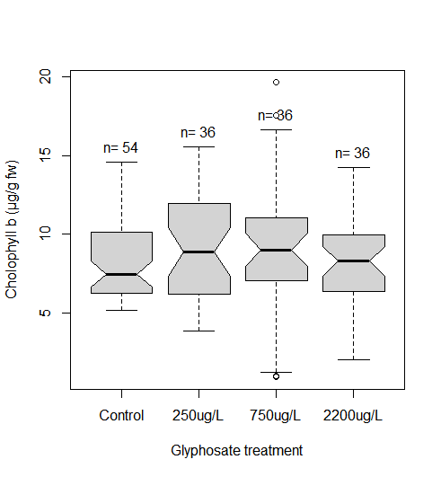
Figure C.1 Notched boxplots showing effect of glyphosate concentration on total chlorophyll, chlorophyll a and chlorophyll b concentration.

Table B.2 Results of Kruskall-Wallis test on photosynthetic pigment concentration
Pigment | Chi-squared | df | p-value
Total chlorophyll | 3.464 | 3 | 0.326
Chlorophyll a | 1.344 | 3 | 0.719
Chlorophyll b | 2.77 | 3 | 0.428

