Normality test of death and no-death groups in NSTEMI patients

Usually there are two test methods for normal distribution, one is Shapiro-Wilk test, which is suitable for small sample data (sample size ≤ 5000); another is Kolmogorov–Smirnov test, which is suitable for large sample data (sample size). >5000). If it is significant (p<0.05 or 0.01), it means that the null hypothesis is rejected (the data conforms to the normal distribution), the data does not satisfy the normal distribution, otherwise, the data conforms to the normal distribution. It is usually difficult to meet the test in real research situations. If the absolute value of the sample kurtosis is less than 10 and the absolute value of the skewness is less than 3, the data can be described as basically conforming to the normal distribution combined with QQ map.

(1) age

Tests of Normality
 | Death | Kolmogorov-Smirnovª |  |  | Shapiro-Wilk
 |  | Statistic | df | Sig. | Statistic | df | Sig.
Age | No | .072 | 734 | .000 | .978 | 734 | .000
 | Yes | .121 | 40 | .142 | .909 | 40 | .003
a. Lilliefors Significance Correction

 | Death | Kurtosis | Skewness
Age | No | -0.561 | -0.369
 | Yes | 3.911 | -1.313

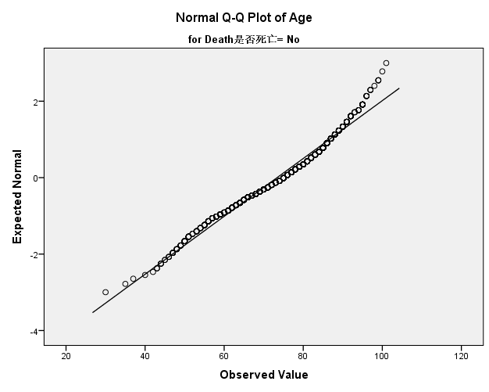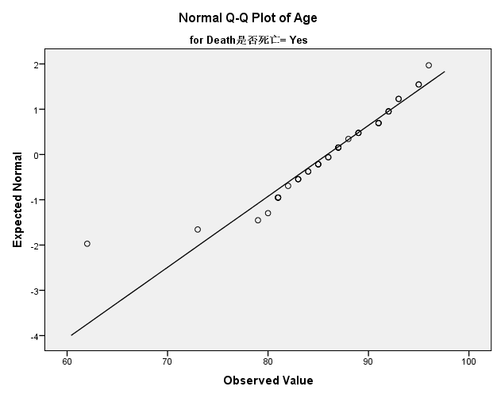

(2) SBP

Tests of Normality
 | Death | Kolmogorov-Smirnovª |  |  | Shapiro-Wilk
 |  | Statistic | df | Sig. | Statistic | df | Sig.
SBP | No | .087 | 728 | .000 | .980 | 728 | .000
 | Yes | .139 | 39 | .057 | .965 | 39 | .256
a. Lilliefors Significance Correction

 | Death | Kurtosis | Skewness
SBP | No | 1.304 | 0.390
 | Yes | 0.483 | 0.347

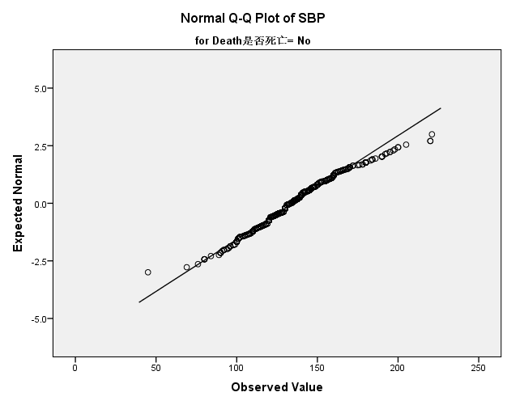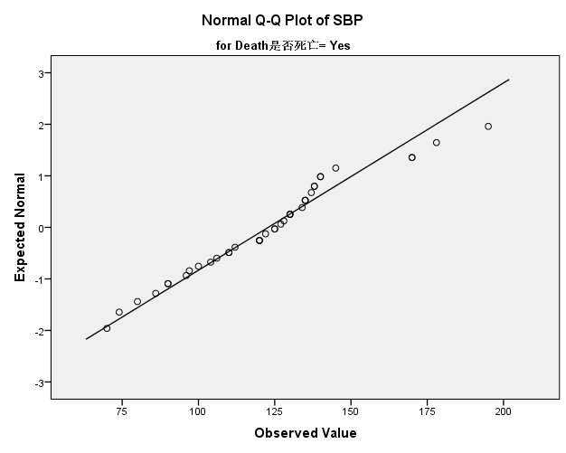

(3) Neutrophil

Tests of Normality
 | Death | Kolmogorov-Smirnovª |  |  | Shapiro-Wilk
 |  | Statistic | df | Sig. | Statistic | df | Sig.
Neut | No | .152 | 688 | .000 | .785 | 688 | .000
 | Yes | .160 | 40 | .012 | .768 | 40 | .000
a. Lilliefors Significance Correction

 | Death | Kurtosis | Skewness
Neutrophil | No | 11.957 | 2.698
 | Yes | 9.488 | 2.562

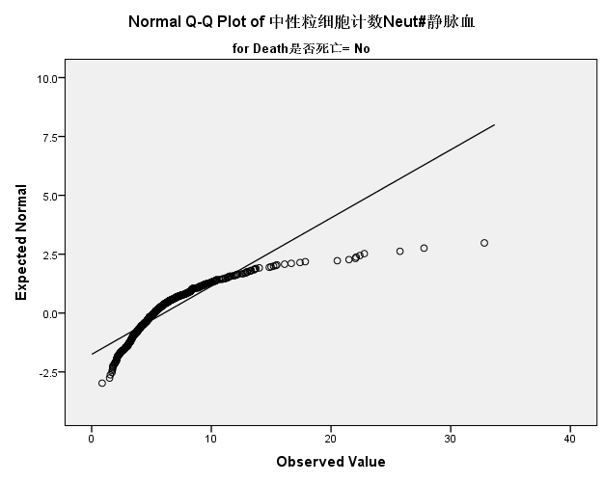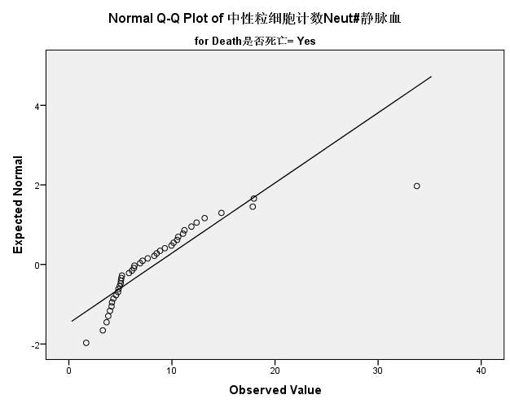

(4) Lymphocyte

Tests of Normality
 | Death | Kolmogorov-Smirnovª |  |  | Shapiro-Wilk
 |  | Statistic | df | Sig. | Statistic | df | Sig.
Lymph | No | .070 | 688 | .000 | .913 | 688 | .000
 | Yes | .187 | 40 | .001 | .877 | 40 | .000
a. Lilliefors Significance Correction

 | Death | Kurtosis | Skewness
Lymphocyte | No | 7.999 | 1.654
 | Yes | 0.215 | 1.068

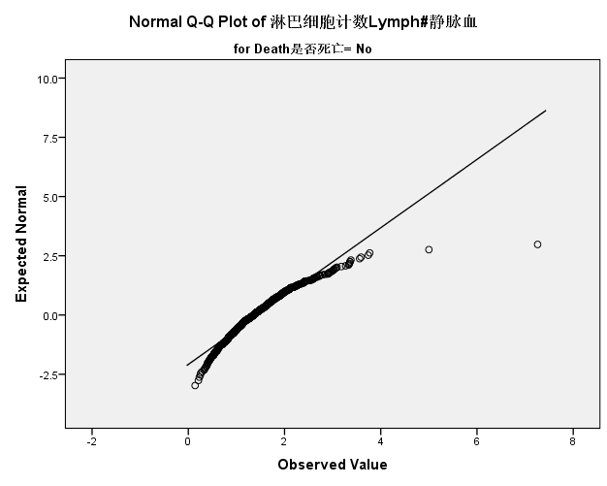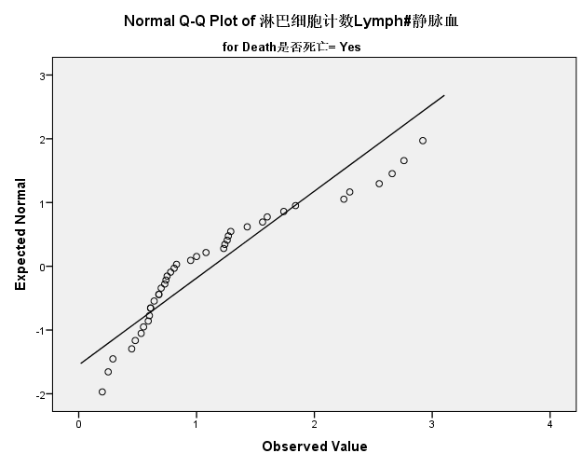

(5) WBC

Tests of Normality
 | Death | Kolmogorov-Smirnovª |  |  | Shapiro-Wilk
 |  | Statistic | df | Sig. | Statistic | df | Sig.
WBC | No | .140 | 689 | .000 | .813 | 689 | .000
 | Yes | .173 | 40 | .004 | .772 | 40 | .000
a. Lilliefors Significance Correction

 | Death | Kurtosis | Skewness
WBC | No | 10.874 | 2.508
 | Yes | 10.616 | 2.674

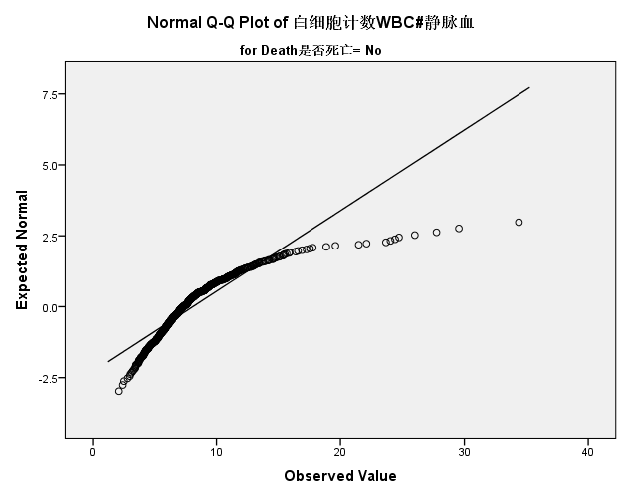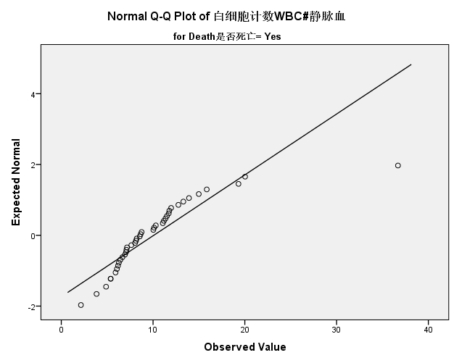

(6) PLT

Tests of Normality
 | Death | Kolmogorov-Smirnovª |  |  | Shapiro-Wilk
 |  | Statistic | df | Sig. | Statistic | df | Sig.
PLT | No | .069 | 689 | .000 | .910 | 689 | .000
 | Yes | .072 | 40 | .200* | .982 | 40 | .748
*. This is a lower bound of the true significance.
a. Lilliefors Significance Correction

 | Death | Kurtosis | Skewness
PLT | No | 12.364 | 1.850
 | Yes | -0.332 | -0.026

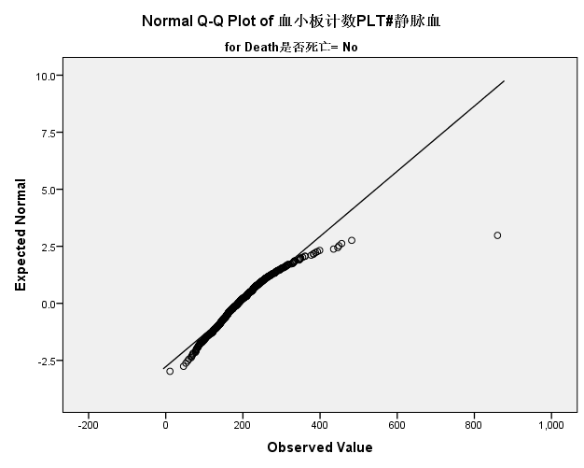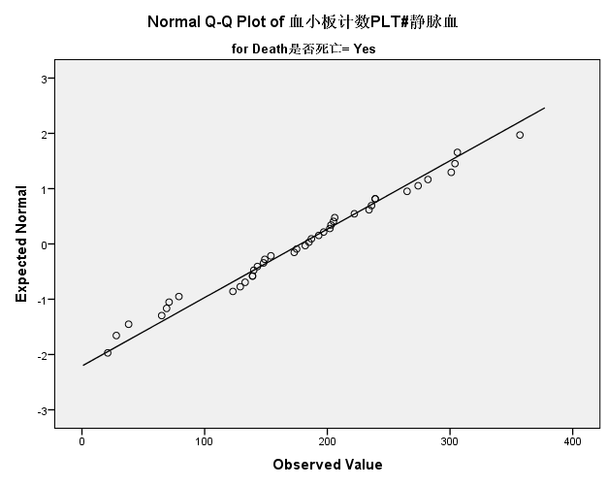

(7) Hb

Tests of Normality
 | Death | Kolmogorov-Smirnovª |  |  | Shapiro-Wilk
 |  | Statistic | df | Sig. | Statistic | df | Sig.
Hb | No | .050 | 689 | .000 | .982 | 689 | .000
 | Yes | .102 | 40 | .200* | .972 | 40 | .420
*. This is a lower bound of the true significance.
a. Lilliefors Significance Correction

 | Death | Kurtosis | Skewness
Hb | No | 0.421 | -0.540
 | Yes | -0.326 | -0.158

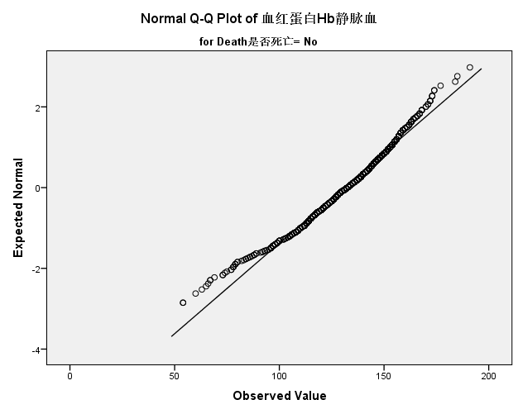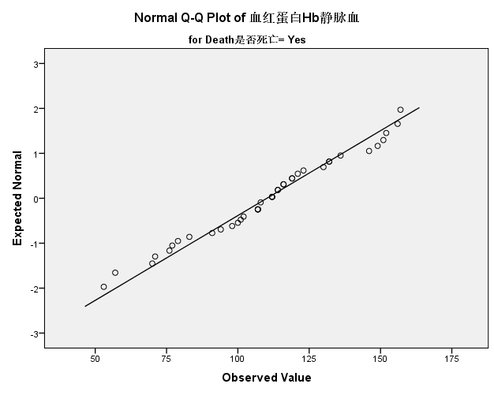

(8) ALT

Tests of Normality
 | Death | Kolmogorov-Smirnovª |  |  | Shapiro-Wilk
 |  | Statistic | df | Sig. | Statistic | df | Sig.
ALT | No | .395 | 733 | .000 | .137 | 733 | .000
 | Yes | .418 | 40 | .000 | .204 | 40 | .000
a. Lilliefors Significance Correction

 | Death | Kurtosis | Skewness
ALT | No | 267.042 | 15.550
 | Yes | 39.081 | 6.221

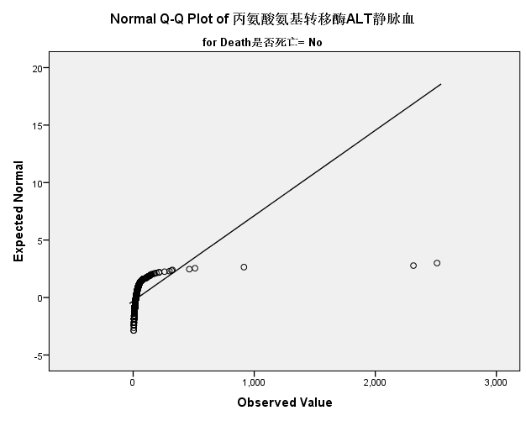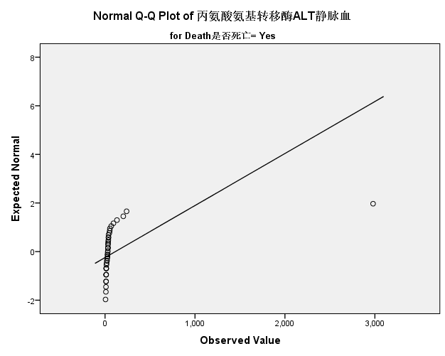

(9) AST

Tests of Normality
 | Death | Kolmogorov-Smirnovª |  |  | Shapiro-Wilk
 |  | Statistic | df | Sig. | Statistic | df | Sig.
AST | No | .380 | 733 | .000 | .190 | 733 | .000
 | Yes | .360 | 40 | .000 | .350 | 40 | .000
a. Lilliefors Significance Correction

 | Death | Kurtosis | Skewness
AST | No | 219.631 | 13.699
 | Yes | 28.944 | 5.166

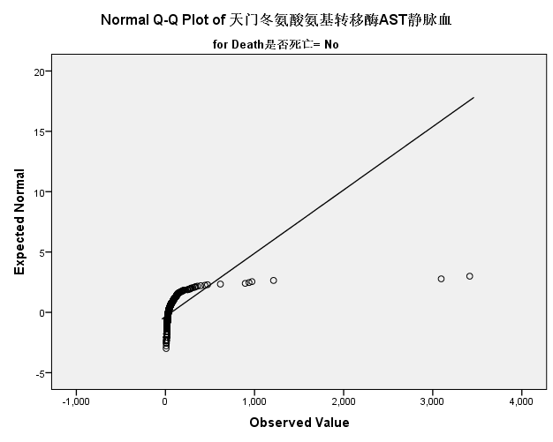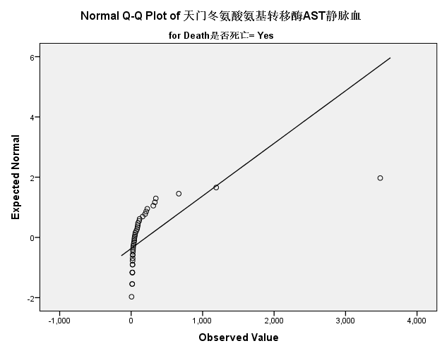

(10) LDH

Tests of Normality
 | Death | Kolmogorov-Smirnovª |  |  | Shapiro-Wilk
 |  | Statistic | df | Sig. | Statistic | df | Sig.
LDH | No | .268 | 733 | .000 | .394 | 733 | .000
 | Yes | .290 | 40 | .000 | .667 | 40 | .000
a. Lilliefors Significance Correction

 | Death | Kurtosis | Skewness
LDH | No | 149.592 | 9.964
 | Yes | 3.008 | 2.004
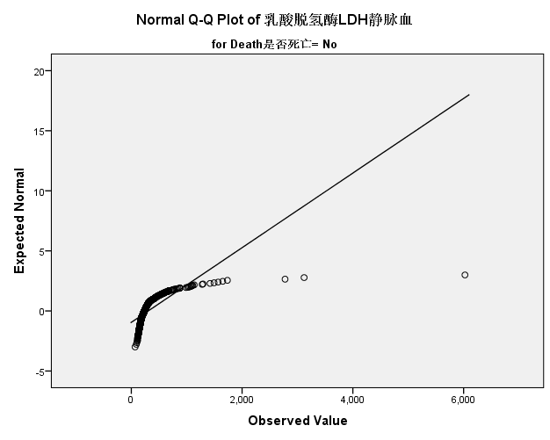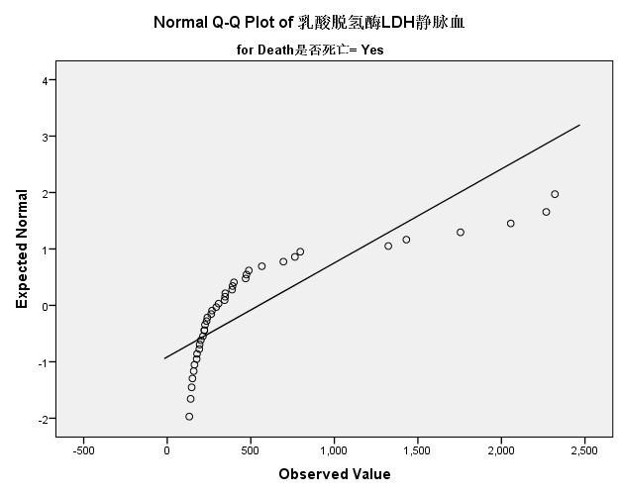

(11) LDL-C

Tests of Normality
 | Death | Kolmogorov-Smirnovª |  |  | Shapiro-Wilk
 |  | Statistic | df | Sig. | Statistic | df | Sig.
LDL-C | No | .068 | 714 | .000 | .941 | 714 | .000
 | Yes | .145 | 38 | .044 | .937 | 38 | .033
a. Lilliefors Significance Correction

 | Death | Kurtosis | Skewness
LDL-C | No | 4.121 | 1.185
 | Yes | -0.105 | 0.744

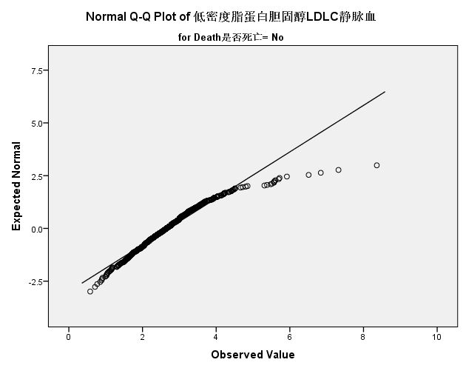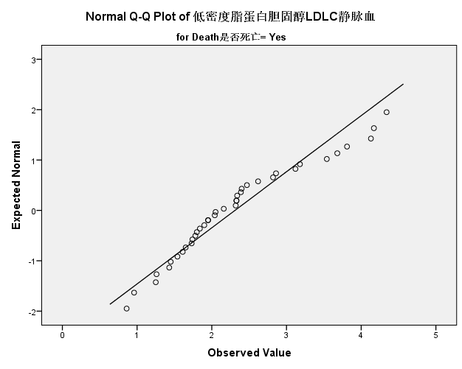

(12) HDL-C

Tests of Normality
 | Death | Kolmogorov-Smirnovª |  |  | Shapiro-Wilk
 |  | Statistic | df | Sig. | Statistic | df | Sig.
HDL-C | No | .094 | 714 | .000 | .960 | 714 | .000
 | Yes | .096 | 38 | .200* | .933 | 38 | .025
*. This is a lower bound of the true significance.
a. Lilliefors Significance Correction

 | Death | Kurtosis | Skewness
HDL-C | No | 1.691 | 0.851
 | Yes | 0.884 | 0.968

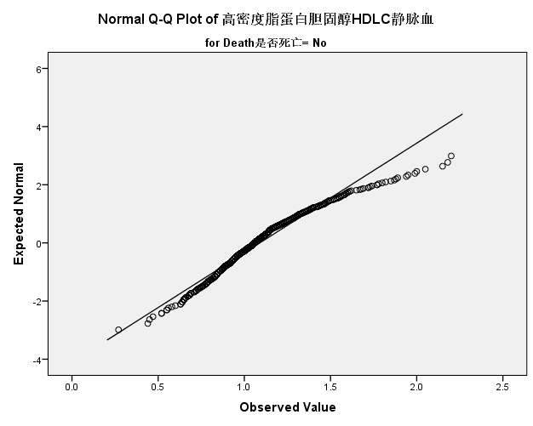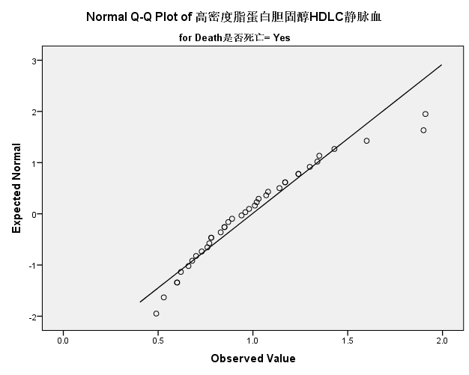

(13) BUN

Tests of Normality
 | Death | Kolmogorov-Smirnovª |  |  | Shapiro-Wilk
 |  | Statistic | df | Sig. | Statistic | df | Sig.
BUN | No | .207 | 733 | .000 | .686 | 733 | .000
 | Yes | .206 | 40 | .000 | .849 | 40 | .000
a. Lilliefors Significance Correction

 | Death | Kurtosis | Skewness
BUN | No | 14.218 | 3.180
 | Yes | 1.411 | 1.402

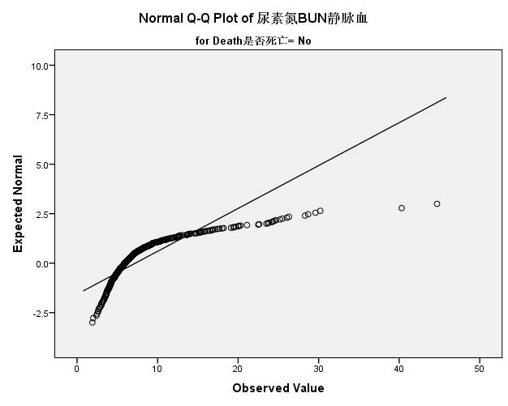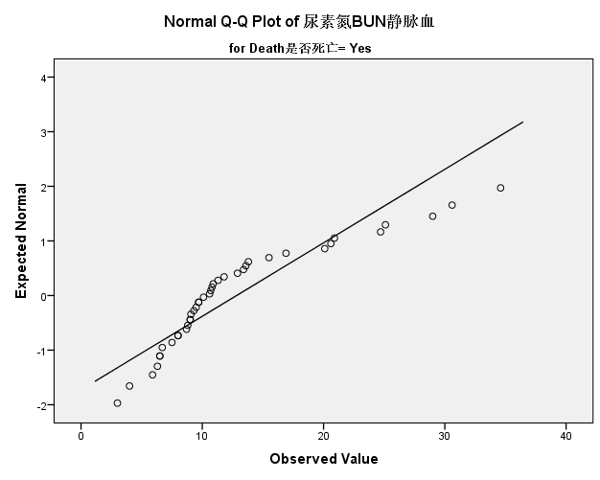

(14) UA

Tests of Normality
 | Death | Kolmogorov-Smirnovª |  |  | Shapiro-Wilk
 |  | Statistic | df | Sig. | Statistic | df | Sig.
UA | No | .076 | 734 | .000 | .928 | 734 | .000
 | Yes | .098 | 40 | .200* | .966 | 40 | .265
*. This is a lower bound of the true significance.
a. Lilliefors Significance Correction

 | Death | Kurtosis | Skewness
UA | No | 4.375 | 1.347
 | Yes | 0.264 | 0.647

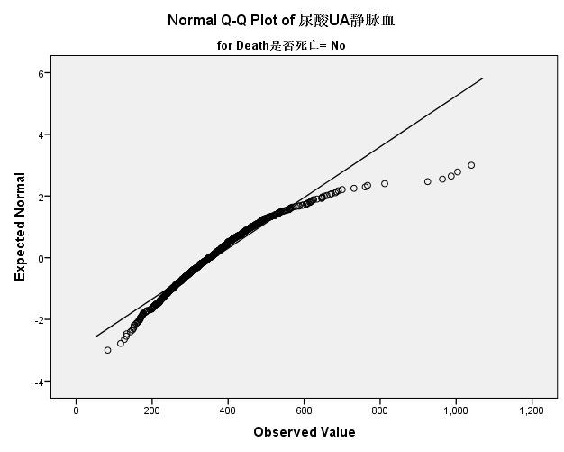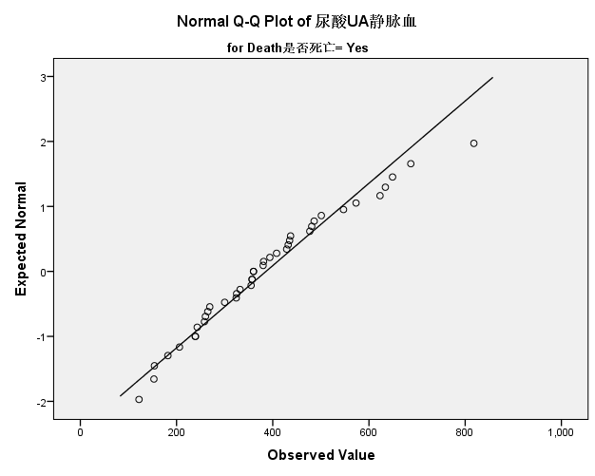

(15) cTNI

Tests of Normality
 | Death | Kolmogorov-Smirnovª |  |  | Shapiro-Wilk
 |  | Statistic | df | Sig. | Statistic | df | Sig.
cTnI | No | .303 | 597 | .000 | .546 | 597 | .000
 | Yes | .267 | 29 | .000 | .664 | 29 | .000
a. Lilliefors Significance Correction

 | Death | Kurtosis | Skewness
cTNI | No | 24.667 | 4.047
 | Yes | 5.974 | 2.403
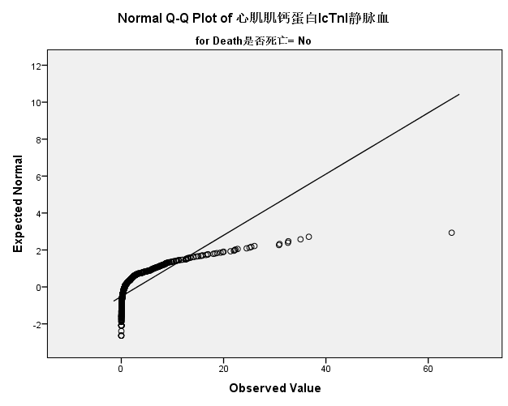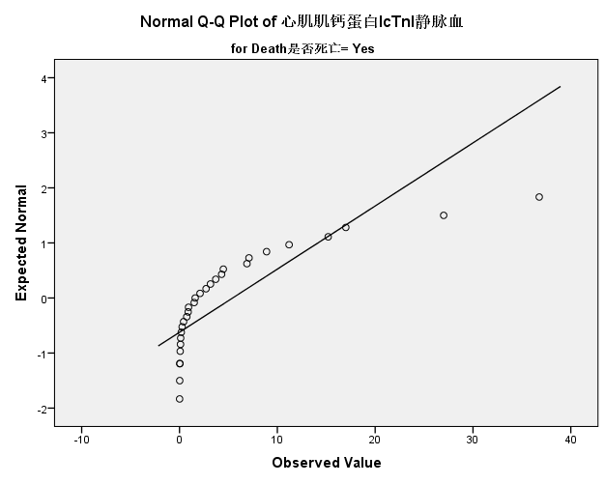

(16) TC

Tests of Normality
 | Death | Kolmogorov-Smirnovª |  |  | Shapiro-Wilk
 |  | Statistic | df | Sig. | Statistic | df | Sig.
TC | No | .058 | 734 | .000 | .958 | 734 | .000
 | Yes | .081 | 40 | .200* | .978 | 40 | .623
*. This is a lower bound of the true significance.
a. Lilliefors Significance Correction

 | Death | Kurtosis | Skewness
TC | No | 2.793 | 0.947
 | Yes | -0.366 | 0.379

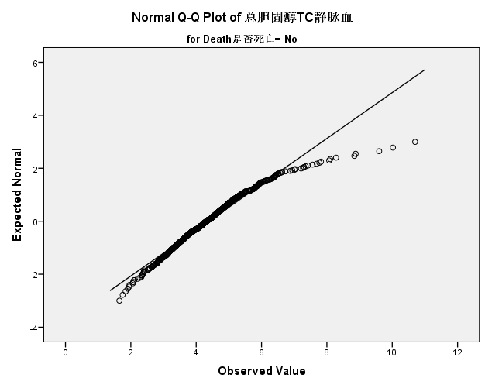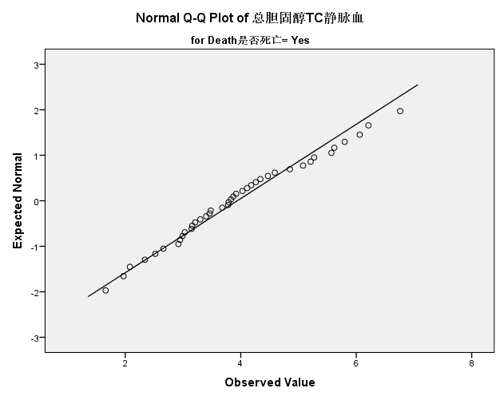

(17) ALB

Tests of Normality
 | Death | Kolmogorov-Smirnovª |  |  | Shapiro-Wilk
 |  | Statistic | df | Sig. | Statistic | df | Sig.
ALB | No | .063 | 733 | .000 | .987 | 733 | .000
 | Yes | .127 | 40 | .103 | .962 | 40 | .197
a. Lilliefors Significance Correction

 | Death | Kurtosis | Skewness
ALB | No | 0.730 | -0.444
 | Yes | -0.289 | -0.558

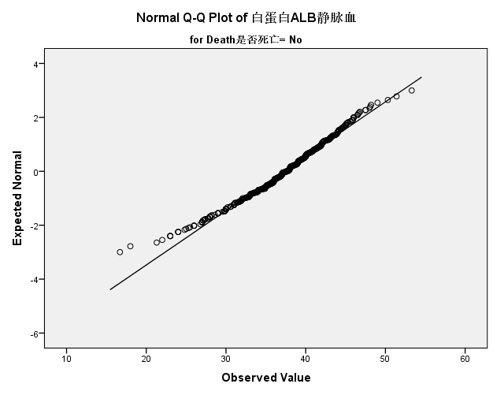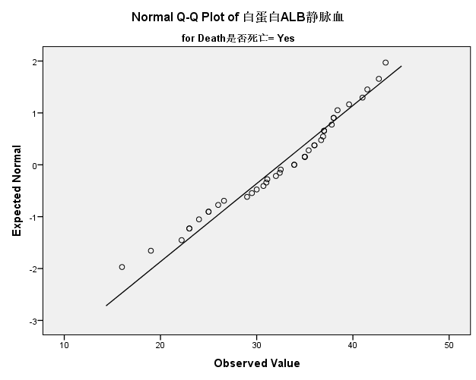

(18) Creatinine

Tests of Normality
 | Death | Kolmogorov-Smirnovª |  |  | Shapiro-Wilk
 |  | Statistic | df | Sig. | Statistic | df | Sig.
Crea | No | .277 | 734 | .000 | .420 | 734 | .000
 | Yes | .168 | 40 | .006 | .767 | 40 | .000
a. Lilliefors Significance Correction

 | Death | Kurtosis | Skewness
Creatinine | No | 39.080 | 5.768
 | Yes | 8.814 | 2.491
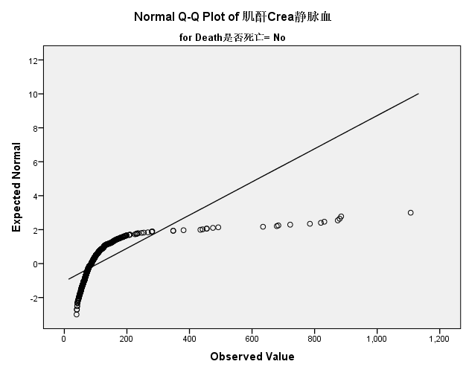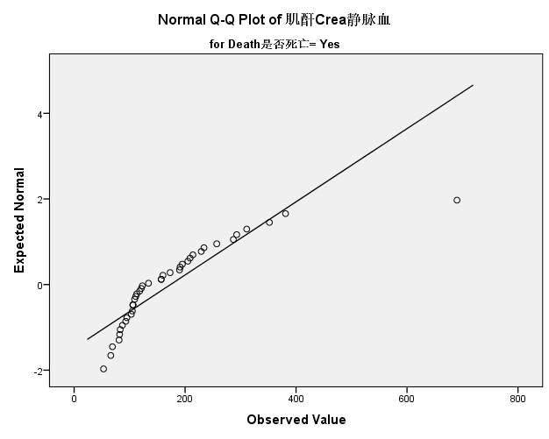

(19) GLU

Tests of Normality
 | Death | Kolmogorov-Smirnovª |  |  | Shapiro-Wilk
 |  | Statistic | df | Sig. | Statistic | df | Sig.
Glu | No | .150 | 734 | .000 | .792 | 734 | .000
 | Yes | .216 | 40 | .000 | .760 | 40 | .000
a. Lilliefors Significance Correction

 | Death | Kurtosis | Skewness
GLU | No | 12.643 | 2.666
 | Yes | 9.478 | 2.554

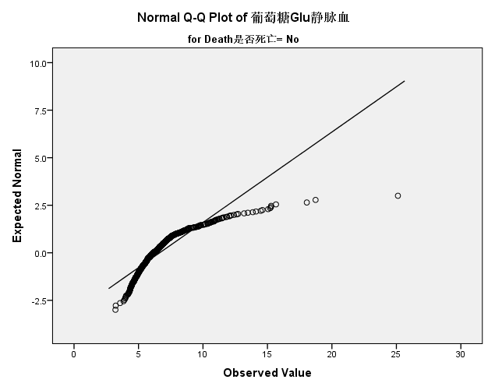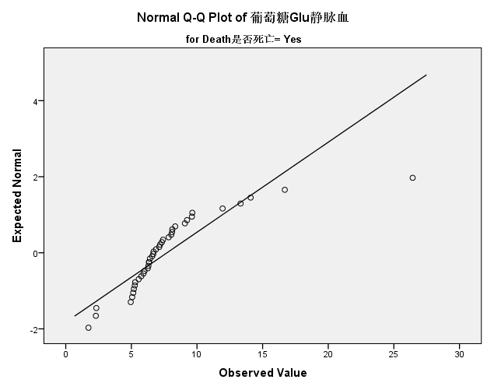

(20) hsCRP

Tests of Normality
 | Death | Kolmogorov-Smirnovª |  |  | Shapiro-Wilk
 |  | Statistic | df | Sig. | Statistic | df | Sig.
hsCRP | No | .254 | 232 | .000 | .691 | 232 | .000
 | Yes | .162 | 25 | .088 | .863 | 25 | .003
a. Lilliefors Significance Correction

 | Death | Kurtosis | Skewness
hsCRP | No | 4.687 | 2.153
 | Yes | 1.390 | 1.308

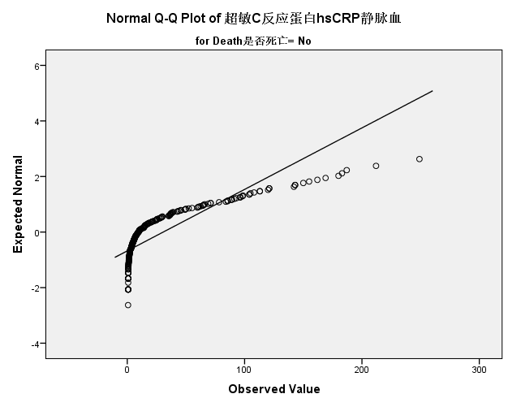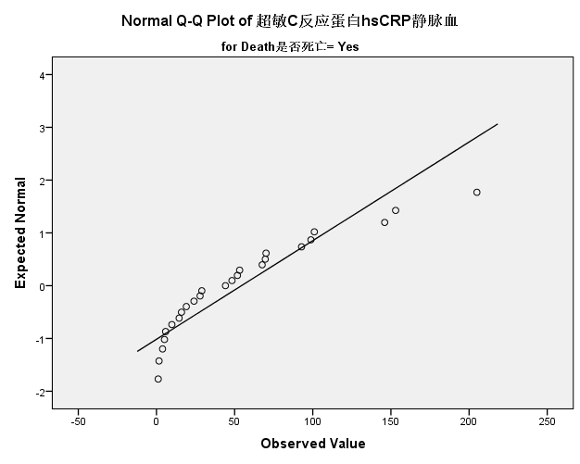

(21) HbA1C

Tests of Normality
 | Death是 | Kolmogorov-Smirnovª |  |  | Shapiro-Wilk
 |  | Statistic | df | Sig. | Statistic | df | Sig.
HbA1c | No | .171 | 106 | .000 | .835 | 106 | .000
 | Yes | .214 | 6 | .200* | .935 | 6 | .619
*. This is a lower bound of the true significance.
a. Lilliefors Significance Correction

 | Death | Kurtosis | Skewness
HbA1C | No | 5.472 | 1.955
 | Yes | 1.998 | 0.952

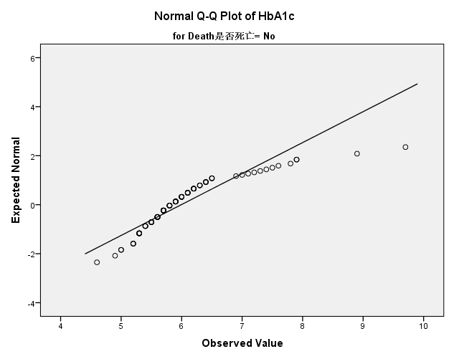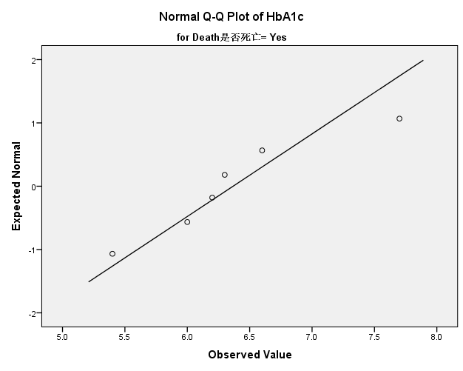

(22) LVEF

Tests of Normality
 | Death | Kolmogorov-Smirnovª |  |  | Shapiro-Wilk
 |  | Statistic | df | Sig. | Statistic | df | Sig.
EF | No | .112 | 563 | .000 | .944 | 563 | .000
 | Yes | .145 | 22 | .200* | .919 | 22 | .073
*. This is a lower bound of the true significance.
a. Lilliefors Significance Correction

 | Death | Kurtosis | Skewness
LVEF | No | 0.040 | -0.791
 | Yes | -0.829 | -0.487

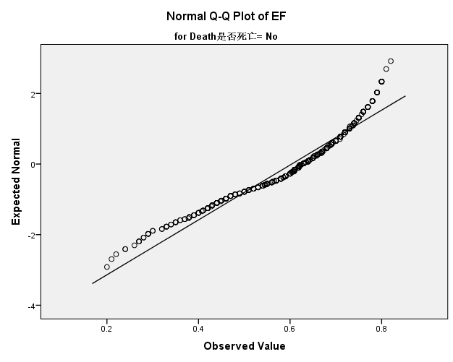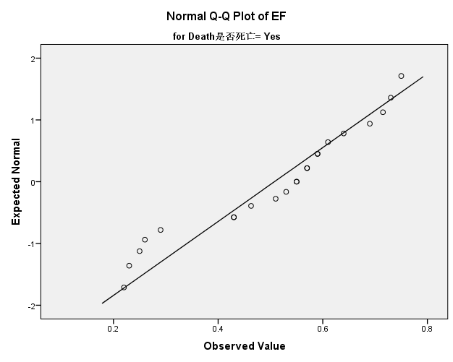

(23) TyG

Tests of Normality
 | Death | Kolmogorov-Smirnovª |  |  | Shapiro-Wilk
 |  | Statistic | df | Sig. | Statistic | df | Sig.
TyG | No | .041 | 734 | .005 | .993 | 734 | .002
 | Yes | .162 | 40 | .010 | .874 | 40 | .000
a. Lilliefors Significance Correction

 | Death | Kurtosis | Skewness
TyG | No | 0.374 | 0.203
 | Yes | 1.032 | 1.249

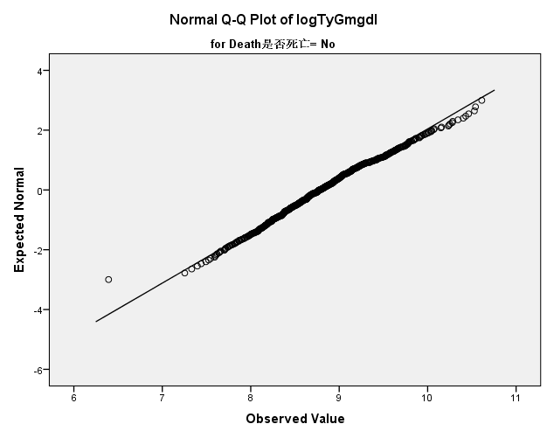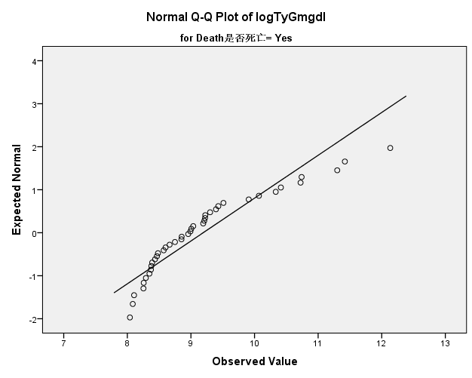

(24) TG/HDL-C

Tests of Normality
 | Death | Kolmogorov-Smirnovª |  |  | Shapiro-Wilk
 |  | Statistic | df | Sig. | Statistic | df | Sig.
TG/HDL-C | No | .141 | 714 | .000 | .807 | 714 | .000
 | Yes | .202 | 38 | .000 | .615 | 38 | .000
a. Lilliefors Significance Correction

 | Death | Kurtosis | Skewness
TG/HDL-C | No | 8.559 | 2.325
 | Yes | 18.400 | 3.821
