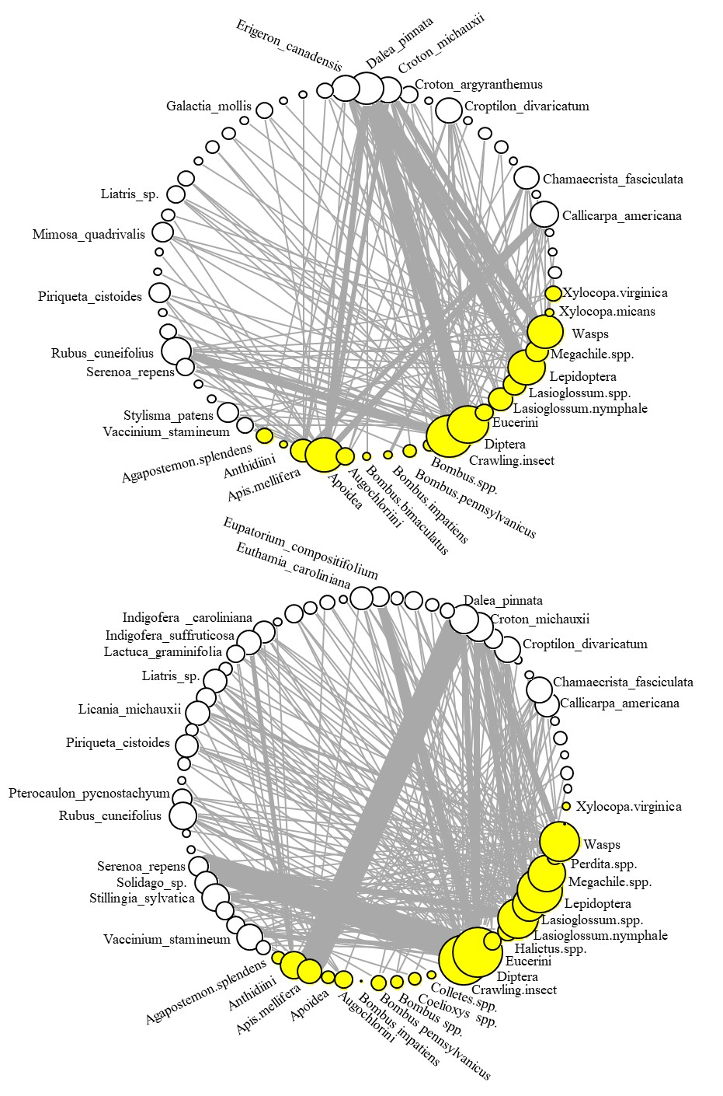
B
A

Appendix 1: Bipartite network plot showing plant-pollinator interactions in (A) 2019, the year between seasonal burn treatment and (B) 2020, the year when burn treatments were again applied

