Supplementary information for: “A new species of Daspletosaurus Russell, 1970 from the Judith River Formation of eastern Montana”
Elías A. Warshaw^{1, 2} and Denver W. Fowler²
- Department of Earth Sciences, Montana State University, Bozeman, Montana, USA
- Badlands Dinosaur Museum, Dickinson, North Dakota, USA
Corresponding author:
Elías A. Warshaw^{1, 2}
2137 S 11th Ave 126B, Bozeman, Montana, 59715, USA
Email address: warshawelias@gmail.com
Character Data
Additions to character matrix of Carr et al. (2017):
- Premaxilla, orientation of alveolar margin: rostromedial-caudolateral, such that several premaxillary teeth are visible in lateral view (0); mediolateral, such that only the distalmost premaxillary tooth is visible in lateral view (1).
- Maxilla, rostral interdental plates, form: first plate truncated, second plate wide (0); first plate narrow, second plate truncated (1); first two plates expanded (2) (Carr et al., 2017)*.
- Lacrimal, orbital margin, form: convex (0); concave (1) (Carr et al., 2017)*.
- Lacrimal, rostroventral edge of rostrodorsal ala, form: sharp, uninflated (0); forming a thick, round bar between rami that is clearly distinct from both the rostral/ventral rami and the remainder of the lacrimal antorbital fossa (1); forming a thick, round bar confluent with rostral and ventral rami but distinct from lacrimal antorbital fossa (2). ORDERED.
- Quadratojugal, dorsal quadrate contact: directed medially, concealed in lateral view (0); directed caudomedially, visible in lateral view (1).
- Prefrontal, orientation of long axis, dorsal view: rostrocaudal (0); rostromedial or mediolateral (1)(can be scored by the orientation of the prefrontal contact surface on the lacrimal in specimens lacking a preserved prefrontal).
- Squamosal, pneumatic recess, form: not undercut around its entire margin (0); undercut around its entire margin (1) (Carr et al., 2017)*.
- Parietal, joint surface for the squamosal, dorsal extent: covers the ventral half of the base of the caudolateral process (0); covers the entire caudolateral process (1) (Carr et al., 2017)*.
- Prootic, tympanic ridge, presence: does not extend onto the prootic (0); extends onto the prootic (1) (Carr et al., 2017)*.
*Proposed by Carr et al. (2017) as an autapomorphy of D. horneri.
Removed characters (Carr et al., 2017):
- Maxilla, maxillary fenestra, caudal margin, shape, lateral view: rounded (0); V-shaped (1) (Brochu, 2003; Loewen et al., 2013:34; Brusatte and Carr, 2016:327).
The shape of the maxillary fenestra has been demonstrated to be highly variable within T. rex; variation in the shape of its caudal margin is taken here to be a result of individual variation (Carr, 2020; Molnar, 1990).
- Lacrimal, accessory caudally extending cornual process on the lateral surface between the cornual process and the supraorbital ramus, presence, lateral view: absent (0), present (1) (Carr and Williamson, 2010:70; Brusatte and Carr, 2016:360).
We could not identify a discrete difference in the morphology of the caudal end of the rostral ramus of the lacrimal among tyrannosaurines that were scored differently for this character (i.e., Teratophoneus and D. torosus, Tarbosaurus Fig. 6 Hurum and Sabbath, 2003), and for this reason exclude this character from our analysis.
- Lacrimal, transition between antorbital fossa and the subcutaneous surface of the ventral ramus, form, lateral view: surfaces are continuous with each other (0); fossa is deeply inset, forming a ridge along the subcutaneous surface (1) (Carr and Williamson 2010:61; Brusatte et al., 2010:55; Brusatte and Carr, 2016:55).
We could not identify a discrete difference in the relief between the antorbital fossa and ventral ramus of the lacrimal in taxa scored for (0) and (1) (i.e., Bistahieversor and D. torosus) and for this reason exclude this character from our analysis.
- Quadratojugal, jugal articulation, form, lateral and dorsal views: dorsal quadratojugal process of jugal does not (0) or does (1) approach the base of the quadratojugal (caudoventral corner of the laterotemporal fenestra) (Carr and Williamson, 2010:118; Brusatte et al., 2010:100; Loewen et al., 2013:146; Brusatte and Carr, 2016:100).
We could not identify a discrete difference between the morphology of the dorsal jugal articulation in taxa scored for (1) or (0), and for this reason exclude this character from our analysis.
- Pes, metatarsal II, lateral surface, shape, proximal view: flat or weakly concave (0); strongly concave (1) (Brusatte et al., 2010:304; Loewen et al., 2013:486; Brusatte and Carr, 2016:304).
This character is redundant with the presence of an arctometatarsalian metatarsus (character 377) and is for this reason excluded from our analysis.
Modified characters (Carr et al., 2017):
- Lacrimal, cornual process, height, lateral view: tall, greater than 60% height of antorbital fossa below it (0); short, less than 60% of the height of the fossa below it (1) indistinguishable in relief from the rest of the dorsal surface of the lacrimal (2)(var. Loewen et al., 2013:64; Brusatte and Carr, 2016:359). ORDERED.
An additional character state has been added here to distinguish the morphology of the lacrimal’s cornual process in Tyrannosaurus and Tarbosaurus as opposed to more basal tyrannosaurines, including D. horneri. Otherwise, we agree with the scorings of Carr et al. (2017), but we note here that the usage of the antorbital fossa as a reference against which to score the height of the cornual process is potentially misleading since the height of the antorbital fossa is itself quite variable between taxa (i.e., CMN 8506, D. torosus, vs. MOR 590, D. horneri). D. wilsoni is scored as having a short cornual process of the lacrimal based on comparisons of the absolute height of the process with Daspletosaurus specimens of other species (see main article text).
- Postorbital, cornual process, presence and form, lateral view: absent (0); limited to rugose rim or small rugose convexity at caudodorsal corner of orbit (1); swollen such that the process overhangs its caudoventral margin, forming a crease between the process and the main body of the postorbital (2); entirety of the caudodorsal region of the postorbital inflated, with cornual process expressed as a large, convex boss that grades into the body of the postorbital caudoventrally (3) (Holtz, 2001:56; Sereno et al., 2009:29; Brusatte et al., 2010:81; Loewen et al., 2013:110). ORDERED.
This character is modified to distinguish between the cornual process morphologies of D. torosus and D. horneri + Tyrannosaurus.
- Frontal, contribution to orbital rim, dorsal and lateral views: extensive (0), present but limited to a small notch (1), excluded by postorbital-lacrimal contact in large specimens (2), excluded by postorbital-lacrimal articulation and novel palpebral ossification (3) (Sereno et al., 2009:21; Carr and Williamson, 2010:104; Brusatte et al., 2010:120; Loewen et al., 2013:90; Brusatte and Carr, 2016:120). ORDERED.
State 3 is redundant with character #148 of Carr et al., (2017) (presence of a palpebral ossification), and is for this reason collapsed into state 2.
Modified character states (Carr et al., 2017):
- D. horneri (? → 2)
Given the relatively complete orbitotemporal region of the holotype of D. horneri, we feel comfortable assigning the shape of its orbit to character state 2 (dorsoventrally tall, more than twice as tall as long).
- D. horneri (0 → 1)
The jugal of D. horneri flexes rostromedially at the level of the orbit, directing the orbits forwards as in T. rex, such that their orientation is best described by character state 1 (directed rostrally at greater than 20 degrees from the sagittal plane).
- D. horneri (0 → 1)
Personal observation of the holotype specimen of D. horneri (MOR 590) by EW revealed that the maxillary fenestra abuts the ventral margin of the antorbital fossa in this specimen.
- D. horneri (0 → 1)
Personal observation of the holotype specimen of D. horneri (MOR 590) by EW revealed that the antorbital fossa does not extend ahead of the rostral boundary of the external antorbital fenestra in this specimen.
- A. libratus, A. sarcophagus, Teratophoneus, and Qianzhousaurus (2 → 1)
We regard the morphology of the postorbital’s cornual process in the taxa listed above as best represented by character state 1 (i.e., a small rugose convexity at the orbit’s caudodorsal margin) as opposed to 2 (a massively swollen tuberosity), and sought to distinguish the postorbital morphology of these taxa from the much more prominent cornual processes of derived tyrannosaurines (character states 2 and 3).
- D. horneri (1 → 0)
We disagree with Carr et al.’s (2017) characterization of the postorbital cornual process of D. horneri as nearing the laterotemporal fenestra (as is the case in D. torosus); we regard the position of this process as more similar to the condition in T. rex: widely separated from the laterotemporal fenestra and terminating more closely to the orbit.
- D. horneri (1 → 0)
We disagree with Carr et al.’s (2017) characterization of the suborbital fenestra of D. horneri as rostrocaudally elongate; personal observation of the articulated skull of the holotype specimen of this species (MOR 590) by EW revealed a subcircular fenestra similar to most specimens of T. rex.
Daspletosaurus autapomorphies recovered by the cladistic analysis:
D. horneri: 89 (0 → 1), 96 (0 → 1), 158 (1 → 0), 206 ( 1 → 0), 275 (1 → 0), 305 (2 → 1)
D. torosus: 89 (0 → 1), 272 (0 → 1), 364 (1 → 0)
D. wilsoni: 251 (2 → 1)
Synapomorphies recovered by the cladistic analysis:
Daspletosaurus + more derived tyrannosaurines: 20 (0 → 1), 24 (0 → 2), 42 (1 → 2), 43 (0 → 2), 59 (0 → 1), 75 (0 → 1), 76 (1 → 0), 78 ( 1 → 2), 85 (0 → 1), 87 (0 → 1), 91 (0 → 1), 93 (0 → 1), 97 (0 → 1), 110 (1 → 2), 111 (1 → 2), 117 (0 → 1), 127 (0 → 1), 160 (1 → 2), 220 (0 →1), 231 (0 → 2), 232 (0 → 1), 238 (0 → 1), 361 (1 → 2), 384 (0 → 1)
D. wilsoni + more derived tyrannosaurines: 7 (1 → 2), 69 (0 → 1), 395 (0 → 1)
D. horneri + more derived tyrannosaurines: 9 (0 → 1), 110 (2 → 3), 396 (0 → 1), 400 (0 → 1)
Supplemental Figures
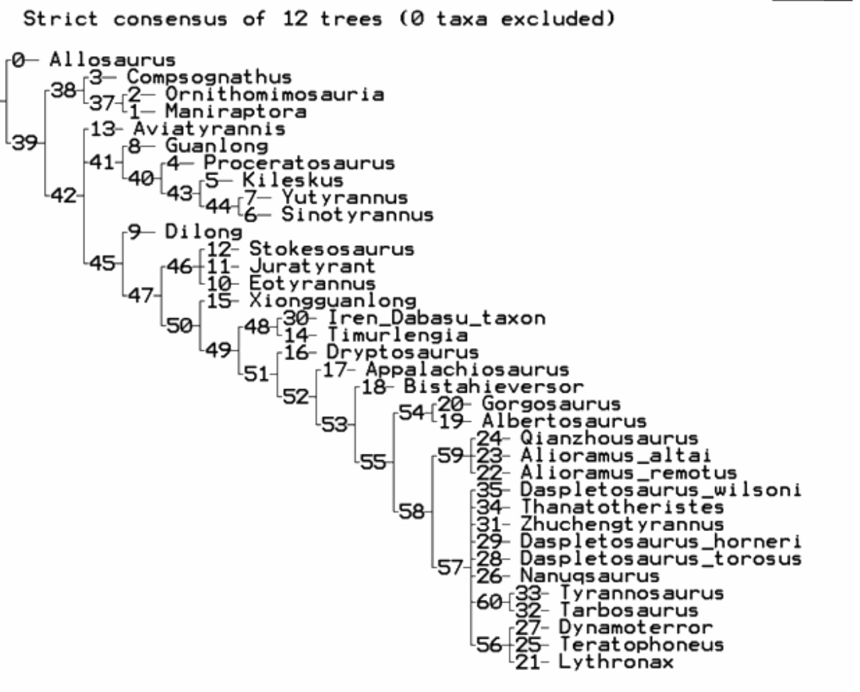

Figure S1: Strict consensus of cladistic analysis with all taxa included. Note the large polytomy formed by tyrannosaurines more derived than alioramini (node 57). See main text for source of matrix and settings used for analysis.

