Supplementary Table S1. Lotus cultivars used in this study.
Color | Genotypes | Number | Cultivars
Purple-red | Flower lotus | 76 | Hongdenglong13(1),Ruyiguanyin(2),Saimeigui-I(4),Qiuwanluoshan(5),Taikongfeitian(6),Zhogshanchongtai(7),Antouchun-I(8),Shanchengdenghai(10),Honghua(11),Guanghui(12),Tonghuan(13),Feihong(14),Tonghuan-I(15),Tongle(16),Xiaojingling13A-I(17),Hongdenglong13-I(18),Ziyu(20),Cuiyuhe(21),Dongfanghong(22),Gongdeng(23),Guoqinghong-I(24),Guanghui-I(25),Cuifuhongya-I(26),Cuifuhongya(27),Qiurihonghua(28),Wanziqianhong(29),Nihelulian-I(31),Qiuzhiju(33),Taikongfeitian-I(35),Feihong-I(36),Antuchun13(37),Saimeigui(38),Manaohong(40),Nihelulian(41),Shunv(42),Xihongyi(43),Xiaojingling13A(44),Xiaozuixian(45),Xuezhongfeicui(46),Youyihong(48),Guoqinghong(49),Qiurihonghua(50),Qiuyefanxing(51),Shunv-I(52),Tianxianhonglian(53),Xihongyi-I(54),Yujiyanzhuang-I(55),Zhongshanchongtai-I(56),Zhuyishizhe(57),Fendieyi(59),Hongtailian(60),Jianxiangzhuangshi(62),Antouchun(65),Qiaoshou(68),Qiaoshou-I(71),Pizhenhong(76),Pizhenhong-I(78),Xiangsidou(82),Yujiyanzhuang(83),Xiangsidou-I(84),Antouchun13-I(86),Chongbanfenhonglian(90),Dazuhonglian(91),Hongdenglong(92),Jubo(94),Qiurihonghua-I(95),Qiushuichangtian(96),Wuniang(98),Xiangbihe(99),Chunhongqiuyan(100),Cuiyuhe-I(101),Fenhonglingxiao(102),Huangwanlian(103),Taikongjiaoyang(110),Shenghuo(114),Lvfanghanzhu(115).
 | Rhizome lotus | 4 | Yeou(85),Shilihe(87),Shilihe1(89),Shilihe1-I(97).
 | Seed lotus | 17 | Yehonglian(47),Wuke5(30),Taikong58(34),Xualian-I(39),Honghuajianhe(58),Hongxianglian(61),Jinfurong2-I(63),Tuxuanlian(77),Taikonglian2(79),Xuanlian(80),Xuanlian5(81),Xuanfurong2(88),Jinfurong2(93),Jinfurong1(104),C-Jinfurong1(111),Guangchangchuantongbailian(112),C-Jinfurong1-I(113).
 | Thailand lotus | 16 | C-Ti-13(3),Ti-13-I(9),Ti-23(64),C-Ti-13-I(66),Taiguo42(67),Taiguo41(69),Taiguo42-I(70),Taiguo41-I(72), C-Taiguobancongban (73),Ti-13(74),C-Ti-23(75),Ti-12-I(105), Taiguobancongban(106), C-Taiguobancongban-I(107), Taiguobancongban-I(108), Taiguohuaqilian(109).
 | Wild lotus | 2 | Guangxiquaolian(19),Qianlingbaihe-I(32).
Red | Flower lotus | 24 | Yanyangtian(116),Zhuoyue13(117),Dashi(119),Dashi-I(121),Jubo-I(122),Meizhonghong(126),Xiaolianzuo13(128),Xiaoxia(129),Aoyunlian(130),Hongbianyudie(131),Meizhonghong-I(132),Shaoxinghonglian(133),Shouxingtao(134),Bailiwangzi(135),Xiaolianzuo13-I(136),Xiaomanjianghong(137),Xiaoxia-I(138),Shengxianfenlian(139),Fenxia13-I(140),Hongbianyudie(142),Hongbianyudie-I(144),Jingyan(145),Jingyan-I(146),Yingnv(147).
 | Rhizome lotus | 2 | Shilihe1(123),Shilihe-I(124).
 | Seed lotus | 2 | Wuke7(127),Guangxichuantongbailian-I(143).
 | Thailand lotus | 1 | Ti-12(141).
 | Wild lotus | 1 | Qianlingbaihe(118).
 | N.lutea | 2 | Meihuanglian-I(120),Meihuanglian(125).
Yellow | Flower lotus | 20 | Jinque(148),Huangwufei(149),Ruixue(150),Jinlingningcui(151),Fenghuangling-I(152),Jinwubian(153),Jinwuyongcui(154),Lvruyi-I(155),Lvruyi(156),Yutangjinma(158),Jinpingguo(159),Molilian(160),Cuiyuhe(161),Huangmudan(162),Huangwufei-I(163),Jinpingguo-I(164),Jintaiyang(165),Bingjiao(166),Bingjiao-I(167),Chongban17(168).
 | Wild lotus | 1 | Puzheheibaihe(157).
White | Flower lotus | 37 | Fenghuangling(169),Xinxiamenwanlian(170),Changebenyue(171),Jinluandian(172),Weixiaojie(173),Yuloutai(174),Yuwan13(175),Daziyu(176),Silian13-I(178),Xiaojinbian-I(179),Yutangjinma-I(180),Baihailian-I(181),Baijunzixiaolian(182),Bailiingniao(183),Silian13(184),Jinzhuluoyupan(185),Xiaozhizi-I(186),Julian(187),Baiju(188),Baiju-I(189),Gongxunlian-I(190),Xiaoyuwan(191),Xiaoyuwan-I(192),Xiaojinbian(193),Xiaozhizi(194),Fenxia13(195),Baihailian(196),151(197),Weixiaojie-I(198),Xinxiamenwanlian-I(199),Xueju(200),Yuchanmingcui(201),Yuloutai-I(202),Yuwan13-I(203),Daziyu-I(204),Baijunzixiaolian-I(205),Gongxunlian(206).
 | Thailand lotus | 1 | Taiguo13(207).
 | Wild lotus | 1 | Puzheheibaihe-I(177).
Note: Numbers in parentheses represented cultivars.

Supplementary Table S2. The primer information of the three structural genes.
Genes | Primer
DFR | F | CCCCCACGAGTTTGAATCAGC
DFR | R | CCACGGCTGCTTCTGAGGTA
UFGT | F | CGGCAACTGGGCATCAAGTC
UFGT | R | CTGTTCGATCCCGTCAGGCT
OMT | F | CGTGAAGGCGAACGGTGAAC
OMT | R | TAAACGGCACGGATACCCCC
Action | F | CTACCTACAACTCCATCAT
Action | R | CTCATACGGTCAGCAATA

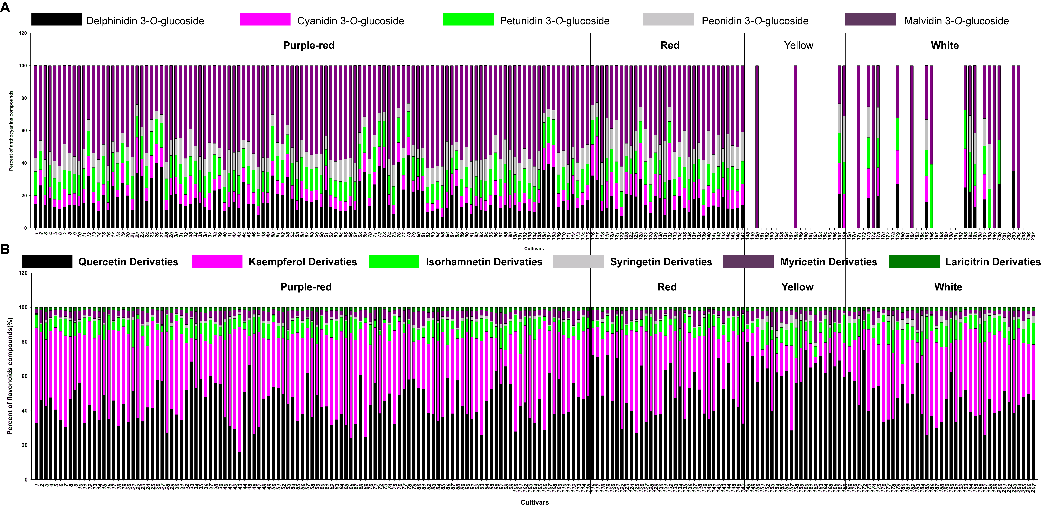
Supplementary Figure S1. Relative content (%) of different anthocyanin contributing to the total anthocyanins (A) and relative content (%) of different non-anthocyanin flavonoid contributing to the total non-anthocyanin flavonoids (B) in 207 lotus cultivars. The numbers (X-axis) in the figure represent the sample numbers, which correspond to the same cultivars as in Supplementary Table S1.

