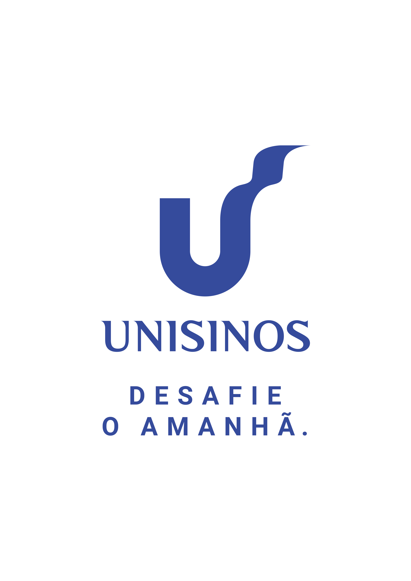

Questionnaire

Name:
E-mail:
Date/Time:

1. Which approach does your team use currently?
( ) Agile
( ) Traditional (PMBoK, RUP, PRINCE2, etc)
( ) Bimodal (hybrid model with characteristics of agile and traditional projects)
( ) The team does not use any specific methodology
( ) Other(s):

2. What is your experience as a Project Manager or a member of a project team?
( ) Less than 2 years
( ) From 2 to 5 years
( ) More than 5 years

3. How many employees work in the company where you work currently?
( ) Less than 20 employees
( ) From 20 to 100 employees
( ) More than 100 employees

4. Which areas do you consider most critical to the success of the project?
( ) Integration
( ) Scope
( ) Time
( ) Costs
( ) Quality
( ) Human Resources
( ) Communications
( ) Risks
( ) Acquisitions
( ) Stakeholders

5. In the projects where problems occurred, what were the areas in which the problems were identified?
( ) Integration
( ) Scope
( ) Time
( ) Costs
( ) Quality
( ) Human Resources
( ) Communications
( ) Risks
( ) Acquisitions
( ) Stakeholders

6. What types of suggestions would you like to receive from a proactive project management tool?
( ) Risks to the project
( ) Resource allocation
( ) Possibility of delay
( ) Possibility of exceeds costs
( ) Suggestions of requirements and new functionalities
( ) Other(s):

7. Do you believe that information from other projects already completed could assist in project management?
( ) Yes
( ) No
( ) Partially

