1. Install MVtec Halcon 20.11 Steady from https://www.mvtec.com

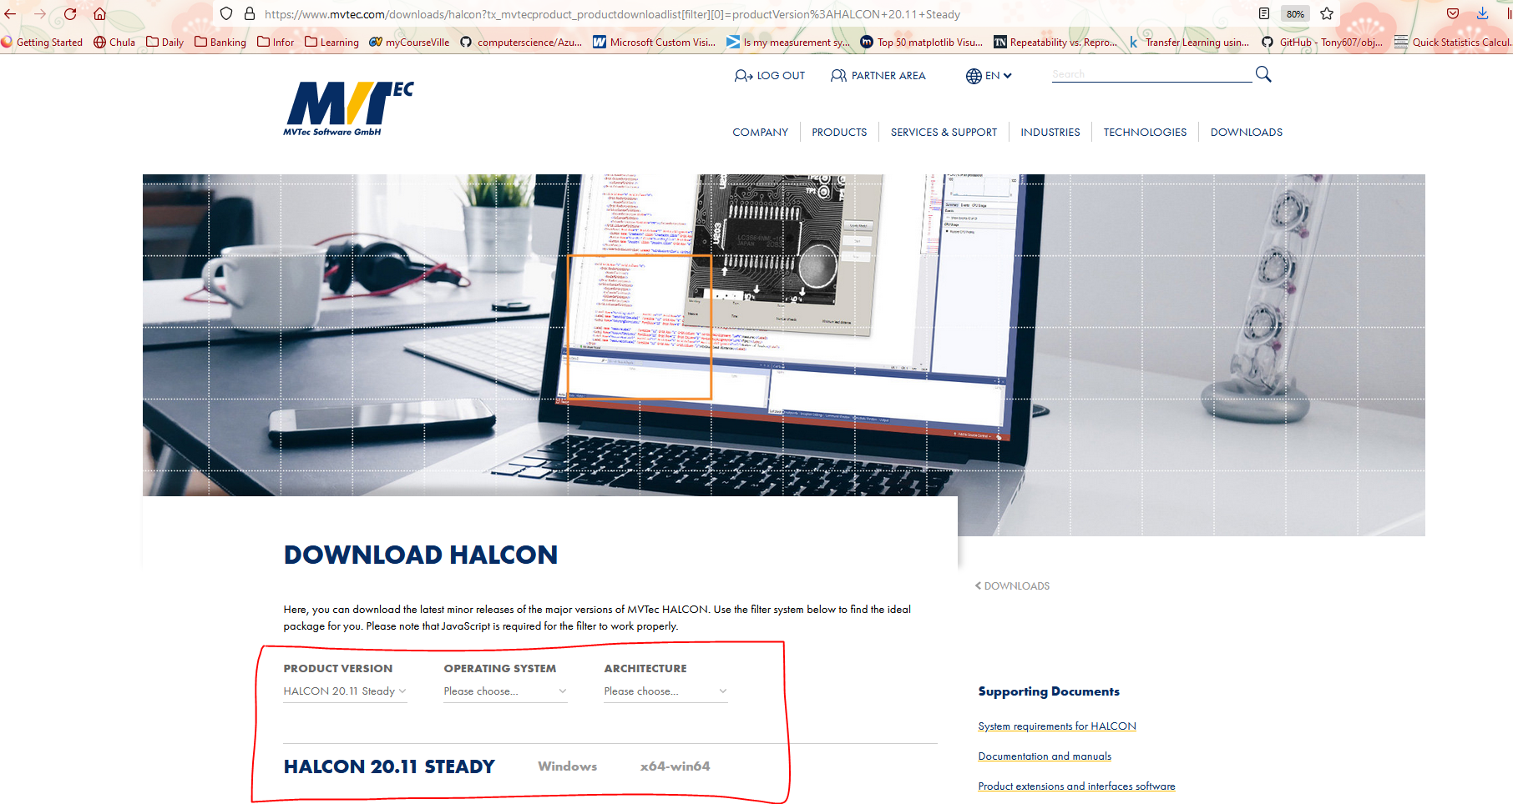

2. Put evaluate license into C:\Program Files\MVTec\HALCON-20.11-Steady\license

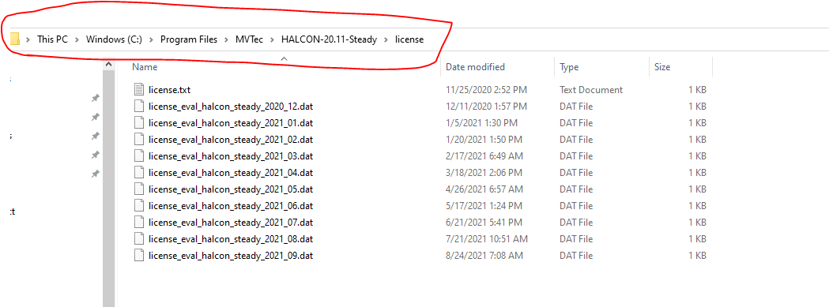

3. Open MVtec Halcon

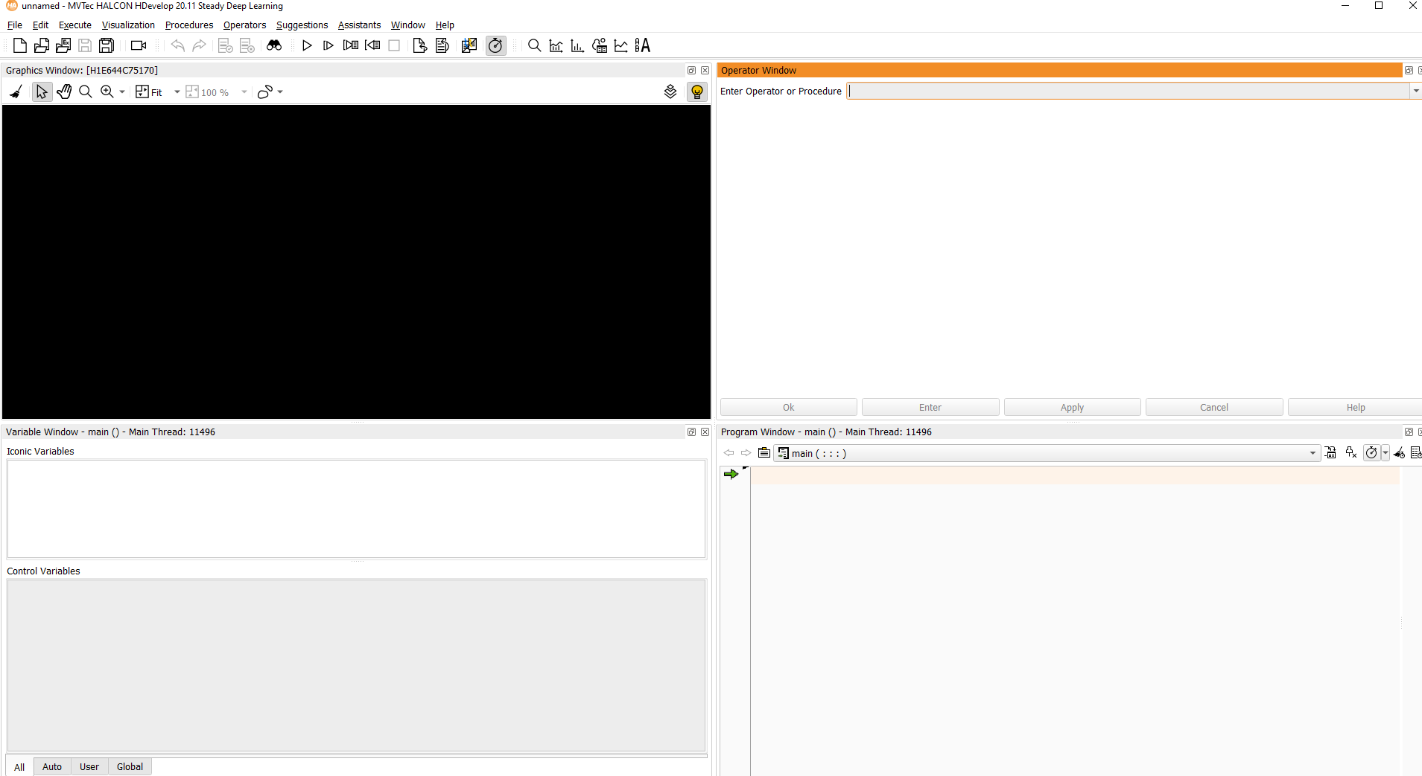

4. Install Halcon function scripts “kmeancluster.hdvp” and “count_plaque.hdvp” by selecting “Procedures” >> “Manage Procedures” from menu bar. Then select the folder that contains those files.

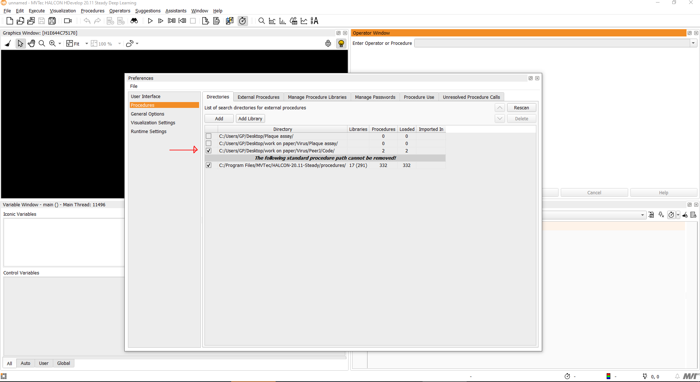

5. Open the “Main” File

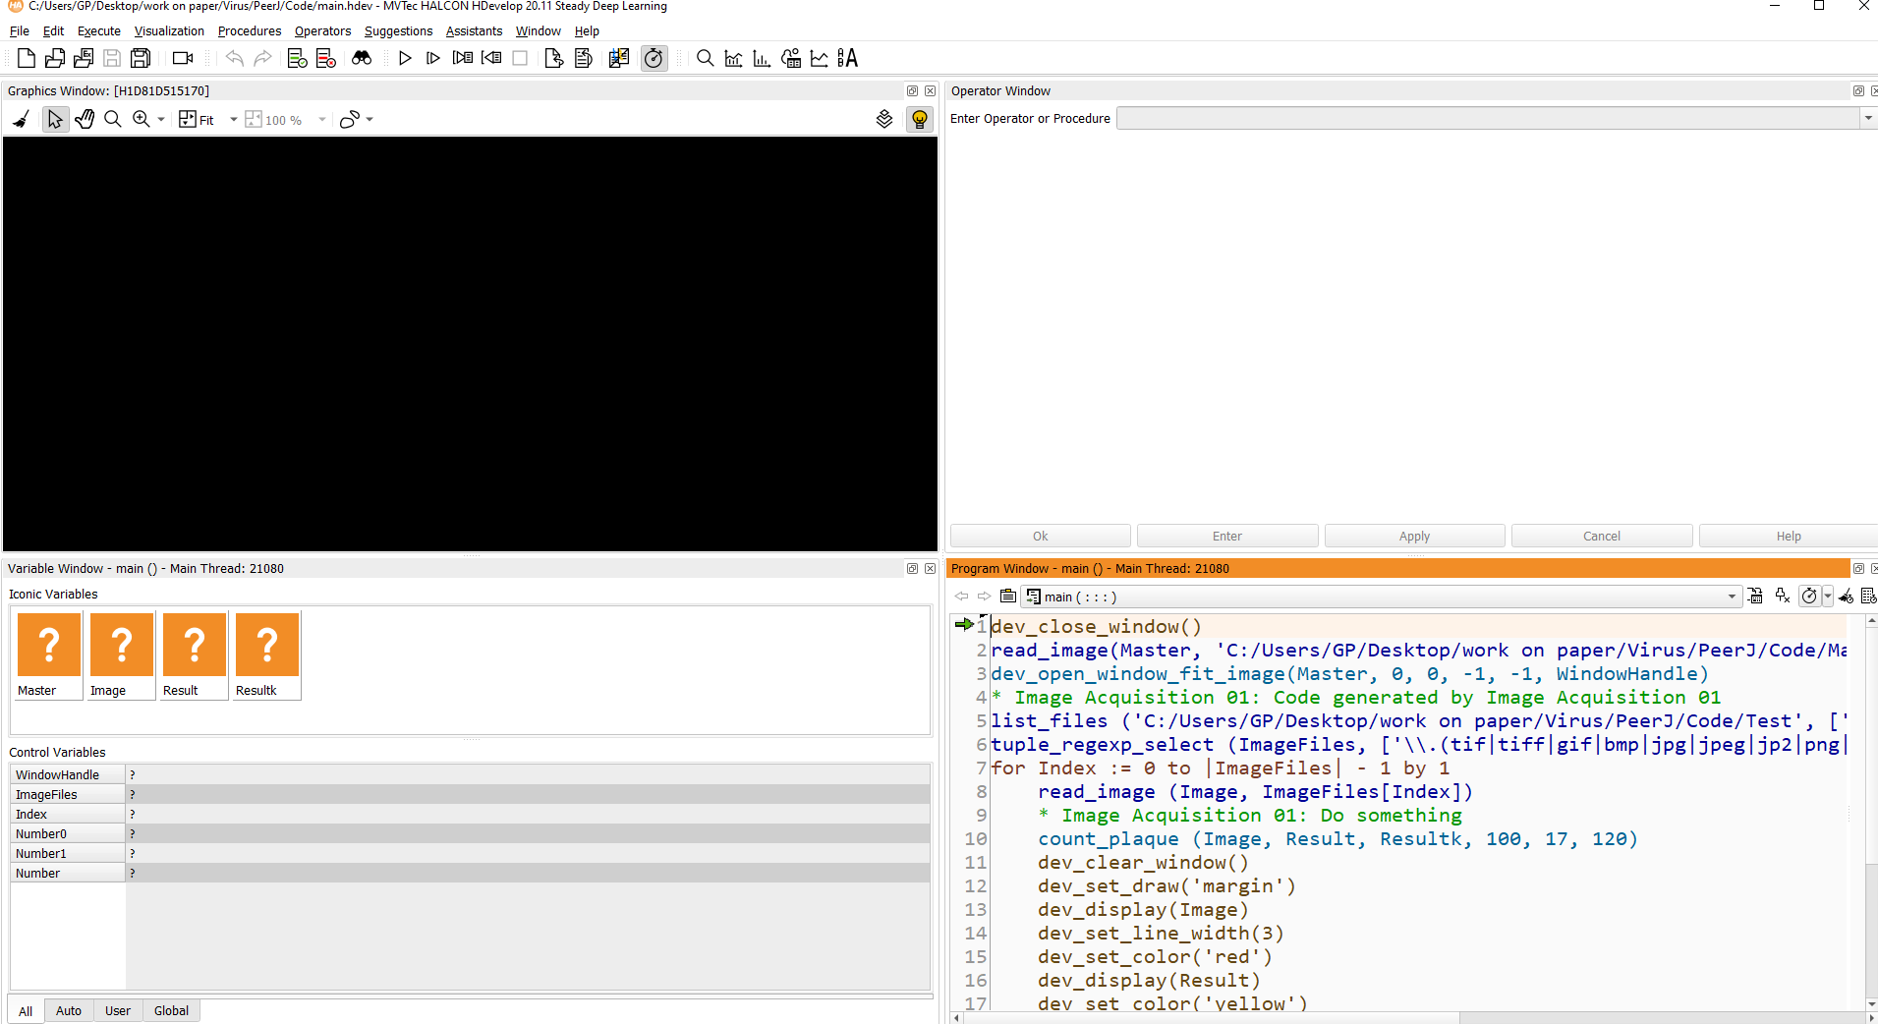

6. Correct the Master Image path. (Main.hdev file line 2)

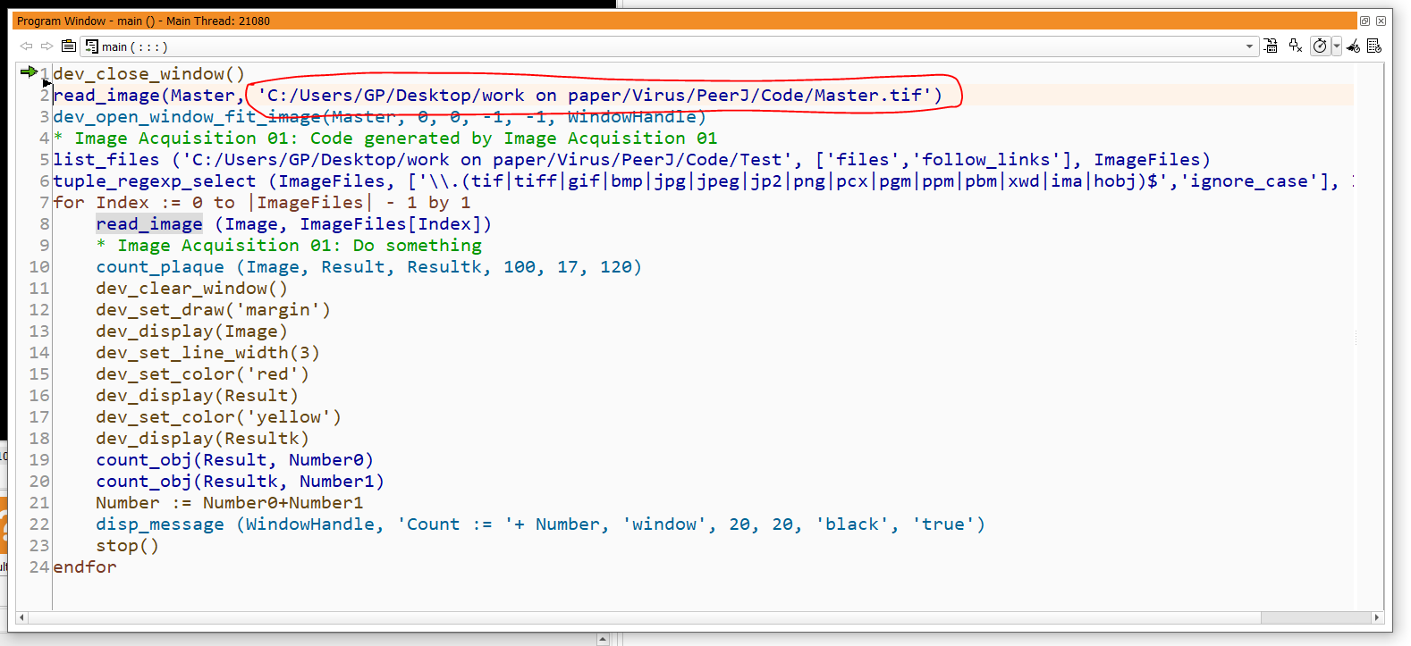

7. Correct the Master Image path. (count_plaque.hdvp file line 1) Right Click on line 10 in Main.hdev file and select Show Procedure in New Tap

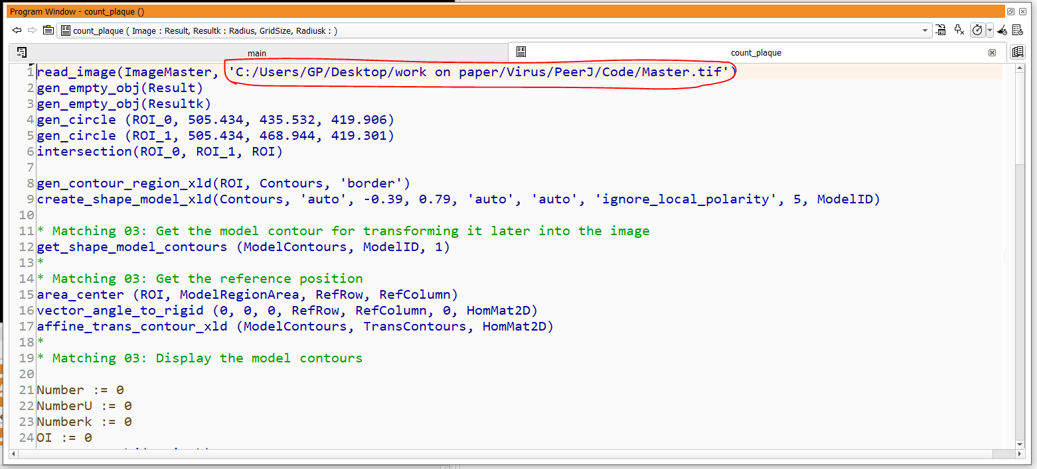

8. Correct image path on line 5 in Main.hdev file

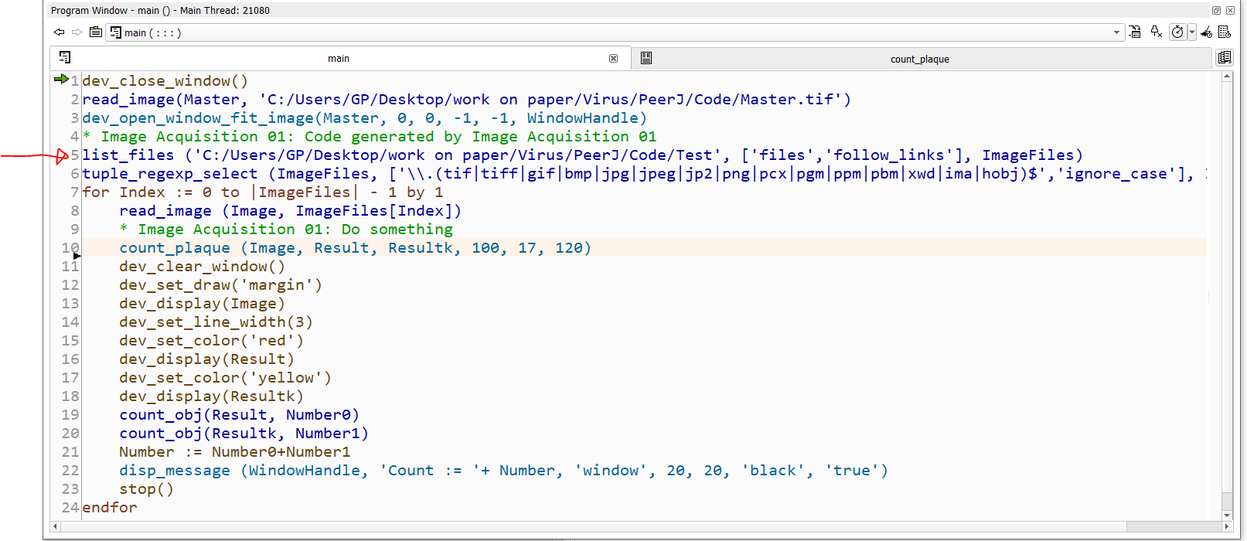

9. Run the Main.hdev file