Supplementary Information
Hydrogen production by photocatalysis using new composites based on SiO₂ coated by TiO₂
Werick Alves Machado,^{1,2}. Antonio Eduardo da Hora Machado^{1,3}

¹Universidade Federal de Uberlândia, Instituto de Química, Laboratório de Fotoquímica e Ciência de Materiais, Uberlândia, Minas Gerais, Brazil
² Instituto Federal de Educação, Ciência e Tecnologia do Triangulo Mineiro (IFTM), Ituiutaba, Minas Gerais, Brazil
³Universidade Federal de Catalão, Unidade Acadêmica Especial de Física, Catalão, Goiás, Brazil

Tables

Table T1- Rietveld refinement reliability factors
Photocatalyst | R_{b} | R_{f} | R_{wp} | R_{exp} | S
W50 | 1,17 | 0,78 | 11,0 | 9,46 | 1,16
W50S25 | 2,82 | 1,05 | 11,7 | 9,85 | 1,18
W50S50 | 2,13 | 1,13 | 16,8 | 12,8 | 1,31
W50S75 | 4,23 | 1,74 | 19,0 | 13,8 | 1,37

Figures
Figure S1- a) Images obtained by SEM; b) EDS spectra and c) particle size distribution histograms for the W50 photocatalyst.
a)
c)
b)
Figure S2- a) Images obtained by SEM; b) EDS spectra and c) particle size distribution histograms for the W50S25 photocatalyst.
a)
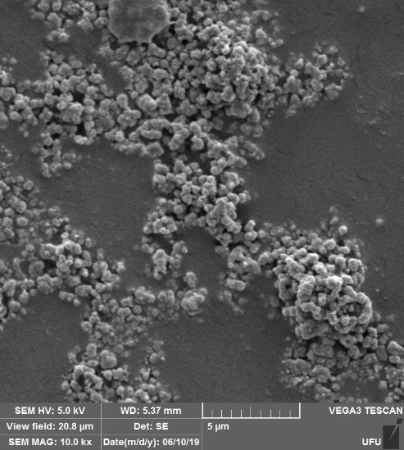
c)
b)
Figure S3- a) Images obtained by SEM; b) EDS spectra and c) particle size distribution histograms for the W50S50 photocatalyst.
a)
c)
b)
Figure S4- a) Images obtained by SEM; b) EDS spectra and c) particle size distribution histograms for the W50S75 photocatalyst.
a)
b)
c)
Figure S5- a) Images obtained by SEM; b) EDS spectra and c) histograms of particle size distribution for silica.
a)
c)
b)
Figure S6- Nitrogen adsorption / desorption isotherms obtained for synthesized oxides: a) W50, b) W50S25, c) W50S50, d) W50S75 and e) SiO₂.

Figure S7- Diffractograms obtained after refinement Rietveld for the following photocatalysts: a) W50, b) W50S25, c) W50S50, d) W50S75.

Figure S8- Raman spectrum of pure SiO₂.

