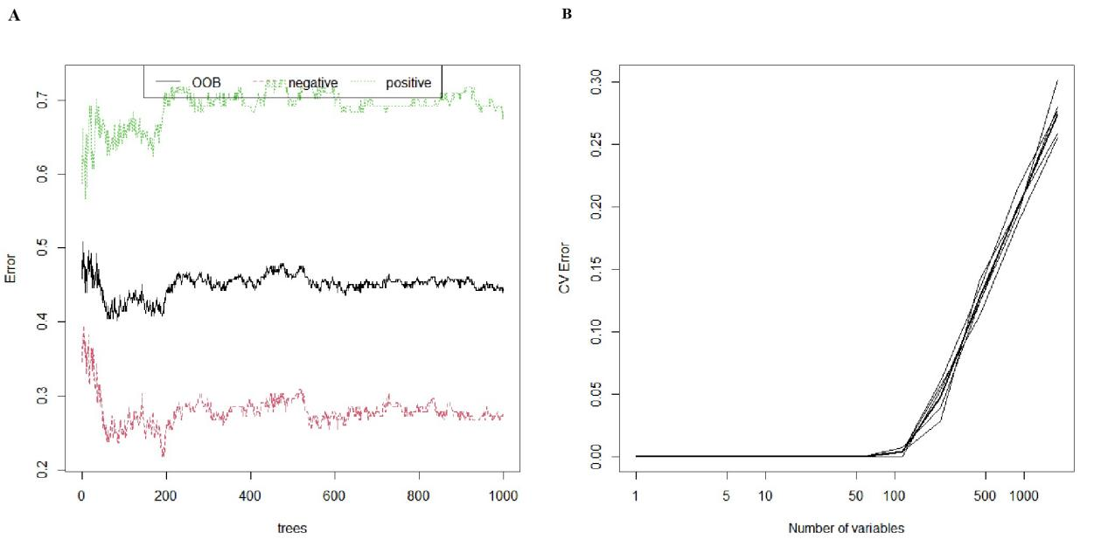
S1. Selection of LNM-associated features using RF in building models. (A) Error convergence curve according to the number of trees used in the RF model in training group. (B) Error convergence curve according to the number of variables in the RF model based on 5-fold cross-validation in training group. LNM, lymph node metastasis; RF, randomforest; OOB, out-of-bag; CV, cross-validation.

S2. The selected features of RF model based on Mean Decrease Accuracy value.
Features | Mean Decrease Accuracy
logsigma70mm3D_GLCM_DifferenceVariance | 3.442338719
logsigma100mm3D_GLCM_Idn | 3.294362441
logsigma50mm3D_GLRLM_LongRunEmphasis | 2.907933971
logsigma100mm3D_GLCM_Imc1 | 2.848503234
logsigma50mm3D_GLCM_JointEntropy | 2.700642897
logsigma50mm3D_GLCM_Idn | 2.680285674
logsigma40mm3D_GLDM_DependenceNonUniformityNormalized | 2.649375099
squareroot_GLSZM_SmallAreaLowGrayLevelEmphasis | 2.561607438
logsigma30mm3D_GLSZM_SizeZoneNonUniformity | 2.515200473
age | 2.469885086
waveletLL_GLSZM_SmallAreaHighGrayLevelEmphasis | 2.415871739
waveletLL_GLCM_SumEntropy | 2.403451695
logsigma30mm3D_GLSZM_LargeAreaHighGrayLevelEmphasis | 2.388607208
logsigma60mm3D_GLRLM_GrayLevelVariance | 2.385591031
logsigma50mm3D_GLRLM_RunVariance | 2.385295934
logsigma50mm3D_GLCM_SumEntropy | 2.381945955
logsigma90mm3D_GLCM_Imc2 | 2.37975256
waveletLH_GLSZM_SizeZoneNonUniformity | 2.351606132
logarithm_firstorder_Median | 2.344617418
logsigma60mm3D_GLCM_Idm | 2.340143257
exponential_firstorder_Variance | 2.334027244
waveletHH_GLRLM_LongRunLowGrayLevelEmphasis | 2.313033086
square_GLRLM_ShortRunLowGrayLevelEmphasis | 2.310312281
logsigma20mm3D_GLRLM_LongRunHighGrayLevelEmphasis | 2.300114726
logsigma50mm3D_GLRLM_LongRunHighGrayLevelEmphasis | 2.258299248
ANTITGAB | 2.257590595
logsigma40mm3D_GLRLM_LongRunHighGrayLevelEmphasis | 2.236490899
logsigma40mm3D_GLDM_DependenceVariance | 2.222274931
squareroot_firstorder_Range | 2.210056901
waveletHL_firstorder_Entropy | 2.20493006
logsigma30mm3D_GLSZM_SmallAreaEmphasis | 2.166425562
logsigma100mm3D_GLDM_SmallDependenceEmphasis | 2.161927299
logsigma50mm3D_GLRLM_HighGrayLevelRunEmphasis | 2.149818249
logsigma40mm3D_GLSZM_ZonePercentage | 2.146638329
square_GLDM_DependenceNonUniformity | 2.115328511
waveletLH_GLDM_DependenceNonUniformity | 2.113110565
logsigma70mm3D_GLCM_Correlation | 2.085284956
logsigma20mm3D_firstorder_Mean | 2.062195706
logarithm_GLCM_Imc1 | 2.058154579
logsigma70mm3D_GLSZM_LargeAreaEmphasis | 2.05195445
waveletLL_GLSZM_GrayLevelVariance | 2.050627697
logsigma40mm3D_GLCM_Imc1 | 2.027466223
logsigma60mm3D_GLCM_MCC | 2.026707168
waveletLL_GLCM_Correlation | 2.021495861
originalshape2D_Maximum_Diameter | 2.015011187
logsigma90mm3D_firstorder_InterquartileRange | 2.012767863
original_shape2D_Elongation | 2.006399302
squareroot_GLCM_SumEntropy | 1.99906682
logsigma60mm3D_firstorder_Median | 1.985804489
logsigma60mm3D_firstorder_10Percentile | 1.984271372
logsigma80mm3D_GLCM_SumEntropy | 1.982301874
logsigma20mm3D_GLRLM_RunEntropy | 1.980886173
logarithm_firstorder_Mean | 1.964682756
logsigma90mm3D_GLSZM_GrayLevelNonUniformity | 1.960297904
logsigma40mm3D_firstorder_TotalEnergy | 1.957262258
original_firstorder_TotalEnergy | 1.952041398
original_GLRLM_RunLengthNonUniformityNormalized | 1.950707237
squareroot_GLSZM_HighGrayLevelZoneEmphasis | 1.946934304
waveletLH_GLCM_JointEnergy | 1.938152843
waveletLH_GLRLM_RunVariance | 1.932361515
waveletHH_GLRLM_LongRunEmphasis | 1.931604791
waveletLL_GLCM_Imc2 | 1.923805337
logsigma80mm3D_firstorder_RobustMeanAbsoluteDeviation | 1.919619001
logsigma20mm3D_firstorder_10Percentile | 1.915172116
logsigma60mm3D_GLRLM_RunPercentage | 1.911094116
waveletHL_firstorder_Median | 1.899101544
logsigma10mm3D_GLSZM_LargeAreaEmphasis | 1.898739837
logsigma30mm3D_GLDM_DependenceNonUniformityNormalized | 1.894202084
logsigma20mm3D_firstorder_TotalEnergy | 1.884635295
squareroot_GLRLM_ShortRunLowGrayLevelEmphasis | 1.882161421
logsigma70mm3D_GLCM_JointEntropy | 1.879656003
exponential_GLSZM_LargeAreaEmphasis | 1.878771427
logsigma60mm3D_GLRLM_LongRunLowGrayLevelEmphasis | 1.875265523
logsigma10mm3D_GLCM_ClusterTendency | 1.87116524
logsigma80mm3D_firstorder_Maximum | 1.865183301
logsigma100mm3D_GLCM_Idmn | 1.864642734
logsigma80mm3D_GLRLM_RunLengthNonUniformityNormalized | 1.852966822
logsigma40mm3D_GLRLM_LongRunEmphasis | 1.835899894
logarithm_GLSZM_GrayLevelNonUniformityNormalized | 1.834274717
logsigma80mm3D_GLCM_JointEntropy | 1.833734197
logsigma30mm3D_GLCM_InverseVariance | 1.829201456
waveletLH_GLRLM_LongRunLowGrayLevelEmphasis | 1.825475796
waveletLH_firstorder_Maximum | 1.82280215
logsigma60mm3D_firstorder_90Percentile | 1.821766788
logsigma50mm3D_GLDM_LargeDependenceEmphasis | 1.817627623
squareroot_GLCM_SumAverage | 1.814586705
exponential_GLDM_DependenceNonUniformity | 1.814045565
original_GLSZM_LargeAreaHighGrayLevelEmphasis | 1.810612012
waveletHL_firstorder_RobustMeanAbsoluteDeviation | 1.802476149
logsigma30mm3D_GLCM_SumSquares | 1.800811751
logsigma10mm3D_GLSZM_GrayLevelVariance | 1.798159556
waveletLL_GLSZM_HighGrayLevelZoneEmphasis | 1.785759743
gradient_firstorder_Energy | 1.782318805
logsigma50mm3D_GLCM_DifferenceVariance | 1.770452141
original_GLSZM_SmallAreaEmphasis | 1.761187711
logarithm_firstorder_InterquartileRange | 1.760621506
logsigma90mm3D_GLRLM_ShortRunHighGrayLevelEmphasis | 1.760161341
waveletHL_GLSZM_SmallAreaHighGrayLevelEmphasis | 1.753846028
original_GLRLM_GrayLevelNonUniformityNormalized | 1.749520871
logsigma80mm3D_GLCM_InverseVariance | 1.744447008
Footnote: RF, randomforest; GLSZM, gray-level size-zone matrix; GLCM, gray-level co-occurrence matrix; GLDM, gray-level dependence matrix; GLRLM, gray-level runlength matrix; LL, low-pass/low-pass; LH, low-pass/high-pass; HL, high-pass/low-pass; HH, high-pass/high-pass; ANTITGAB, anti-thyroglobulin antibodies.

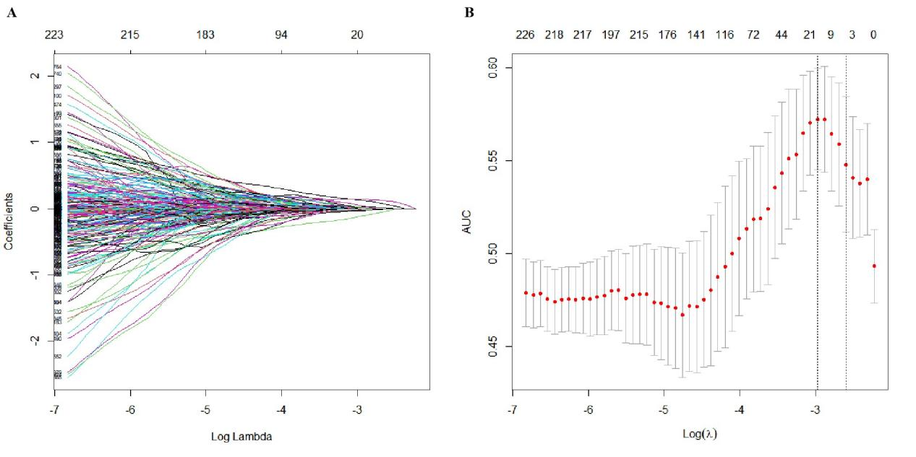
S3. Selection of LNM-associated features using LASSO regression in building models. (A) The coefficient profiles of 1804 features against the log Lambda (λ) when building models. (B) Tuning parameter (λ) selection in the LASSO logistic model based on 7-fold cross-validation. LNM, lymph node metastasis; LASSO, the least absolute shrinkage and selection operator; AUC, area under the curve.

S4. The coefficients of selected features of LASSO logistic model.
Features | Coefficients
size | -0.3511604
sex | 0.02778425
composition | -0.1209118
echogenicfoci | 0.1278081
TT3 | 0.05224362
Logarithm_firstorder_Kurtosis | 0.000599087
Logarithm_firstorder_RobustMeanAbsoluteDeviation | 0.1411578
Square_GLRLM_RunLengthNonUniformityNormalized | 0.01784644
Exponential_GLRLM_RunLengthNonUniformityNormalized | 1.92759E-16
Gradient_GLRLM_RunLengthNonUniformityNormalized | 2.40948E-17
WaveletLL_GLSZM_GrayLevelVariance | -0.03316834
WaveletLL_GLSZM_HighGrayLevelZoneEmphasis | 2.13783E-14
WaveletLL_GLSZM_LargeAreaEmphasis | 0.02457482
WaveletLL_GLSZM_SizeZoneNonUniformity | -1.20231E-14
Square_GLSZM_SmallAreaEmphasis | 0.00189928
Square_GLSZM_SmallAreaHighGrayLevelEmphasis | -0.01868737
Square_GLSZM_SmallAreaLowGrayLevelEmphasis | -1.1082E-15
Square_GLSZM_ZoneEntropy | -1.64821E-16
Exponential_GLSZM_SmallAreaHighGrayLevelEmphasis | -5.03261E-18
Exponential_GLSZM_SmallAreaLowGrayLevelEmphasis | -1.50978E-17
Gradient_GLSZM_SmallAreaHighGrayLevelEmphasis | -5.03261E-18
logsigma20mm3D_GLSZM_SmallAreaEmphasis | -0.02484
logsigma90mm3D_GLSZM_SizeZoneNonUniformityNormalized | 0.000232344
Footnote: LASSO, the least absolute shrinkage and selection operator; GLSZM, gray-level size-zone matrix; GLRLM, gray-level runlength matrix; LL, low-pass/low-pass; TT3, total triiodothyronine 3.

S5. Error convergence curve according to the number of variables in the RF-RF model based on 5-fold cross-validation in training group. RF, randomforest; CV, cross-validation.

