Supplementary Material
Supplementary Tables
Supplementary Table S1. Thermal indices used in this study. Abbreviations are mentioned in parenthesis, and units are noted in square brackets.

Indices | Description | Reference
Cumulative stress
Degree heating days (DHD)  [°C -days] | The value is the summed positive deviations of daily mean sea surface temperatures (STSP_{daily}) from the mean of the monthly means of STSP in July and August (MMM_{max})  .  $$DHD= \sum{({STSP}_{daily}-MMMmax)}, if : \left({STSP}_{daily}-MMMmax\right)>0$$  Single cumulative value per year were calculated. | Maynard et al. (2008)
Cumulative thermal anomaly  (CSA )  [°C -  days] | Trapezoidal integration of daily hotspot (HS_{maxi}) ≥ 1°C, during summer periods for each year. Where daily HS_{maxi} is the difference between the STSP_{daily} and MMM_{max}.  Single cumulative value per year were calculated. | Safaie et al. (2018)
Degree heating week (DHW)  [°C -week] | Cumulative thermal stress over a 12-week window.  $$DHW= \frac{1}{7}\sum_{i=1}^{84}{({HSmax}_{i },} if: {HSmax}_{i }≥α °C)$$  $$Where: α=1 °C$$  Daily DHW values were calculated. | Liu, Strong & Skirving (2003)
Degree heating month (DHM)  [°C - month] | Monthly hotspots (MHS) ≥ 1°C, summated over the entire year. Where MHS is the difference between monthly STSP and MMM_{max}.  $$DHM=\sum_{i=1}^{i=12}{({MHS}_{i}, {if: MSH}_{i} ≥ 1 °C)}$$  Single cumulative value per year were calculated. | Donner et al. (2005)
Acute stress
Acute 1 | Presence or absence of days when HS_{maxi}≥ 1°C within each year.  Single cumulative value expressed as percentage of days when HS_{maxi} ≥ 1°C within each year were calculated. | Safaie et al. (2018)
Acute 2 | Presence or absence of days when HS_{maxi} ≥ 2°C within each year.  Single cumulative value expressed as percentage of days when HS_{maxi} ≥ 2°C within each year were calculated.
Max₃d STSP [°C] | Maximum STSP over any consecutive three days during the warmest two months (July-August).  Daily Max₃d STSPs from July-August were estimated. | Berkelmans et al. (2004)
Rate in change of STSP
Heating rate 1  [°C/day] | DHD divided by the number of days were STSP exceeded long- term summer mean. | Maynard et al. (2008b)
Heating rate 2  [°C/day] | Slope of daily STSPs three months prior to the week with maximum weekly STSP for both years | Chollett, Enríquez & Mumby (2014)
High frequency STSP variability
Daily temperature variation  [°C] | Difference between daily maximum and daily minimum STSP  DTR total: Mean DTR over entire year.  DTR heat: Mean DTR over warmest two months in the year (July - August) | Safaie et al. (2018)
DTR shape | Kurtosis of daily DTR values of each year.  Skewness of daily DTR values of each year | Safaie et al. (2018)

Supplementary Table S2. The sample number used for bleaching and mortality analyses for each group in each year. The group “Others” includes all Acropora except A. digitifera, A. gemmifera, and Tabular Acropora. The group “Acropora” includes all Acropora present in the study plots.

Response | Groups | 2016 | 2017
Bleaching (Complete and Partial) | A. digitifera | 25 | 25
 | A. gemmifera | 12 | 12
 | Tabular Acropora | 9 | 9
 | Others | 16 | 16
 | Acropora | 62 | 62
Whole Mortality | A. digitifera | 39 | 29
 | A. gemmifera | 40 | 17
 | Tabular Acropora | 17 | 12
 | Others | 26 | 17
 | Acropora | 122 | 75
Partial Mortality | A. digitifera | 25 | 25
 | A. gemmifera | 12 | 12
 | Tabular Acropora | 7 | 7
 | Others | 14 | 14
 | Acropora | 58 | 58

Supplementary Table S3. Effect of random variable, Colony ID on the best-fit models describing the variations in bleaching degree and mortality rates of all Acropora corals in 2016 and 2017. Models with and without the random effect were compared using a log-likelihood ratio test. If the p values were > 0.05 the random effect was eliminated from the model. df is the degree of freedom, which equals the difference in the number of parameters between the models being compared. LRT is the log likelihood ratio based on the difference in the residual deviance of the two models.
Response | df | LRT | Pr(>Chisq)
Bleaching Degree (2016 & 2017) | 1.0 | 0.0 | 1.0
Partial Mortality | 1.0 | 1.2 | 2.7
Whole Mortality | 1.0 | 1.4 | 0.2

Supplementary Table S4. Results of statistical tests that compared various variables or thermal indices and the duration of sunshine between 2016 and 2017. Significant P values (< 0.05) are indicated in italic and bold font. Thermal indices are shown in Table S1.

Test | Variables | Chi-squared | p value
Friedman test | Daily Minimum STSP | 0.1 | 0.79
 | Daily Mean STSP | 5.2 | 0.02
 | Daily Maximum STSP | 9.3 | 0.002
 | DTR_{total} | 5.5 | 0.02
 | DTR_{h} | 10.9 | 0.001
 | Total precipitation (mm) | 2.9 | 0.09
 | Maximum precipitation over 1 hour | 3.5 | 0.06
 | Maximum precipitation over 10 minutes | 2.5 | 0.18
Wilcoxson signed  rank test |  | V statistics
 | Max3_{d}STSP | 787.0 | 0.19
 | DHW | 874.0 | <0.00001
McNemar's test |  | Z statistics
 | Acute1 | -1.0 | 0.32
GLS regression |  | Value
 | Heating rate (GLS Slope) | -0.93 | 0.40
Mann-Whitney U-test |  | Z- statistics
 | Duration of sunshine | 1.8, | 0.07

Supplementary Table S5. Summary of best fit models describing bleaching degree of Acropora corals. There are two intercepts per model because it is an ordinal regression. UB|PB means log odds of being unbleached versus being partially or completely bleached. PB|CB means log odds of being unbleached or partially bleached compared to completely bleached. Significant P values (< 0.05) are indicated in italic and bold font. UB, unbleached; PB, partially bleached; CB, completely bleached.
Response | Group | Model Summary | Terms | Value | Std. Error | t value | p value
Bleaching Degree (2016 & 2017) | All Acropora | Coefficients | Time - 2017 | -3.6 | 0.5 | -6.8 | <0.00001
 |  | Intercepts | UB|PB | -5.5 | 0.6 | -9.1 | <0.00001
 |  |  | PB|CB | -2.0 | 0.4 | -5.1 | <0.00001
Bleaching Degree (2017) | All Acropora | Coefficients | Growth | -0.8 | 0.4 | -2.4 | 0.02
 | A. digitifera | Coefficients | Colony Size | 3.2 | 1.3 | 2.5 | 0.01
 | Tabular Acropora | Coefficients | Growth | -75.5 | 226650 | 0 | 1.0
 | All Acropora | Intercepts | UB|PB | -2.2 | 0.4 | -4.9 | <0.00001
 |  | Intercepts | PB|CB | 1.8 | 0.4 | 4.8 | <0.00001
 | A. digitifera | Intercepts | UB|PB | 3.8 | 2.2 | 1.7 | 0.08
 |  | Intercepts | PB|CB | 9.6 | 3.3 | 2.9 | 0.004
 | Tabular Acropora* | Intercepts | UB|PB | -28.9 | 100381.1 | 0 | 1.0
 |  | Intercepts | PB|CB | 51.9 | 247807.4 | 0 | 1.0

Supplementary Table S6. Model summaries of best fit models describing whole or partial mortality of all Acropora. Significant P values (< 0.05) are indicated in italic and bold font.
Response | Model variables
 | Terms | Estimate | Std. Error | z value | Pr(>|z|)
Whole Mortality | Intercept | -1.0 | 0.4 | -3.0 | 0.003
 | Group A. digitifera | -0.3 | 0.5 | -0.7 | 0.5
 | Group A. gemmifera | 1.0 | 0.4 | 2.3 | 0.02
 | Group Tabular | 0.4 | 0.5 | 0.8 | 0.5
Partial Mortality | Intercept | -3.0 | 1.6 | -1.9 | 0.06
 | Colony Size | 2.3 | 0.7 | 3.1 | 0.002
 | Time t2 | 3.4 | 1.8 | 1.9 | 0.06
 | Group A. digitifera | -2.3 | 0.7 | -3.4 | 0.001
 | Group A. gemmifera | -0.7 | 0.8 | -1.0 | 0.3
 | Group Tabular | -2.5 | 0.9 | -2.7 | 0.008
 | Colony Size - Time t2 | -1.7 | 0.8 | -2.1 | 0.03
 | Summary of deviance residuals
 | Min | 1Q | Median | 3Q | Max
Whole Mortality | -1.2 | -0.8 | -0.7 | 1.2 | 1.8
Partial Mortality | -2.2 | -0.9 | 0.2 | 0.9 | 1.9
 | Deviance
 | Null |  |  | Residual
Whole Mortality | 246.15 on 195 Df |  |  | 233.82 on 192 df
Partial Mortality | 155.15 on 112 Df |  |  | 116.68 on 106 Df

Supplementary Figures
Supplementary Figure S1. (A) Daily minimum, (B) mean, (C) maximum, and (D) Max₃d (maximum over any consecutive three days) STSPs (seawater temperature recorded hourly at the study plots) during the warmest two months. Asterisks represent significant differences between years or time periods (‘***’ P < 0.001, ‘**’ P < 0.01 ‘*’ P < 0.05 ‘·’ ‘ns’ P > 0.05).

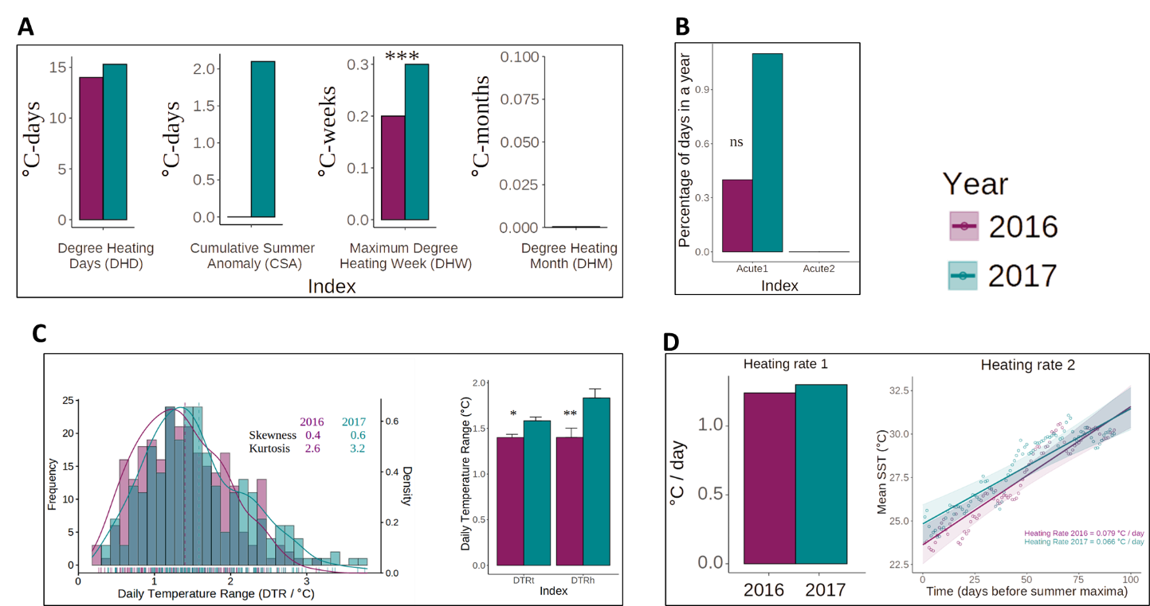
Supplementary Figure S2. (A) Temporal variations in cumulative thermal stress indices, (B) acute stress indices, (C) frequency distribution of daily DTR (daily temperature range) and Mean ± SE of DTR over the entire year and the warmest two months, and (D) heating rate. Asterisks represent significant differences between years or time periods (‘***’ P < 0.001, ‘**’ P < 0.01 ‘*’ P < 0.05 ‘·’ ‘ns’ P > 0.05).

Supplementary Figure S3. Relationship between colony size and probability of partial mortality in different Acropora groups at time t1 and t2. Lines in the plot represent binomial regression fit with 95% confidence intervals. Dots in the plot represent the observed data.

References
Berkelmans R, De’ath G, Kininmonth S, Skirving WJ. 2004. A comparison of the 1998 and 2002 coral bleaching events on the Great Barrier Reef: Spatial correlation, patterns, and predictions. Coral Reefs. 23, 74-83. DOI:10.1007/s00338-003-0353-y
Chollett I, Enríquez S, and Mumby PJ. 2014. Redefining thermal regimes to design reserves for coral reefs in the face of climate change. PLoS ONE. 9, 1-8. DOI:10.1371/journal.pone.0110634.
Donner SD, Skirving WJ, Little, CM, Oppenheimer M, Hoegh-Guldberg O. 2005. Global assessment of coral bleaching and required rates of adaptation under climate change. Glob. Chang. Biol. 11, 2251-2265. DOI:10.1111/j.1365-2486.2005.01073.x
Maynard JA, Turner PJ, Anthony KRN, Baird AH, Berkelmans R, Eakin CM, et al. 2008. ReefTemp : An interactive monitoring system for coral bleaching using high-resolution SST and improved stress predictors. Geophys. Res. Lett. 35, L05603. DOI:10.1029/2007GL032175
Liu, G, Strong AE, Skirving W. 2003. Remote sensing of sea surface temperatures during 2002 Barrier Reef coral bleaching. Eos, Trans. Am. Geophys. Union. 84, 137-144. DOI:10.1029/2003EO150001.

Safaie A, Silbiger NJ, McClanahan TR, Pawlak G, Barshis DJ, Hench JL, et al. 2018. High frequency temperature variability reduces the risk of coral bleaching. Nat. Commun. 9, 1-12. DOI :10.1038/s41467-018-04074-2

