# 图表, 散点图 描述已自动生成Figure 5. Funnel plot presenting Fisher’s z transformed correlation coefficient between standing long jump and acceleration performance, plotted against its standard error

# Figure 6. Funnel plot presenting Fisher’s z transformed correlation coefficient between standing long jump and maximal speed performance, plotted against its standard error

# 

# Figure 7. Funnel plot presenting Fisher’s z transformed correlation coefficient between horizontal drop jump and acceleration performance, plotted against its standard error

# 

# Figure 8. Funnel plot presenting Fisher’s z transformed correlation coefficient between single-leg standing long jump and acceleration performance, plotted against its standard error

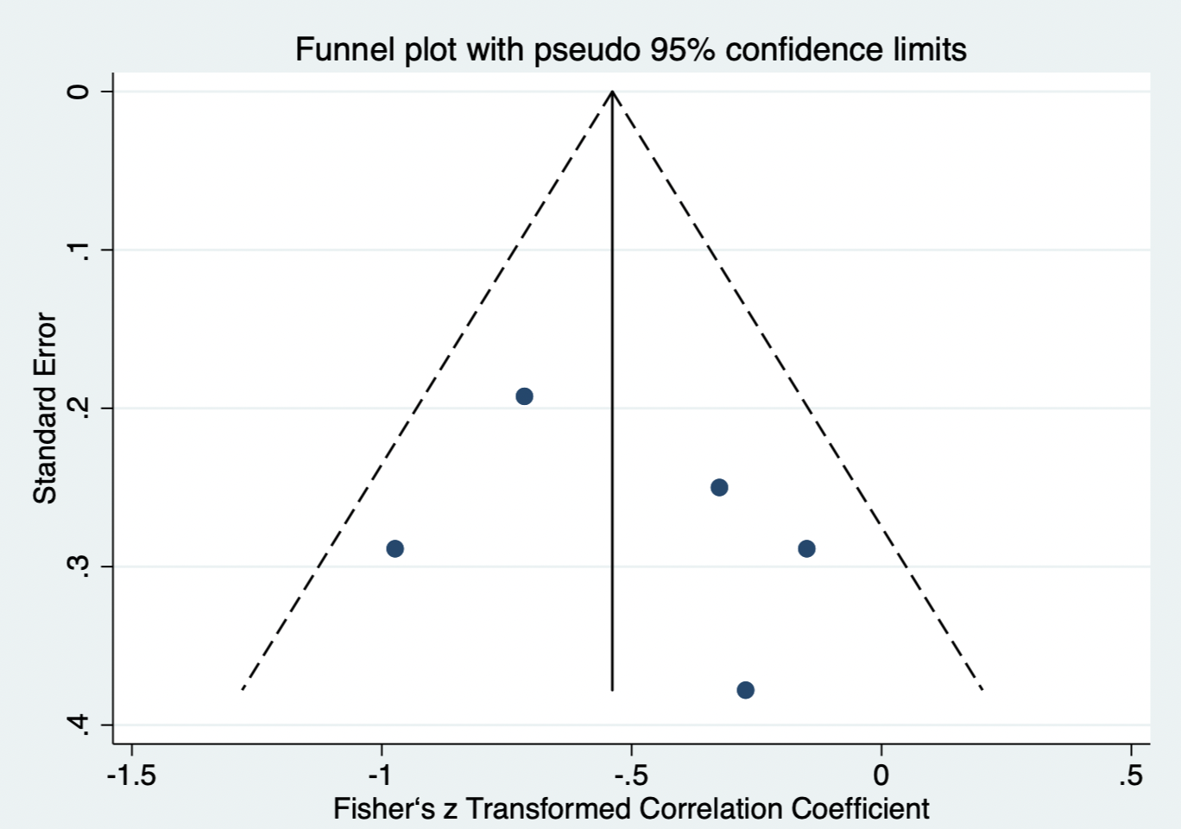

Figure 9. Funnel plot presenting Fisher’s z transformed correlation coefficient between multiple jump and acceleration performance, plotted against its standard error

Figure 10. Funnel plot presenting Fisher’s z transformed correlation coefficient between multiple jump and maximal speed performance, plotted against its standard error

