Supplementary Material

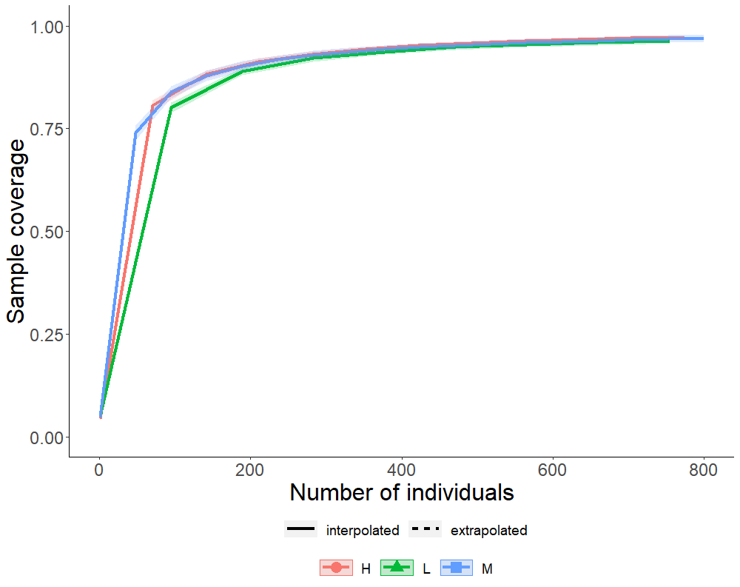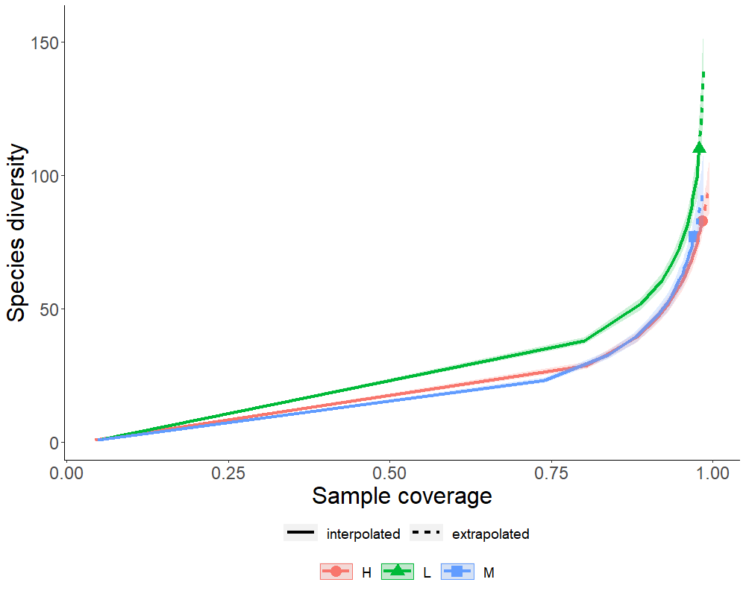

Figure S.1: Coverage-base rarefaction curves and species richness with coverage. In a) the solid lines represent the interpolated percent sample coverage and in b) the solid line represents the interpolated sample-based rarefaction curve; the dotted section are the extrapolated sections of the curves.

Table S.1: Average Impervious surface and green area with honey bee abundance and greenspace type. Honey bee abundance indicates the average number of honey bees detected during sampling periods. Herbaceous vegetation was the amount of green vegetation of > 3m in height within a buffer zone of 500m, centered on the study sites, and was used as a proxy for floral resource availability within the foraging range of wild bees. Impervious surface was calculated in the same buffer zone, and was a proxy for habitat availability. Floral richness and density were measured locally at each site.
 | HB abundance (site|sampling period) |  |  | Greenspace type (site)
 | > 20 HB  (n=39) | 20-40 HB  (n=13) | > 40 HB  (n = 22) | Garden  (n=9) | Park  (n=2) | Cemetery  (n=4)
Herbaceous greenery  Mean ± SD (%) | 27.70 ± 8.52 | 24.18 ± 11.07 | 18.68 ± 12.31 | 29.73 ± 19.09 | 27.33 ± 3.06 | 25.67 ± 11.02
Impervious surface  Mean ± SD (%) | 0.54 ± 0.15 | 0.59 ± 0.18 | 0.65 ± 0.19 | 62.48 ± 17.21 | 44.75 ± 8.70 | 57.00 ± 3.06
Floral richness | 9.53 ± 6.07 | 12.30 ± 6.67 | 18.3 ± 6.78 | 17.08 ± 5.84 | 5.5 ± 2.33 | 6.06 ± 2.93
Floral density | 0.072 ± 0.035 | 0.086 ± 0.034 | 0.087 ± 0.026 | 0.08 ± 0.03 | 0.09 ± 0.02 | 0.06 ± 0.04

Table S.2: Results of GLMM testing of the influence of honey bee abundance on wild bee diversity metrics. Data were pooled across plots at each site and sampling period (N = 8 plots per site, 15 sites, 5 sampling periods). Shannon-H is the Shannon-Weiner diversity index, Simpson-D is Simpson’s diversity index and Pilou’s J is Pielous evenness index (Shannon-H/ln(species)). Covariates included, floral richness, floral density, greenspace type (park, community garden, cemetery), sampling period, and the proportion of herbaceous vegetation and impervious surface within a 500 m buffer around each site. Floral richness and density were measured locally at each site, and herbaceous vegetation was the amount of green vegetation of >3m in height within the buffer zone, and was used as a proxy for floral resource availability within the foraging range of wild bees. Predictors for each model were scaled and centered on zero. β is the coefficients for each predictor, Cl is the 95% confidence intervals and p is the significance. Significant predictors of any of the three diversity metrics are in bold.
 | Diversity  (Shannon-H) |  |  | Diversity  (Simpson-D) |  |  | Evenness  (Pielou’s J)
Predictors | β | CI | p | β | CI | p | β | Cl | p
(Intercept) | 1.51 | -1.13 – 4.16 | 0.262 | 0.66 | -0.00 – 1.32 | 0.051 | 1.18 | 0.78 – 1.57 | <0.001
Honey bee abundance | -0.27 | -0.54 – -0.01 | 0.045 | -0.02 | -0.08 – 0.05 | 0.656 | -0.01 | -0.05 – 0.04 | 0.730
Floral richness | 0.55 | 0.01 – 1.08 | 0.044 | 0.16 | 0.02 – 0.30 | 0.023 | -0.06 | -0.15 – 0.02 | 0.147
Floral density | -0.01 | -0.42 – 0.41 | 0.975 | -0.09 | -0.15 – 0.07 | 0.040 | -0.10 | -0.18 – -0.01 | 0.028
Herbaceous veg. (%) | 0.14 | -0.93 – 1.20 | 0.801 | 0.09 | -0.18 – 0.35 | 0.523 | -0.02 | -0.17 – 0.13 | 0.819
Impervious surface (%) | 0.02 | -1.53 – 1.56 | 0.983 | 0.05 | -0.33 – 0.43 | 0.787 | -0.11 | -0.32 – 0.11 | 0.332
Greenspace type (garden) | 0.35 | -0.29 – 0.99 | 0.282 | -0.00 | -0.16 – 0.16 | 0.971 | 0.03 | -0.07 – 0.12 | 0.571
Greenspace type (park) | 0.41 | -0.26 – 1.08 | 0.233 | 0.08 | -0.09 – 0.24 | 0.362 | -0.07 | -0.17 – 0.02 | 0.140
Sampling period (2) | 0.29 | -0.60 – 1.19 | 0.525 | 0.04 | -0.20 – 0.29 | 0.720 | -0.00 | -0.20 – 0.19 | 0.974
Sampling period (3) | 0.10 | -0.80 – 1.00 | 0.826 | -0.01 | -0.25 – 0.23 | 0.928 | -0.04 | -0.24 – 0.15 | 0.667
Sampling period (4) | -0.24 | -1.13 – 0.65 | 0.596 | -0.06 | -0.31 – 0.18 | 0.602 | -0.06 | -0.26 – 0.14 | 0.552
Sampling period (5) | -0.36 | -1.26 – 0.54 | 0.432 | -0.09 | -0.34 – 0.15 | 0.461 | -0.08 | -0.28 – 0.11 | 0.402

Table S.3. Results of GLMM testing of the influence of honey bee abundance on wild bee community traits in 2020. Data were pooled across plots at each site and sampling period (N = 8 plots per site, 15 sites, 5 sampling periods). Covariates included, floral richness, floral density, greenspace type (park, community garden, cemetery), sampling period, and the proportion of herbaceous vegetation and impervious surface within a 500 m buffer around each site. Bombus models used a 1500 m buffer to account for the larger foraging range of these bees. Floral richness and density were measured locally at each site, and herbaceous vegetation was the amount of green vegetation of >3m in height within the buffer zone, and was used as a proxy for floral resource availability within the foraging range of wild bees. Predictors for each model were scaled and centered on zero. β is the coefficients for each predictor, Cl is the 95% confidence intervals and p is the significance. Significant predictors of any of the three diversity metrics are in bold.
Response trait | Estimate | CL | HB Abundance  χ² p
Native species richness | 0.09 | -0.09 – 0.27 | 0.87 | 0.350
Native abundance | 0.06 | -0.25 – 0.38 | 0.14 | 0.707
Exotic species | 0.02 | -0.20 – 0.24 | 0.03 | 0.871
Exotic abundance | -0.10 | -0.45 – 0.25 | 0.32 | 0.573
Small bee richness | -0.31 | -0.59 - -0.03 | 4.76 | 0.029
Small bee abundance | -0.45 | -0.82 - -0.08 | 3.94 | 0.019
Large bee richness | 0.15 | -0.04 – 0.35 | 2.30 | 0.129
Large bee abundance | -0.06 | -0.24 – 0.13 | 0.36 | 0.548
Bombus richness | 0.21 | -0.13 – 0.55 | 1.46 | 0.227
Bombus abundance | 0.12 | -0.16 – 0.39 | 0.72 | 0.397

Table S.4. Wild bee species absent from sites that saw the highest increase in honey bee abundance since 2013. First and second columns indicate the number of each species at these high honey bee abundance sites (sites where more than 20 honey bees were detected in sampling periods). The third and fourth columns show the abundance of the same wild bee species at sites that had fewer honey bees in 2020 (with 20 or fewer honey bees detected during sampling periods).
 | Species | Sites with > 20 HB in | Abundance in 2013 | Sites with ≤ 20 HB 2020 | Abundance in 2013
1 | Andrena cratagei | 0 | 14 | 2 | 15
2 | Augochlora aurata | 0 | 6 | 0 | 196
3 | Andrena wheeleri | 0 | 1 | 7 | 10
4 | Andrena nassoni | 0 | 1 | 1 | 1
5 | Augochlora pura | 0 | 1 | 19 | 12
6 | Bombus citrinus | 0 | 3 | 3 | 3
7 | Bombus vagans | 0 | 1 | 2 | 4
8 | Coelioxys porterae | 0 | 7 | 1 | 2
9 | Hoplitis spoliata | 0 | 4 | 15 | 7
10 | Lasioglossum macoupinense | 0 | 1 | 2 | 9
11 | Lasioglossum planatum | 0 | 3 | 1 | 1
12 | Melissodes druriellus | 0 | 1 | 2 | 8
13 | Melissodes illata | 0 | 28 | 1 | 6

Table S.5. Results of GLMM testing of the influence of honey bee increase between 2013 and 2020 on wild bee diversity metrics. Data were pooled across plots at each site and sampling period, N = 15 sites (2020), N = 13 sites (2013), 5 sampling periods. Shannon-H is the Shannon-Weiner diversity index, Simpson-D is Simpson’s diversity index and Pilou’s J is Pielous evenness index (Shannon-H/ln(species)) Covariates included greenspace type (park, community garden, cemetery), sampling period, and the proportion of herbaceous vegetation and impervious surface within a 500 m buffer around each site. Herbaceous vegetation was the amount of green vegetation of >3m in height within the buffer zone, and was used as a proxy for floral resource availability within the foraging range of wild bees. Local floral richness and density were not measured in 2013, but were in 2016, thus the floral richness and density were. Predictors for each model were scaled and centered on zero. Significant predictors of any of the three diversity metrics are in bold.
 | Diversity  (Shannon-H) |  |  | Diversity  (Simpson-D) |  |  | Evenness  (Pielou’s J)
Predictors | β | CI | p | β | CI | p | β | Cl | p
(Intercept) | 2.99 | 1.68 – 4.31 | <0.001 | 0.84 | 0.60 – 1.08 | <0.001 | 0.66 | 0.44 – 0.87 | <0.001
Honey bee abundance x Year | 0.02 | -0.18 – 0.21 | 0.869 | -0.02 | -0.06 – 0.02 | 0.339 | -0.03 | -0.07 – 0.01 | 0.191
Honey bee abundance | 0.01 | -0.18 – 0.20 | 0.943 | 0.01 | -0.03 – 0.06 | 0.523 | 0.01 | -0.03 – 0.04 | 0.766
Year (2020) | -0.06 | -0.25 – 0.13 | 0.547 | 0.01 | -0.03 – 0.06 | 0.523 | 0.07 | 0.03 – 0.11 | 0.001
Herbaceous veg. (%) | -0.13 | -0.73 – 0.46 | 0.663 | 0.03 | -0.08 – 0.14 | 0.546 | 0.10 | -0.00 – 0.19 | 0.051
Impervious surface | -0.47 | -1.28 – 0.33 | 0.249 | -0.02 | -0.17 – 0.12 | 0.776 | 0.10 | -0.03 – 0.23 | 0.141
Greenspace Type[Garden] | 0.19 | -0.08 – 0.46 | 0.167 | 0.03 | -0.02 – 0.07 | 0.319 | -0.01 | -0.05 – 0.04 | 0.814
Greenspace Type [Park] | -0.01 | -0.36 – 0.35 | 0.972 | 0.00 | -0.06 – 0.07 | 0.932 | -0.00 | -0.06 – 0.05 | 0.876
Sampling period [2] | -0.10 | -0.34 – 0.14 | 0.420 | -0.02 | -0.07 – 0.04 | 0.569 | -0.02 | -0.07 – 0.04 | 0.554
Sampling period [3] | -0.18 | -0.42 – 0.06 | 0.140 | -0.03 | -0.08 – 0.03 | 0.327 | -0.01 | -0.06 – 0.04 | 0.743
Sampling period [4] | -0.63 | -0.87 – -0.39 | <0.001 | -0.11 | -0.16 – -0.06 | <0.001 | -0.04 | -0.09 – 0.01 | 0.132
Sampling period [5] | -0.19 | -0.44 – 0.05 | 0.121 | -0.03 | -0.08 – 0.02 | 0.275 | -0.02 | -0.08 – 0.03 | 0.379

Table S.6. The influence of honey bee abundance on richness in bee community trait groups in 2020 vs. 2013
Response trait | Estimate | CL | HB increase × Year  χ² p
Native species richness | 0.05 | -0.11 – 0.22 | 0.39 | 0.531
Exotic species richness | -0.08 | -0.29 – 0.12 | 0.67 | 0.412
Small bee richness | - 0.18 | -0.35 – 0.00 | 3.95 | 0.047
Large bee richness | 0.18 | -0.01 – 0.36 | 3.60 | 0.058
Bombus richness | 0.22 | -0.06 – 0.50 | 2.34 | 0.126

Table S.7: Species list, with the number of individual specimens observed or collected. Letter and number designations for species epithet indicates morphospecies designation.
Species | Individuals
Apis mellifera Linnaeus, 1958 | 2291
Ceratina calcarata Robertson, 1900 | 311
Agapostemon virescens Fabricius, 1775 | 260
Hylaeus communis Nylander, 1852 | 238
Hylaeus hyalinatus Smith, 1842 | 204
Lasioglossum laevissimum Smith, 1853 | 192
Bombus impatiens Cresson, 1863 | 186
Lasioglossum imitatum Smith, 1853 | 169
Halictus ligatus Say, 1837 | 141
Bombus griseocollis De Geer, 1773 | 127
Megachile rotundata Fabricius, 1787 | 123
Ceratina mikmaqi Rehan and Sheffield, 2011 | 117
Hylaeus punctatus Brullé, 1832 | 113
Hoplitis producta Cresson, 1864 | 106
Halictus rubicundus Christ, 1791 | 101
Hylaeus modestus Say, 1837 | 86
Ceratina dupla Say, 1837 | 85
Lasioglossum lineatulum Crawford, 1906 | 77
Anthidium florentinum Fabricius, 1775 | 74
Hylaeus mesillae Cockerell, 1896 | 74
Halictus confusus Smith, 1853 | 71
Lasioglossum cinctipes Provancher, 1888 | 65
Chelostoma rapunculi Lepeletier, 1841 | 56
Lasioglossum leucozonium Schrank, 1781 | 49
Hylaeus affinis Smith, 1853 | 46
Megachile mendica Cresson, 1878 | 42
Megachile texana Cresson, 1878 | 39
Lasioglossum sagax Sandhouse, 1924 | 38
Lasioglossum tegulare Robertson, 1890 | 34
Bombus rufocinctus Cresson, 1863 | 30
Anthidium manicatum Linnaeus, 1758 | 28
Melissodes subillatus LaBerge, 1961 | 28
Bombus bimaculatus Cresson, 1863 | 27
Lasioglossum coriaceum Smith, 1853 | 27
Lasioglossum zonulum Smith, 1848 | 25
Lasioglossum ephialtum Gibbs, 2010 | 24
Lasioglossum pilosum Smith, 1853 | 24
Andrena wilkella Kirby, 1802 | 23
Hylaeus leptocephalus Morawitz, 1871 | 22
Augochlora pura Say, 1837 | 21
Anthidium oblongatum Illiger, 1806 | 20
Augochlorella aurata Smith, 1853 | 20
Andrena commoda Smith, 1879 | 17
Chelostoma campanularum Kirby, 1802 | 17
Lasioglossum oenotherae Stevens, 1920 | 17
Hoplitis spoliata Provancher, 1888 | 15
Hylaeus annulatus Linnaeus, 1758 | 15
Megachile campanulae Robertson, 1903 | 15
Megachile brevis Say, 1837 | 14
Coelioxys sayi Robertson, 1897 | 12
Megachile lapponica Thomson, 1872 | 12
Melissodes desponsus Smith, 1854 | 11
Megachile A1 | 10
Peponapis pruinosa Say, 1837 | 10
Anthophora terminalis Cresson, 1869 | 8
Lasioglossum A1 | 8
Lasioglossum pectorale Smith, 1853 | 8
Lasioglossum quebecense Crawford, 1907 | 8
Andrena wheeleri Graenicher, 1904 | 7
Hoplitis pilosifrons Cresson, 1864 | 7
Lasioglossum cressonii Robertson, 1890 | 7
Lasioglossum versatum Robertson, 1902 | 7
Megachile relativa Cresson, 1878 | 7
Lasioglossum hitchensi Gibbs, 2012 | 6
Lasioglossum perpunctatum Ellis, 1913 | 6
Andrena nivalis Smith, 1853 | 4
Coelioxys octodentatus Say, 1824 | 4
Hoplitis A1 | 4
Lasioglossum admirandum Sandhouse, 1924 | 4
Lasioglossum foxii Robertson, 1895 | 4
Lasioglossum versans Lovell, 1905 | 4
Osmia albiventris Cresson, 1864 | 4
Agapostemon sericeus Forster, 1771 | 3
Andrena cressonii Robertson, 1891 | 3
Bombus citrinus Smith, 1854 | 3
Bombus fervidus Fabricius, 1798 | 3
Lasioglossum albipenne Robertson, 1890 | 3
Lasioglossum smilacinae Robertson, 1897 | 3
Lasioglossum zephyrum Smith, 1853 | 3
Megachile centuncularis Linnaeus, 1758 | 3
Megachile A2 | 3
Megachile frigida Smith, 1853 | 3
Agapostemon texanus Cresson, 1872 | 2
Andrena cratagei Robertson, 1893 | 2
Andrena w-scripta Viereck, 1904 | 2
Bombus terricola Kirby, 1837 | 2
Bombus vagans Smith, 1854 | 2
Coelioxys rufitarsis Smith, 1854 | 2
Lasioglossum macoupinense Robertson, 1895 | 2
Melissodes druriellus Kirby, 1802 | 2
Osmia A1 | 2
Sphecodes dichrous Smith, 1853 | 2
Andrena geranii Robertson, 1891 | 1
Andrena imitatrix Cresson, 1872 | 1
Andrena nasonii Robertson, 1895 | 1
Andrena robertsonii Dalla Torre, 1896 | 1
Calliopsis andreniformis Smith, 1853 | 1
Coelioxys porterae Cockerell, 1900 | 1
Hoplitis anthocopoides Schenck, 1853 | 1
Lasioglossum bruneri Crawford, 1902 | 1
Lasioglossum heterognathum Mitchell, 1960 | 1
Lasioglossum leucocomum Lovell, 1908 | 1
Lasioglossum nigroviride Graenicher, 1911 | 1
Lasioglossum oblongum Lovell, 1905 | 1
Lasioglossum planatum Lovell, 1905 | 1
Lasioglossum A2 | 1
Lasioglossum subversans Mitchell, 1960 | 1
Lasioglossum A3 | 1
Lasioglossum viridatum Lovell, 1905 | 1
Macropis nuda Provancher, 1882 | 1
Megachile latimanus Say, 1823 | 1
Megachile melanophaea Smith, 1853 | 1
Megachile montivaga Cresson, 1878 | 1
Megachile pugnata Say, 1837 | 1
Melissodes A1 | 1
Melissodes illata Lovell and Cockerell, 1906 | 1
Melissodes trinodis Robertson, 1901 | 1
Osmia pumila Cresson, 1864 | 1
Osmia sandhouseae Mitchell, 1927 | 1
Sphecodes dichrous Smith, 1853 | 1
Stelis A1 | 1
Total | 120 species  6185 individuals (3894 wild bees)

Table S.8: Flowering plant species recorded at across all sites with the number of individuals counted and the percent cover averaged over eight, 2 m x 2 m quadrats centered on the pan trap locations.
Species | Individuals | % cover
Erigeron strigosus | 50 | 11.53
Calibrachoa parviflora | 47 | 9.585106
Tagetes patula | 46 | 6.728261
Viola tricolor | 35 | 5.885714
Trifolium repens | 33 | 9.166667
Sonchus arvensis | 32 | 10.07813
Cosmos sulphureus | 31 | 9.903226
Thymus x citriodorus | 30 | 11.86667
Achillea millefolium | 29 | 8.982759
Solanum melongena | 27 | 10.61111
Levisticum officinale | 26 | 10.76923
Erigeron annuus | 25 | 11.94
Rudbeckia laciniata | 24 | 11.5625
Hysop officinalis | 23 | 4.065217
Osteospermum sp. | 23 | 8.152174
Centaurea jacea | 22 | 17.81818
Physalis philadelphica | 21 | 12.2381
Tropaeolum majus | 19 | 12.10526
Dasiphora fruticosa | 17 | 4.411765
Coreopsis grandiflora | 16 | 7.03125
Cucurbita pepo | 16 | 9.633333
Anethum graveolens | 15 | 6.666667
Rosa moyesii | 15 | 8.333333
Valeriana officinalis | 15 | 4.6
Allium cepa | 14 | 7.392857
Lunaria annua | 14 | 7.714286
Salvia officinalis | 14 | 5.821429
Solanum lycopersicum | 14 | 3.392857
Begonia evansiana | 13 | 12.30769
Cosmos bipinnatus | 13 | 13.84615
Hydrangea paniculata | 13 | 24.66667
Taraxacum officinale | 13 | 7.692308
Hemerocallis lilioasphodelus | 12 | 10.70833
Brassica rapa | 11 | 9.318182
Hesparis matronalis | 11 | 7.954545
Medicago lupulina | 11 | 9.863636
Pelargonium x hortorum | 11 | 12.59091
Phacelia tanacetifolia | 11 | 4.454545
Viola x wittrockiana | 11 | 11.27273
Helianthus annuus | 10 | 9.95
Momordica charantia | 10 | 7.1
Tanacetum vulgare | 10 | 11.75
Antirrhinum majus | 9 | 5.111111
Galinsoga quadriradiata | 9 | 5.555556
Rudbeckia triloba | 9 | 14.44444
Verbena bonariensis | 9 | 5.166667
Campanula rapunculoides | 8 | 5.1875
Lavandula dentata | 8 | 12.6875
Phlox drummondii | 8 | 14.125
Phlox paniculata | 8 | 16.25
Trifolium pratense | 8 | 2.5
Delphinium elatum | 7 | 3.214286
Lactuca sativa | 7 | 6.785714
Lilium bulbiferum | 7 | 9.642857
Paeonia sp. | 7 | 3.928571
Ageratum houstonianum | 6 | 5.666667
Chrysanthemum leucanthemum | 6 | 3.333333
Hibiscus moscheutos | 6 | 6.666667
Hyacinthoides hispanica | 6 | 6.083333
Lagenaria siceraria | 6 | 5.666667
Pastinaca sativa | 6 | 3.75
Phlox maculata | 6 | 8.666667
Prunella vulgaris | 6 | 2.916667
Raphanus raphanistrum | 6 | 4.833333
Tanacetum parthenium | 6 | 7.666667
Campanula latifolia | 5 | 4.9
Celosia argentea | 5 | 4.6
Daucus carota | 5 | 12
Gaillardia x grandiflora | 5 | 27
Inconnu | 5 | 9.6
Lantana camara | 5 | 5
Malcomia maritima | 5 | 11.5
Perilla frutescens | 5 | 3.3
Pisum sativum | 5 | 6.5
Rosa cinnamomea | 5 | 4.4
Thymus vulgaris | 5 | 5.1
Agastache foeniculum | 4 | 5
Aquilegia vulgaris | 4 | 6.12
Asclepias tuberosa | 4 | 8.125
Crepis capillaris | 4 | 22.5
Impatiens walleriana | 4 | 7.375
Lotus corniculatus | 4 | 8.125
Malva moschata | 4 | 10.5
Medicago sativa | 4 | 38.5
Ocimum minimum | 4 | 2.875
Rosa chinensis | 4 | 4.875
Ruta graveolens | 4 | 15.625
Santolina chamaecyparissus | 4 | 5.625
Sinapis arvensis | 4 | 9
Verbena rigida | 4 | 6.875
Weigela florida | 4 | 6.875
Zinnea haageana | 4 | 3.625
Alcea rosea | 3 | 6.666667
Anemone hipehensis | 3 | 9.166667
Brassica spp. | 3 | 4.166667
Centaurea montana | 3 | 4.166667
Dianthus sp. | 3 | 2.5
Eruca vesicaria | 3 | 18.66667
Gaillardia pulchella | 3 | 2.5
Helianthus tuberosus | 3 | 2.333333
Hypericum perforatum | 3 | 7.166667
Hypericum scouleri | 3 | 5.666667
Lavandula angustifolia | 3 | 5.5
Melilotus albus | 3 | 6.5
Mentha spicata | 3 | 10
Ocimum basilicum | 3 | 26.66667
Origanum vulgare | 3 | 3.333333
Pelargonium zonale | 3 | 4.166667
Perovskia atriplicifolia | 3 | 4.166667
Potentilla recta | 3 | 13.33333
Rudbeckia fulgida | 3 | 4.666667
Satureja hortensis | 3 | 11.66667
Solanum dulcamara | 3 | 3.333333
Zinnea elegans | 3 | 4.75
Allium tuberosum | 2 | 6
Amaranthus hybridus | 2 | 10
Anemone sylvestris | 2 | 15
Arabsis alpina | 2 | 8.5
Brassicaceae unknown | 2 | 9
Calendula arvensis | 2 | 3
Calystegia sepium | 2 | 2.5
Capsicum annuum | 2 | 3
Chaenomeles japonica | 2 | 4
Chelone obliqua | 2 | 3.25
Chrysanthemum superbum | 2 | 34
Circium vulgare | 2 | 21
Dianthus armeria | 2 | 3.75
Dianthus plumarius | 2 | 2.5
Gladiolus communis | 2 | 2
Glebionis segetum | 2 | 5
Gypsophila elegans | 2 | 4.75
Heliotropium arborescens | 2 | 12.5
Hemerocallis fulva | 2 | 2.25
Hydrangea arborescens | 2 | 12.5
Hylotelephium telephium | 2 | 10
Impatiens hawkeri | 2 | 3.75
Ipomoea purpurea | 2 | 6
Leucanthemum vulgare | 2 | 17
Matricaria chamomilla | 2 | 2.5
Nasturtium officinale | 2 | 2
Oenothera biennis | 2 | 2.5
Phaseolus sp. | 2 | 12.5
Rubus idaeus | 2 | 3
Salvia rosmarinus | 2 | 3
Satureja montana | 2 | 11
Sedum acre | 2 | 3.75
Sonchus oleraceus | 2 | 5
Symphytum officinale | 2 | 3.75
Vicia faba | 2 | 48
Alliaria petiolata | 1 | 2.5
Allium ampeloprasum | 1 | 2.5
Allium schoenoprasum | 1 | 2.5
Anthriscus cerefolium | 1 | 12
Arctium lappa | 1 | 2.5
Astrantia major | 1 | 2.5
Begonia cucullata | 1 | 5
Borage officinalis | 1 | 5
Calendula officinalis | 1 | 2.5
Campanula persicifolia | 1 | 2.5
Campsis radicans | 1 | 5
Canna indica | 1 | 5
Centaurea cyanus | 1 | 5
Cerastium arvense | 1 | 5
Chamaesyce hypericifolia | 1 | 2
Chelidonium majus | 1 | 10
Chicorium intybus | 1 | 2.5
Conoclinium coelestimum | 1 | 2.5
Convolvulus arvensis | 1 | 9
Coreopsis tinctoria | 1 | 5
Corepsis tinctoria | 1 | 5
Coriandrum sativum | 1 | 7
Crepis rubra | 1 | 2.5
Crocosmia aurea | 1 | 2.5
Cucumis sativus | 1 | 7
Digitalis purpurea | 1 | 4
Digitalis purpurea albiflora | 1 | 2.5
Echinacea purpurea | 1 | 4
Erysimum cheiri | 1 | 7
Erysimum odoratum | 1 | 5
Erysiumum cheiri | 1 | 2.5
Eschscholtzia californica | 1 | 5
Filipendula rubra | 1 | 2
Fragaria x ananassa | 1 | 2.5
Galinsoga parviflora | 1 | 10
Galium asprellum | 1 | 2.5
Galium mollugo | 1 | 4
Geranium sanguineum | 1 | 5
Geranium sylvaticum | 1 | 2.5
Gerbera sp. | 1 | 5
Gomphrena globosa | 1 | 2.5
Helenium autumnale | 1 | 5
Heliopsis helianthoides | 1 | 7
Hosta plantaginea | 1 | 1
Hypochaeris radicata | 1 | 30
Impatiens balsamina | 1 | 20
Lamium maculatum | 1 | 2
Leonorus cardiaca | 1 | 2
Liatris aspera | 1 | 10
Liatris spicata | 1 | 15
Lupinus sp. | 1 | 2.5
Lycium barbarum | 1 | 2
Lythrum salicaria | 1 | 2.5
Malcomia spp. | 1 | 4
Malva alcea | 1 | 2
Malva officinalis | 1 | 2.5
Malva sylvestris | 1 | 12
Melilotus officinalis | 1 | 5
Monarda didyma | 1 | 8
Myosotis sp. | 1 | 5
Nepeta racemosa | 1 | 7
Oenothera fructicosa | 1 | 2.5
Oenothera fruticosa | 1 | 20
Origanum satirum | 1 | 20
Oxalis stricta | 1 | 4
Papaver rhoeas | 1 | 4
Papaver somniferum | 1 | 5
Persicaria maculosa | 1 | 5
Petroselinum crispum | 1 | 5
Petunia axillaris | 1 | 4
Petunia violacea | 1 | 5
Petunia x hybrida | 1 | 2.5
Phaseolus coccineus | 1 | 2.5
Phaseolus vulgaris | 1 | 4
Physostegia virginiana | 1 | 4
Rorippa sylvestris | 1 | 5
Rosa gallica | 1 | 5
Rosa rugosa | 1 | 10
Rosa sp. | 1 | 5
Rubus allegheniensis | 1 | 8
Rubus idaeus var. strigosus | 1 | 10
Salvia farinacea | 1 | 2
Saponaria officinalis | 1 | 70
Sedum sp. | 1 | 10
Sempervivum tectorum | 1 | 4
Senecio vulgaris | 1 | 2.5
Silene vulgaris | 1 | 4
Solidago canadensis | 1 | 10
Sonchus asper | 1 | 2.5
Spiraea japonica | 1 | 5
Spirea x vanhouttei | 1 | 10
Tagetes erecta | 1 | 5
Tragopogon pratensis | 1 | 24
Trifolium dubium | 1 | 4
Vicia cracca | 1 | 15
Vicia villosa | 1 | 4
Total | 246 spp. 1370 indiv

