Determination and Risk Assessment of Pharmaceutical Residues in the Urban Water Cycle

Zarimah Mohd Hanafiah¹, Wan Hanna Melini Wan Mohtar¹, Teh Sabariah Abd Manan^{2,3}, Nur Aina Bachi'¹, Nurfaizah Abu Tahrim⁴, Haris Hafizal Abd Hamid⁵, Abdulnoor A. J. Ghanim⁶, Amirrudin Ahmad^{2,7}, Nadiah Wan Rasdi^{2,8}, Hamidi Abdul Aziz³

¹Department of Civil Engineering, Faculty of Engineering and Built Environment, Universiti Kebangsaan Malaysia, 43600 UKM Bangi, Selangor Darul Ehsan, Malaysia.
²Institute of Tropical Biodiversity and Sustainable Development, Universiti Malaysia Terengganu, 21030 Kuala Nerus, Terengganu Darul Iman, Malaysia.
³School of Civil Engineering, Universiti Sains Malaysia, 14300 Nibong Tebal, Pulau Pinang, Malaysia.
⁴Department of Chemical Sciences, Faculty of Science and Technology, Universiti Kebangsaan, 43600 UKM Bangi, Selangor Darul Ehsan, Malaysia.
⁵Department of Earth Sciences and Environment, Faculty of Science and Technology, Universiti Kebangsaan Malaysia, 43600 UKM Bangi, Selangor Darul Ehsan, Malaysia.
⁶Department of Civil Engineering, College of Engineering, Najran University, Najran 61441, KSA.
⁷Faculty of Science and Marine Environment, Universiti Malaysia Terengganu, 21030 Kuala Nerus, Terengganu Darul Iman, Malaysia.
⁸Faculty of Fisheries and Food Science, Universiti Malaysia Terengganu, 21030 Kuala Nerus, Terengganu Darul Iman, Malaysia.

Corresponding Author:
Wan Hanna Melini Wan Mohtar¹
Department of Civil Engineering, Faculty of Engineering and Built Environment, Universiti Kebangsaan Malaysia, 43600 UKM Bangi, Selangor Darul Ehsan, Malaysia.
Email address: hanna@ukm.edu.my

Table S-1 Chemical structure and molecular formula of targeted compounds
Targeted compounds | Chemical Structure | Molecular formula | CAS number | Molecular Weight (g/mol) | LogK_{ow}
Ibuprofen (IBU) | 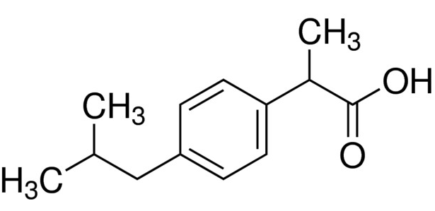 | C₁₃H₁₈O₂ | 15687-27-1 | 206.28 | 3.97
Naproxen (NAP) | 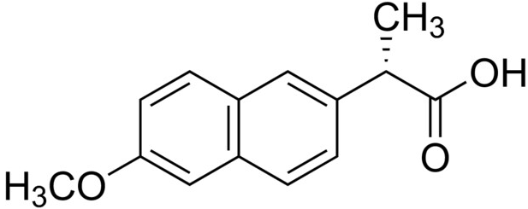 | C₁₄H₁₄O₃ | 22204-53-1 | 230.26 | 3.18
Ketoprofen (KET) | 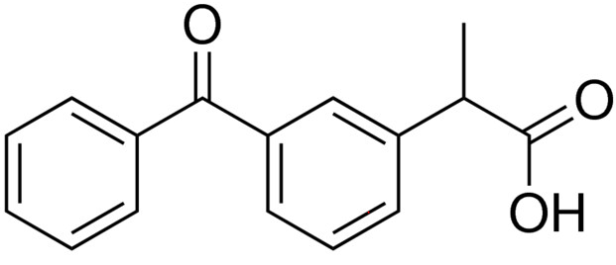 | C₁₆H₁₄O₃ | 22071-15-4 | 254.28 | 2.66
Diazepam (DIA) | 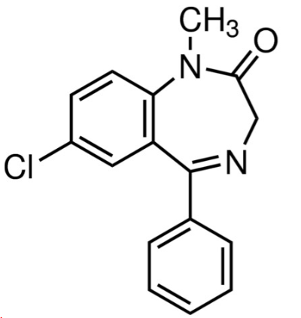 | C₁₆H₁₃ClN₂O | 439-14-5 | 284.74 | 2.85
Diclofenac (DIC) | 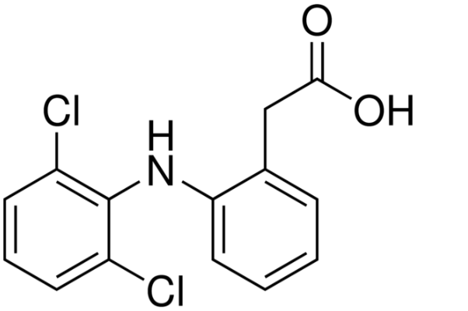 | C₁₄H₁₁Cl₂NO₂ | 15307-86-5 | 296.15 | 1.90

Table S-2 Recovery and quality standard for targeted analyte
Analyte | Retention  time (min) | Recovery (%) | Linearity from response | Coefficient of determination (R²) from a response | Coefficient of variation (σ/mean)  (%) | Standard deviation of response (σ) | Slope of the calibration curve  (s) | LOD  (x10⁵ ng/L)  3.3*(σ/s) | LOQ  (x10⁶ ng/L)  10*(σ/s)
IBU | 9.05 | 99.1 | y=53977x-21811 | 0.9844 | 15.14 | 7093.08 | 53977 | 4.337 | 1.314
NAP | 12.0 | 97.7 | y=4331.4x+6382.8 | 0.9607 | 5.32 | 505.919 | 4331.4 | 3.854 | 1.168
KET | 12.8 | 111.7 | y=106608x+65246 | 0.9889 | 16.30 | 21820.06 | 106608 | 6.754 | 2.046
DIA | 14.9 | 74.86 | y=144164x+162864 | 0.9755 | 17.59 | 29990.55 | 144164 | 6.865 | 2.080
DIC | 13.0 | 69.1 | y=48855x+6961.8 | 0.9992 | 9.36 | 5241.51 | 48855 | 3.540 | 1.072

Table S-3 The pharmaceutical residue (IBU, NAP, KET, DIA, DIC) in the urban water
Country | Water cycle | Pharmaceuticals | Ref.
Sweden | STP | IBU, NAP, KET, DIC | (Larsson et al., 2014)
Canada | STP | IBU, NAP | (Guerra et al., 2014)
South Africa | STP | IBU, NAP, DIC | (Madikizela and Chimuka, 2017)
Spain | STP | IBU, NAP, KET, DIC | (Gracia-Lor et al., 2017)
Spain | Surface water | IBU, KET, DIC | (Jurado et al., 2021) *Groundwater
Spain | Treated water | IBU, NAP, DIC | (Carmona et al., 2014)
India | STP | DIA | (Subedi et al., 2017)
Beijing, China | STP | DIA | (Wang et al., 2017)
United Kingdom | STP | DIA | (Baker and Kasprzyk-Hordern, 2013)
Thailand | Surface water | IBU, NAP, DIC | (Tewari et al., 2013)
Italy | Surface water | IBU, NAP, KET, DIC | (Marchese et al., 2003)
Italy | Surface water | DIA | (Zuccato et al., 2000)
Serbia | Treated water | KET | (Petrović et al., 2014)
France | Treated water | IBU, NAP, DIC | (Togola and Budzinski, 2008)
Algeria | Treated water | KET | (Kermia et al., 2016)
Johor, Malaysia | STP | IBU, NAP | (Yacob et al., 2017)
Selangor, Malaysia | Surface water | KET | (Abu Tahrim et al., 2018)
Putrajaya, Malaysia | Treated water | DIC | (Wee et al., 2020)
Selangor, Malaysia | STP, Surface water, Treated water | IBU, NAP, KET, DIA, DIC | Current Study
cycle (STP, surface water, and treated water).

Model No. | ANOVA Model |  | Sum of Squares | df | Mean Square | F | Sig. F Change
1. | Influent Vs. Effluent | SSW | 1888825833 | 1 | 1888825833 | 235.671 | 0.001
 |  | SSB | 24043967.36 | 3 | 8014655.785
 |  | SST | 1912869800 | 4
a Dependent Variable: Effluent
b Predictors: (Constant), Influent
2. | Effluent Vs. Surface Water | SSW | 484.843 | 1 | 484.843 | 16.746 | 0.026
 |  | SSB | 86.856 | 3 | 28.952
 |  | SST | 571.699 | 4
a Dependent Variable: Water
b Predictors: (Constant), Effluent
3. | Surface Water Vs. Treated Water | SSW | 244.891 | 1 | 244.891 | 11.223 | 0.044
 |  | SSB | 65.464 | 3 | 21.821
 |  | SST | 310.354 | 4
a Dependent Variable: Treated water
b Predictors: (Constant), River water
Table S-4 ANOVA analysis on NSAIDs in the urban water cycle.
Table S-5 The Pearson correlation on NSAIDs in the urban water cycle
Pearson Correlation | Influent | Effluent | Surface Water | Treated Water
Influent | 1.000 | - | - | -
Effluent | 0.994** | 1.000 | - | -
Surface Water | 0.950* | 0.921 | 1.000 | -
Treated Water | 0.982** | 0.992** | 0.888* | 1.000
** Correlation is significant at the 0.01 level (2-tailed).
* Correlation is significant at the 0.05 level (2-tailed).

