Supplementary Information
Table S1. Baseline Characteristics of LIMIT participants with Cord Blood DNAm Data

Characteristic | Lifestyle Advice | Standard Care | Overall
Overall Numbers | n=325 | n=320 | n=645
BMI (kg/m2): Median (IQR) | 31.40 (28.10, 36.20) | 31.45 (27.98, 36.90) | 31.40 (28.00, 36.50)
BMI Category: (N%)
- 25.0-29.9 | 129 (39.69) | 130 (40.62) | 259 (40.16)
- 30.0-34.9 | 99 (30.46) | 86 (26.88) | 185 (28.68)
- 35.0-39.9 | 58 (17.85) | 55 (17.19) | 113 (17.52)
- ≥40.0 | 39 (12.00) | 49 (15.31) | 88 (13.64)
Height(cm): Mean (SD) | 165.29 (6.66) | 164.73 (6.48) | 165.01 (6.57)
Weight(kg): Mean (SD) | 89.81 (17.48) | 89.75 (18.65) | 89.78 (18.06)
Parity: N(%)
- 0 | 141 (43.38) | 128 (40.00) | 269 (41.71)
- 1+ | 184 (56.62) | 192 (60.00) | 376 (58.29)
Age at TE: Mean (SD) | 29.28 (5.56) | 29.63 (5.24) | 29.45 (5.41)
Smoking: N(%)
- Yes | 274 (84.31) | 274 (85.62) | 548 (84.96)
- No | 47 (14.46) | 37 (11.56) | 84 (13.02)
- Missing | 4 (1.23) | 9 (2.81) | 13 (2.02)
Ethnicity: N(%)
- Non-Caucasian | 29 (8.92) | 29 (9.06) | 58 (8.99)
- Caucasian | 294 (90.46) | 291 (90.94) | 585 (90.70)
- Missing | 2 (0.62) | 0 (0.00) | 2 (0.31)
Quintile of Relative Socioeconomic Disadvantage: N(%)
- Q1 | 107 (32.92) | 87 (27.19) | 194 (30.08)
- Q2 | 61 (18.77) | 83 (25.94) | 144 (22.33)
- Q3 | 59 (18.15) | 52 (16.25) | 111 (17.21)
- Q4 | 46 (14.15) | 52 (16.25) | 98 (15.19)
- Q5 | 52 (16.00) | 46 (14.37) | 98 (15.19)
Infant Sex: N(%)
- Male | 164 (50.46) | 163 (50.94) | 327 (50.70)
- Female | 161 (49.54) | 157 (49.06) | 318 (49.30)
Study Site: N(%)
- WCH | 135 (41.54) | 136 (42.50) | 271 (42.02)
- FMC | 98 (30.15) | 103 (32.19) | 201 (31.16)
- LMH | 92 (28.31) | 81 (25.31) | 173 (26.82)

Table S2. Numbers assigned to fake groups

 | Long | Short | Total
Tabby | 134 | 192 | 326 (50.5)
Tortoiseshell | 126 | 193 | 319 (49.5)
Total | 260 (40.3) | 385 (59.7) | 645

Figure S1. UpSet plot showing overlap between models in the DMPs with p value <1e-100 for Infant Sex
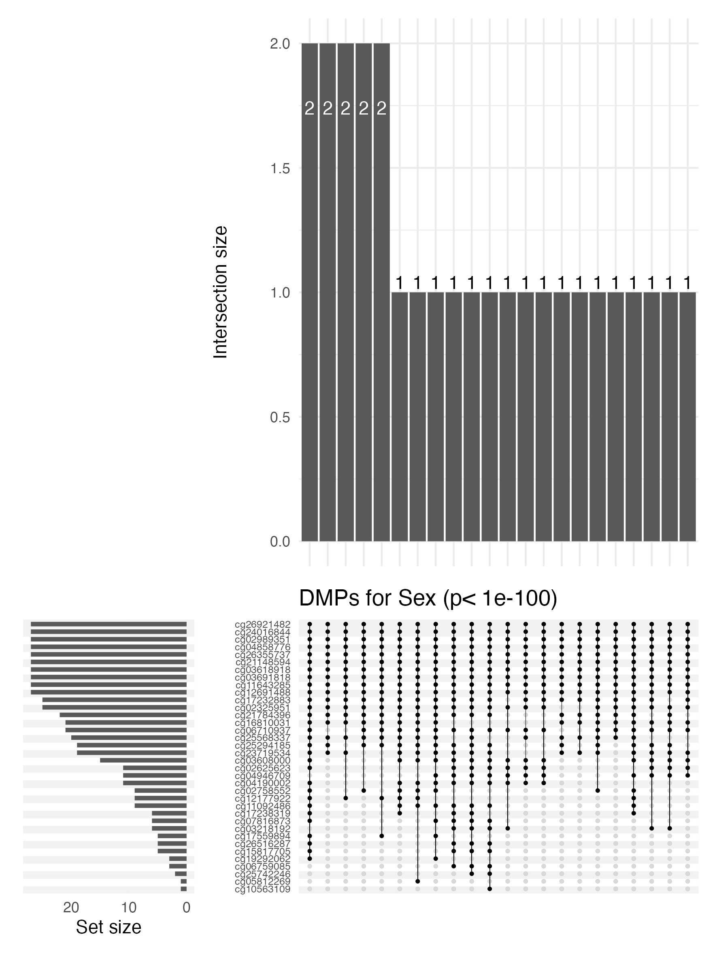
Table S3 RefGene Names and Accession Numbers for DMPs (p<1e-100) for Infant Sex
Chr | Name | UCSC RefGene Name | UCSC RefGene Accession
chr1 | cg03618918
chr1 | cg12177922 | HAX1 | NM_001018837;NM_006118
chr1 | cg12691488
chr1 | cg15817705
chr1 | cg24016844 | C1orf103 | NM_001006945;NM_018372
chr1 | cg25742246
chr11 | cg04858776
chr11 | cg17232883
chr11 | cg25294185 | RNASEH2C | NM_032193
chr12 | cg03691818 | KRT77 | NM_175078
chr12 | cg07816873 | ERC1 | NM_178039;NM_178040;NR_027948;NM;  NR_027949;NM_178039;NR_027946
chr13 | cg02625623
chr13 | cg06710937
chr13 | cg26355737 | TFDP1 | NR_026580;NM_007111
chr14 | cg02325951 | FOXN3 | NM_005197;NM_001085471
chr14 | cg21148594
chr15 | cg23719534
chr16 | cg04946709 | LOC644649 | NR_028471
chr16 | cg26921482 | AMDHD2 | NM_001145815;NM_015944
chr17 | cg03218192 | AP2B1 | NM_001282;NM_001030006
chr17 | cg16810031 | ZPBP2 | NM_199321;NM_198844
chr18 | cg05812269 | RIOK3 | NM_003831
chr19 | cg03608000 | ZNF69 | NM_021915
chr2 | cg02989351 | YWHAQ | NM_006826
chr2 | cg06759085 | NAB1 | NM_005966
chr20 | cg19292062 | CSNK2A1 | NM_177560;NM_001895;NM_177559;NM_001895
chr22 | cg04190002 | SHANK3 | NM_001080420
chr3 | cg02758552 | GPX1 | NM_000581;NM_201397
chr3 | cg11643285 | RFTN1 | NM_015150
chr3 | cg17238319 | RFTN1 | NM_015150
chr6 | cg10563109
chr6 | cg11092486
chr6 | cg25568337 | ARID1B | NM_175863;NM_017519;NM_020732
chr7 | cg17559894
chr7 | cg21784396 | PRRT4 | NM_001114726
chr7 | cg26516287 | SCIN | NM_001112706;NM_033128

Figure S2 UpSet plot showing overlap between models in DMPs with p value <0.05 for effect of intervention at the mean cohort BMI value
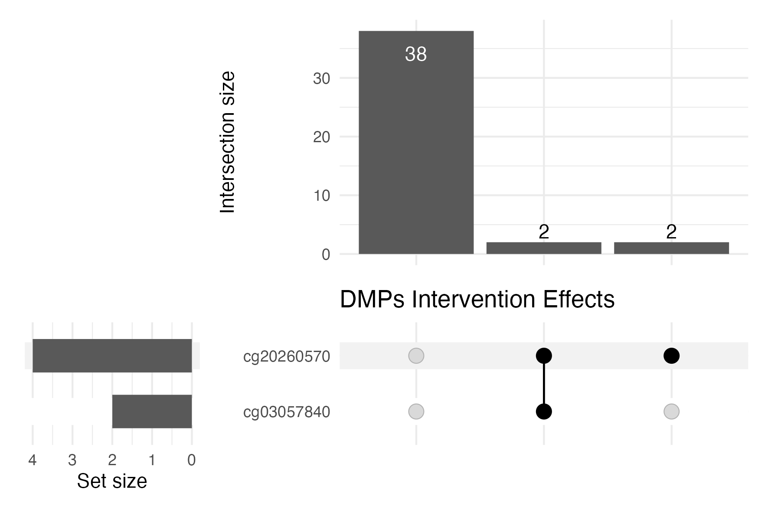
Figure S3 UpSet plot showing overlap between models in DMPs with p value <0.01 for effect of BMI in the Standard Care group
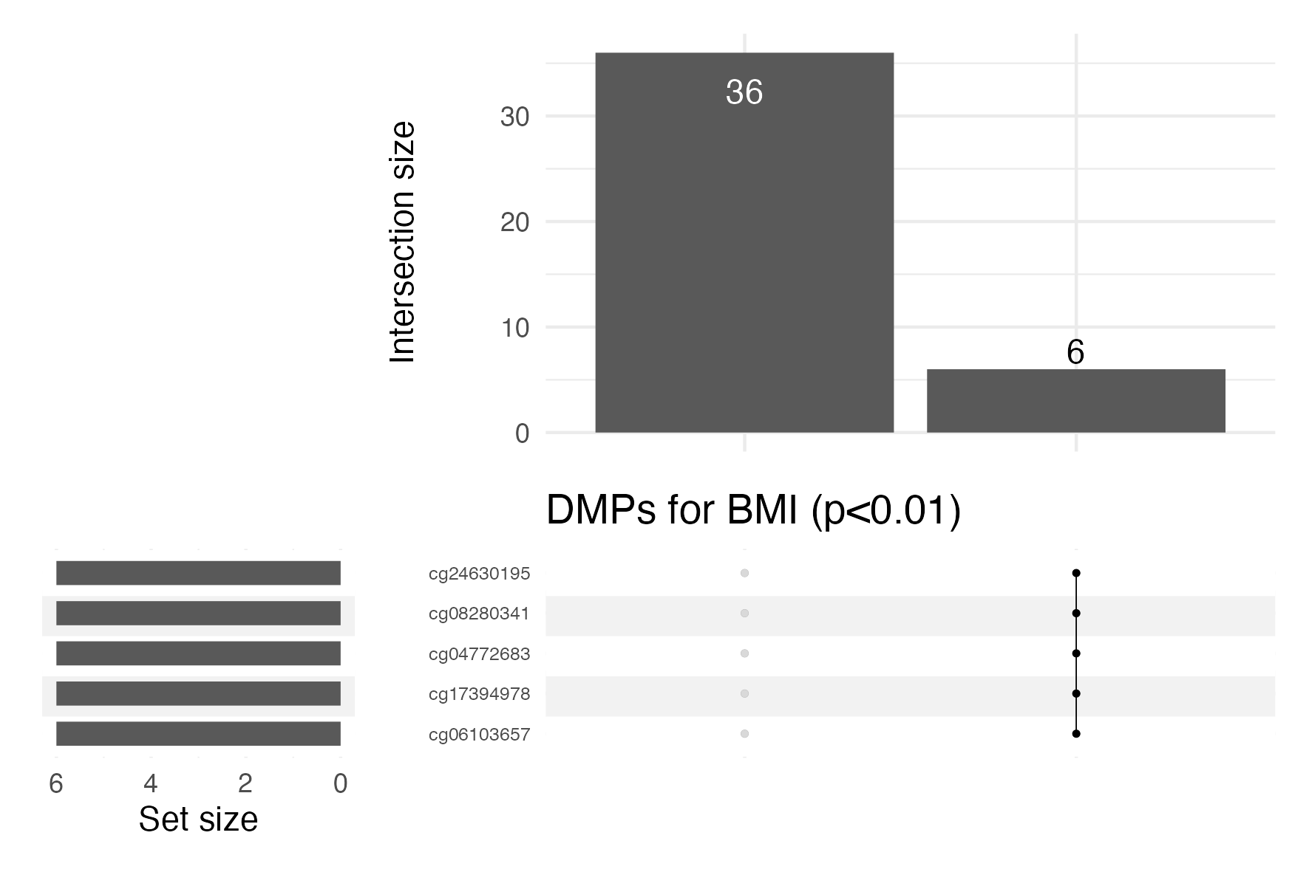

Figure S4 UpSet plot showing overlap between models in DMPs with p value < 0.01 for Short-Haired in Tabby
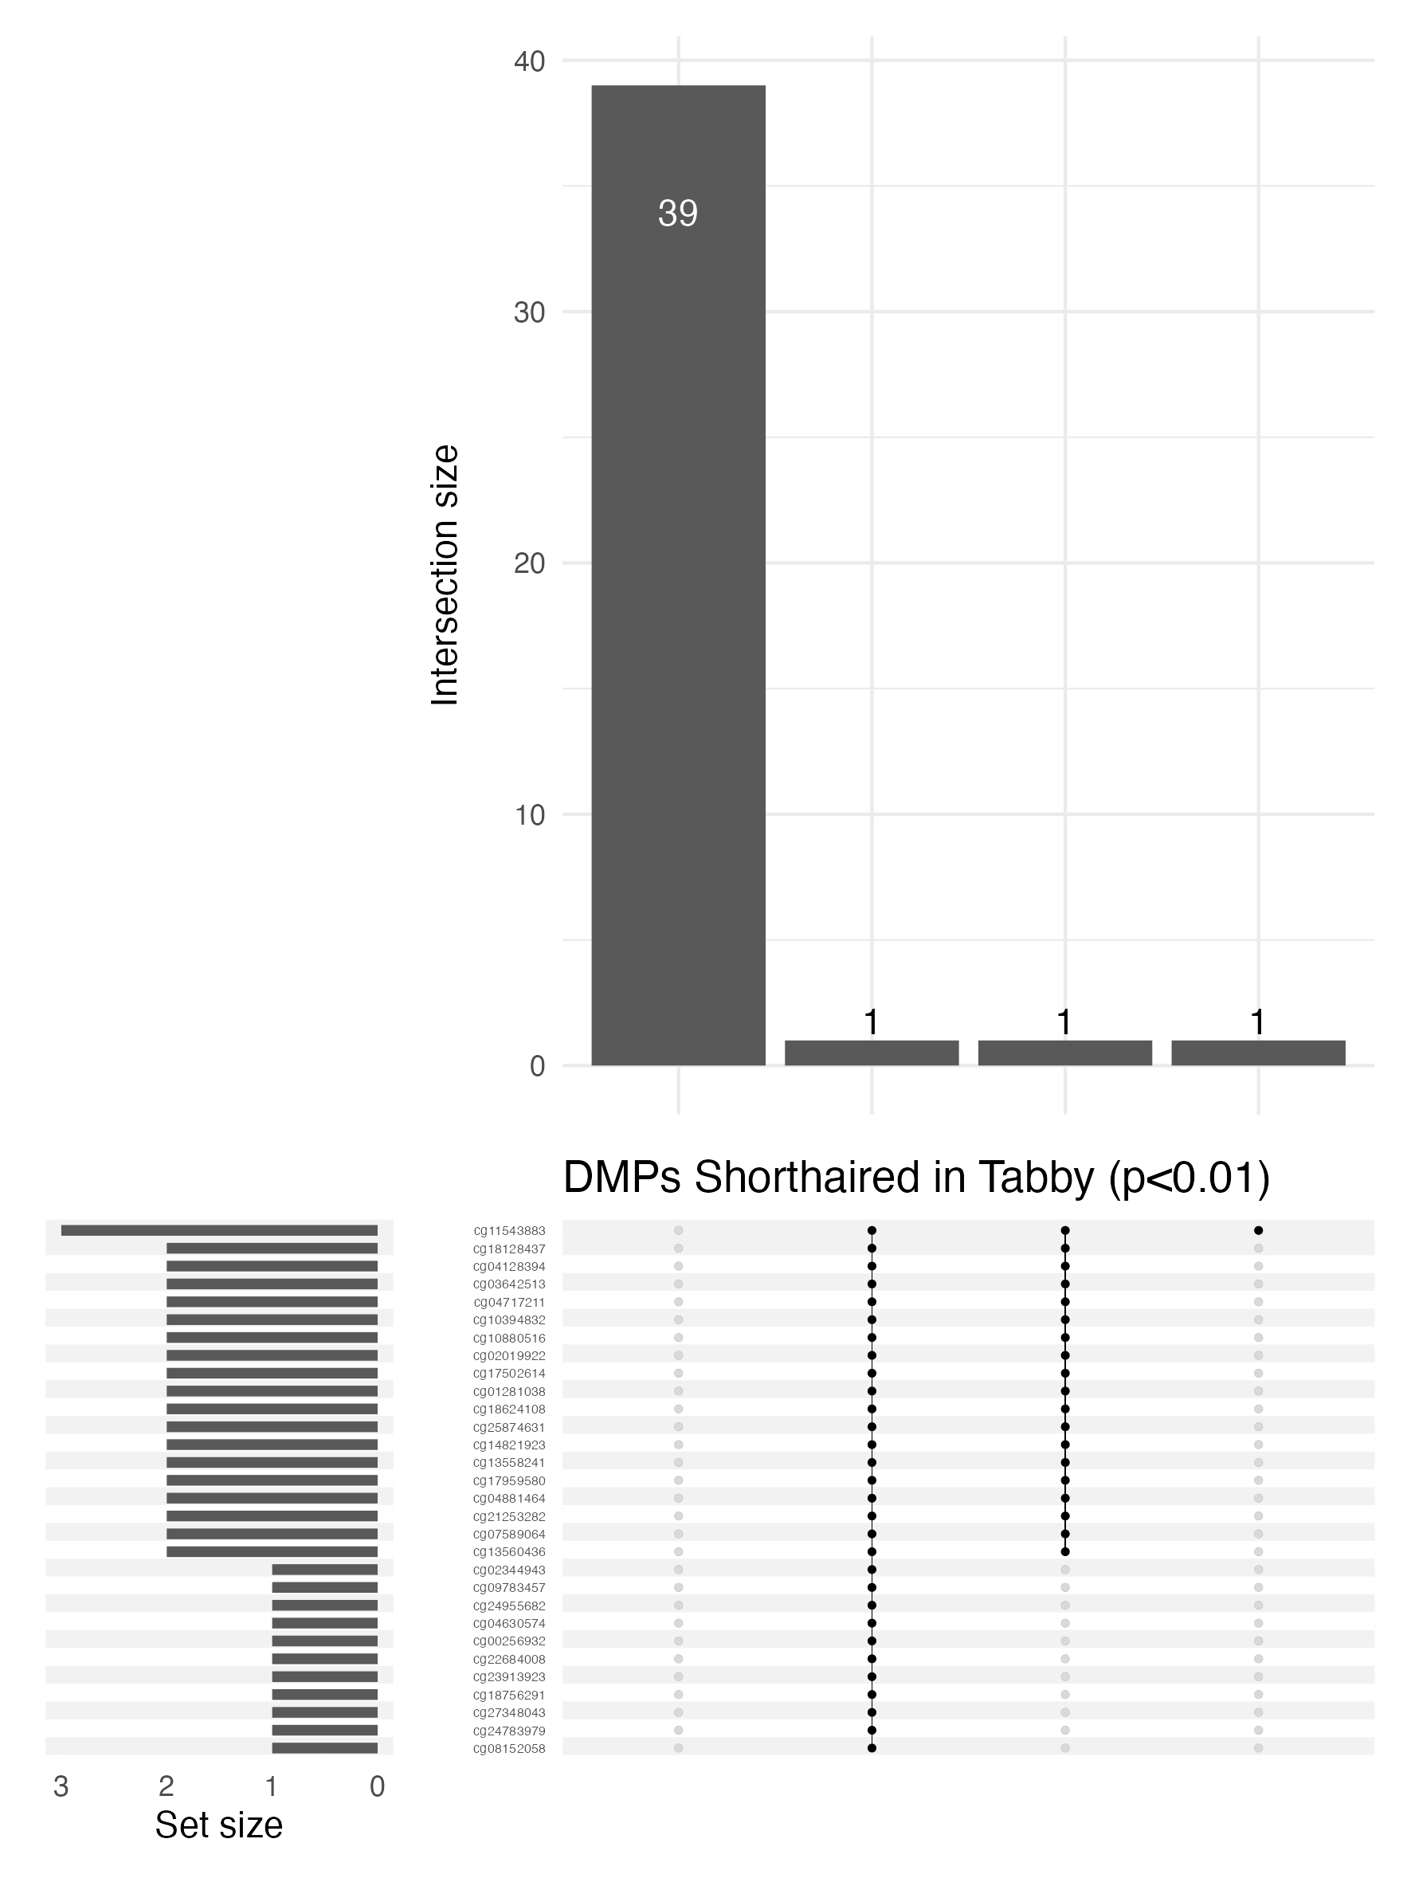

Table S4 Models and Contrast Matrices
Model | Model Matrix | Contrasts
Fake Group and Infant Sex
Fake Groups + infant sex:  Model 1 (unadjusted) | ~ fakegrp*fakegrp2 + BSex  $$β_{0}+ β_{1}FakeGroup1+ β_{2}FakeGroup2+ β_{3}Sex+ β_{4}FakeGroup1×FakeGroup2$$ | Effect of Tortoiseshell (vs Tabby) in Short-Haired and in Long-Haired  c(0, 1, 0, 0, 0)  c(0, 1, 0, 0, 1)  Effect of Long-Haired (vs Short-Haired) in Tabby and in Tortoiseshell:  c(0, 0, 1, 0, 0)  c(0, 0, 1, 0, 1)  Effect of infant sex  c(0, 0, 0, 1, 0)
Fake Groups:  Model 2  (adjustment for 55 batches) | ~ fakegrp*fakegrp2 + Bsex + factor(Sentrix_Barcode)  $$β_{0}+ β_{1}FakeGroup1+ β_{2}FakeGroup2+ β_{3}Sex+ β_{4}Batch_{2}+ . . . +β_{57}Batch55 + β_{58}FakeGroup1×FakeGroup2$$ | Effect of Tortoiseshell (vs Tabby) in Short-Haired and in Long-Haired  c(0, 1, rep(0, 57))  c(0, 1, rep(0, 56), 1)  Effect of Long-Haired (vs Short-Haired) in Tabby and in Tortoiseshell:  c(0, 0, 1, rep(0, 56))  c(0, 0, 1, rep(0, 55), 1)  Effect of infant sex  c(0, 0, 0, 1, rep(0, 55))
Fake Groups:  Model 3  (adjustment for batch and cell type) | ~ fakegrp1*fakegrp2 + Bsex + factor(Sentrix_Barcode) + Bcell + CD4T + CD8T + Gran + Mono + NK + nRBC  $$β_{0}+ β_{1}FakeGroup1+ β_{2}FakeGroup2+ β_{3}Sex+ β_{4}Batch_{2}+ . . . +β_{57}Batch55 +β_{58}Bcell+ β_{59}CD4T+ β_{60}CD8T+ β_{61}Gran+ β_{62}Mono+ β_{63}NK+ β_{64}nRBC+ β_{65}FakeGroup1×FakeGroup2$$ | Effect of Tortoiseshell (vs Tabby) in Short-Haired and in Long-Haired  c(0, 1, rep(0, 64))  c(0, 1, rep(0, 63), 1)  Effect of Long-Haired (vs Short-Haired) in Tabby and in Tortoiseshell:  c(0, 0, 1, rep(0, 63))  c(0, 0, 1, rep(0, 62), 1)  Effect of infant sex  c(0, 0, 0, 1, rep(0, 62))
Intervention(Treatment) and BMI Effects
BMI + Intervention: Model 1 (unadjusted) | ~ Treatment*bmic  $$β_{0}+β_{1}Intervention+ β_{2}BMI_{c}+ β_{3}Intervention×BMI_{c}$$ | Effect of intervention at mean BMI and at +5 BMI:  c(0, 1, 0, 0)  c(0, 1, 0, 5)  Effect of 5 kg/m² increase in BMI in standard care group and in lifestyle group  c(0, 0, 5, 0)  c(0, 0, 5, 5)
BMI + Intervention: Model 2 (adjusted for 55 batches) | ~ Treatment*bmic + factor(Sentrix_Barcode)  $$β_{0}+β_{1}Intervention+ β_{2}BMI_{c}+ {β_{3}Batch_{2}. . . β_{56}Batch_{55}+ β}_{57}Intervention×BMI_{c}$$ | Effect of intervention at mean BMI at at +5 BMI:  c(0, 1, rep(0, 56))  c(0, 1, rep(0, 55), 5)  Effect of 5kg/m² increase in BMI in standard care group and in lifestyle group  c(0, 0, 5, rep(0, 55))  c(0, 0, 5, rep(0, 54), 5))
BMI + Intervention: Model 3 (adjusted for batch and cell type proportion) | ~ Treatment*bmic + factor(Sentrix_Barcode) + Bcell + CD4T + CD8T + Gran + Mono + NK + nRBC  $$β_{0}+β_{1}Intervention+ β_{2}BMI_{c}+ {β_{3}Batch_{2}. . . β_{56}Batch_{55}+β_{56}Bcell+ β_{57}CD4T+ β_{58}CD8T+ β_{59}Gran+ β_{60}Mono+ β_{61}NK+ β_{62}nRBC+ β}_{63}Intervention×BMI_{c}$$ | Effect of intervention at mean BMI at at +5 BMI:  c(0, 1, rep(0, 63))  c(0, 1, rep(0, 62), 5)  Effect of 5kg/m² increase in BMI in standard care group and in lifestyle group  c(0, 0, 5, rep(0, 62))  c(0, 0, 5, rep(0, 61), 5))

Table S5 Spearman rank correlations for p value rankings: BMI in Standard Care
Post= probe filtering after normalisation ; Pre=probe filtering before normalisation
Adj=batch included as covariate in the model; SCB=Supervised ComBat algorithm; UCB=Unsupervised ComBat algorithm
 |  | SQN |  |  |  |  |  | BMIQ |  |  |  |  |  | SWAN
 |  | Post  Adj | Pre  Adj | Post  SCB | Pre  SCB | Post  UCB | Pre  UCB | Post  Adj | Pre  Adj | Post  SCB | Pre  SCB | Post  UCB | Pre  UCB | Post  Adj | Pre  Adj | Post  SCB | Pre  SCB | Post  UCB | Pre  UCB
SQN | Post Adj | 1.00
 | Pre Adj | 1.00 | 1.00
 | Post SCB | 0.52 | 0.52 | 1.00
 | Pre SCB | 0.51 | 0.52 | 1.00 | 1.00
 | PostUCB | 0.50 | 0.50 | 0.96 | 0.96 | 1.00
 | Pre UCB | 0.51 | 0.51 | 0.96 | 0.96 | 1.00 | 1.00
BMIQ | Post Adj | -0.40 | -0.41 | -0.43 | -0.44 | -0.40 | -0.42 | 1.00
 | Pre Adj | -0.40 | -0.41 | -0.42 | -0.43 | -0.38 | -0.40 | 0.97 | 1.00
 | Post SCB | 0.10 | 0.10 | 0.47 | 0.46 | 0.48 | 0.46 | 0.07 | 0.09 | 1.00
 | Pre SCB | 0.10 | 0.09 | 0.41 | 0.41 | 0.42 | 0.40 | 0.10 | 0.16 | 0.97 | 1.00
 | PostUCB | 0.06 | 0.05 | 0.40 | 0.39 | 0.44 | 0.42 | 0.12 | 0.13 | 0.95 | 0.92 | 1.00
 | Pre UCB | 0.03 | 0.02 | 0.31 | 0.31 | 0.35 | 0.33 | 0.12 | 0.19 | 0.91 | 0.94 | 0.96 | 1.00
SWAN | Post Adj | 0.36 | 0.35 | 0.22 | 0.21 | 0.24 | 0.22 | 0.15 | 0.16 | 0.68 | 0.72 | 0.64 | 0.65 | 1.00
 | Pre Adj | 0.40 | 0.39 | 0.26 | 0.25 | 0.28 | 0.26 | 0.12 | 0.13 | 0.68 | 0.71 | 0.63 | 0.64 | 0.99 | 1.00
 | Post SCB | 0.13 | 0.12 | 0.41 | 0.40 | 0.39 | 0.37 | -0.05 | -0.02 | 0.90 | 0.90 | 0.84 | 0.84 | 0.77 | 0.75 | 1.00
 | Pre SCB | 0.17 | 0.16 | 0.42 | 0.41 | 0.41 | 0.38 | -0.04 | 0.00 | 0.90 | 0.90 | 0.85 | 0.84 | 0.78 | 0.77 | 0.99 | 1.00
 | PostUCB | 0.16 | 0.15 | 0.39 | 0.37 | 0.41 | 0.39 | -0.03 | 0.00 | 0.89 | 0.88 | 0.87 | 0.85 | 0.79 | 0.77 | 0.97 | 0.96 | 1.00
 | Pre UCB | 0.18 | 0.17 | 0.39 | 0.37 | 0.42 | 0.40 | -0.03 | 0.00 | 0.88 | 0.87 | 0.87 | 0.85 | 0.79 | 0.78 | 0.96 | 0.96 | 1.00 | 1.00

Table S6 Spearman Rank Correlations for p value rankings: Short-Haired in Tabby
 |  | SQN |  |  |  |  |  | BMIQ |  |  |  |  |  | SWAN
 |  | Post  Adj | Pre  Adj | Post  SCB | Pre  SCB | Post  UCB | Pre  UCB | Post  Adj | Pre  Adj | Post  SCB | Pre  SCB | Post  UCB | Pre  UCB | Post  Adj | Pre  Adj | Post  SCB | Pre  SCB | Post  UCB | Pre  UCB
SQN | Post Adj | 1.00
 | Pre Adj | 1.00 | 1.00
 | Post SCB | 0.64 | 0.64 | 1.00
 | Pre SCB | 0.64 | 0.64 | 1.00 | 1.00
 | PostUCB | 0.57 | 0.58 | 0.96 | 0.96 | 1.00
 | Pre UCB | 0.58 | 0.59 | 0.96 | 0.96 | 1.00 | 1.00
BMIQ | Post Adj | 0.53 | 0.53 | -0.11 | -0.10 | -0.18 | -0.16 | 1.00
 | Pre Adj | 0.50 | 0.50 | -0.13 | -0.13 | -0.20 | -0.18 | 0.98 | 1.00
 | Post SCB | -0.02 | -0.02 | -0.17 | -0.17 | -0.23 | -0.23 | 0.47 | 0.46 | 1.00
 | Pre SCB | -0.06 | -0.06 | -0.19 | -0.19 | -0.26 | -0.26 | 0.42 | 0.45 | 0.96 | 1.00
 | PostUCB | -0.02 | -0.02 | -0.20 | -0.21 | -0.23 | -0.23 | 0.44 | 0.43 | 0.88 | 0.85 | 1.00
 | Pre UCB | -0.08 | -0.08 | -0.25 | -0.26 | -0.28 | -0.29 | 0.42 | 0.44 | 0.86 | 0.88 | 0.97 | 1.00
SWAN | Post Adj | 0.56 | 0.55 | -0.03 | -0.02 | -0.06 | -0.05 | 0.87 | 0.87 | 0.35 | 0.32 | 0.38 | 0.36 | 1.00
 | Pre Adj | 0.58 | 0.57 | -0.02 | -0.01 | -0.06 | -0.05 | 0.89 | 0.88 | 0.37 | 0.34 | 0.39 | 0.37 | 0.99 | 1.00
 | Post SCB | 0.11 | 0.11 | 0.21 | 0.21 | 0.16 | 0.15 | 0.09 | 0.10 | 0.60 | 0.60 | 0.54 | 0.55 | 0.29 | 0.28 | 1.00
 | Pre SCB | 0.12 | 0.12 | 0.24 | 0.24 | 0.19 | 0.17 | 0.07 | 0.06 | 0.61 | 0.60 | 0.56 | 0.55 | 0.23 | 0.24 | 0.97 | 1.00
 | PostUCB | 0.15 | 0.15 | 0.17 | 0.17 | 0.15 | 0.14 | 0.18 | 0.19 | 0.66 | 0.65 | 0.66 | 0.66 | 0.36 | 0.36 | 0.95 | 0.93 | 1.00
 | Pre UCB | 0.14 | 0.14 | 0.20 | 0.19 | 0.17 | 0.15 | 0.16 | 0.14 | 0.67 | 0.65 | 0.68 | 0.67 | 0.30 | 0.32 | 0.94 | 0.96 | 0.97 | 1.00

Table S7 Spearman Rank Correlations for p value ranks for Infant Sex
 |  | SQN |  |  |  |  |  | BMIQ |  |  |  |  |  | SWAN
 |  | Post  Adj | Pre  Adj | Post  SCB | Pre  SCB | Post  UCB | Pre  UCB | Post  Adj | Pre  Adj | Post  SCB | Pre  SCB | Post  UCB | Pre  UCB | Post  Adj | Pre  Adj | Post  SCB | Pre  SCB | Post  UCB | Pre  UCB
SQN | Post Adj | 1.00
 | Pre Adj | 0.99 | 1.00
 | Post SCB | 0.98 | 0.98 | 1.00
 | Pre SCB | 0.98 | 1.00 | 0.99 | 1.00
 | PostUCB | 0.96 | 0.97 | 1.00 | 0.98 | 1.00
 | Pre UCB | 0.95 | 0.98 | 0.99 | 0.99 | 0.99 | 1.00
BMIQ | Post Adj | 0.51 | 0.44 | 0.55 | 0.46 | 0.55 | 0.51 | 1.00
 | Pre Adj | 0.51 | 0.44 | 0.55 | 0.46 | 0.55 | 0.51 | 1.00 | 1.00
 | Post SCB | 0.41 | 0.34 | 0.45 | 0.35 | 0.46 | 0.41 | 0.99 | 0.99 | 1.00
 | Pre SCB | 0.41 | 0.34 | 0.45 | 0.35 | 0.46 | 0.41 | 0.99 | 0.99 | 1.00 | 1.00
 | PostUCB | 0.50 | 0.43 | 0.54 | 0.45 | 0.54 | 0.50 | 0.98 | 0.98 | 0.98 | 0.98 | 1.00
 | Pre UCB | 0.48 | 0.41 | 0.51 | 0.42 | 0.52 | 0.47 | 0.99 | 0.99 | 0.98 | 0.98 | 0.99 | 1.00
SWAN | Post Adj | 0.53 | 0.48 | 0.57 | 0.48 | 0.58 | 0.54 | 0.96 | 0.96 | 0.94 | 0.94 | 0.94 | 0.94 | 1.00
 | Pre Adj | 0.55 | 0.51 | 0.60 | 0.51 | 0.61 | 0.57 | 0.96 | 0.96 | 0.95 | 0.95 | 0.95 | 0.94 | 0.99 | 1.00
 | Post SCB | 0.44 | 0.39 | 0.49 | 0.39 | 0.50 | 0.45 | 0.95 | 0.95 | 0.96 | 0.96 | 0.93 | 0.93 | 0.99 | 0.98 | 1.00
 | Pre SCB | 0.47 | 0.43 | 0.52 | 0.43 | 0.54 | 0.49 | 0.95 | 0.95 | 0.96 | 0.96 | 0.94 | 0.93 | 0.98 | 0.99 | 0.99 | 1.00
 | PostUCB | 0.51 | 0.46 | 0.56 | 0.47 | 0.58 | 0.53 | 0.95 | 0.95 | 0.94 | 0.94 | 0.95 | 0.95 | 0.98 | 0.99 | 0.98 | 0.98 | 1.00
 | Pre UCB | 0.55 | 0.51 | 0.59 | 0.51 | 0.60 | 0.56 | 0.96 | 0.96 | 0.95 | 0.95 | 0.96 | 0.95 | 0.98 | 0.99 | 0.96 | 0.98 | 0.99 | 1.00

