Supplementary Materials
Exploring the mechanisms by which camel lactoferrin can kill Salmonella enterica serovar typhimurium and Shigella sonnei
Hussein A. Almehdar¹, Nawal Abd El-Baky², Ehab H. Mattar¹, Raed S. Albiheyri¹, Atif A. Bamagoos¹, Vladimir N. Uversky ^{1,3,*}, and Elrashdy M. Redwan ^{1,2,*}
¹Department of Biological Sciences, Faculty of Sciences, King Abdulaziz University, P.O. Box 80203, Jeddah, Saudi Arabia.
²Therapeutic and Protective Proteins Laboratory, Protein Research Department, Genetic Engineering and Biotechnology Research Institute, City of Scientific Research and Technological Applications, New Borg EL-Arab, 21934, Alexandria, Egypt.
³Department of Molecular Medicine and USF Health Byrd Alzheimer's Research Institute, Morsani College of Medicine, University of South Florida, Tampa, FL, USA.

*Corresponding author:
E.M. Redwan: lradwan@kau.edu.sa

Table S1. Antibacterial effects of different lactoferrins on S. typhimurium and S. sonnei growth after 1, 3, 6, 12, and 24 h of incubation.
Lf | Concentration  (mg/ml) | OD at 620 nm (mean ± SEM)
 |  | S. typhimurium |  |  |  |  |  |  |  | S. sonnei
 |  | 0 h |  |  | 1 h | 3 h | 6 h | 12 h | 24 h | 0 h | 1 h | 3 h | 6 h | 12 h | 24 h
cLf1 | 0 | 0.003  ±0.002 |  |  | 0.294  ±0.01 | 0.451  ±0.011 | 0.919  ±0.005 | 2.558  ±0.036 | 2.901  ±0.023 | 0.004  ±0.002 | 0.323  ±0.019 | 0.491  ±0.01 | 0.881  ±0.005 | 2.311  ±0.007 | 3.107  ±0.005
 | 3 | 0.005  ±0.002 | 0.207  ±0.013 |  |  | CIG | CIG | CIG | CIG | 0.007  ±0.003 | 0.259  ±0.01 | CIG | CIG | CIG | CIG
 | 2.5 | 0.004  ±0.001 | 0.287  ±0.017 |  |  | CIG | CIG | CIG | CIG | 0.005  ±0.001 | 0.291  ±0.012 | CIG | CIG | CIG | CIG
 | 2 | 0.005  ±0.001 | 0.265  ±0.011 |  |  | CIG | CIG | CIG | CIG | 0.003  ±0.002 | 0.277  ±0.009 | CIG | CIG | CIG | CIG
 | 1.5 | 0.004  ±0.002 | 0.295  ±0.005 |  |  | CIG | CIG | CIG | CIG | 0.005  ±0.002 | 0.305  ±0.009 | CIG | CIG | CIG | CIG
 | 1 | 0.003  ±0.002 | 0.187  ±0.008 |  |  | CIG | CIG | CIG | CIG | 0.008  ±0.003 | 0.307  ±0.013 | CIG | CIG | CIG | CIG
 | 0.75 | 0.002  ±0.001 | 0.281  ±0.003 |  |  | 0.122  ±0.003 | CIG | CIG | CIG | 0.004  ±0.001 | 0.317  ±0.01 | 0.152  ±0.007 | CIG | CIG | CIG
 | 0.5 | 0.005  ±0.002 |  | 0.274  ±0.003 |  | 0.174  ±0.004 | 0.082  ±0.002 | CIG | CIG | 0.003  ±0.002 | 0.329  ±0.005 | 0.191  ±0.01 | 0.100  ±0.004 | CIG | CIG
 | 0.25 | 0.005  ±0.002 |  | 0.187  ±0.003 |  | 0.106  ±0.004 | 0.092  ±0.002 | 0.077  ±0.002 | CIG | 0.003  ±0.001 | 0.210  ±0.001 | 0.155  ±0.005 | 0.119  ±0.004 | 0.09  ±0.006 | CIG
 | 0.125 | 0.005  ±0.002 |  | 0.374  ±0.003 |  | 0.221  ±0.002 | 0.145  ±0.003 | 0.071  ±0.003 | CIG | 0.005  ±0.001 | 0.279  ±0.005 | 0.183  ±0.005 | 0.117  ±0.004 | 0.094  ±0.002 | CIG
cLf2 | 0 | 0.003  ±0.002 |  | 0.351  ±0.011 |  | 0.492  ±0.017 | 0.879  ±0.003 | 2.481  ±0.024 | 2.773  ±0.031 | 0.004  ±0.002 | 0.402  ±0.013 | 0.604  ±0.011 | 0.958  ±0.005 | 2.378  ±0.009 | 3.217  ±0.012
 | 3 | 0.005  ±0.001 |  | 0.315  ±0.009 |  | CIG | CIG | CIG | CIG | 0.004  ±0.001 | 0.271  ±0.007 | CIG | CIG | CIG | CIG
 | 2.5 | 0.002  ±0.001 |  | 0.216  ±0.004 |  | CIG | CIG | CIG | CIG | 0.005  ±0.001 | 0.243  ±0.006 | CIG | CIG | CIG | CIG
 | 2 | 0.007  ±0.001 |  | 0.268  ±0.007 |  | CIG | CIG | CIG | CIG | 0.005  ±0.002 | 0.224  ±0.01 | CIG | CIG | CIG | CIG
 | 1.5 | 0.004  ±0.002 |  | 0.226  ±0.002 |  | CIG | CIG | CIG | CIG | 0.005  ±0.003 | 0.197  ±0.009 | CIG | CIG | CIG | CIG
 | 1 | 0.004  ±0.002 |  | 0.291  ±0.006 |  | CIG | CIG | CIG | CIG | 0.007  ±0.002 | 0.319  ±0.01 | CIG | CIG | CIG | CIG
 | 0.75 | 0.003  ±0.001 |  | 0.288  ±0.002 |  | 0.135  ±0.002 | CIG | CIG | CIG | 0.005  ±0.003 | 0.320  ±0.007 | 0.181  ±0.003 | CIG | CIG | CIG
 | 0.5 | 0.005  ±0.001 |  | 0.379  ±0.005 |  | 0.243  ±0.004 | 0.171  ±0.002 | CIG | CIG | 0.003  ±0.001 | 0.302  ±0.01 | 0.192  ±0.002 | 0.115  ±0.009 | CIG | CIG
 | 0.25 | 0.003  ±0.002 |  | 0.300  ±0.002 |  | 0.211  ±0.006 | 0.142  ±0.004 | 0.083  ±0.003 | CIG | 0.005  ±0.001 | 0.279  ±0.005 | 0.192  ±0.004 | 0.125  ±0.009 | 0.08  ±0.004 | CIG
 | 0.125 | 0.005  ±0.001 |  | 0.279  ±0.01 |  | 0.144  ±0.003 | 0.095  ±0.004 | 0.062  ±0.002 | CIG | 0.007  ±0.001 | 0.285  ±0.005 | 0.138  ±0.005 | 0.09  ±0.001 | 0.075  ±0.006 | CIG
cLf3 | 0 | 0.003  ±0.002 |  | 0.258  ±0.009 |  | 0.485  ±0.021 | 0.823  ±0.015 | 2.377  ±0.023 | 2.675  ±0.033 | 0.003  ±0.002 | 0.355  ±0.011 | 0.541  ±0.016 | 0.917  ±0.008 | 2.506  ±0.015 | 3.416  ±0.027
 | 3 | 0.005  ±0.001 |  | 0.285  ±0.009 |  | CIG | CIG | CIG | CIG | 0.004  ±0.002 | 0.325  ±0.01 | CIG | CIG | CIG | CIG
 | 2.5 | 0.002  ±0.001 |  | 0.236  ±0.014 |  | CIG | CIG | CIG | CIG | 0.003  ±0.001 | 0.271  ±0.009 | CIG | CIG | CIG | CIG
 | 2 | 0.005  ±0.001 |  | 0.288  ±0.011 |  | CIG | CIG | CIG | CIG | 0.007  ±0.001 | 0.196  ±0.007 | CIG | CIG | CIG | CIG
 | 1.5 | 0.002  ±0.002 |  | 0.316  ±0.007 |  | CIG | CIG | CIG | CIG | 0.004  ±0.002 | 0.270  ±0.002 | CIG | CIG | CIG | CIG
 | 1 | 0.005  ±0.002 |  | 0.221  ±0.005 |  | CIG | CIG | CIG | CIG | 0.004  ±0.002 | 0.191  ±0.006 | CIG | CIG | CIG | CIG
 | 0.75 | 0.003  ±0.002 |  | 0.295  ±0.005 |  | 0.174  ±0.007 | CIG | CIG | CIG | 0.003  ±0.001 | 0.308  ±0.002 | 0.123  ±0.003 | CIG | CIG | CIG
 | 0.5 | 0.004  ±0.001 |  | 0.348  ±0.011 |  | 0.212  ±0.009 | 0.124  ±0.003 | CIG | CIG | 0.005  ±0.001 | 0.261  ±0.005 | 0.193  ±0.004 | 0.102  ±0.002 | CIG | CIG
 | 0.25 | 0.003  ±0.001 |  | 0.370  ±0.009 |  | 0.276  ±0.002 | 0.199  ±0.005 | 0.100  ±0.003 | CIG | 0.005  ±0.002 | 0.388  ±0.01 | 0.248  ±0.005 | 0.125  ±0.002 | 0.084  ±0.001 | CIG
 | 0.125 | 0.005  ±0.001 |  | 0.297  ±0.005 |  | 0.214  ±0.004 | 0.145  ±0.002 | 0.100  ±0.002 | CIG | 0.004  ±0.001 | 0.336  ±0.01 | 0.194  ±0.006 | 0.132  ±0.004 | 0.093  ±0.003 | CIG
cLf4 | 0 | 0.003  ±0.002 |  | 0.299  ±0.01 |  | 0.477  ±0.009 | 0.754  ±0.005 | 2.465  ±0.016 | 2.891  ±0.013 | 0.004  ±0.002 | 0.302  ±0.008 | 0.435  ±0.011 | 0.788  ±0.007 | 2.505  ±0.012 | 2.771  ±0.017
 | 3 | 0.005  ±0.002 |  | 0.364  ±0.013 |  | CIG | CIG | CIG | CIG | 0.004  ±0.002 | 0.300  ±0.01 | CIG | CIG | CIG | CIG
 | 2.5 | 0.004  ±0.001 |  | 0.244  ±0.012 |  | CIG | CIG | CIG | CIG | 0.003  ±0.001 | 0.277  ±0.015 | CIG | CIG | CIG | CIG
 | 2 | 0.005  ±0.001 |  | 0.175  ±0.013 |  | CIG | CIG | CIG | CIG | 0.003  ±0.001 | 0.183  ±0.017 | CIG | CIG | CIG | CIG
 | 1.5 | 0.004  ±0.002 |  | 0.195  ±0.007 |  | CIG | CIG | CIG | CIG | 0.004  ±0.002 | 0.217  ±0.004 | CIG | CIG | CIG | CIG
 | 1 | 0.003  ±0.001 |  | 0.237  ±0.007 |  | CIG | CIG | CIG | CIG | 0.005  ±0.001 | 0.230  ±0.009 | CIG | CIG | CIG | CIG
 | 0.75 | 0.002  ±0.001 |  | 0.177  ±0.005 |  | 0.091  ±0.004 | CIG | CIG | CIG | 0.004  ±0.001 | 0.244  ±0.002 | 0.117  ±0.009 | CIG | CIG | CIG
 | 0.5 | 0.005  ±0.002 |  | 0.298  ±0.006 |  | 0.200  ±0.007 | 0.161  ±0.006 | CIG | CIG | 0.005  ±0.002 | 0.247  ±0.004 | 0.195  ±0.005 | 0.096  ±0.002 | CIG | CIG
 | 0.25 | 0.005  ±0.002 |  | 0.336  ±0.005 |  | 0.264  ±0.007 | 0.121  ±0.005 | 0.09  ±0.001 | CIG | 0.005  ±0.002 | 0.327  ±0.004 | 0.200  ±0.01 | 0.155  ±0.007 | 0.088  ±0.004 | CIG
 | 0.125 | 0.005  ±0.001 |  | 0.317  ±0.005 |  | 0.211  ±0.004 | 0.09 ±0.002 | 0.07  ±0.003 | CIG | 0.005  ±0.001 | 0.277  ±0.003 | 0.180  ±0.008 | 0.097 ±0.001 | 0.081  ±0.004 | CIG
hLf | 0 | 0.003  ±0.002 |  | 0.431  ±0.01 |  | 0.599  ±0.013 | 0.954  ±0.005 | 2.266  ±0.014 | 2.781  ±0.021 | 0.005  ±0.002 | 0.390  ±0.009 | 0.604  ±0.015 | 1.022  ±0.027 | 2.320  ±0.01 | 2.905  ±0.025
 | 3 | 0.005  ±0.001 |  | 0.385  ±0.009 |  | CIG | CIG | CIG | CIG | 0.004  ±0.001 | 0.310  ±0.018 | CIG | CIG | CIG | CIG
 | 2.5 | 0.002  ±0.001 |  | 0.206  ±0.007 |  | CIG | CIG | CIG | CIG | 0.004  ±0.003 | 0.254  ±0.009 | CIG | CIG | CIG | CIG
 | 2 | 0.007  ±0.001 |  | 0.168  ±0.007 |  | CIG | CIG | CIG | CIG | 0.007  ±0.001 | 0.173  ±0.01 | CIG | CIG | CIG | CIG
 | 1.5 | 0.004  ±0.002 |  | 0.176  ±0.002 |  | CIG | CIG | CIG | CIG | 0.005  ±0.002 | 0.184  ±0.005 | 0.107  ±0.009 | CIG | CIG | CIG
 | 1 | 0.004  ±0.002 |  | 0.201  ±0.01 |  | 0.117  ±0.006 | CIG | CIG | CIG | 0.003  ±0.002 | 0.280  ±0.017 | 0.166  ±0.016 | 0.086  ±0.007 | CIG | CIG
 | 0.75 | 0.003  ±0.001 |  | 0.273  ±0.002 |  | 0.155  ±0.004 | 0.123  ±0.003 | CIG | CIG | 0.005  ±0.001 | 0.329  ±0.008 | 0.619  ±0.016 | 1.260  ±0.013 | 1.637  ±0.025 | 2.760  ±0.016
 | 0.5 | 0.005  ±0.001 |  | 0.279  ±0.013 |  | 0.687  ±0.01 | 1.181  ±0.006 | 1.570  ±0.007 | 2.567  ±0.022 | 0.007  ±0.001 | 0.349  ±0.008 | 0.728  ±0.019 | 1.390  ±0.016 | 2.056  ±0.022 | 2.941  ±0.017
 | 0.25 | 0.003  ±0.001 |  | 0.273  ±0.008 |  | 0.597  ±0.007 | 1.177  ±0.004 | 2.566  ±0.011 | 3.066  ±0.014 | 0.005  ±0.002 | 0.384  ±0.011 | 0.735  ±0.012 | 1.284  ±0.017 | 2.118  ±0.009 | 2.970  ±0.011
 | 0.125 | 0.005  ±0.001 |  | 0.379  ±0.013 |  | 0.694  ±0.011 | 1.564  ±0.016 | 2.334  ±0.021 | 2.982  ±0.013 | 0.007  ±0.001 | 0.244  ±0.003 | 0.677  ±0.009 | 1.855  ±0.011 | 2.638  ±0.024 | 3.082  ±0.009
bLf | 0 | 0.003  ±0.002 |  | 0.451  ±0.014 |  | 0.684  ±0.024 | 1.699  ±0.035 | 2.676  ±0.022 | 2.911  ±0.014 | 0.004  ±0.002 | 0.490  ±0.014 | 0.743  ±0.02 | 1.422  ±0.007 | 2.013  ±0.02 | 2.800  ±0.01
 | 3 | 0.005  ±0.001 |  | 0.375  ±0.011 |  | CIG | CIG | CIG | CIG | 0.005  ±0.001 | 0.328  ±0.007 | CIG | CIG | CIG | CIG
 | 2.5 | 0.002  ±0.001 |  | 0.214  ±0.008 |  | CIG | CIG | CIG | CIG | 0.004  ±0.001 | 0.278  ±0.01 | CIG | CIG | CIG | CIG
 | 2 | 0.007  ±0.001 |  | 0.258  ±0.007 |  | CIG | CIG | CIG | CIG | 0.005  ±0.001 | 0.299  ±0.017 | CIG | CIG | CIG | CIG
 | 1.5 | 0.004  ±0.002 |  | 0.233  ±0.002 |  | CIG | CIG | CIG | CIG | 0.003  ±0.002 | 0.258  ±0.01 | 0.138  ±0.009 | CIG | CIG | CIG
 | 1 | 0.004  ±0.002 |  | 0.344  ±0.006 |  | 0.208  ±0.003 | CIG | CIG | CIG | 0.005  ±0.002 | 0.329  ±0.011 | 0.261  ±0.014 | 0.156  ±0.004 | CIG | CIG
 | 0.75 | 0.003  ±0.001 |  | 0.388  ±0.002 |  | 0.219  ±0.002 | 0.158  ±0.006 | CIG | CIG | 0.005  ±0.001 | 0.287  ±0.015 | 0.594  ±0.018 | 0.946  ±0.012 | 1.397  ±0.023 | 2.300  ±0.01
 | 0.5 | 0.005  ±0.001 |  | 0.297  ±0.005 |  | 0.640  ±0.004 | 1.126  ±0.002 | 1.519  ±0.013 | 2.335  ±0.007 | 0.004  ±0.001 | 0.283  ±0.01 | 0.624  ±0.01 | 0.983  ±0.017 | 1.475  ±0.02 | 2.544  ±0.019
 | 0.25 | 0.003  ±0.001 |  | 0.275  ±0.002 |  | 0.587  ±0.01 | 1.181  ±0.022 | 1.499  ±0.007 | 2.576  ±0.002 | 0.005  ±0.001 | 0.296  ±0.004 | 0.530  ±0.007 | 1.029  ±0.013 | 1.622  ±0.017 | 2.700  ±0.01
 | 0.125 | 0.005  ±0.001 |  | 0.239  ±0.005 |  | 0.644  ±0.003 | 1.566  ±0.014 | 2.377  ±0.007 | 2.865  ±0.006 | 0.003  ±0.002 | 0.288  ±0.007 | 0.570  ±0.011 | 1.400  ±0.009 | 2.624  ±0.015 | 3.012  ±0.021
Abbreviations: CIG, Complete inhibition of growth (OD ≤ 0.05).

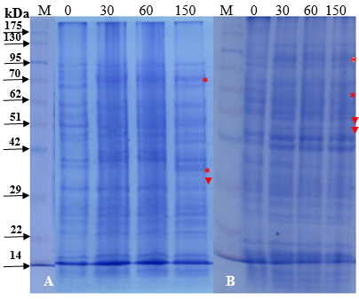
Figure S1. 12.5% reducing SDS-PAGE for camel lactoferrin effect on protein profile of S. typhimurium (A) and S. sonnei (B) at 0, 30, 60, and 150 min. The kinetics of changes in bacterial proteins were followed through sequential chronological SDS-PAGE profiling. The content of bacterial cells was separated on 12.5% SDS-PAGE after boiling for 7 min, stained with Coomassie brilliant blue and destained. Panels A and B represent individual gels, which were not modified in any way.

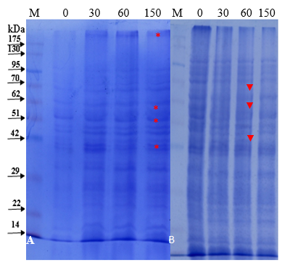

Figure S2. 12.5% reducing SDS-PAGE for carbenicillin effect on protein profile of S. typhimurium (A) and S. sonnei (B) at 0, 30, 60, and 150 min. The content of bacterial cells was separated on 12.5% SDS-PAGE after boiling for 7 min, stained with Coomassie brilliant blue and destained. Panels A and B represent individual gels, which were not modified in any way.

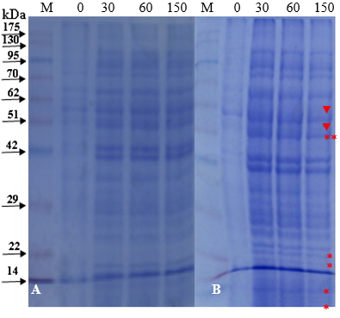
Figure S3. 12.5% reducing SDS-PAGE for effect of carbenicillin combined with camel lactoferrin on protein profile of S. typhimurium (A) and S. sonnei (B) at 0, 30, 60, and 150 min. The content of bacterial cells was separated on 12.5% SDS-PAGE after boiling for 7 min, stained with Coomassie brilliant blue and destained. Panels A and B represent individual gels, which were not modified in any way.
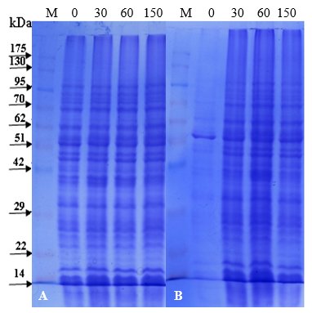
Figure S4. 12.5% reducing SDS-PAGE for chloramphenicol effect on protein profile of S. typhimurium (A) and S. sonnei (B) at 0, 30, 60, and 150 min. The content of bacterial cells was separated on 12.5% SDS-PAGE after boiling for 7 min, stained with Coomassie brilliant blue and destained. Panels A and B represent individual gels, which were not modified in any way.
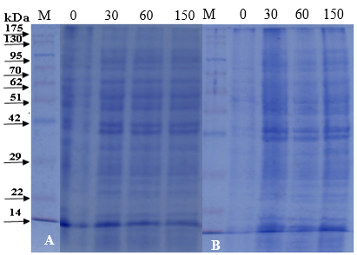
Figure S5. 12.5% reducing SDS-PAGE for effect of chloramphenicol combined with camel lactoferrin on protein profile of S. typhimurium (A) and S. sonnei (B) at 0, 30, 60, and 150 min. The content of bacterial cells was separated on 12.5% SDS-PAGE after boiling for 7 min, stained with Coomassie brilliant blue and destained. Panels A and B represent individual gels, which were not modified in any way.
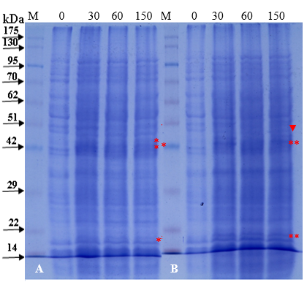
Figure S6. 12.5% reducing SDS-PAGE for imipenem effect on protein profile of S. typhimurium (A) and S. sonnei (B) at 0, 30, 60, and 150 min. The content of bacterial cells was separated on 12.5% SDS-PAGE after boiling for 7 min, stained with Coomassie brilliant blue and destained. Panels A and B represent individual gels, which were not modified in any way.
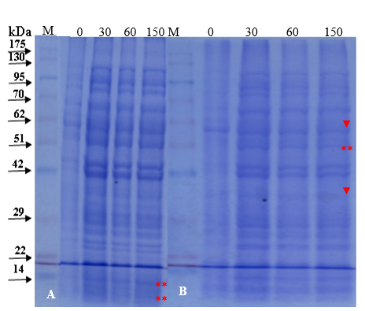
Figure S7. 12.5% reducing SDS-PAGE for effect of imipenem combined with camel lactoferrin on protein profile of S. typhimurium (A) and S. sonnei (B) at 0, 30, 60, and 150 min. The content of bacterial cells was separated on 12.5% SDS-PAGE after boiling for 7 min, stained with Coomassie brilliant blue and destained. Panels A and B represent individual gels, which were not modified in any way.

