SUPPLEMENTARY FIGURE
Figure S1 Diurnal variation of photosynthetic active radiation (PAR) for 3 days.
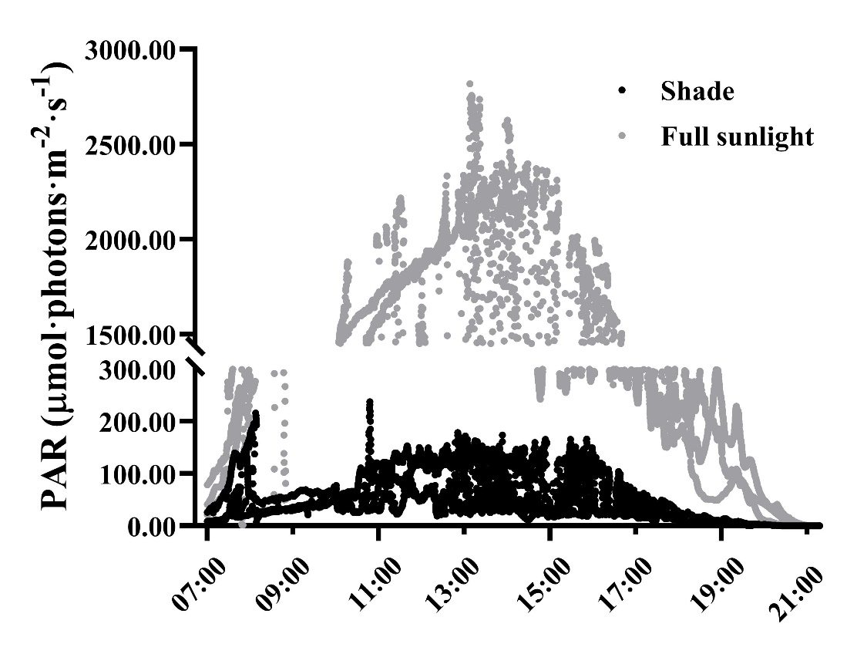

Figure S2 Leaf phenotypic traits of three-year-old Panax notoginseng grown under different nitrogen levels.
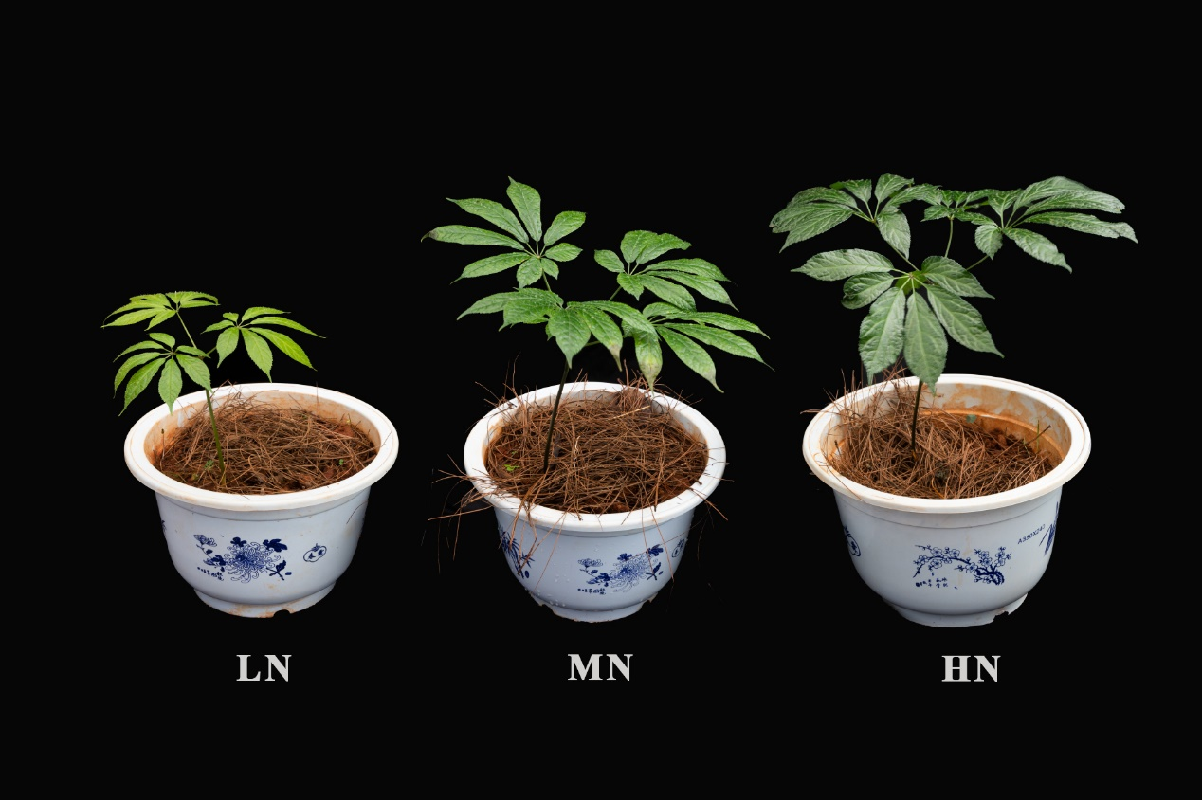

Figure S3 HPLC chromatograms of Panax notoginseng grown under different nitrogen levels.
