APPENDIX

Characterization of Viral Pathogens Associated with Symptomatic Upper Respiratory Tract Infection in Adults during a Low COVID-19 Transmission Period.

Sandybayev N.T.^{1*}, Beloussov V.Yu.^{1,2}, Strochkov V.M.¹, Solomadin M.V.³, Granica J.², Yegorov S.^{4,5*}

Supplementary Table 1: Multiplex PCR panel characteristics. IC= internal control.
PCR mix | Channel
 | green | yellow | orange
hRSv - hMpv | IC | hRSv | hMpv
hAdv - hBov | IC | hBov | hAdv
hRv | IC | – | hRv
hPiv 1/3 | IC | hPiv3 | hPiv1
hPiv 2/4 | IC | hPiv2 | hPiv4
hCov | IC | NL-63, 229E | HKU-1, ОС 43

Supplementary Table 2: Representative amplification plots from the multiplex PCR testing experiment.
Target | Sample # | Amplification plot
hAdv | #7 | 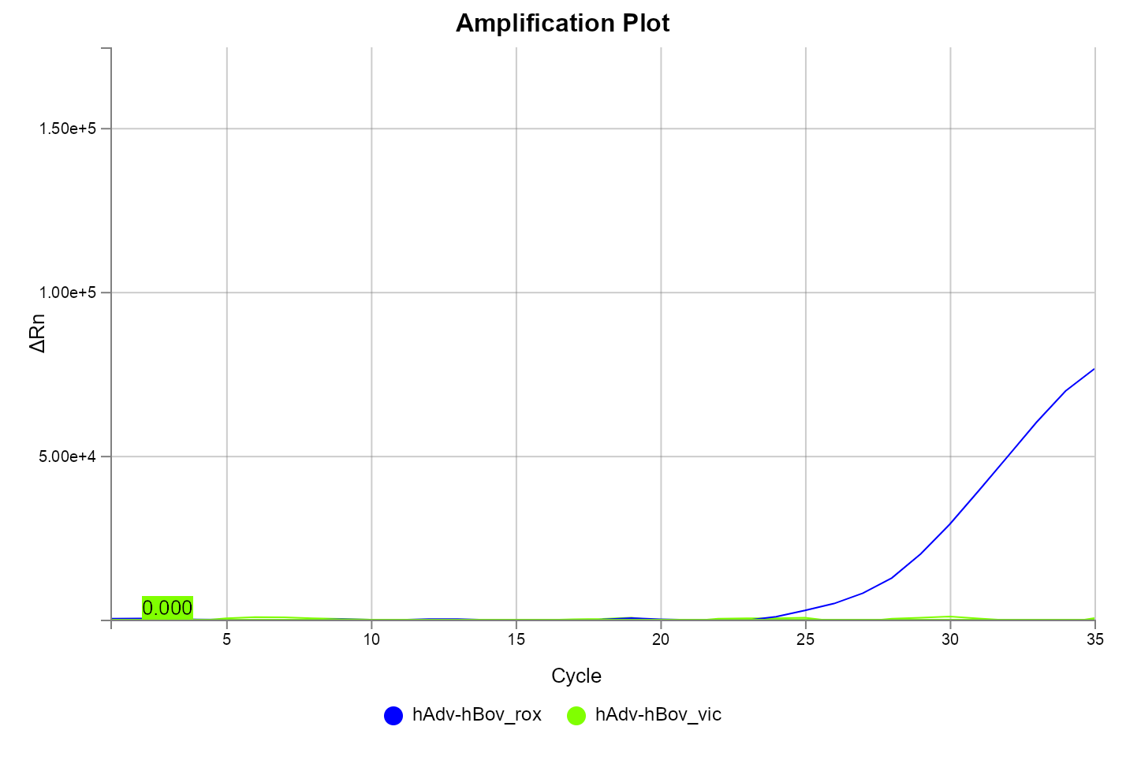
hCoV ОС43/HKU-1 | #7 | 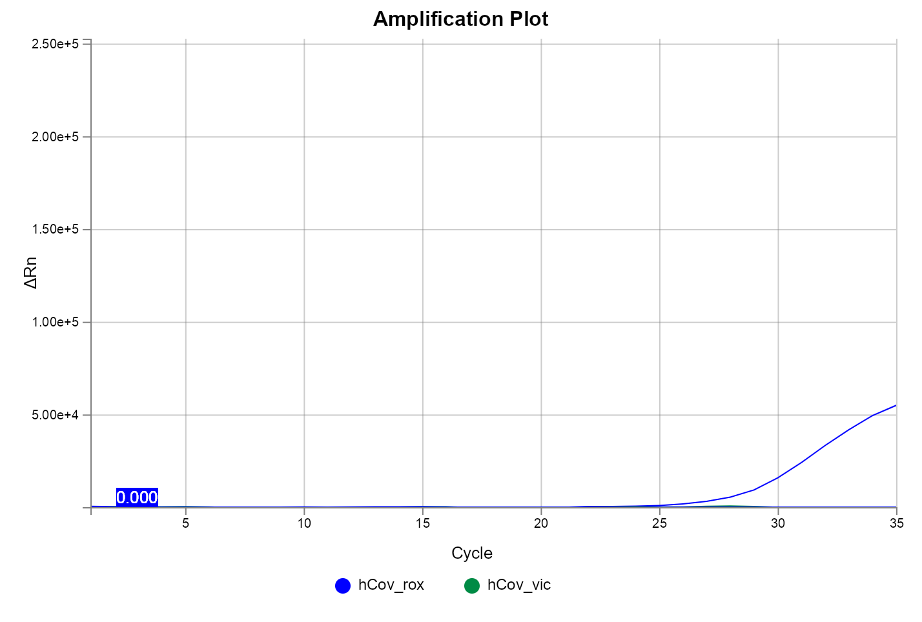
hPIV | #13 | 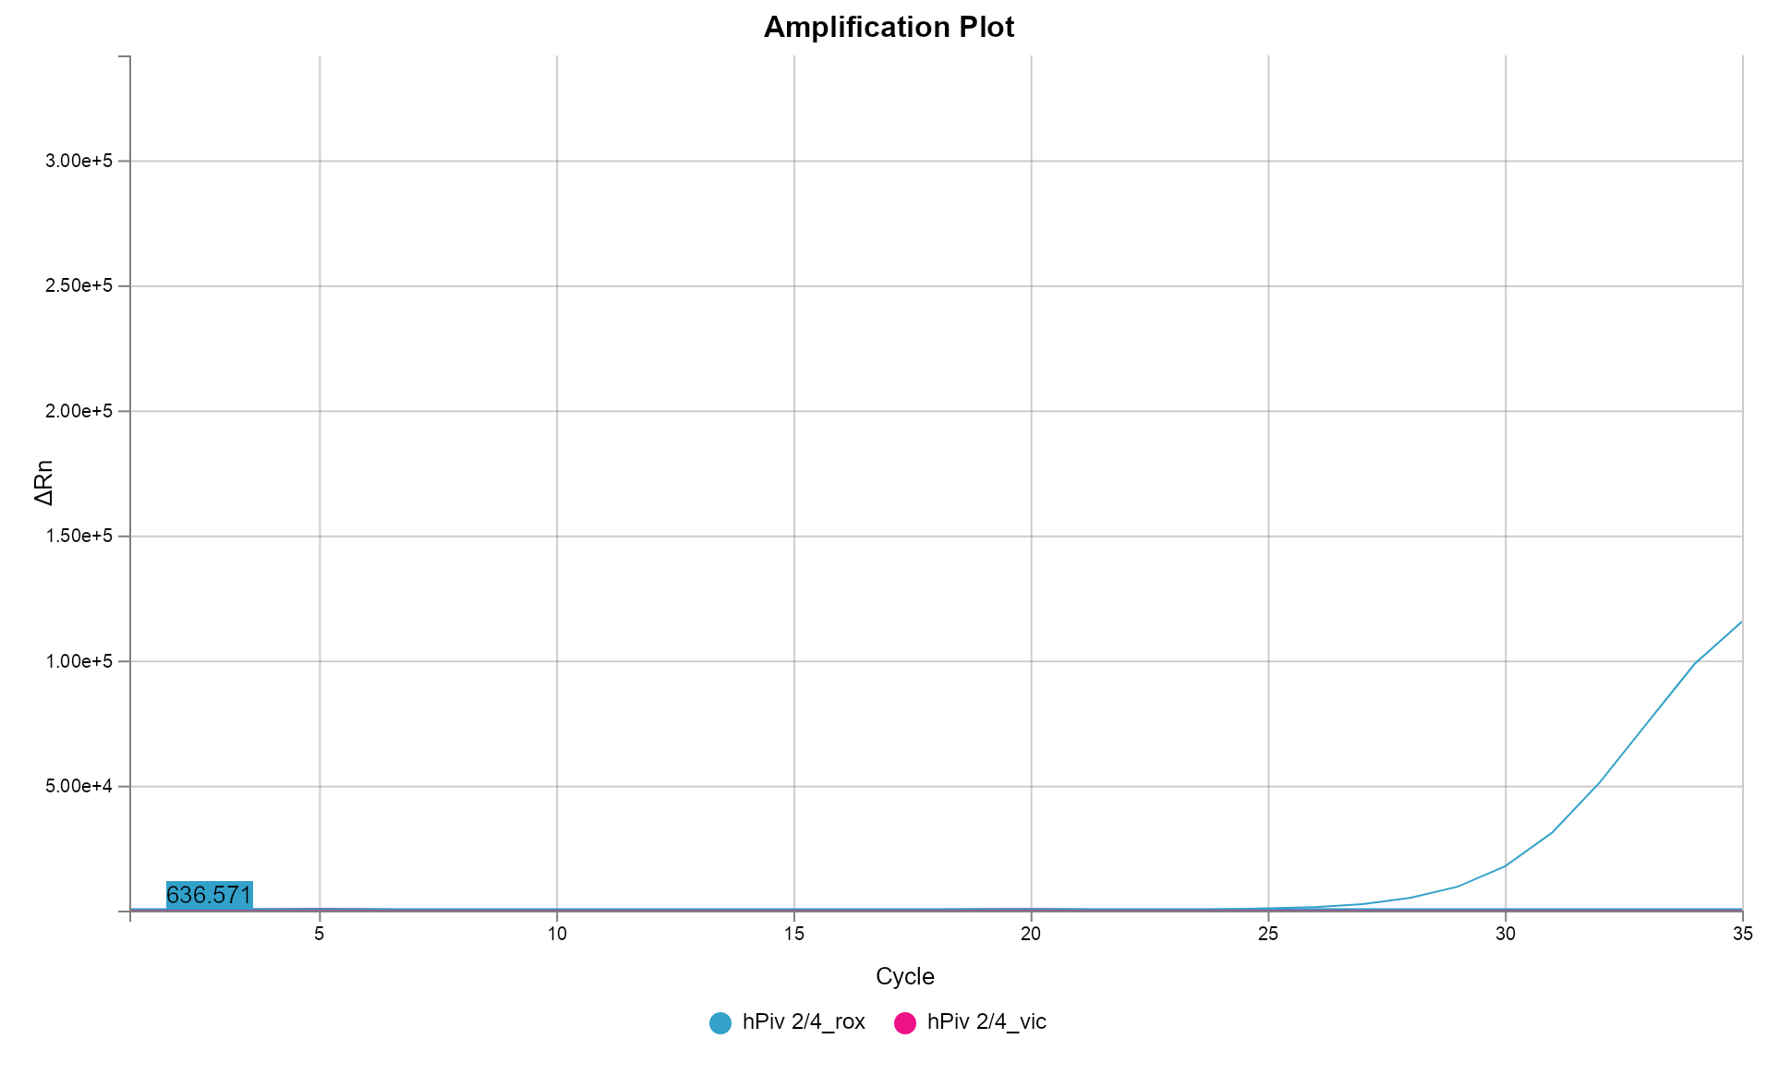
hRV | #75 | 