MTT results

Huh-7
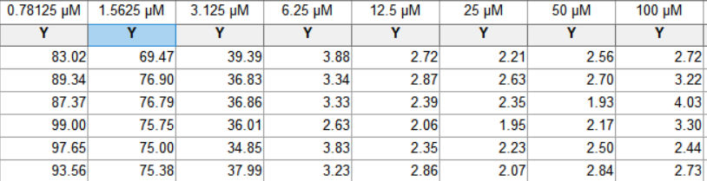

HepG2
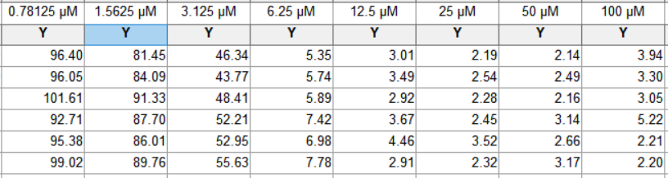

MIHA
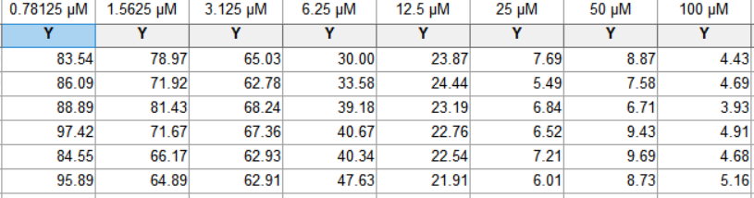

Colony formation results
Huh-7
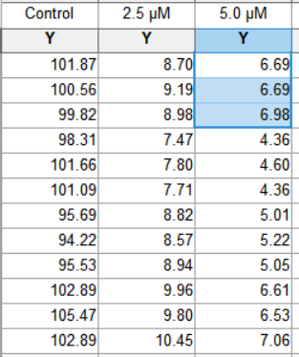

HePG2
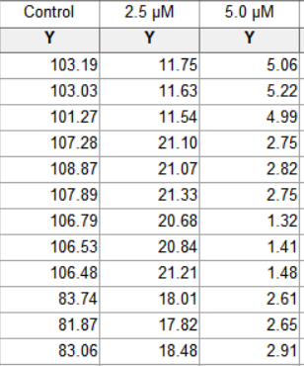

IF
Huh-7

HepG2

DAPI staining
Huh-7
HepG2

Cell apoptosis

Huh-7

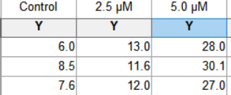

HepG2

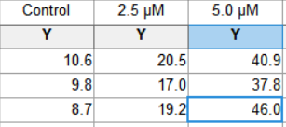

WB

Huh-7 repeat 1:

GAPDH
p-EGFR
EGFR
p-STAT3
STAT3
p-AKT
AKT

Bcl2

BAX

GAPDH
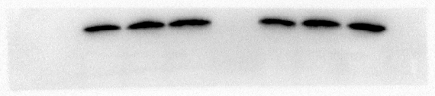

Huh-7 repeat 2, repeat 3
p-EGFR
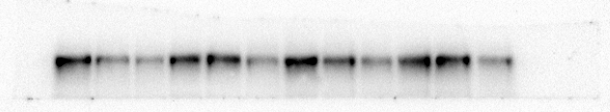
EGFR
p-STAT3
STAT3
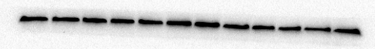
p-AKT
AKT
GAPDH
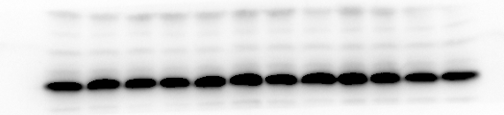
Bcl2
BAX
GAPDH
Repeat3
Bcl2
BAX
GAPDH
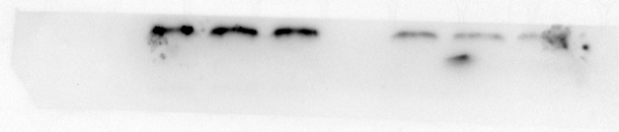
HepG2 WB

GAPDH
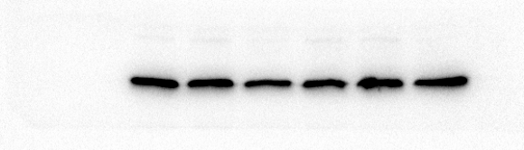
p-EGFR
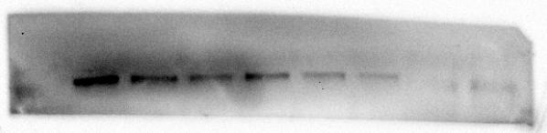
EGFR
p-STAT3
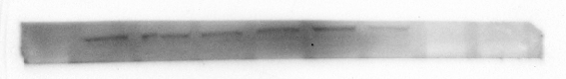
STAT3
p-AKT
AKT
Bcl2
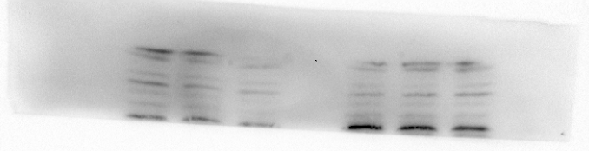
BAX
GAPDH
Repeat 2, 3
p-EGFR
EGFR
p-STAT3
STAT3
p-AKT
AKT
GAPDH
Repeat 2
Bcl2
BAX
GAPDH
Repeat 3
Bcl2
BAX
GAPDH
