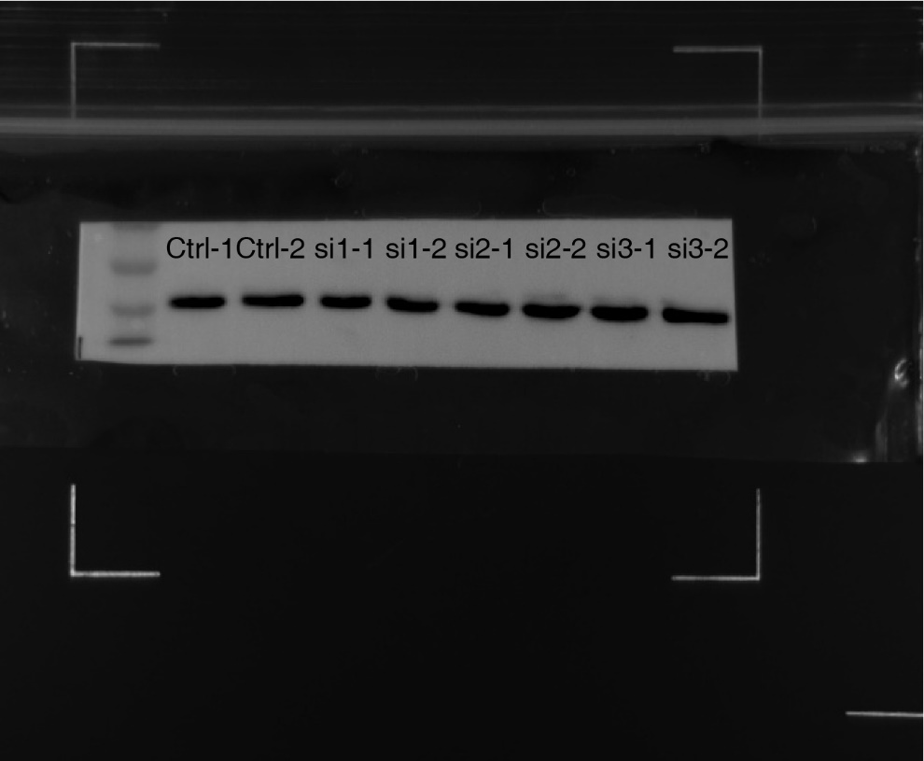

Photograph of GAPDH band in HepG2.

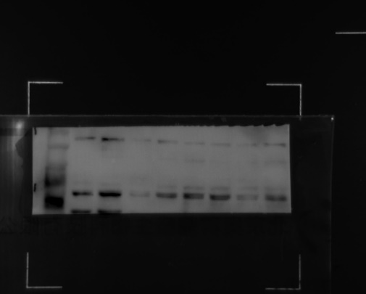

Photograph of PAIP1 band in HepG2.

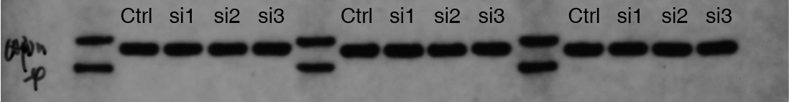

Photograph of GAPDH band in Huh7.

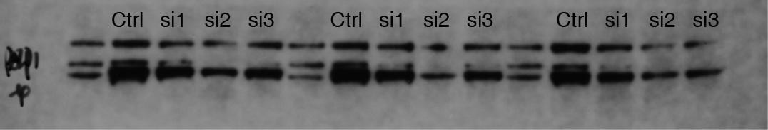

Photograph of PAIP1 band in Huh7.