Attitudes Questionnaire
Date:
Age:
Grade:
Choose what applies: Boy
Girl

Q1: Which group do you think chimpanzees belong to?
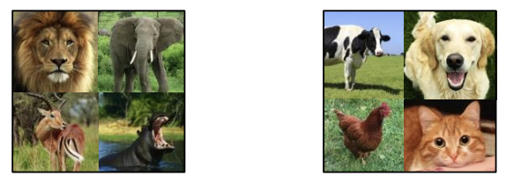
Q2: Which of these photos do you prefer to see in a Mona sanctuary ad?
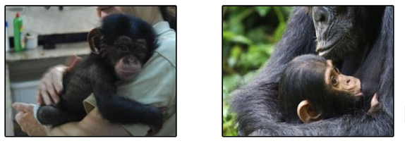
Q3: Which group do you think chimpanzees belong to?
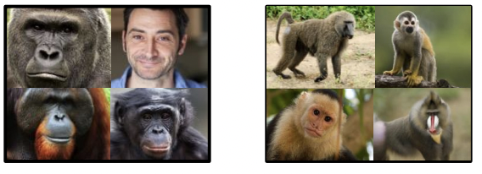
Q4: Which photo best shows the value of the forest?
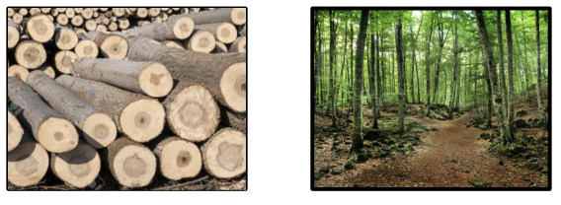

Q5: Which group do you think chimpanzees belong to?
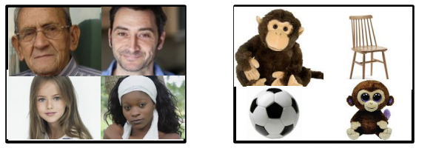
Q6: Which of these photos do you prefer to see in a Mona sanctuary ad?
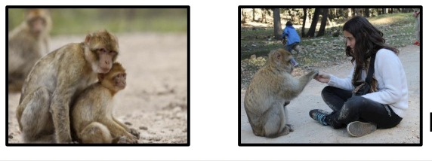
Q7: Which of these two situations do you prefer to be in?
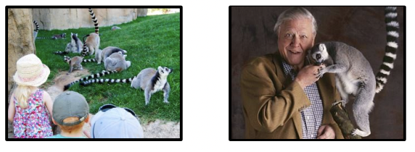
Q8: How do you like to see this chimpanzee?
