Figure S1. The study area, Sea of Marmara and location of Istanbul Fish Market (red triangle) together with fishing ports (black dots) and small capacity fish markets (black triangle).
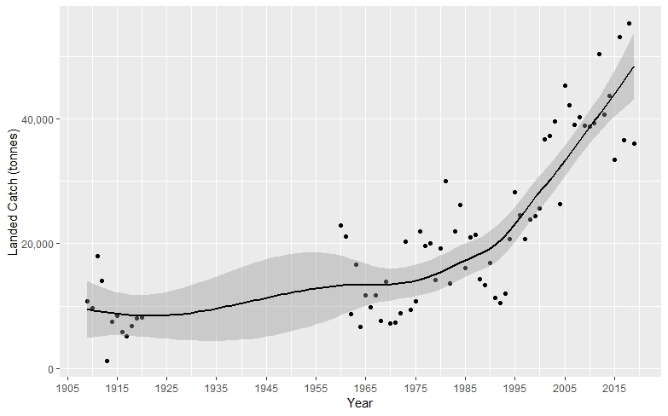
Figure S2. Long term landed catch quantity in the IFM

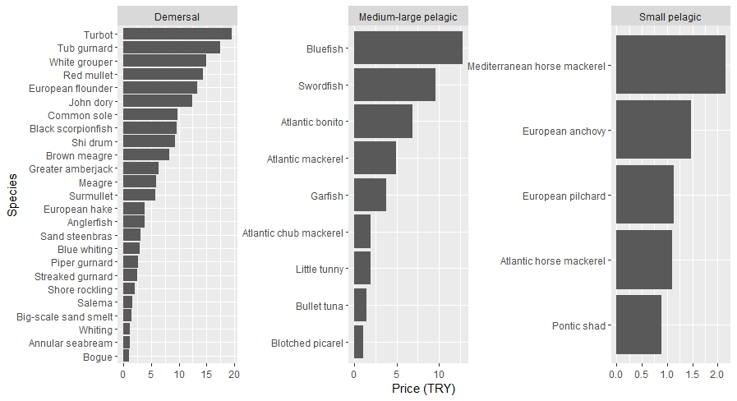
Figure S3. Mean prices (per unit/Turkish Lira, averaged from 2006-2019) for groupings of studied species, for A) demersals, B) pelagics, and C) small pelagics.
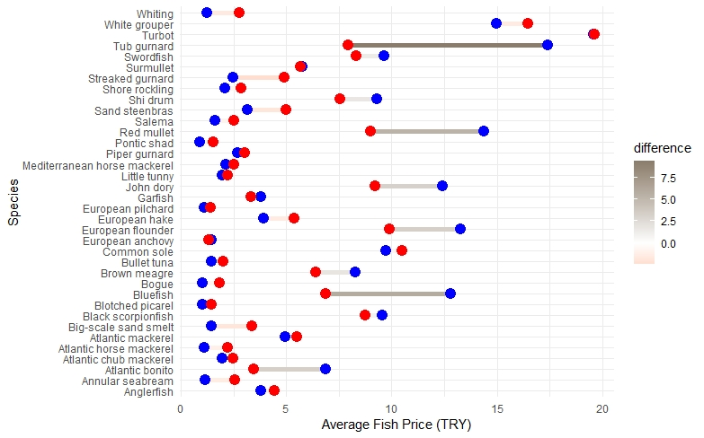
Figure S4. Mean price (2006-2019) comparison between Istanbul Fish Market and Turkish general (Red and blue points indicate the Turkish general and IFM, respectively)

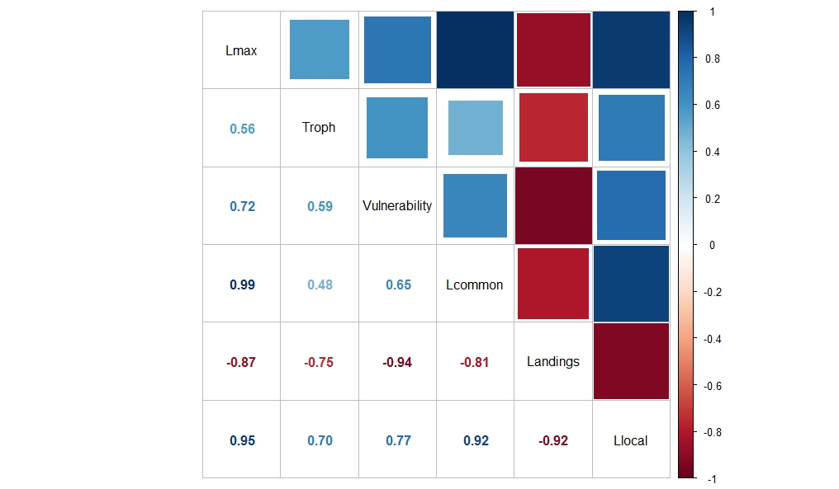
Figure S5. Results of correlation analysis of GAM modeling predictors

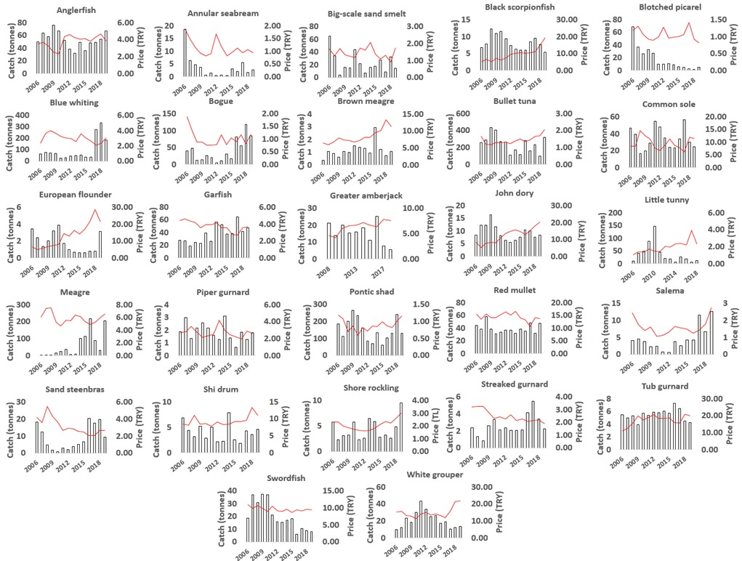
Figure S6. Annual changes for 27 species in landed catch (bars) and unit market prices (red lines) for the main commercial fish species between 2006 and 2019 in Istanbul Fish Market.
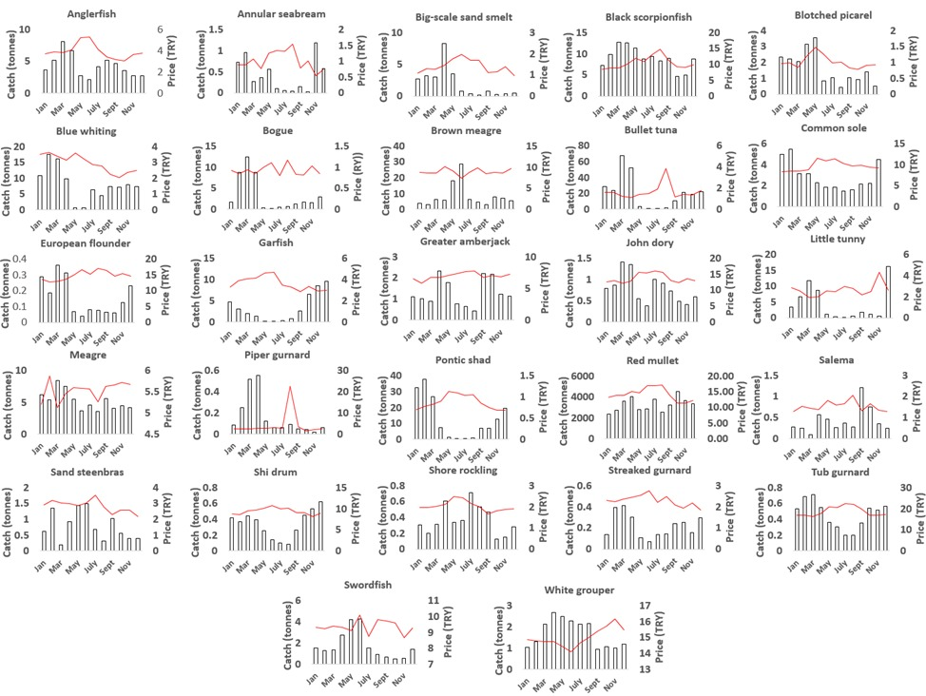
Figure S7. Average monthly changes of 27 species in landed catch (bars) and unit prices (red lines) for the key fish species between 2009 and 2019 in Istanbul Fish Market.
Table S1. Examined fish species by scientific name, common name, group (SP= small pelagic, MP= medium pelagic, D=Demersal fish), trophic level (TL), vulnerability category (V), maximum recorded length (Lmax), catch length (Lc) with respective references (FishBase, 2020)
Species | FishBase Data |  |  |  | IFM Data |  | MAFA Data | Literature Data
 | Lmax | Troph | Vulnerability | Common length | Landings | Real Price | MLS | Local Lmax | Source of Local Lmax | Region
Alosa immaculata | 60 | 4 | 50 | 40 | 150.95 | 0.89 |  | 32.8 | Akgümüş, 2017 | Black Sea
Argyrosomus regius | 230 | 4.3 | 67 | 150 | 60.95 | 5.88 | 25 | 131 | Tokaç et al,2017 | Aegean Sea
Atherina boyeri | 20 | 3.2 | 44 |  | 23 | 1.45 |  | 13.5 | Gençoğlu, 2017 | Marmara
Auxis rochei | 50 | 4.4 | 27 |  | 243 | 1.44 |  | 48 | Kahraman et al., 2010 | Mediterranean
Belone belone | 104 | 4.2 | 49 | 45 | 37.56 | 3.78 |  | 65.1 | Bilgin et al., 2014 | Black Sea
Boops boops | 40 | 2.8 | 50 | 20 | 40.19 | 1.02 |  | 27.6 | Cengiz et al., 2019 | Aegean Sea
Chelidonichthys lastoviza | 40 | 3.5 | 32 | 15 | 2.60 | 2.48 |  | 22.1 | Uçkun. 2005 | Aegean Sea
Chelidonichthys lucerna | 75.1 | 4 | 40 | 30 | 5.48 | 17.41 | 18 | 64 | Bök et al., 2011 | Marmara
Diplodus annularis | 27.5 | 3.6 | 27 | 13 | 3.72 | 1.14 |  | 16.7 | Demirel and Murat-Dalkara, 2012 | Marmara
Engraulis encrasicolus | 20 | 3.1 | 25 | 13.5 | 15844 | 1.47 | 9 | 15.2 | Doğu 2049 | Marmara
Epinephelus aeneus | 120 | 4 | 52 | 60 | 21.06 | 14.95 | 50 | 101 | Özgür Özbek et al., 2013 | Mediterranean
Euthynnus alletteratus | 122 | 4.5 | 57 | 80 | 37.12 | 1.95 |  | 87 | Kahraman et al., 2008 | Mediterranean
Gaidropsarus mediterraneus | 50 | 3.5 | 26 |  | 4.30 | 2.09 |  | 25 | Osma, 2019 | Black Sea
Lithognathus mormyrus | 55 | 3.4 | 40 | 30 | 9.01 | 3.16 |  | 30 | Aydın 2018 | Black Sea
Lophius budegassa | 100 | 4.4 | 69 | 50 | 52 | 3.81 |  | 107 | Yiğin et al., 2015 | Aegean Sea
Merlangius merlangus | 70 | 4.4 | 37 | 23 | 2093 | 1.24 | 13 | 41.2 | Bal, 2021 | Marmara
Merluccius merluccius | 140 | 4.4 | 64 | 45 | 369 | 3.91 |  | 58.8 | Yildiz, 2020 | Marmara
Micromesistius poutassou | 55 | 4.1 | 34 | 20 | 95 | 3.02 |  | 39 | İşmen et al. 2010 | Aegean Sea
Mullus barbatus | 33.2 | 3.1 | 29 | 20 | 39 | 14.39 | 13 | 22.7 | Demirel and Murat-Dalkara, 2012 | Marmara
Mullus surmuletus | 40 | 3.5 | 39 | 25 | 867 | 5.76 | 11 | 23.5 | Moldur, 1999 | Marmara
Pleuronectes flesus | 100 | 3.2 | 71 | 40 | 1.84 | 13.28 | 20 | 37.5 | Şahin and Güneş, 1998 | Black Sea
Pomatomus saltatrix | 130 | 4.5 | 63 | 60 | 2301 | 12.80 | 18 | 86 | Türgan, 1959 | Marmara
Sarda sarda | 91.4 | 4.5 | 33 | 50 | 3768 | 6.86 | 25 | 63 | Kahraman et al., 2014 | Marmara
Sardina pilchardus | 27.5 | 3.1 | 27 | 20 | 860 | 1.13 | 11 | 14.3 | Erdoğan et al., 2010 | Edremit Bay
Sarpa salpa | 51 | 2 | 41 | 30 | 4.57 | 1.6 |  | 33.1 | Bektaş, 2017 | North Aegean
Sciaena umbra | 70 | 3.8 | 64 | 28 | 1.14 | 8.27 | 35 | 63 | Engin and Seyhan, 2009 | Black Sea
Scomber colias | 64 | 3.4 | 31 | 30 | 301 | 1.97 | 18 | 31.1 | Cengiz, 2012 | Aegean Sea
Scomber scombrus | 60 | 3.6 | 44 | 30 | 82.77 | 4.94 | 20 | 27 | Bal and Türker | Marmara
Scopthalmus maximus | 100 | 4.4 | 43 | 50 | 138 | 19.56 | 45 | 70 | Erylmaz and Dalyan, 2015 | Black Sea
Scorpaena porcus | 40.5 | 3.9 | 51 | 15 | 107 | 9.56 | 18 | 32 | Alparslan et al., 2007 | Marmara
Seriola dumerili | 190 | 4.5 | 54 | 100 | 15.41 | 6.37 | 30 | 142 | Tuncer et al., 2010 | Marmara
Solea solea | 70 | 3.2 | 36 | 35 | 34 | 9.73 | 20 | 34 | Oral, 1996 | Marmara
Spicara maena | 20 | 3 | 39 | 14 | 18.15 | 1.05 |  | 18.8 | Sevgili et al., 2016 | Marmara
Trachurus mediterraneus | 60 | 3.8 | 47 | 30 | 5094 | 2.15 | 13 | 18.5 | Demirel and Murat-Dalkara, 2012 | Marmara
Trachurus trachurus | 70 | 3.7 | 59 | 22 | 635 | 1.10 | 13 | 21 | Demirel and Murat-Dalkara, 2012 | Marmara
Trigla lyra | 60 | 3.7 | 63 | 30 | 1.85 | 2.71 |  | 51 | Bök et al., 2011 | Marmara
Umbrina cirrosa | 73 | 3.4 | 40 | 40 | 4.02 | 9.29 | 45 | 94 | Aydın and Sözer, 2020 | Black Sea
Xiphias gladius | 455 | 4.5 | 72 | 300 | 20 | 9.62 | 125 | 161 | Alıçlı et al 2012 | Mediterranean
Zeus faber | 90 | 4.5 | 68 | 40 | 9.43 | 12.40 |  | 52.8 | İşmen et al. 2012 | Aegean Sea

Table S2. Different market sizes of bonito and bluefish in Turkey.
Fish | TL (cm) | TW (g) | Acknowledged Turkish name
Bluefish | 25 - 35 | 250 - 500 | Lüfer
 | 35 - 40; >40 | 1000 - 1500; > 1500 | Kofana
Atlantic bonito | 30 - 35 | 600 -900 | Palamut
 | 50-60 | 3000-4000 | Torik

