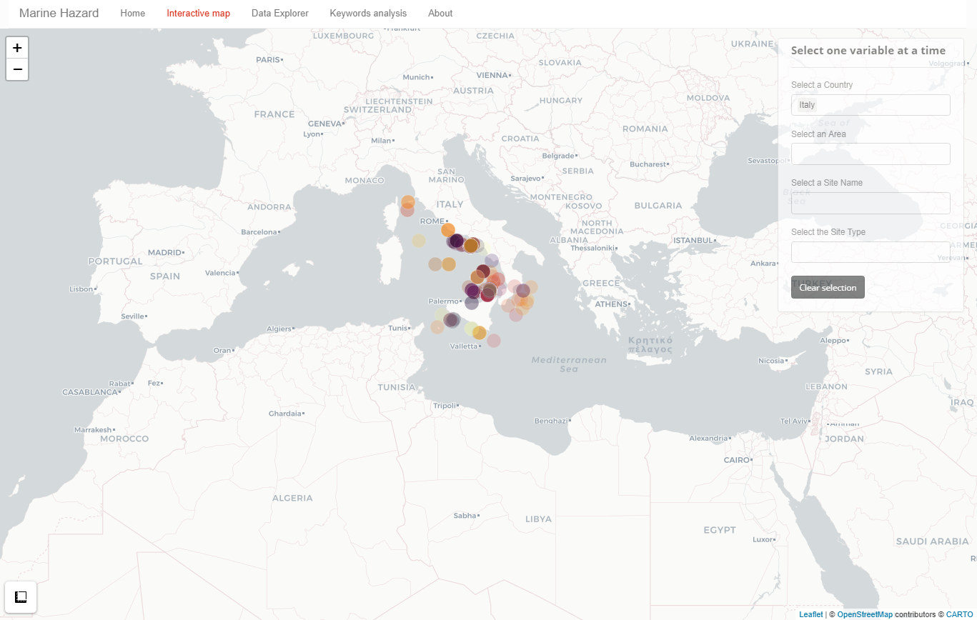
Figure S2: Section “Interactive Map” of the MH-shiny app.
The graphical output example of the “Interactive Map” section used the selection of all the Italian sites.

