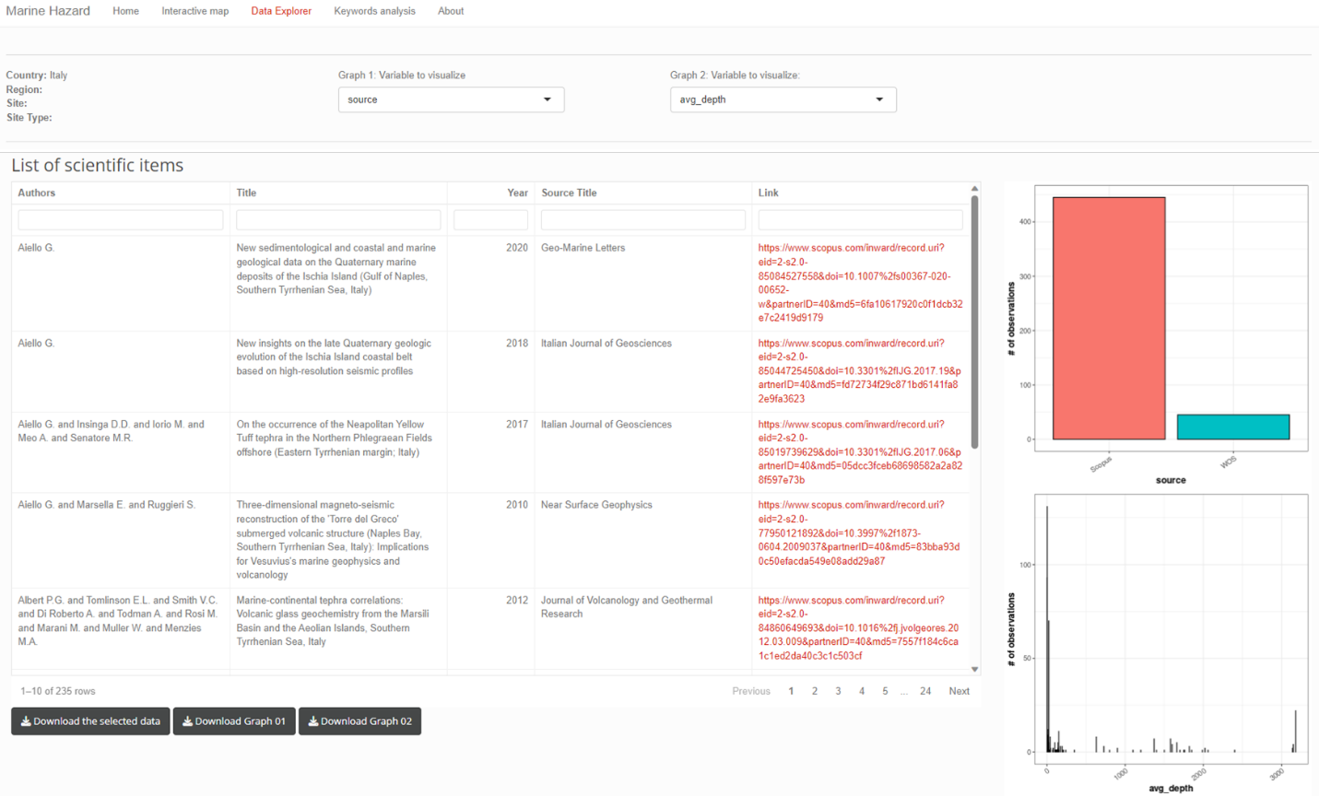
Figure S3: Section “Data Explorer” of the MH-shiny app.
The graphical output example of the “Data Explorer” section is based on the selection made in the “Interactive Map” section.

