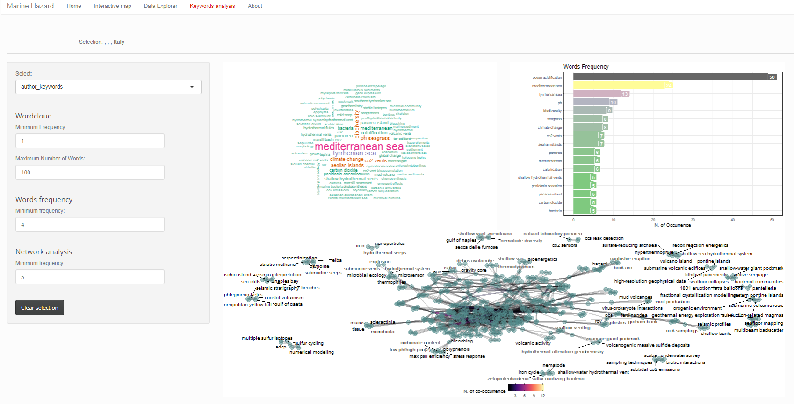
Figure S4: Section “Keyword Analysis” of the MH-shiny app.
The graphical output example of the “Keyword Analysis” section is produced with the selection of “author_keywords”, Minimum Frequency of 1 and Maximum Number of Words of 100 and Network analysis based on the selection made in the “Interactive Map” section.

