SUPPLEMENTARY MATERIALS

THE SKULL VARIATION OF THE OLIVE FIELD MOUSE ABROTHRIX OLIVACEA (CRICETIDAE: ABROTRICHINI) IS LOCALIZED AND CORRELATED TO THE ECOGEOGRAPHIC FEATURES OF ITS GEOGRAPHIC DISTRIBUTION

Marcial Quiroga-Carmona, Pablo Teta, Guillermo D’Elía

Table S1. List of specimens of Abrothrix olivacea morphometrically examined. Acronyms are as follow: ARGENTINA (AR): Buenos Aires, Museo Argentino de Ciencias Naturales “Bernardino Rivadavia” (MACN-Ma); Chubut, Puerto Madryn, Colección de Mamíferos del Centro Nacional Patagónico (CNP); La Plata, Museo de La Plata (MLP); Mendoza, Colección de Mamíferos del Instituto Argentino de Investigaciones de las Zonas Áridas, Mendoza, Argentina (CMI). CHILE (CH): Valdivia, Colección de Mamíferos de la Universidad Austral de Chile (UACH). UNITED STATES: Chicago, Field Museum of Natural History (FMNH); Washington, D.C., United States National Museum (USNM). Specimens are sorted according to locality number as shown in Figure 1. Geographical coordinates are provided for each locality.

Collection number | Locality | Locality number | latitude | longitude
FMNH23007 | CH, Atacama, Copiapó, Caldera | Locality 1 | -27.11173 | -70.76631
FMNH23008 | CH, Atacama, Copiapó, Caldera | Locality 1 | -27.11173 | -70.76631
FMNH23009 | CH, Atacama, Copiapó, Caldera | Locality 1 | -27.11173 | -70.76631
FMNH23005 | CH, Atacama, Ramadilla | Locality 2 | -28.11297 | -69.74992
FMNH23006 | CH, Atacama, Ramadilla | Locality 2 | -28.11297 | -69.74992
UACH1419 | CH, Elqui, Quebrada Las Vacas | Locality 3 | -30.70631 | -71.63828
UACH1421 | CH, Elqui, Quebrada Las Vacas | Locality 3 | -30.70631 | -71.63828
UACH72 | CH, Cachagua, Puchuncavi, Valparaiso | Locality 4 | -32.56851 | -71.44615
UACH73 | CH, Cachagua, Puchuncavi, Valparaiso | Locality 4 | -32.56851 | -71.44615
UACH74 | CH, Cachagua, Puchuncavi, Valparaiso | Locality 4 | -32.56851 | -71.44615
UACH74 | CH, Cachagua, Puchuncavi, Valparaiso | Locality 4 | -32.56851 | -71.44615
UACH75 | CH, Cachagua, Puchuncavi, Valparaiso | Locality 4 | -32.56851 | -71.44615
UACH76 | CH, Cachagua, Puchuncavi, Valparaiso | Locality 4 | -32.56851 | -71.44615
UACH77 | CH, Cachagua, Puchuncavi, Valparaiso | Locality 4 | -32.56851 | -71.44615
UACH77 | CH, Cachagua, Puchuncavi, Valparaiso | Locality 4 | -32.56851 | -71.44615
UACH78 | CH, Cachagua, Puchuncavi, Valparaiso | Locality 4 | -32.56851 | -71.44615
UACH79 | CH, Cachagua, Puchuncavi, Valparaiso | Locality 4 | -32.56851 | -71.44615
UACH80 | CH, Cachagua, Puchuncavi, Valparaiso | Locality 4 | -32.56851 | -71.44615
UACH81 | CH, Cachagua, Puchuncavi, Valparaiso | Locality 4 | -32.56851 | -71.44615
UACH81 | CH, Cachagua, Puchuncavi, Valparaiso | Locality 4 | -32.56851 | -71.44615
UACH82 | CH, Cachagua, Puchuncavi, Valparaiso | Locality 4 | -32.56851 | -71.44615
UACH83 | CH, Cachagua, Puchuncavi, Valparaiso | Locality 4 | -32.56851 | -71.44615
UACH84 | CH, Cachagua, Puchuncavi, Valparaiso | Locality 4 | -32.56851 | -71.44615
UACH5364 | CH, Parque Nacional La Campana | Locality 5 | -32.95957 | -71.12328
UACH5365 | CH, Parque Nacional La Campana | Locality 5 | -32.95957 | -71.12328
UACH5366 | CH, Parque Nacional La Campana | Locality 5 | -32.95957 | -71.12328
UACH5367 | CH, Parque Nacional La Campana | Locality 5 | -32.95957 | -71.12328
UACH5368 | CH, Parque Nacional La Campana | Locality 5 | -32.95957 | -71.12328
UACH5369 | CH, Parque Nacional La Campana | Locality 5 | -32.95957 | -71.12328
UACH5370 | CH, Parque Nacional La Campana | Locality 5 | -32.95957 | -71.12328
UACH5371 | CH, Parque Nacional La Campana | Locality 5 | -32.95957 | -71.12328
UACH5372 | CH, Parque Nacional La Campana | Locality 5 | -32.95957 | -71.12328
UACH5601 | CH, Parque Nacional La Campana | Locality 5 | -32.95957 | -71.12328
UACH3614 | CH, Santiago, Las Condes, Los Dominicos | Locality 6 | -33.41462 | -70.48905
CMI7345 | AR, 8 km O Manzano Histórico, Tunuyán, Mendoza [tipo] | Locality 7 | -33.61758 | -69.39704
CMI2166 | AR, 10,5 km a lo largo de RN 40, Laguna del Diamante | Locality 8 | -34.14906 | -69.72142
CMI2167 | AR, 10,5 km a lo largo de RN 40, Laguna del Diamante | Locality 8 | -34.14906 | -69.72142
CMI2188 | AR, 10,5 km a lo largo de RN 40, Laguna del Diamante | Locality 8 | -34.14906 | -69.72142
CMI4953 | AR, San Carlos, Laguna del Diamante, 10.700 pies | Locality 9 | -34.17562 | -69.67534
CMI4926 | AR, San Carlos, 3 km W refugio militar General Alvarado | Locality 10 | -34.17952 | -69.65479
CMI4940 | AR, San Carlos, 3 km W refugio militar General Alvarado | Locality 10 | -34.17952 | -69.65479
UACH87 | CH, Lagunillas, PiCHmu, O'Higgins | Locality 11 | -34.40085 | -71.98429
UACH88 | CH, Lagunillas, PiCHmu, O'Higgins | Locality 11 | -34.40085 | -71.98429
CMI2153 | AR, 40,2 km a lo largo de la R150, 25 de Mayo | Locality 12 | -34.48331 | -68.95051
MLP8-10-2-13 | AR, Laguna El Sosneado, San Rafael, Mendoza | Locality 13 | -34.84192 | -69.92285
MLP8-10-2-14 | AR, Laguna El Sosneado, San Rafael, Mendoza | Locality 13 | -34.84192 | -69.92285
MLP8-10-2-15 | AR, Laguna El Sosneado, San Rafael, Mendoza | Locality 13 | -34.84192 | -69.92285
UACH3754 | CH, Curico, Romeral, Rio Teno | Locality 14 | -34.94024 | -71.10142
UACH3755 | CH, Curico, Romeral, Rio Teno | Locality 14 | -34.94024 | -71.10142
UACH5033 | CH, Fundo Tonlemu, Hualañe, Curico | Locality 15 | -34.95983 | -71.81588
UACH5034 | CH, Fundo Tonlemu, Hualañe, Curico | Locality 15 | -34.95983 | -71.81588
UACH5375 | CH, Fundo Tonlemu, Hualañe, Curico | Locality 15 | -34.95983 | -71.81588
UACH5376 | CH, Fundo Tonlemu, Hualañe, Curico | Locality 15 | -34.95983 | -71.81588
UACH5380 | CH, Fundo Tonlemu, Hualañe, Curico | Locality 15 | -34.95983 | -71.81588
UACH5383 | CH, Fundo Tonlemu, Hualañe, Curico | Locality 15 | -34.95983 | -71.81588
UACH5385 | CH, Fundo Tonlemu, Hualañe, Curico | Locality 15 | -34.95983 | -71.81588
UACH5387 | CH, Fundo Tonlemu, Hualañe, Curico | Locality 15 | -34.95983 | -71.81588
CMI7049 | AR, 1900 m, 10 km S de Las Leñas, Malargue | Locality 16 | -35.19715 | -70.04472
CMI7051 | AR, 1900 m, 10 km S de Las Leñas, Malargue | Locality 16 | -35.19715 | -70.04472
CMI7060 | AR, 1900 m, 10 km S de Las Leñas, Malargue | Locality 16 | -35.19715 | -70.04472
UACH5001 | CH, Fundo Unihue, Cauquenes | Locality 17 | -35.94099 | -72.30704
UACH5002 | CH, Fundo Unihue, Cauquenes | Locality 17 | -35.94099 | -72.30704
UACH5005 | CH, Fundo Unihue, Cauquenes | Locality 17 | -35.94099 | -72.30704
UACH5007 | CH, Fundo Unihue, Cauquenes | Locality 17 | -35.94099 | -72.30704
UACH5008 | CH, Fundo Unihue, Cauquenes | Locality 17 | -35.94099 | -72.30704
UACH5010 | CH, Fundo Unihue, Cauquenes | Locality 17 | -35.94099 | -72.30704
UACH5012 | CH, Fundo Unihue, Cauquenes | Locality 17 | -35.94099 | -72.30704
UACH5013 | CH, Fundo Unihue, Cauquenes | Locality 17 | -35.94099 | -72.30704
UACH1000 | CH, Coelemu, Burca, Fundo la Madera | Locality 18 | -36.14852 | -72.70017
UACH1001 | CH, Coelemu, Burca, Fundo la Madera | Locality 18 | -36.14852 | -72.70017
UACH1002 | CH, Coelemu, Burca, Fundo la Madera | Locality 18 | -36.14852 | -72.70017
UACH1402 | CH, Coelemu, Burca, Fundo la Madera | Locality 18 | -36.14852 | -72.70017
UACH2690 | CH, Coelemu, Burca, Fundo la Madera | Locality 18 | -36.14852 | -72.70017
UACH2692 | CH, Coelemu, Burca, Fundo la Madera | Locality 18 | -36.14852 | -72.70017
UACH4420 | CH, Coelemu, Burca, Fundo la Madera | Locality 18 | -36.14852 | -72.70017
UACH4423 | CH, Coelemu, Burca, Fundo la Madera | Locality 18 | -36.14852 | -72.70017
UACH998 | CH, Coelemu, Burca, Fundo la Madera | Locality 18 | -36.14852 | -72.70017
UACH999 | CH, Coelemu, Burca, Fundo la Madera | Locality 18 | -36.14852 | -72.70017
UACH3769 | CH, Las Eras, Quirihue, Ñuble | Locality 19 | -36.26691 | -72.50117
UACH2392 | CH, Los Remates, Quirihue | Locality 20 | -36.28512 | -72.53117
UACH2395 | CH, Los Remates, Quirihue | Locality 20 | -36.28512 | -72.53117
CNP813 | AR, Volcán Tromen, Neuquén | Locality 21 | -37.12403 | -70.09004
UACH231 | CH, Valdivia, Fundo Rucapangue | Locality 22 | -39.49975 | -73.03484
UACH233 | CH, Valdivia, Fundo Rucapangue | Locality 22 | -39.49975 | -73.03484
UACH192 | CH, Valdivia, Fundo San Martin | Locality 23 | -39.64541 | -73.19988
UACH195 | CH, Valdivia, Fundo San Martin | Locality 23 | -39.64541 | -73.19988
UACH208 | CH, Valdivia, Fundo San Martin | Locality 23 | -39.64541 | -73.19988
UACH232 | CH, Valdivia, Fundo San Martin | Locality 23 | -39.64541 | -73.19988
UACH1012 | CH, Fundo La Dehesa, Valdivia | Locality 24 | -39.75497 | -73.21885
UACH1018 | CH, Fundo La Dehesa, Valdivia | Locality 24 | -39.75497 | -73.21885
UACH1019 | CH, Fundo La Dehesa, Valdivia | Locality 24 | -39.75497 | -73.21885
UACH1022 | CH, Fundo La Dehesa, Valdivia | Locality 24 | -39.75497 | -73.21885
UACH1023 | CH, Fundo La Dehesa, Valdivia | Locality 24 | -39.75497 | -73.21885
UACH229 | CH, Valdivia, Fundo La Mision | Locality 25 | -39.79865 | -73.39219
UACH1369 | CH, Fundo Santa Rosa | Locality 26 | -39.83167 | -72.75187
UACH223 | CH, Fundo Santa Rosa | Locality 26 | -39.83167 | -72.75187
UACH211 | CH, Esc. Normal Huachocopihue | Locality 27 | -39.83382 | -72.74957
UACH212 | CH, Esc. Normal Huachocopihue | Locality 27 | -39.83382 | -72.74957
UACH213 | CH, Esc. Normal Huachocopihue | Locality 27 | -39.83382 | -72.74957
UACH214 | CH, Esc. Normal Huachocopihue | Locality 27 | -39.83382 | -72.74957
UACH215 | CH, Esc. Normal Huachocopihue | Locality 27 | -39.83382 | -72.74957
UACH215 | CH, Esc. Normal Huachocopihue | Locality 27 | -39.83382 | -72.74957
UACH216 | CH, Esc. Normal Huachocopihue | Locality 27 | -39.83382 | -72.74957
UACH220 | CH, Esc. Normal Huachocopihue | Locality 27 | -39.83382 | -72.74957
UACH221 | CH, Esc. Normal Huachocopihue | Locality 27 | -39.83382 | -72.74957
UACH222 | CH, Esc. Normal Huachocopihue | Locality 27 | -39.83382 | -72.74957
UACH1979 | CH, La Picada, Puerto Octay, Osorno | Locality 28 | -41.03686 | -72.56093
UACH1986 | CH, La Picada, Puerto Octay, Osorno | Locality 28 | -41.03686 | -72.56093
UACH1987 | CH, La Picada, Puerto Octay, Osorno | Locality 28 | -41.03686 | -72.56093
UACH1989 | CH, La Picada, Puerto Octay, Osorno | Locality 28 | -41.03686 | -72.56093
UACH2009 | CH, La Picada, Puerto Octay, Osorno | Locality 28 | -41.03686 | -72.56093
UACH234 | CH, La Picada, Puerto Octay, Osorno | Locality 28 | -41.03686 | -72.56093
UACH236 | CH, La Picada, Puerto Octay, Osorno | Locality 28 | -41.03686 | -72.56093
UACH237 | CH, La Picada, Puerto Octay, Osorno | Locality 28 | -41.03686 | -72.56093
UACH238 | CH, La Picada, Puerto Octay, Osorno | Locality 28 | -41.03686 | -72.56093
UACH239 | CH, La Picada, Puerto Octay, Osorno | Locality 28 | -41.03686 | -72.56093
UACH246 | CH, La Picada, Puerto Octay, Osorno | Locality 28 | -41.03686 | -72.56093
UACH1384 | CH, Llanquihue, Frutillar, Los Lagos | Locality 29 | -41.17251 | -73.20641
CMI_FBM470 | AR, Estación de Aforo, río Manso Superior | Locality 30 | -41.51081 | -71.83415
CMI_FBM505 | AR, Estación de Aforo, río Manso Superior | Locality 30 | -41.51081 | -71.83415
CMI181 | AR, Estación de Aforo, río Manso Superior | Locality 30 | -41.51081 | -71.83415
CMI182 | AR, Estación de Aforo, río Manso Superior | Locality 30 | -41.51081 | -71.83415
CNP863 | AR, Subida de las Nacientes, Río Negro | Locality 31 | -41.71271 | -67.17443
CNP331 | AR, El Maitén, Chubut | Locality 32 | -42.03525 | -71.22076
CNP1268 | AR, Estancia El Maitén, Chubut | Locality 33 | -42.04306 | -71.22139
UACH1235 | CH, Chiloe, Fundo El Venado | Locality 34 | -42.05361 | -73.96306
UACH1237 | CH, Chiloe, Fundo El Venado | Locality 34 | -42.05361 | -73.96306
UACH1238 | CH, Chiloe, Fundo El Venado | Locality 34 | -42.05361 | -73.96306
UACH1241 | CH, Chiloe, Fundo El Venado | Locality 34 | -42.05361 | -73.96306
UACH1242 | CH, Chiloe, Fundo El Venado | Locality 34 | -42.05361 | -73.96306
UACH1246 | CH, Chiloe, Fundo El Venado | Locality 34 | -42.05361 | -73.96306
UACH1247 | CH, Chiloe, Fundo El Venado | Locality 34 | -42.05361 | -73.96306
UACH1256 | CH, Chiloe, Fundo El Venado | Locality 34 | -42.05361 | -73.96306
UACH1257 | CH, Chiloe, Fundo El Venado | Locality 34 | -42.05361 | -73.96306
UACH1263 | CH, Chiloe, Fundo El Venado | Locality 34 | -42.05361 | -73.96306
UACH1198 | CH, Chiloe, Chonchi, Cucao | Locality 35 | -42.64518 | -74.10739
UACH1202 | CH, Chiloe, Chonchi, Cucao | Locality 35 | -42.64518 | -74.10739
UACH1207 | CH, Chiloe, Chonchi, Cucao | Locality 35 | -42.64518 | -74.10739
UACH1208 | CH, Chiloe, Chonchi, Cucao | Locality 35 | -42.64518 | -74.10739
UACH1213 | CH, Chiloe, Chonchi, Cucao | Locality 35 | -42.64518 | -74.10739
UACH1214 | CH, Chiloe, Chonchi, Cucao | Locality 35 | -42.64518 | -74.10739
UACH1215 | CH, Chiloe, Chonchi, Cucao | Locality 35 | -42.64518 | -74.10739
UACH1215 | CH, Chiloe, Chonchi, Cucao | Locality 35 | -42.64518 | -74.10739
UACH1217 | CH, Chiloe, Chonchi, Cucao | Locality 35 | -42.64518 | -74.10739
UACH1219 | CH, Chiloe, Chonchi, Cucao | Locality 35 | -42.64518 | -74.10739
UACH1222 | CH, Chiloe, Chonchi, Cucao | Locality 35 | -42.64518 | -74.10739
UACH1225 | CH, Chiloe, Chonchi, Cucao | Locality 35 | -42.64518 | -74.10739
UACH1227 | CH, Chiloe, Chonchi, Cucao | Locality 35 | -42.64518 | -74.10739
UACH1228 | CH, Chiloe, Chonchi, Cucao | Locality 35 | -42.64518 | -74.10739
CNP4337 | CH, Establecimiento La Maroma | Locality 36 | -42.69436 | -68.23391
CNP4549 | CH, Establecimiento La Maroma | Locality 36 | -42.69436 | -68.23391
CNP1284 | CH, Pasarela Piedra Parada, Chubut | Locality 37 | -42.76013 | -70.54493
CNP409 | CH, Pasarela Piedra Parada, Chubut | Locality 37 | -42.76013 | -70.54493
CNP4544 | CH, Caruhé Niyeu | Locality 38 | -42.82907 | -68.39393
UACH1273 | CH, Chiloe, Puerto Carmen | Locality 39 | -43.14052 | -73.79427
UACH1275 | CH, Chiloe, Puerto Carmen | Locality 39 | -43.14052 | -73.79427
UACH1276 | CH, Chiloe, Puerto Carmen | Locality 39 | -43.14052 | -73.79427
UACH1286 | CH, Chiloe, Puerto Carmen | Locality 39 | -43.14052 | -73.79427
UACH1287 | CH, Chiloe, Puerto Carmen | Locality 39 | -43.14052 | -73.79427
UACH1288 | CH, Chiloe, Puerto Carmen | Locality 39 | -43.14052 | -73.79427
UACH1289 | CH, Chiloe, Puerto Carmen | Locality 39 | -43.14052 | -73.79427
UACH1294 | CH, Chiloe, Puerto Carmen | Locality 39 | -43.14052 | -73.79427
UACH1295 | CH, Chiloe, Puerto Carmen | Locality 39 | -43.14052 | -73.79427
UACH1331 | CH, Chiloe, Puerto Carmen | Locality 39 | -43.14052 | -73.79427
UACH1333 | CH, Chiloe, Puerto Carmen | Locality 39 | -43.14052 | -73.79427
UACH1334 | CH, Chiloe, Puerto Carmen | Locality 39 | -43.14052 | -73.79427
UACH1335 | CH, Chiloe, Puerto Carmen | Locality 39 | -43.14052 | -73.79427
UACH1336 | CH, Chiloe, Puerto Carmen | Locality 39 | -43.14052 | -73.79427
UACH1337 | CH, Chiloe, Puerto Carmen | Locality 39 | -43.14052 | -73.79427
UACH1346 | CH, Chiloe, Puerto Carmen | Locality 39 | -43.14052 | -73.79427
CNP1136 | AR, Estancia Bajada del Guanaco, Chubut | Locality 40 | -44.10087 | -67.99038
CNP4479 | AR, Lago Fontana, 1 km E RP 57 desde cabaña municipal | Locality 42 | -44.86841 | -71.55591
CNP2254 | AR, Puerto Piojo | Locality 41 | -44.88458 | -65.67531
CNP932 | AR, Estancia La Madrugada, Chubut | Locality 43 | -45.37684 | -69.93445
CNP2156 | AR, Pico Salamanca, Chubut | Locality 44 | -45.57937 | -67.34833
CNP2157 | AR, Pico Salamanca, Chubut | Locality 44 | -45.57937 | -67.34833
CNP2163 | AR, Pico Salamanca, Chubut | Locality 44 | -45.57937 | -67.34833
CNP2210 | AR, Pico Salamanca, Chubut | Locality 44 | -45.57937 | -67.34833
CNP2265 | AR, Pico Salamanca, Chubut | Locality 44 | -45.57937 | -67.34833
CNP1149 | AR, Estancia Los Manantiales, Chubut | Locality 45 | -45.69083 | -67.76698
CNP2902 | AR, Río Ecker, 500 Ea. Casa de Piedra | Locality 46 | -47.12472 | -70.86962
CNP4485 | AR, Cajón del río Chico, 3 km al O de río Oro | Locality 47 | -47.43835 | -72.05314
CNP4488 | AR, Cajón del río Chico, 3 km al O de río Oro | Locality 47 | -47.43835 | -72.05314
CNP4505 | AR, Cajón del río Chico, 3 km al O de río Oro | Locality 47 | -47.43835 | -72.05314
CNP2543 | AR, Estancia Cerro del Paso, Santa Cruz | Locality 48 | -47.89314 | -66.42225
CNP2541 | AR, Estancia Cerro Ventana, Santa Cruz | Locality 49 | -48.01573 | -66.00315
CNP2552 | AR, Estancia Cerro Ventana, Santa Cruz | Locality 49 | -48.01573 | -66.00315
CNP2560 | AR, Estancia Cerro Ventana, Santa Cruz | Locality 49 | -48.01573 | -66.00315
CNP2901 | AR, Estancia Cerro Ventana, Santa Cruz | Locality 49 | -48.01573 | -66.00315
CNP2907 | AR, Estancia Cerro Ventana, Santa Cruz | Locality 49 | -48.01573 | -66.00315
CNP4335 | AR, Estancia Las Tunas | Locality 50 | -48.79447 | -71.14051
CNP4559 | AR, Estancia Las Tunas | Locality 50 | -48.79447 | -71.14051
USNM501220 | CH, Magallanes, Antártica CHna, Isla Wellington, Puerto Edén | Locality 51 | -49.11882 | -74.48543
USNM501221 | CH, Magallanes, Antártica CHna, Isla Wellington, Puerto Edén | Locality 51 | -49.11882 | -74.48543
CNP2557 | AR, 4 km W Punta Quilla s/RP 288, Santa Cruz | Locality 52 | -50.11757 | -68.42044
CNP2598 | AR, Cañadón alfa, Ea. Río Cullen | Locality 53 | -52.88278 | -68.47841
UACH2119 | CH, Quinta Emilia, Punta Arenas, Magallanes | Locality 54 | -53.11628 | -70.91358
UACH2120 | CH, Quinta Emilia, Punta Arenas, Magallanes | Locality 54 | -53.11628 | -70.91358
UACH2124 | CH, Quinta Emilia, Punta Arenas, Magallanes | Locality 54 | -53.11628 | -70.91358
UACH2127 | CH, Quinta Emilia, Punta Arenas, Magallanes | Locality 54 | -53.11628 | -70.91358
CNP2535 | AR, Laguna Kosovo, Tierra del Fuego, AR | Locality 55 | -53.81799 | -67.77131
CNP2550 | AR, Estancia San Martín, Río Grande | Locality 56 | -53.83325 | -67.64437
FMNH124544 | CH, Magallanes, Isla Capitán Aracena, Bahía Morris, 50 m | Locality 57 | -54.17352 | -71.33625
MACN28506 | AR, Isla de los Estados, Bahía Francklin | Locality 58 | -54.75832 | -63.97954
CNP2534 | AR, Glaciar Le Martial | Locality 59 | -54.78965 | -68.39495
CNP2551 | AR, Glaciar Le Martial | Locality 59 | -54.78965 | -68.39495
CNP2563 | AR, Glaciar Le Martial | Locality 59 | -54.78965 | -68.39495
CNP2664 | AR, Glaciar Le Martial | Locality 59 | -54.78965 | -68.39495
CNP2565 | AR, Puesto Río Milna | Locality 60 | -54.80506 | -68.49591
CNP2602 | AR, CADIC | Locality 61 | -54.82369 | -68.31719
CNP2608 | AR, CADIC | Locality 61 | -54.82369 | -68.31719
CNP2618 | AR, CADIC | Locality 61 | -54.82369 | -68.31719
CNP2620 | AR, CADIC | Locality 61 | -54.82369 | -68.31719
CNP2654 | AR, CADIC | Locality 61 | -54.82369 | -68.31719
CNP2655 | AR, CADIC | Locality 61 | -54.82369 | -68.31719
CNP2683 | AR, CADIC | Locality 61 | -54.82369 | -68.31719
MACN-Ma27824 | AR, Arroyo Piloto, P.N. Tierra del Fuego | Locality 62 | -54.84383 | -68.55453
MACN-Ma27827 | AR, Arroyo Piloto, P.N. Tierra del Fuego | Locality 62 | -54.84383 | -68.55453
MACN-Ma27841 | AR, Arroyo Piloto, P.N. Tierra del Fuego | Locality 62 | -54.84383 | -68.55453
MACN-Ma27844 | AR, Arroyo Piloto, P.N. Tierra del Fuego | Locality 62 | -54.84383 | -68.55453
MACN-Ma27845 | AR, Arroyo Piloto, P.N. Tierra del Fuego | Locality 62 | -54.84383 | -68.55453
MACN-Ma27848 | AR, Arroyo Piloto, P.N. Tierra del Fuego | Locality 62 | -54.84383 | -68.55453
MACN-Ma27850 | AR, Arroyo Piloto, P.N. Tierra del Fuego | Locality 62 | -54.84383 | -68.55453
MACN-Ma27851 | AR, Arroyo Piloto, P.N. Tierra del Fuego | Locality 62 | -54.84383 | -68.55453
MACN-Ma27853 | AR, Arroyo Piloto, P.N. Tierra del Fuego | Locality 62 | -54.84383 | -68.55453
MACN-Ma27854 | AR, Arroyo Piloto, P.N. Tierra del Fuego | Locality 62 | -54.84383 | -68.55453
MACN-Ma27855 | AR, Arroyo Piloto, P.N. Tierra del Fuego | Locality 62 | -54.84383 | -68.55453
USNM482127 | AR, Isla de los Estados, Bahía Capitán Canepa | Locality 63 | -54.85797 | -64.62608
USNM 482128 | AR, Isla de los Estados, Bahía Capitán Canepa | Locality 63 | -54.85797 | -64.62608
USNM 482129 | AR, Isla de los Estados, Bahía Capitán Canepa | Locality 63 | -54.85797 | -64.62608
USNM 482144 | AR, Isla de los Estados, Bahía Capitán Canepa | Locality 63 | -54.85797 | -64.62608
CNP2596 | CH, Estancia Harberton | Locality 64 | -54.87215 | -67.42443
CNP2632 | CH, Estancia Haberton | Locality 64 | -54.87215 | -67.42443
CNP2671 | CH, Estancia Haberton | Locality 64 | -54.87215 | -67.42443
CNP2932 | CH, Estancia Harberton | Locality 64 | -54.87215 | -67.42443

Table S2. Results of the Principal Component Analysis (PCA) performed to explore cranial differences among populations of Abrothrix olivacea distributed in different environmental units. Contributions of cranial variables to the first three principal components (PC) are shown, together with eigenvalues and percentages of explained variance.

Cranial measurements | PC 1 |  | PC 2 |  | PC 3
SL: skull length | 0.939 |  | -0.251 |  | 0.116
CIL: condylo-incisive length | 0.982 |  | -0.003 |  | -0.018
ZB: zygomatic breadth | 0.849 |  | 0.355 |  | -0.300
BB: braincase breadth | 0.608 |  | 0.349 |  | -0.247
ParL: parietal length | 0.946 |  | -0.035 |  | 0.033
IL: incisive foramina length | 0.815 |  | -0.082 |  | 0.112
IW: incisive foramina width | 0.554 |  | -0.170 |  | 0.093
DL: diastema length | 0.809 |  | -0.305 |  | 0.142
TRL: maxillary toothrow length | 0.577 |  | 0.437 |  | -0.238
PW.M1: palatal width at M1 | 0.814 |  | 0.256 |  | -0.209
PW.M3: palatal width at M3 | 0.616 |  | 0.268 |  | 0.050
ZPW: zygomatic plate width | 0.702 |  | 0.306 |  | -0.136
NL: nasal length | 0.642 |  | -0.451 |  | -0.276
NW: nasal width | 0.380 |  | 0.004 |  | 0.100
RW: rostrum width | 0.601 |  | 0.360 |  | -0.456
FSW: frontal sinus width | 0.513 |  | 0.270 |  | -0.038
IB: interorbital breadth | 0.244 |  | -0.218 |  | 0.369
FL: frontal length | 0.519 |  | 0.528 |  | 0.524
PalL: palatilar length | 0.566 |  | 0.166 |  | 0.211
WMF: mesopterygoid fossa width | 0.217 |  | -0.290 |  | 0.284
Eigenvalues | 3.706 |  | 0.407 |  | 0.257
Percentage of explained variance (EV) | 67.550 |  | 7.423 |  | 4.690

Table S3. Results of the second Discriminant Function Analysis (DFA) performed to explore cranial differences among populations of Abrothrix olivacea and differences of the samples from the geographic distributions of the nominal forms hershkovitzi (Capitan Aracena Island), llanoi (de los Estados Island), and markhami (Wellington Island). Loadings of the cranial variables to the first three discriminant functions (DF), F values, and significance (p value) obtained for each variable are shown. Percentage of variance explained by each DF and their eigenvalues are provided at the end of the table.

Cranial measurements | Linear discriminant functions |  |  | F value |  | p value
 | DF1 | DF2 | DF3
SL: skull length | 36.787 | -14.365 | 2.474 | 12.796 |  | 2.20E-16
CIL: condylo-incisive length | -28.796 | 20.414 | -31.522 | 22.095 |  | 2.20E-16
ZB: zygomatic breadth | 8.202 | 5.085 | 24.060 | 22.589 |  | 2.20E-16
BB: braincase breadth | -4.790 | 6.445 | -10.368 | 12.089 |  | 1.57E-15
ParL: parietal length | -14.437 | -6.288 | 1.705 | 26.067 |  | 2.20E-16
IL: incisive foramina length | -3.990 | -5.857 | 6.360 | 21.067 |  | 2.20E-16
IW: incisive foramina width | -0.504 | -3.236 | 2.540 | 9.1447 |  | 8.86E-12
DL: diastema length | 8.897 | 1.498 | -7.982 | 11.07 |  | 2.94E-14
TRL: maxillary toothrow length | -6.336 | 3.301 | -4.300 | 25.872 |  | 2.20E-16
PW.M1: palatal width at M1 | -8.144 | -6.900 | -9.700 | 26.681 |  | 2.20E-16
PW.M3: palatal width at M3 | 0.327 | 5.938 | 0.196 | 12.887 |  | 2.20E-16
ZPW: zygomatic plate width | -1.902 | 2.371 | 0.872 | 18.875 |  | 2.20E-16
NL: nasal length | 2.099 | -5.648 | 10.017 | 5.8642 |  | 2.41E-07
NW: nasal width | 4.807 | 1.197 | 1.865 | 4.2218 |  | 4.58E-05
RW: rostrum width | -2.609 | 3.919 | 0.718 | 16.928 |  | 2.20E-16
FSW: frontal sinus width | -0.255 | -2.024 | 2.568 | 9.7106 |  | 1.62E-12
IB: interorbital breadth | 2.513 | -10.179 | -4.957 | 13.177 |  | 2.20E-16
FL: frontal length | -3.562 | -8.103 | 4.355 | 11.511 |  | 8.21E-15
PalL: palatilar length | -6.584 | -3.525 | 4.068 | 21.375 |  | 2.20E-16
WMF: mesopterygoid fossa width | -1.876 | -3.235 | -0.216 | 13.155 |  | 2.20E-16
Percentage of explained variance (EV) | 52.24 | 24.14 | 9.16
Eigenvalues | 10.055 | 6.836 | 4.210

Figure S1. Orthogonal projections of the three first Principal Components (PC), which cumulate 79.66% of the explained variance contained by the cranial variables considered (see Table S1). Specimens were grouped according to environmental units present in their sampling locality; in turns, groups are colored as is depicted in the legend. Abbreviation of the environmental units and their corresponding n are as follow: CS, Chilean shrubland = 23; DF, dry forest = 45; HF, humid forest = 81; LM, Low monte = 1; PP, Andean steppe or Prepuna = 13; PS, Patagonian steppe 30; TF, temperate forest = 42. In the right panel are biplots of this PCA analysis depicting the association of cranial variables to the principal components considered.

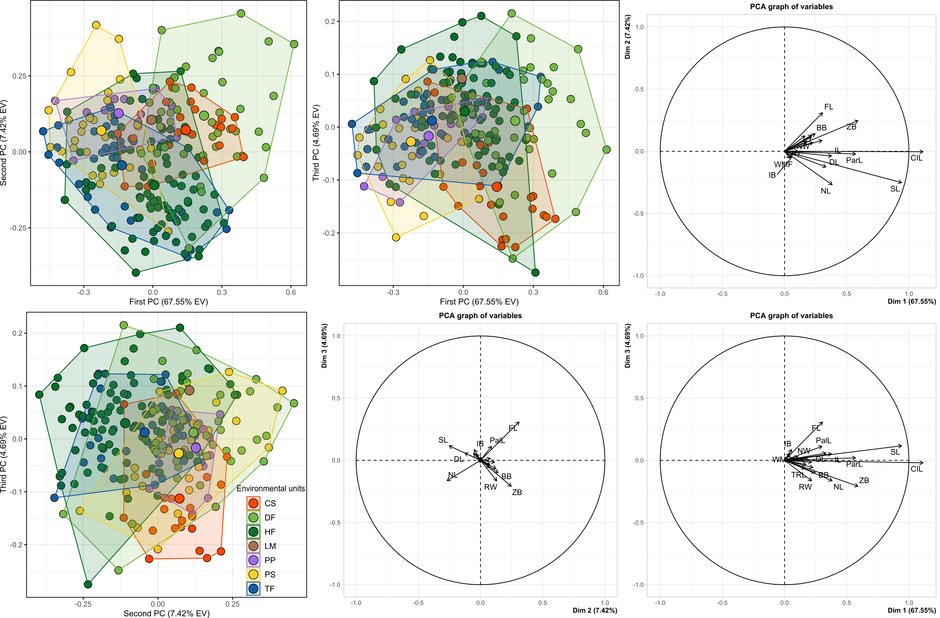

Figure S2. Orthogonal projection of the three first Discriminant Functions (DF), which explain 85.54% of the variance accounted by the DFA, based on the cranial variables considered (see Table S2). Specimens were grouped according to the environmental units to which correspond their sampling locality, and the insular localities from which the nominal forms hershkovitzi, llanoi, and markhami come from (see above). Groups are colored as is depicted in the legend (see also Figure 1). Abbreviations of the environmental units are as follow: CS, Chilean shrubland; DF, dry forest; HF, humid forest; LM, Low monte; PP, Andean steppe or Prepuna; PS, Patagonian steppe; TF, temperate forest. As is depicted in the Figure 1, evaluated insular localities occurred along Temperate forests. Percentages of correct a priori assignation of specimens to each group are as follow: CS = 86.96%; DF = 95.55%; HF = 90.12%; LM = 100%; PP = 92.31%; PS = 83.33%; TF = 73.53%; TF_C. Aracena = 100%; TF_I. Estados = 100%; TF_I. Wellington = 100%.

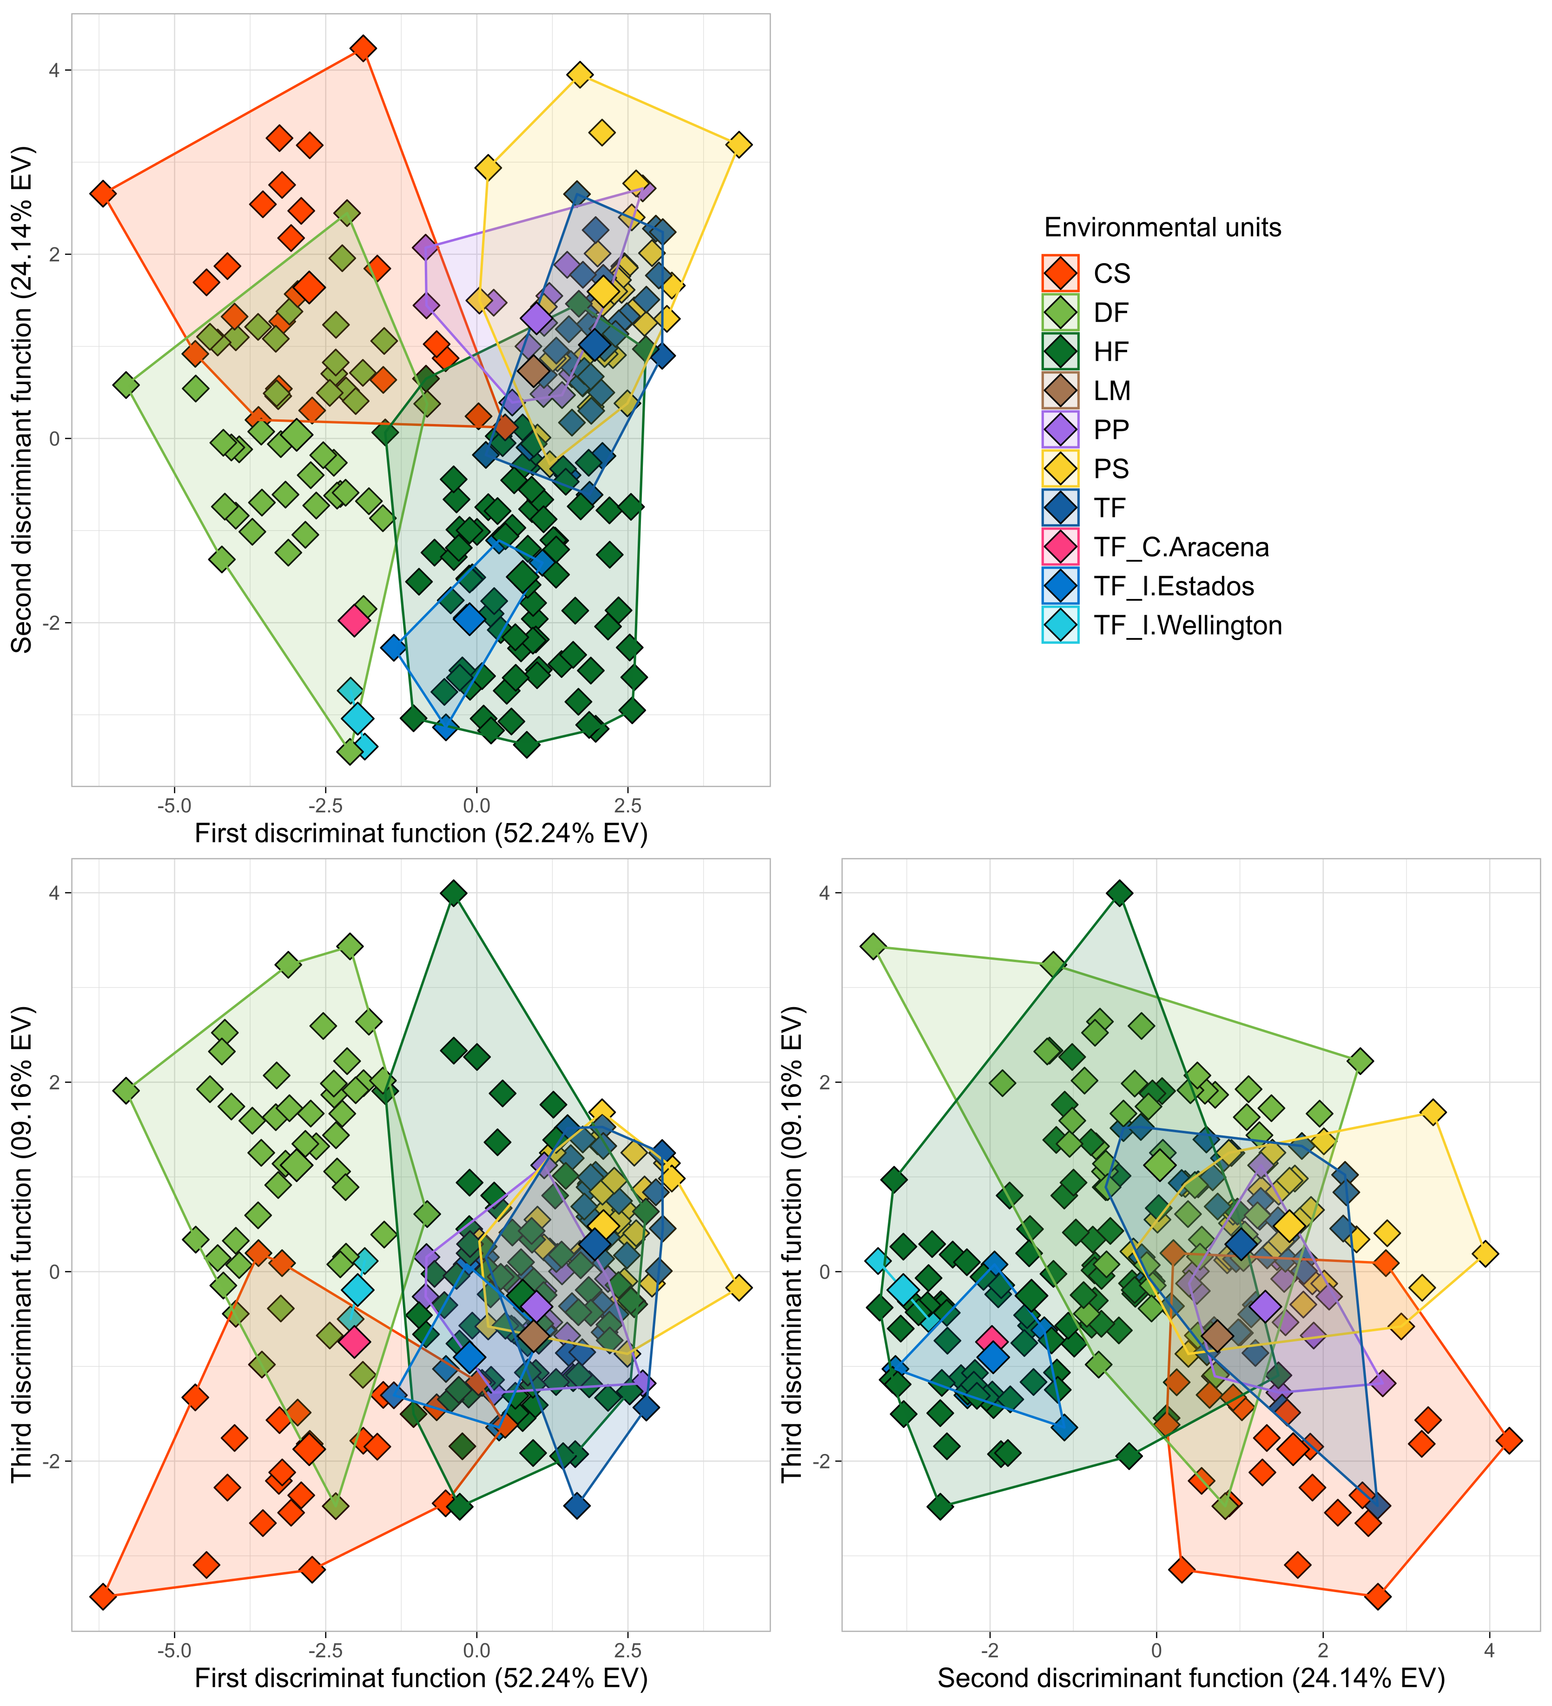

Table S3. Results of linear regression analyses conducted showing associations the scores of cranial variables on PC 1 (summary of cranial size) and PC 2 (summary of cranial shape) alongside to the uncorrelated environmental variables and geospatial variables considered. Patterns of correlation are depicted for the entire dataset of cranial measurements (i.e., at species level) and for those resulting after dividing the morphological dataset according to the environmental units in which the species inhabit (i.e., at population). Coefficients of correlation (r) and their respective p-value is indicated by each associations analyzed. Abbreviations of the environmental units are as follow: CS, Chilean shrubland; DF, dry forest; HF, humid forest; LM, Low monte; PP, Andean steppe or Prepuna; PS, Patagonian steppe; TF, temperate forest. As is depicted in the Figure 1, evaluated insular localities occurred along Temperate forests.

 | At species level |  | At environmental units
 | Abrothrix olivacea |  | CS | DF | HF | PP | PS | TF
PC 1 vs. Environmental and Geospatial variables
Bio 01: Annual Mean Temperature | R = 0.51; p = 0.00 |  | R = 0.26; p = 0.23 | R = 0.13; p = 0.41 | R = 0.52; p = 0.00 | R = -0.05; p = 0.87 | R = -0.26, p = 0.16 | R = -0.37; p = 0.02
Bio 03: Isothermality (BIO2/BIO7) (×100) | R = 0.35; p = 0.00 |  | R = 0.15; p = 0.49 | R = -0.03; p = 0.84 | R = 0.23; p = 0.07 | R = =0.02; p = 0.95 | R = 0.23; p = 0.21 | R = 0.13; p = 0.44
Bio 08: Mean Temperature of Wettest Quarter | R = 0.47; p = 0.00 |  | R = 0.28; p = 0.21 | R = 0.03; p = 0.84 | R = 0.41; p = 0.00 | R = -0.04; p = 0.89 | R = 0.04; p = 0.84 | R = 0.11; p = 0.52
Bio 12: Annual Precipitation | R = 0.21; p = 0.00 |  | R = 0.41; p = 0.06 | R = 0.07; p = 0.63 | R = 0.41; p = 0.00 | R = 0.55; p = 0.05 | R = 0.38; p = 0.04 | R = 0.59; p = 0.00
Bio 15: Precipitation Seasonality (Coefficient of Variation) | R = 0.61; p = 0.00 |  | R = 0.18; p = 0.41 | R = 0.14; p = 0.52 | R = 0.35; p = 0.01 | R = 0.59; p = 0.03 | R = -0.10; p = 0.59 | R = 0.21; p = 0.19
Bio 16: Precipitation of Wettest Quarter | R = 0.33; p = 0.00 |  | R = 0.42; p = 0.06 | R = 0.12; p = 0.51 | R = 0.49; p = 0.00 | R = 0.58; p = 0.04 | R = 0.27; p = 0.15 | R = 0.61; p = 0.00
Humidity | R = 0.06; p = 0.33 |  | R = 0.39; p = 0.05 | R = 0.03; p = 0.82 | R = 0.22; p = 0.04 | R = 0.04; p = 0.89 | R = 0.43; p = 0.02 | R = 0.66; p = 0.00
Evapotranspiration | R = 0.09; p = 0.14 |  | R = -0.44; p = 0.35 | R = -0.01; p = 0.94 | R = -0.07; p = 0.53 | R = 0.01; p = 0.98 | R = -0.07; p = 0.72 | R = -0.31; p = 0.06
Primary productivity | R = 0.38; p = 0.00 |  | R = 0.38; p = 0.07 | R = 0.06; p = 0.67 | R = 0.11; p = 0.33 | R = -0.53; p = 0.06 | R = 0.24; p = 0.21 | R = 0.06; p = 0.71
Elevation | R = -0.10; p = 0.13 |  | R = -0.33; p = 0.13 | R = -0.11; p = 0.48 | R = -0.38; p = 0.00 | R = 0.03; p = 0.92 | R = 0.28; p = 0.13 | R = 0.53; p = 0.00
Latitude | R = 0.51; p = 0.00 |  | R = -0.44; p = 0.04 | R = 0.04; p = 0.78 | R = 0.44; p = 0.00 | R = -0.21; p = 0.48 | R = 0.05; p = 0.81 | R = 0.44; p = 0.00
Longitude | R = -0.41; p = 0.00 |  | R = -0.43; p = 0.04 | R = 0.24; p = 0.12 | R = -0.24; p = 0.07 | R = -0.28; p = 0.35 | R = 0.17; p = 0.36 | R = -0.10; p = 0.58
PC 2 vs. Environmental and Geospatial variables
Bio 01: Annual Mean Temperature | R = 0.17; p = 0.00 |  | R = 0.09; p = 0.66 | R = 0.11; p = 0.46 | R = -0.19; p = 0.08 | R = -0.15; p = 0.62 | R = 0.34; p = 0.07 | R = 0.06; p = 0.71
Bio 03: Isothermality (BIO2/BIO7) (×100) | R = 0.34; p = 0.00 |  | R = 0.15; p = 0.48 | R = -0.22; p = 0.14 | R = 0.45; p = 0.00 | R = 0.07; p = 0.82 | R = -0.45; p = 0.01 | R = -0.12; p = 0.46
Bio 08: Mean Temperature of Wettest Quarter | R = 0.00; p = 0.92 |  | R = 0.11; p = 0.63 | R = 0.08; p = 0.59 | R = -0.36; p = 0.00 | R = -0.15; p = 0.63 | R = 0.48; p = 0.00 | R = -0.32; p = 0.05
Bio 12: Annual Precipitation | R = -0.47; p = 0.00 |  | R = 0.25; p = 0.25 | R = 0.21; p = 0.19 | R = -0.08; p = 0.46 | R = -0.3; p = 0.33 | R = -0.33; p = 0.07 | R = -0.39; p = 0.01
Bio 15: Precipitation Seasonality (Coefficient of Variation) | R = 0.31; p = 0.00 |  | R = 0.04; p = 0.85 | R = -0.06; p = 0.67 | R = 0.13; p = 0.23 | R = -0.24; p = 0.44 | R = -0.08; p = 0.65 | R = -0.45; p = 0.04
Bio 16: Precipitation of Wettest Quarter | R = -0.37; p = 0.00 |  | R = 0.25; p = 0.25 | R = 0.25; p = 0.10 | R = 0.00; p = 0.99 | R = -0.29; p = 0.34 | R = -0.37; p = 0.04 | R = -0.42; p = 0.00
Humidity | R = -0.42; p = 0.00 |  | R = 0.25; p = 0.25 | R = 0.14; p = 0.35 | R = -0.01; p = 0.90 | R = 0.16; p = 0.62 | R = -0.32; p = 0.09 | R = -0.34; p = 0.03
Evapotranspiration | R = 0.51; p = 0.00 |  | R = -0.25; p = 0.26 | R = -0.25; p = 0.10 | R = 0.51; p = 0.00 | R = -0.12; p = 0.69 | R = 0.22; p = 0.29 | R = 0.05; p = 0.74
Primary productivity | R = -0.16; p = 0.02 |  | R = 0.24; p = 0.27 | R = 0.25; p = 0.09 | R = 0.24; p = 0.03 | R = -0.06; p = 0.82 | R = 0.38; p = 0.039 | R = -0.36; p = 0.02
Elevation | R = 0.22; p = 0.00 |  | R = -0.14; p = 0.51 | R = -0.24; p = 0.11 | R = 0.40; p = 0.00 | R = 0.17; p = 0.57 | R = -0.37; p = 0.04 | R = -0.08; p = 0.59
Latitude | R = 0.26; p = 0.00 |  | R = -0.27; p = 0.21 | R = -0.17; p = 0.27 | R = 0.16; p = 0.14 | R = 0.39; p = 0.10 | R = -0.22; p = 0.24 | R = -0.26; p = 0.11
Longitude | R = 0.25; p = 0.00 |  | R = -0.22; p = 0.31 | R = -0.049; p = 0.75 | R = 0.53; p = 0.00 | R = 0.41; p = 0.16 | R = 0.21; p = 0.28 | R = -0.14; p = 0.38

Figure S3. Associations of the first Principal Component with environmental and geospatial variables. Linear regression analysis shows the association scores of cranial variables on PC 1 (summary of cranial size) alongside to the uncorrelated environmental variables and geospatial variables considered. Correlation coefficients (R) and associated p-values are shown for each analysis.

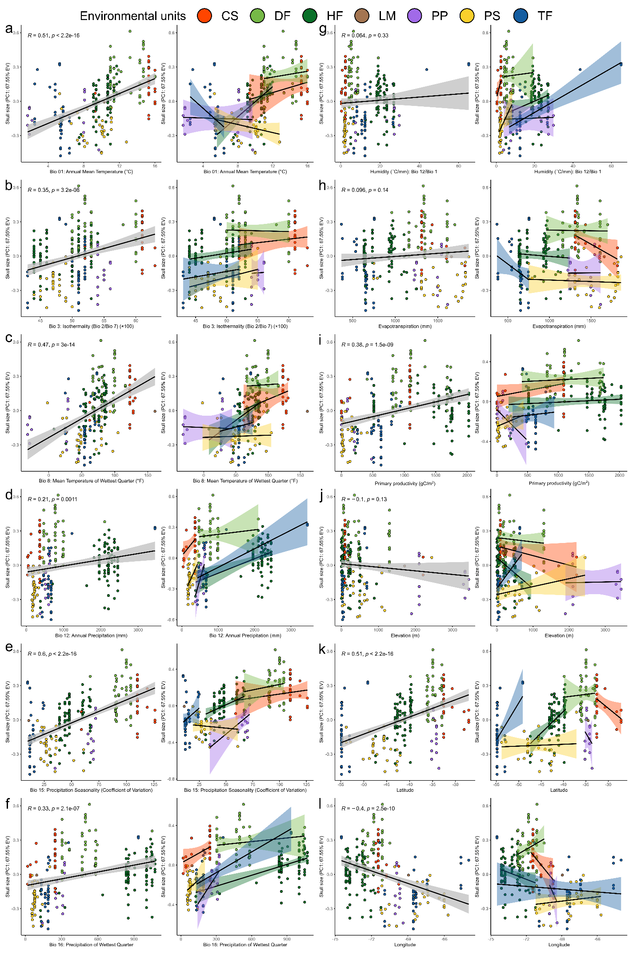
Figure S4. Associations of the second principal component with environmental and geospatial variables. Linear regression analysis shows association scores of cranial variables on PC 2 (summary of cranial shape) alongside to the uncorrelated environmental variables and geospatial variables considered. Correlation coefficients (R) and associated p-values are shown for each analysis.

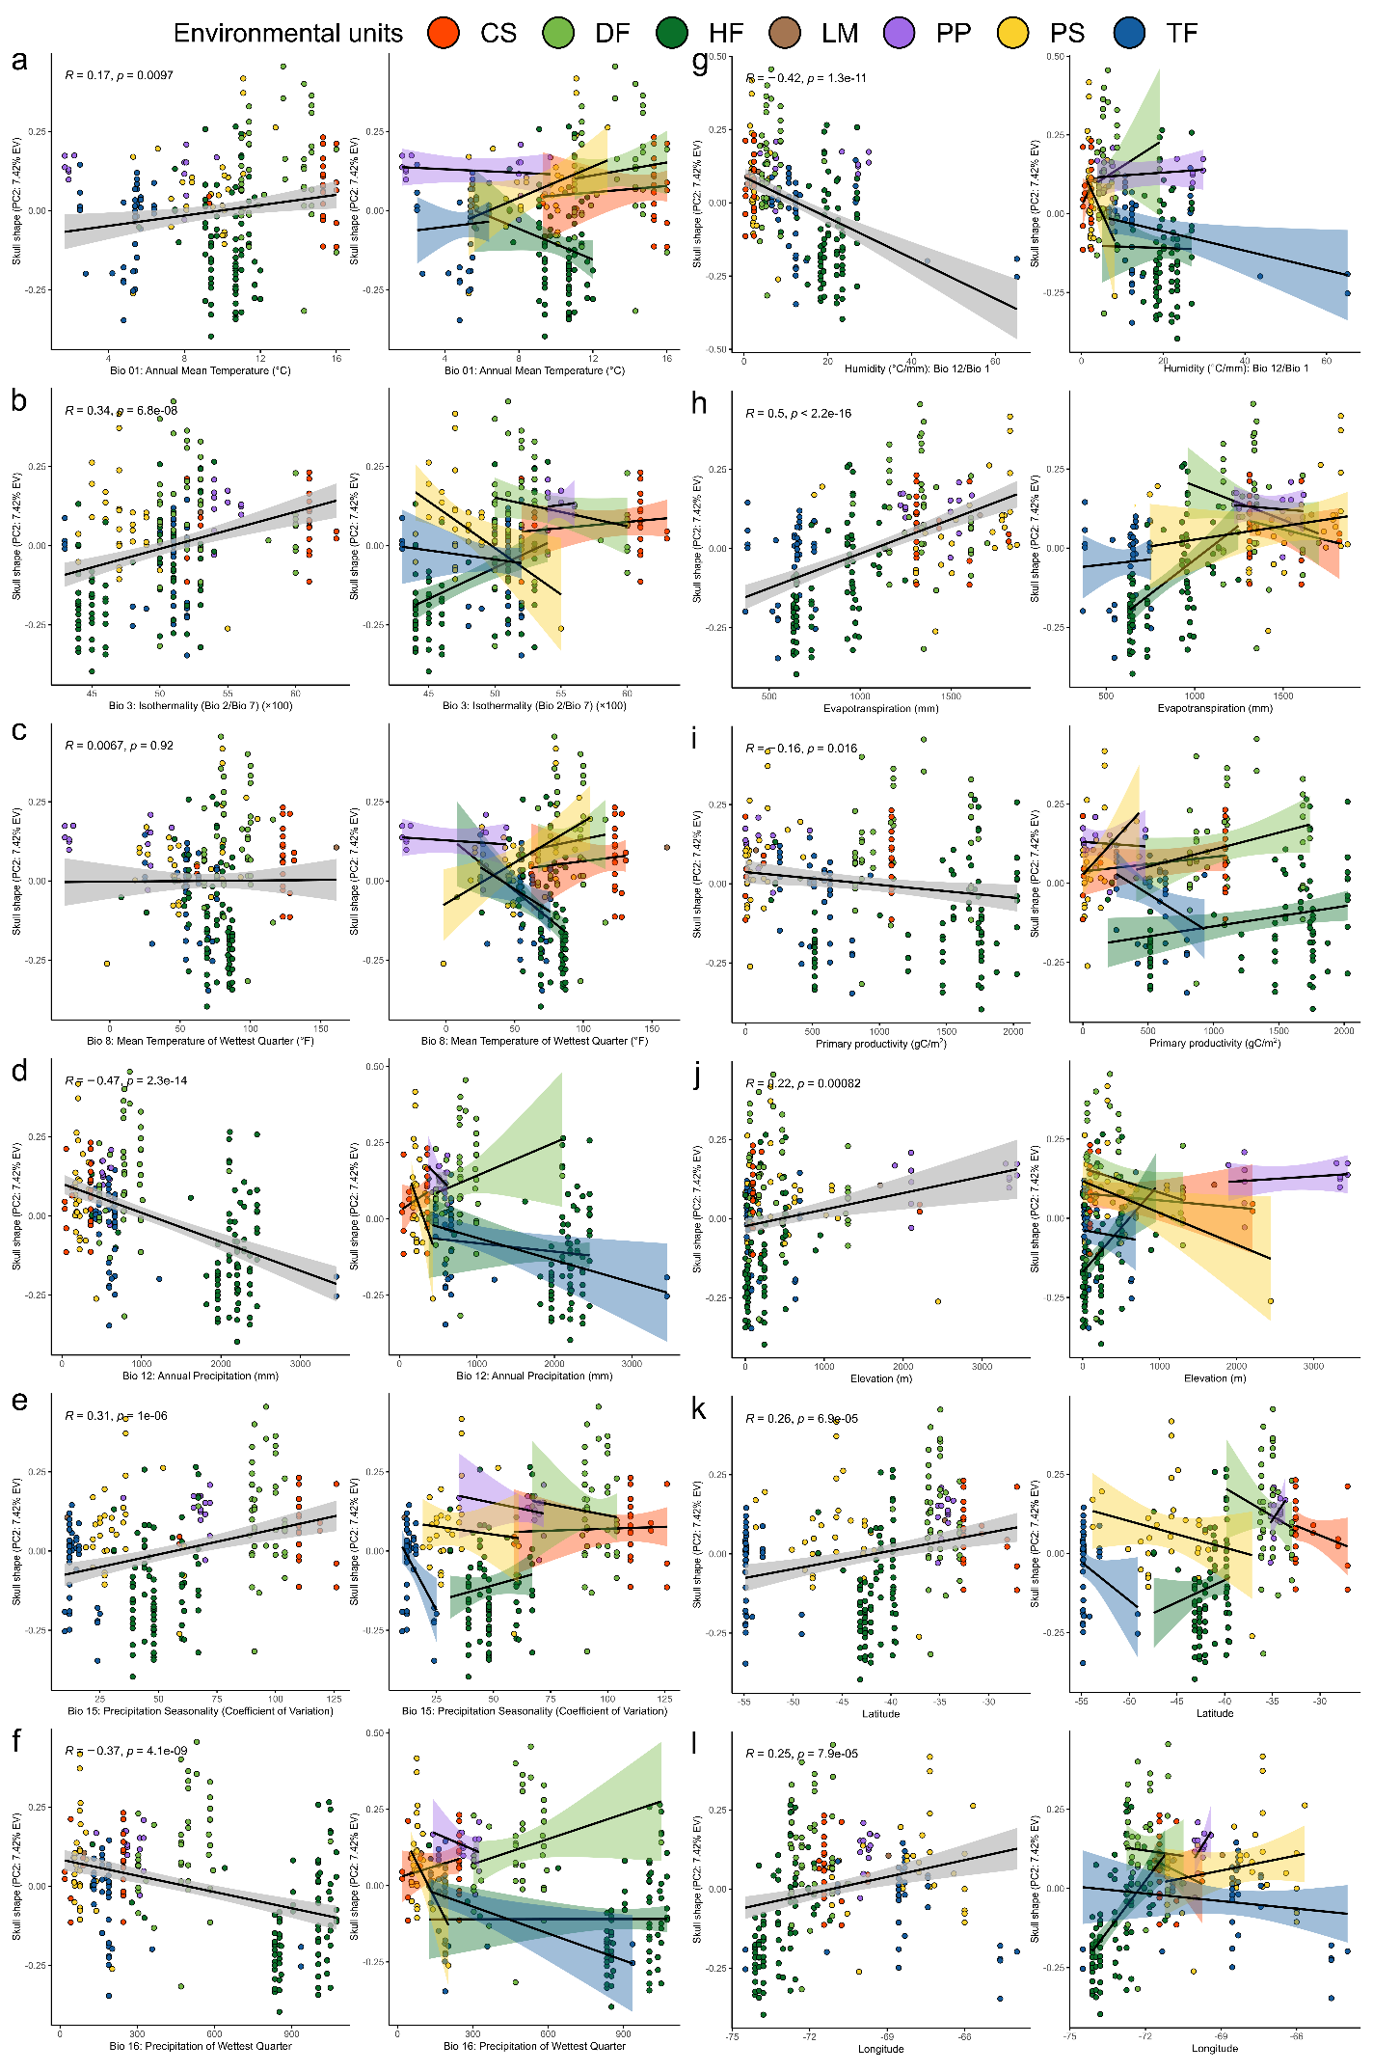
Figure S5. Results of Mantel tests performed to explore associations between genetic (proxy of neutral differentiation) and Euclidean morphological distances calculate between pairs of a reduce set of 29 localities with mitochondrial and morphological data available. The results are based on Tajima-Nei distance and Tamura-Nei distance. Spearman correlation coefficients (R) and associated p-values are shown for each Mantel test implementation. According to Bacigalupe et al. (2008), a pattern of positive correlation between morphological and neutral genetic distances indicates that genetic drift is likely responsible for the morphological differentiation of populations. In this case, there is not a positive correlation between the levels of neutral genetic and morphological differentiation among populations. Therefore, the role of genetic drift in the process of morphological differentiation of the populations considered can be ruled out. Given the limited geographic coverage that founded these analyses, the pattern evidenced by these results cannot be generalized to the entire geographic distribution of Abrothrix olivacea. Moreover, its generalization to the entire Patagonian region could be premature, due to the representative limitations associated to the dataset used (Bacigalupe, personal communication).

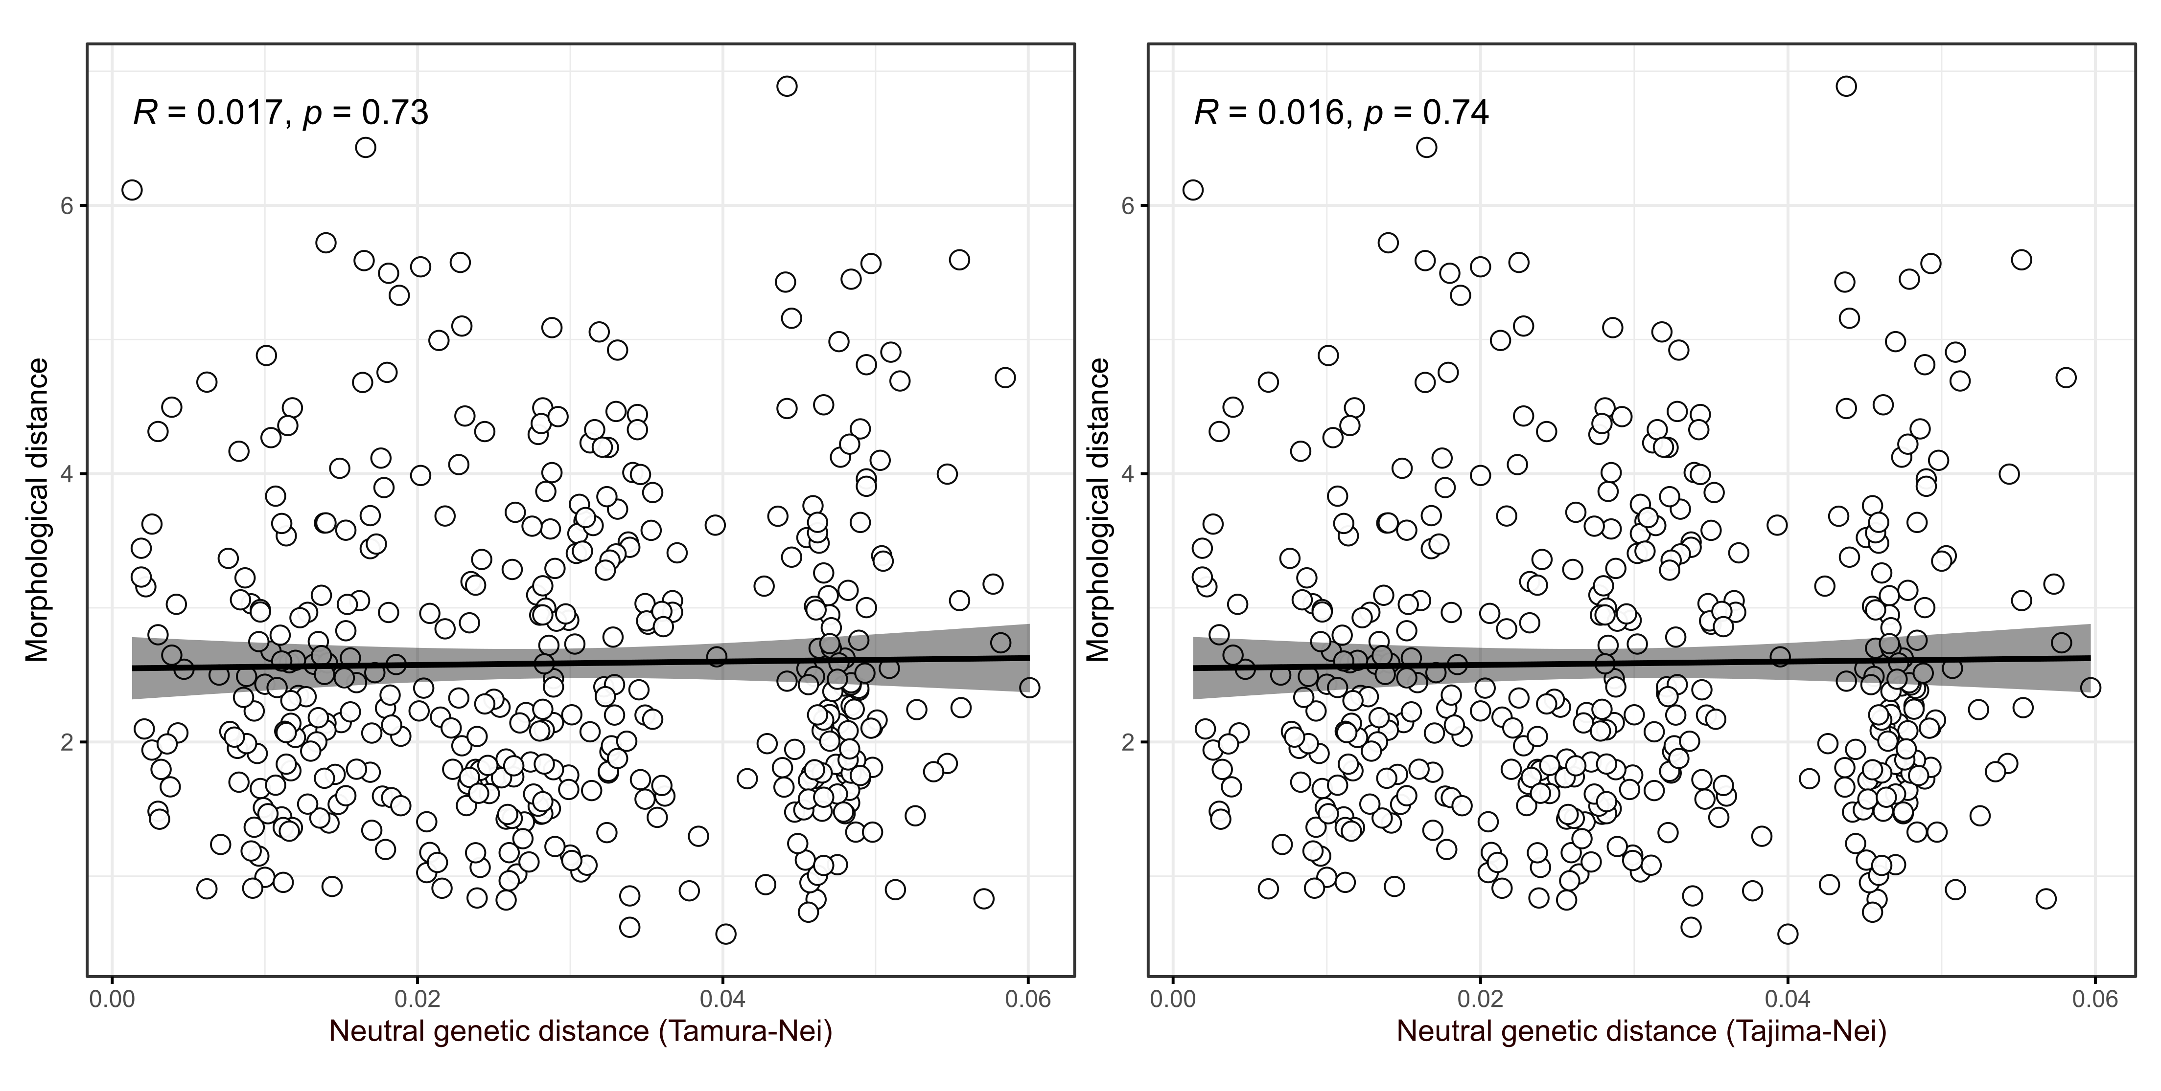

Figure S6. Cranial size variation within and among populations of Abrothrix olivacea. Plots show individual scores for the first principal component (upper panel) and size index estimated from the geometric means of the cranial measurements considered (lower panel). Population samples are colored according to environmental units (see Figure 1: CS, Chilean shrubland; DF, dry forest; HF, humid forest; LM, Low monte; PP, Andean steppe/Prepuna; PS, Patagonian steppe; TF, temperate forest); samples from insular regions are individualized (e.g., Capitán Aracena, C.Aracena; Chiloé, Chiloe.I; los Estados, I.Estados; Tierra del Fuego, T.Fuego; Wellington, I.Wellington). Codification of each population is in the legend.

