Test Instrument Permissions

* CCNES

The use is in accordance with a published license: [Coping with Children's Negative Emotions Scale (ccnes.org)](https://ccnes.org/)

* TCI-R

Prof. Zohar is the Israeli developer of the TCI-R and Prof. Cloninger has attached is consent.

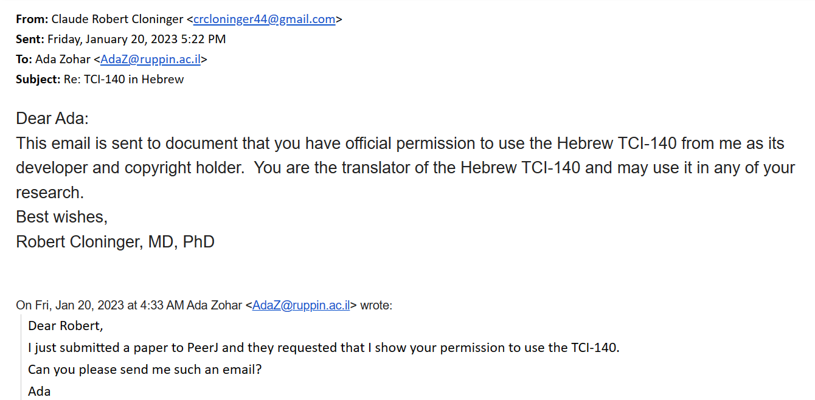

* SDQ

The use is in accordance with a published license: [The strengths and difficulties questionnaire (SDQ): Mentally Healthy Schools](https://mentallyhealthyschools.org.uk/resources/the-strengths-and-difficulties-questionnaire-sdq/)