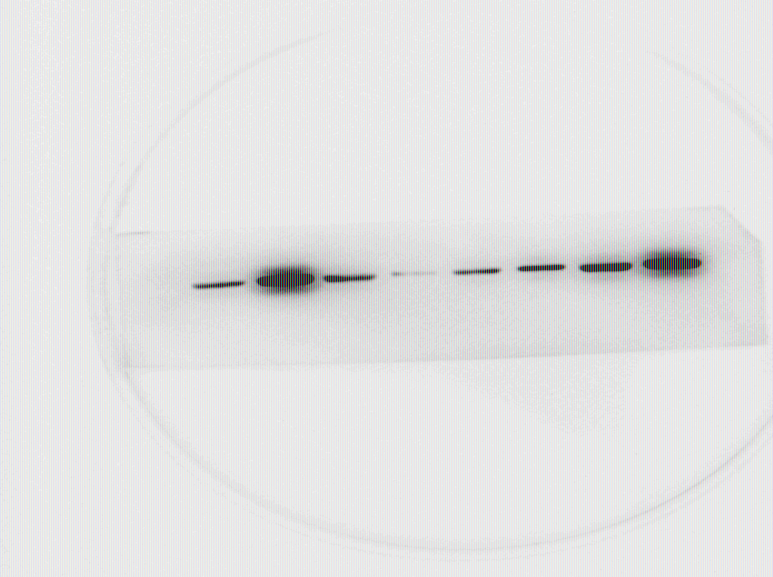
Sv-huc-1 T24 EJ 5637 BIU87
Western blot detection of AKAP7 protein expression level in Sv-huc-1, T24, EJ, 5637, BIU87 cells
Sv-huc-1 T24 EJ 5637 BIU87
Western blot detection of GAPDH protein expression level in Sv-huc-1, T24, EJ, 5637, BIU87 cells

NC OE1 OE2 OE3
The expression level of AKAP7 protein in EJ cells was detected by WB after overexpression
NC OE1 OE2 OE3
The expression level of GAPDH protein in EJ cells was detected by WB after overexpression

T24NC sh1 sh2 sh3 NC sh1 sh2 sh3
The expression level of AKAP7 protein in T24 cells was detected by WB after knockdown
T24NC sh1 sh2 sh3 NC sh1 sh2 sh3
The expression level of GAPDH protein in T24 cells was detected by WB after knockdown

