Original Western Blot Images

A wild rice-derived peptide R14 ameliorates monosodium urate crystals-induced IL-1β secretion through inhibition of NF-κB signaling and NLRP3 inflammasome activation

Supattra Charoenwutthikun¹, Kasem Chanjitwiriya¹, Sittiruk Roytrakul² and Duangkamol Kunthalert^{1, 3}*

¹ Department of Microbiology and Parasitology, Faculty of Medical Science, Naresuan University, Phitsanulok, Thailand
² National Center for Genetic Engineering and Biotechnology, National Science and Technology Development Agency, Thailand Science Park, Pathumthani, Thailand
³ Centre of Excellence in Medical Biotechnology, Faculty of Medical Science, Naresuan University, Phitsanulok, Thailand

Corresponding author:
Duangkamol Kunthalert

Email address: duangkamolk@nu.ac.th, kunthalertd@yahoo.com

Figure 3
Proteins from supernatant
Caspase-1 | A: Exposure time 1/100 sec | B: Exposure time 600 sec
Exp.1 | 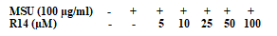  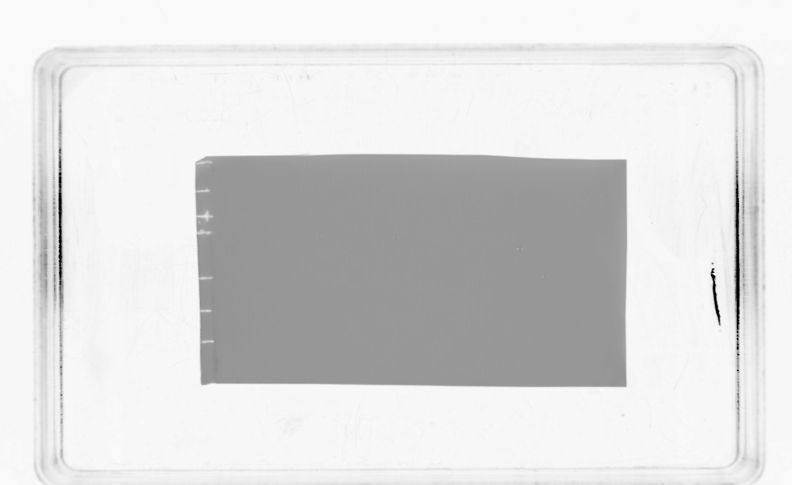  15  75  50  37  25  10  100 | 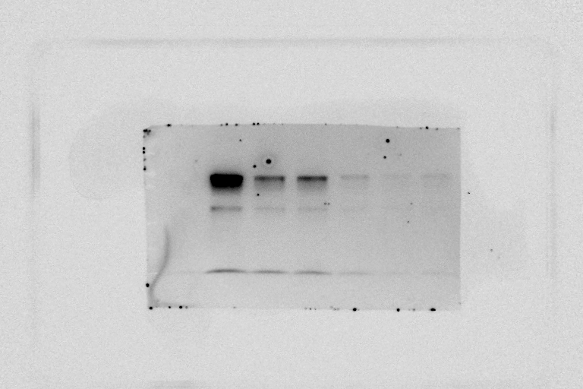  Pro-caspase-1  Intermediate  Caspase-1  50  37  25  10  100  15  75
Exp.2 | 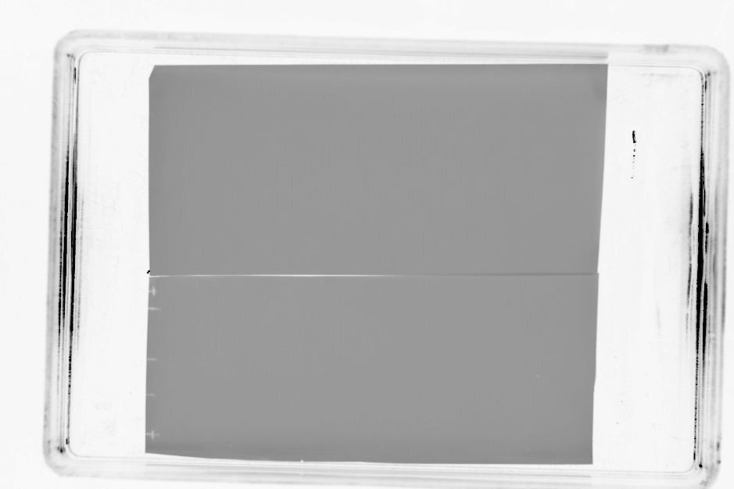  50  37  25  10  15 | 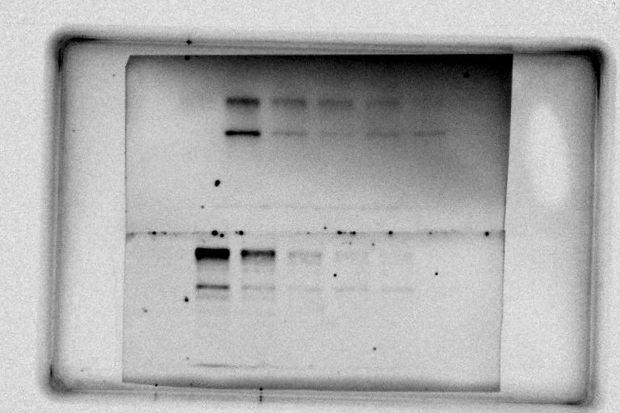  Pro-caspase-1  50  37  25  10  Intermediate  Caspase-1  15
Exp.3 | 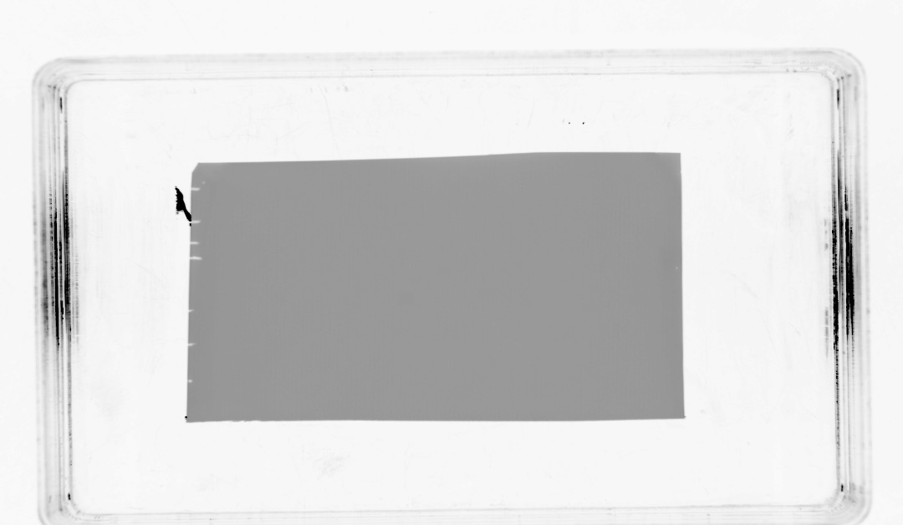  50  37  25  10  100  15  75 | 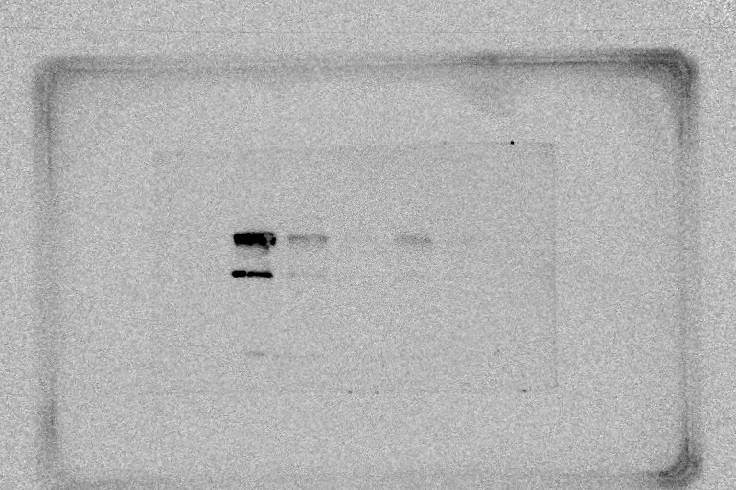  Caspase-1  Intermediate  Pro-caspase-1  50  37  25  10  100  75  15

IL-1β | A: Exposure time 1/100 sec | B: Exposure time 600 sec
Exp.1 | 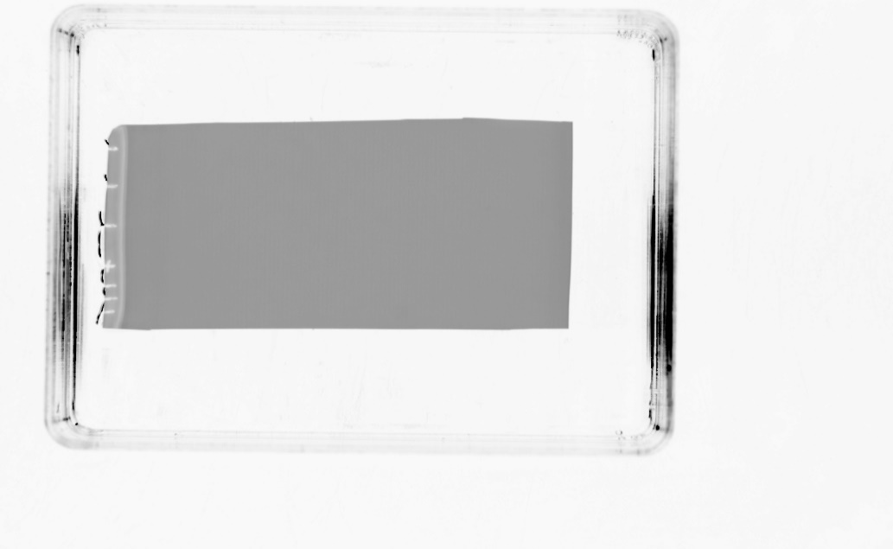  17  20  25  35  48  11 | 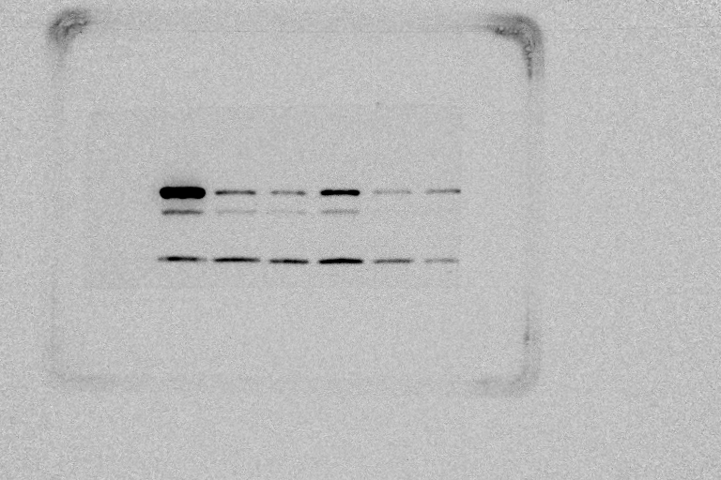  11  17  20  25  35  48  IL-1β  Pro-IL-1β
Exp.2 | 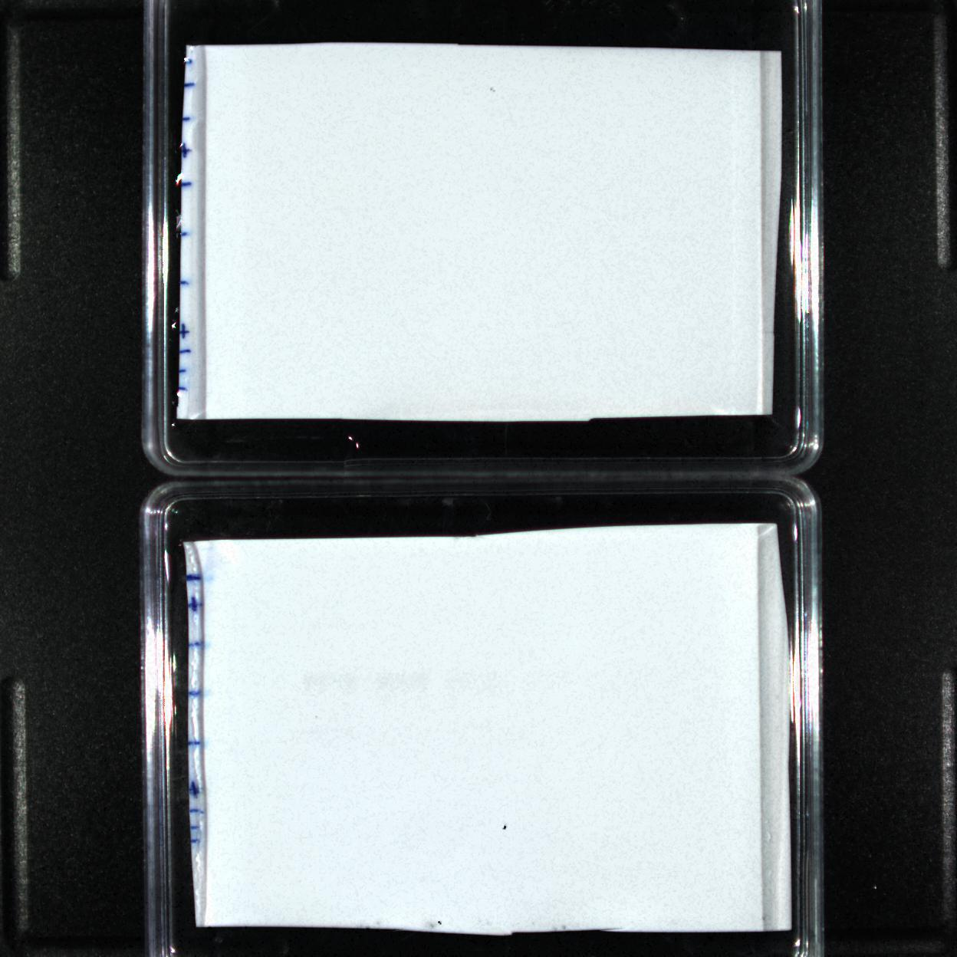  17  20  25  35  48 | 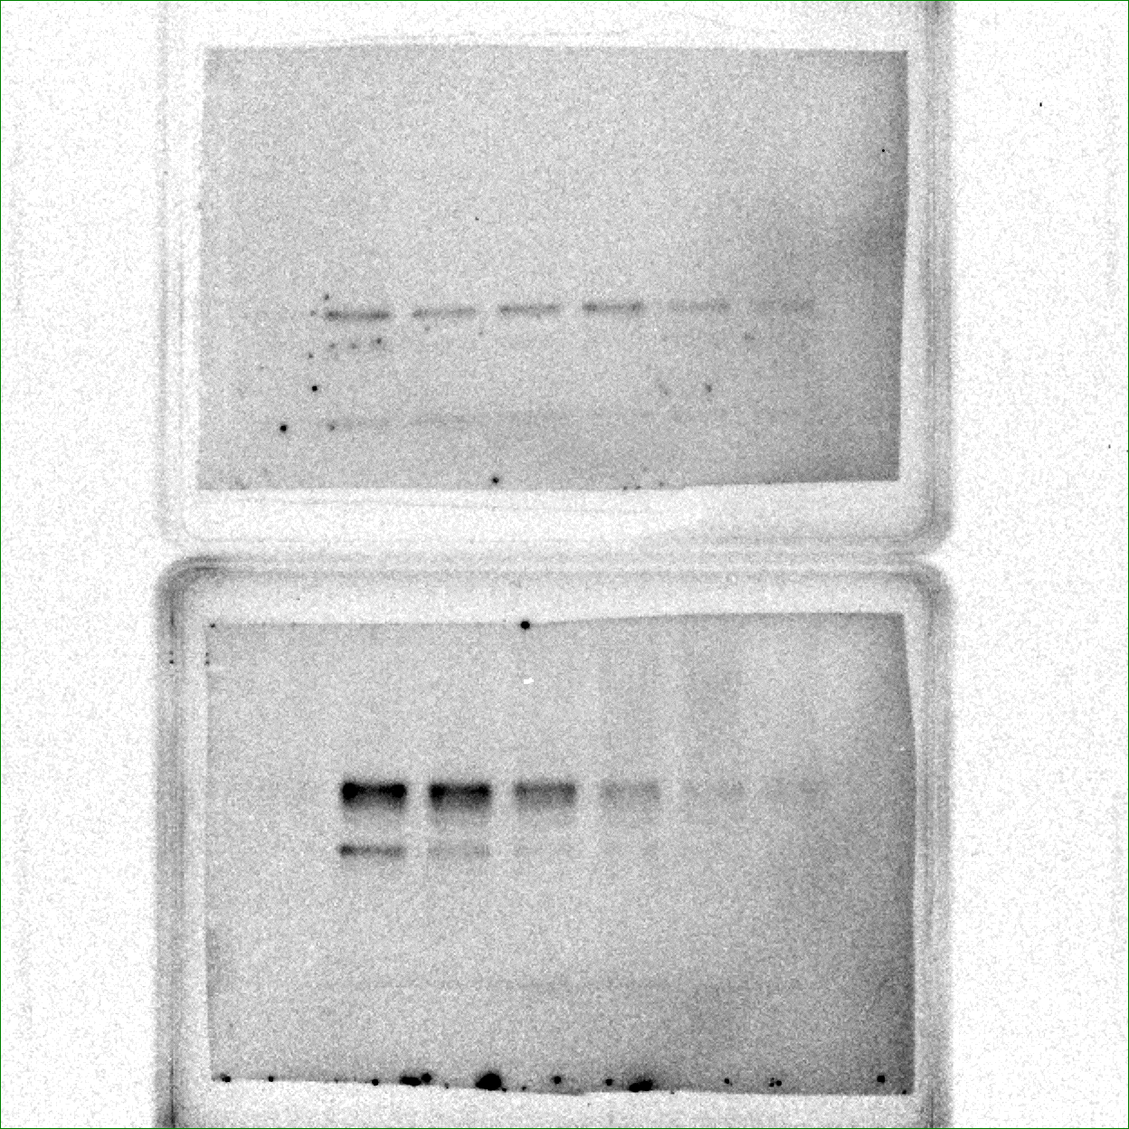  17  20  25  35  48  IL-1β  Pro-IL-1β
Exp.3 | 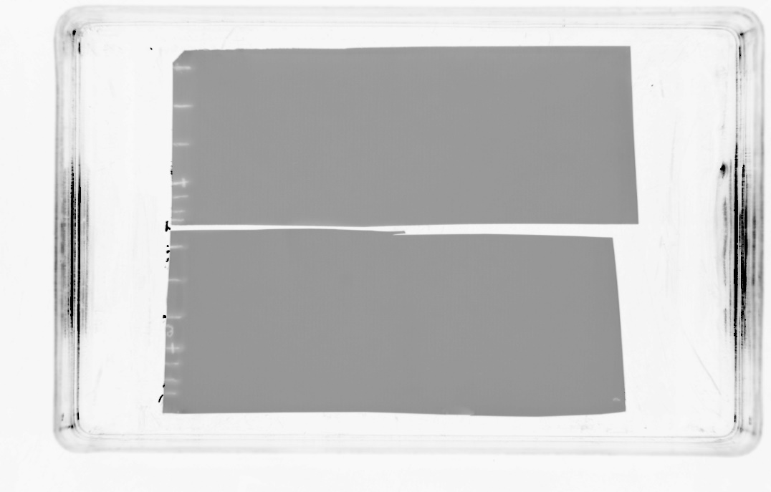  17  20  25  35  48  11  11 | 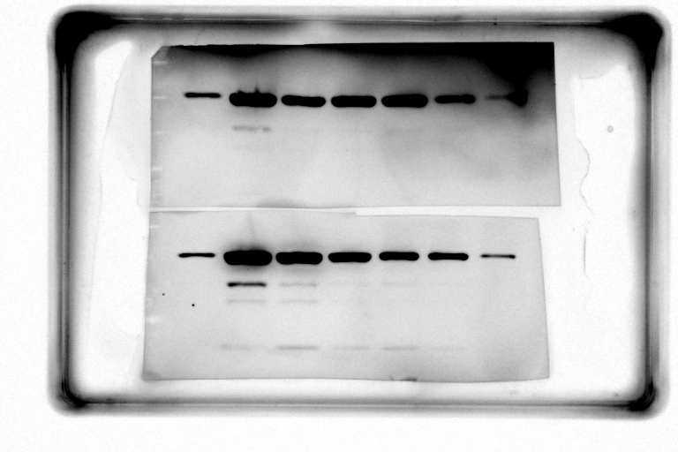  IL-1β  Pro-IL-1β  17  20  25  35  48  11  11

β-actin | A: Exposure time 1/100 sec | B: Exposure time 20 sec
Exp.1 | 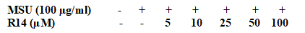  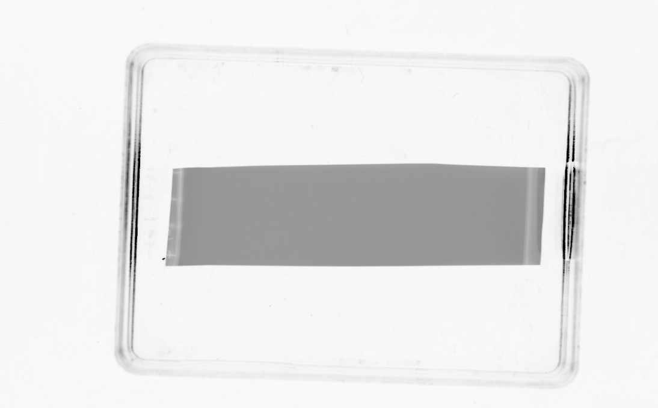  63  48  35  25 | 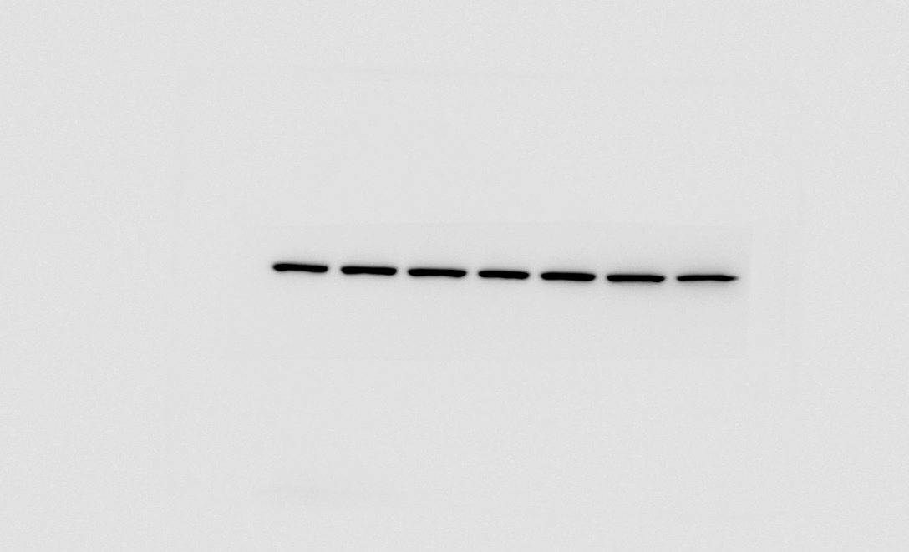  β-actin  63  48  35  25
Exp.2 | 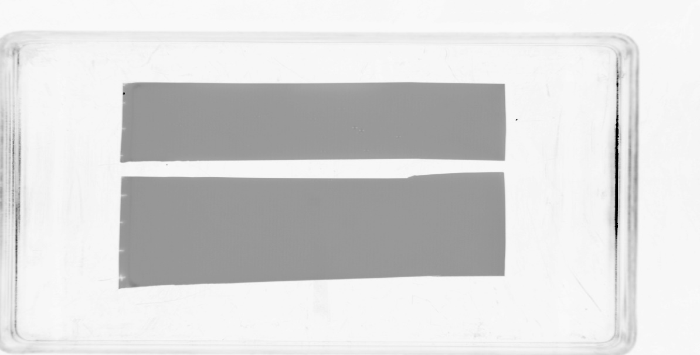  63  48  35  25 | 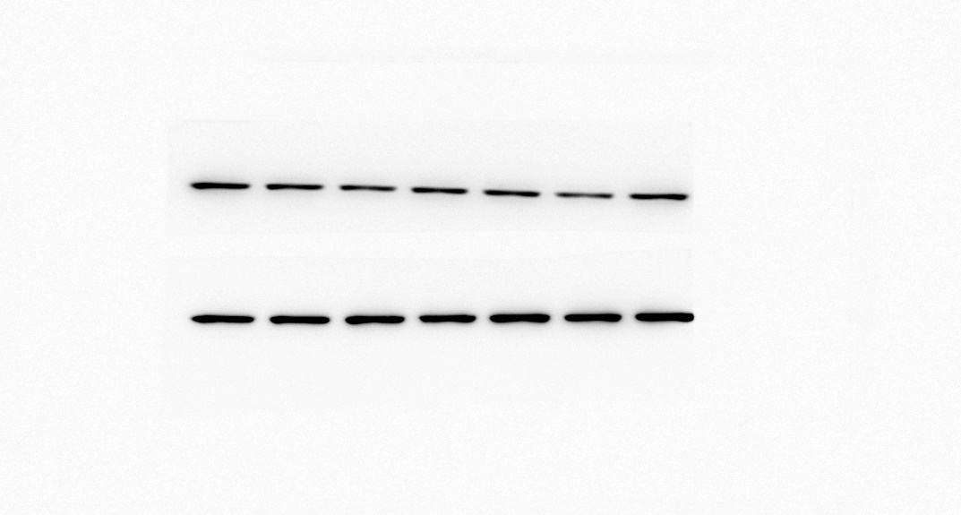  β-actin  63  48  35  25
Exp.3 | 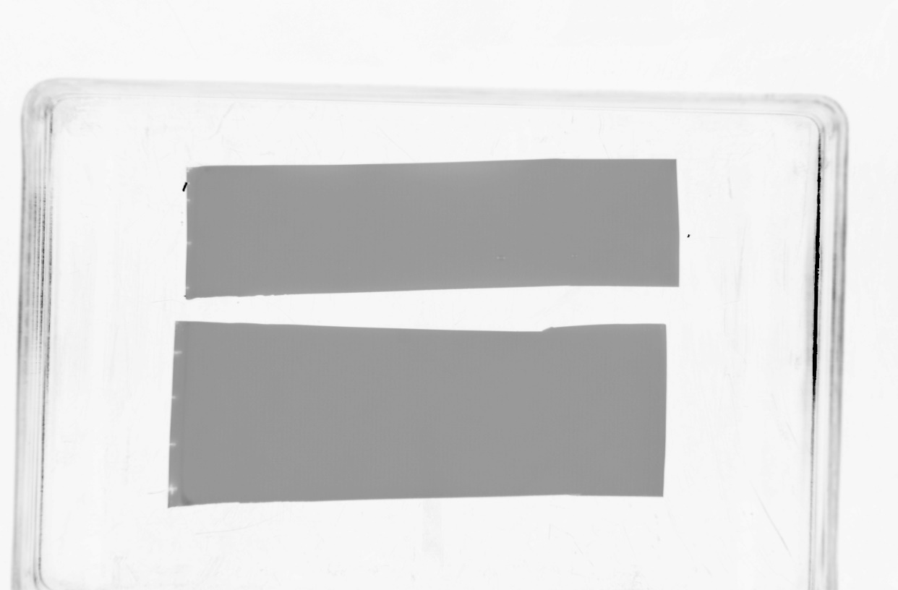  63  48  35  25 | 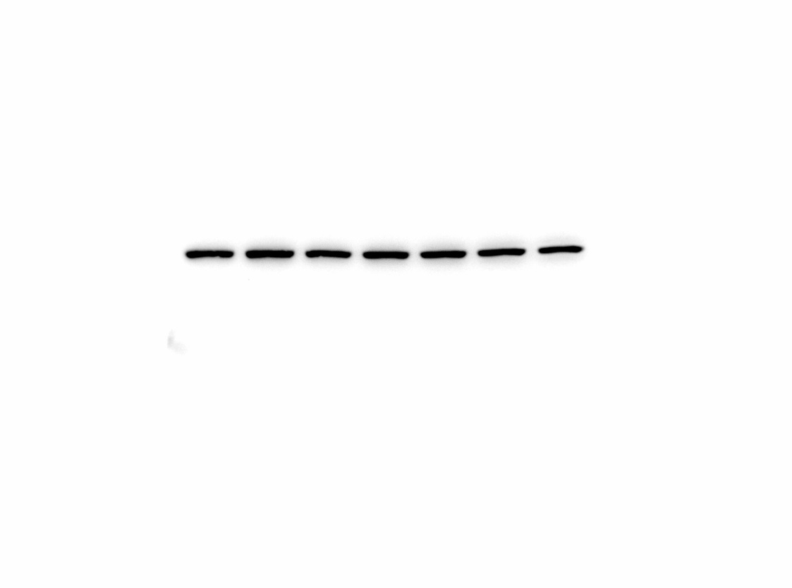  63  48  35  25  β-actin

Proteins from cell lysates

NLRP3 | A: Exposure time 1/100 sec | B: Exposure time 100 sec
Exp.1 | 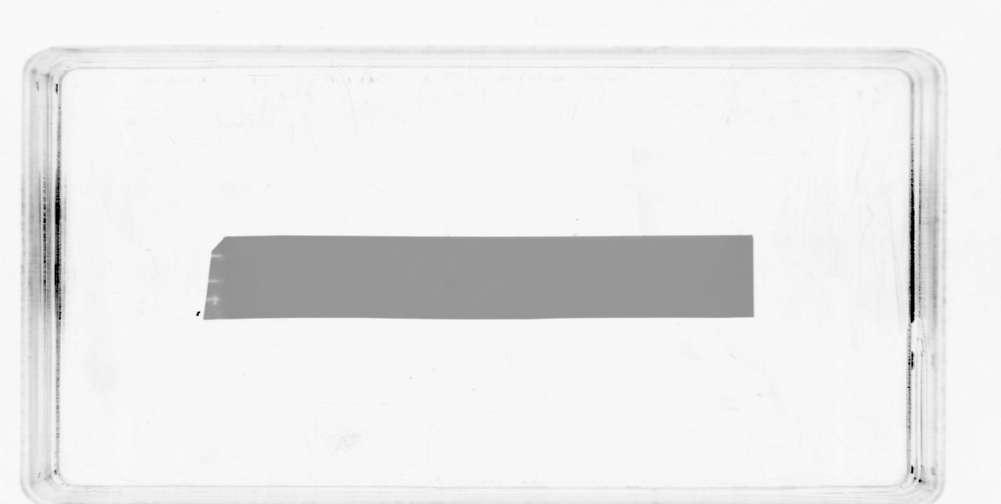  135  100  75 | 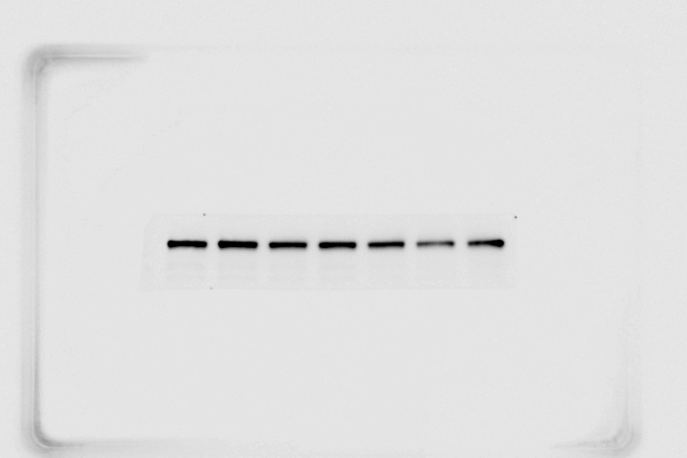  135  100  75  NLRP3
Exp.2 | 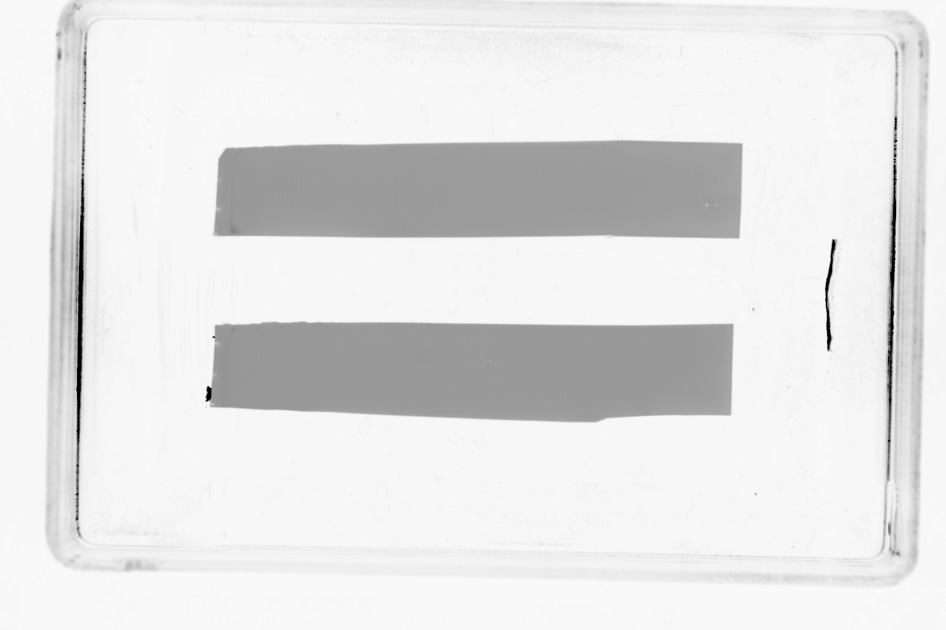  135  100  75 | 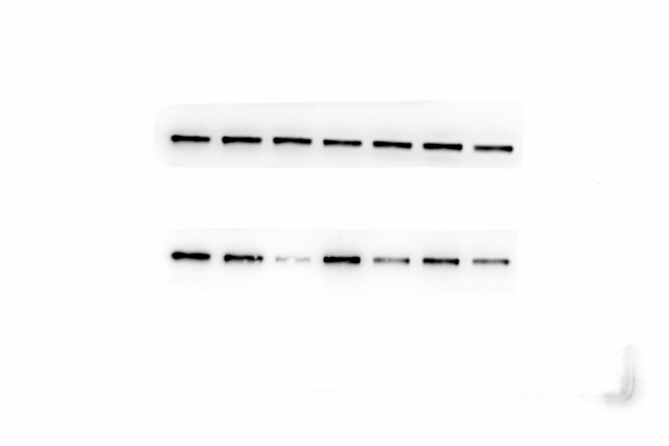  NLRP3  135  100  75
Exp.3 | 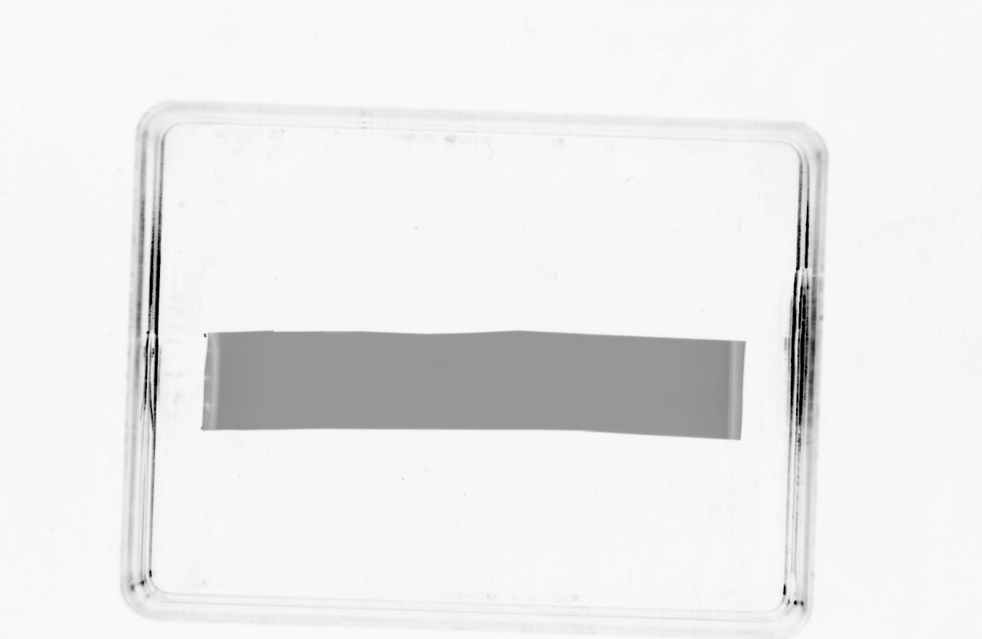  135  100  75 | 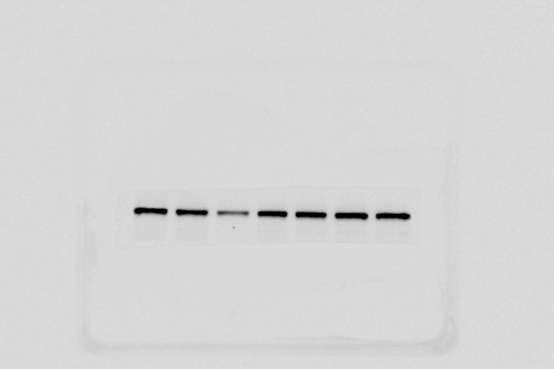  NLRP3  135  100  75

β-actin | A: Exposure time 1/100 sec | B: Exposure time 20 sec
Exp.1 | 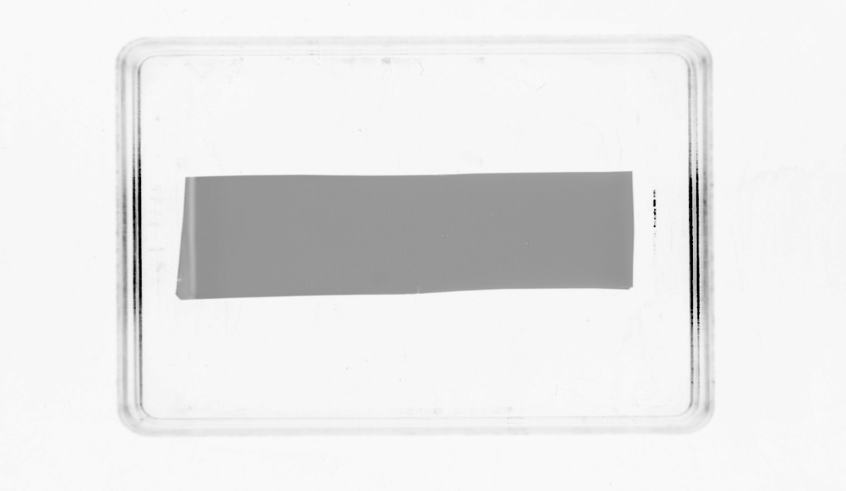  63  48  35  25 | 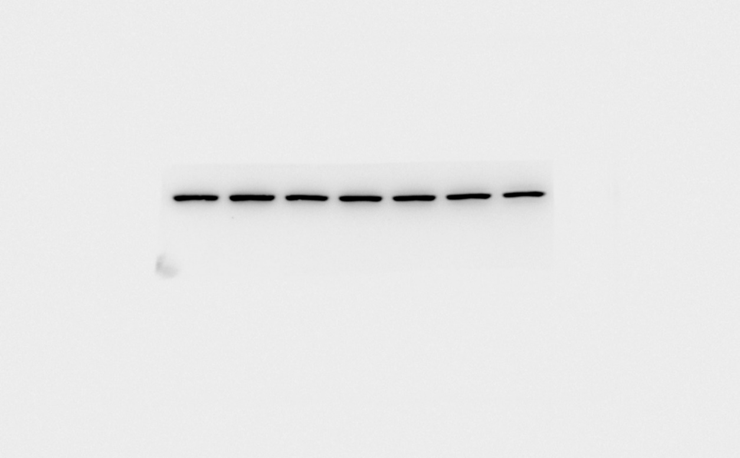  63  48  35  25  β-actin
Exp.2 | 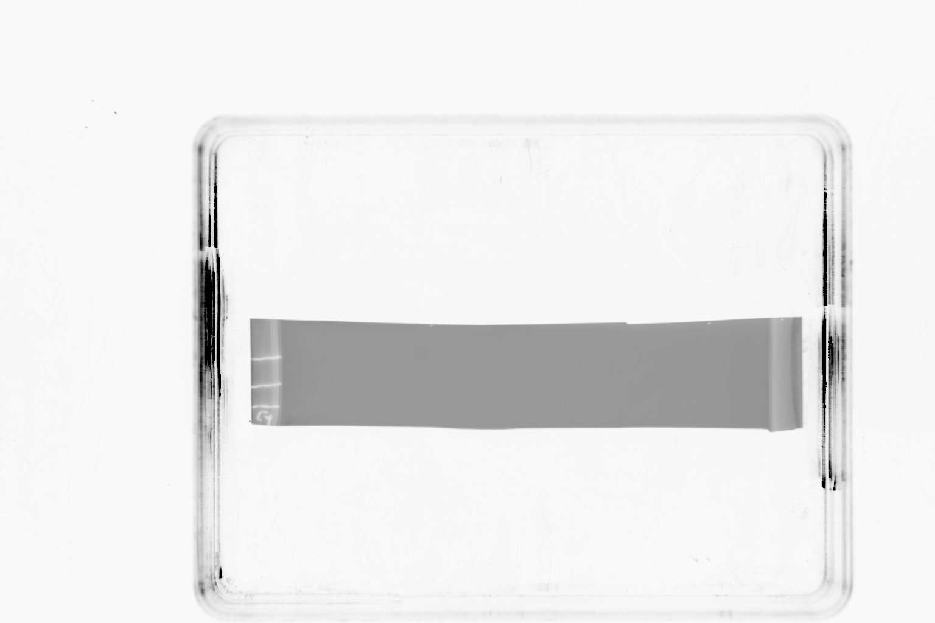  48  35  63  25 | 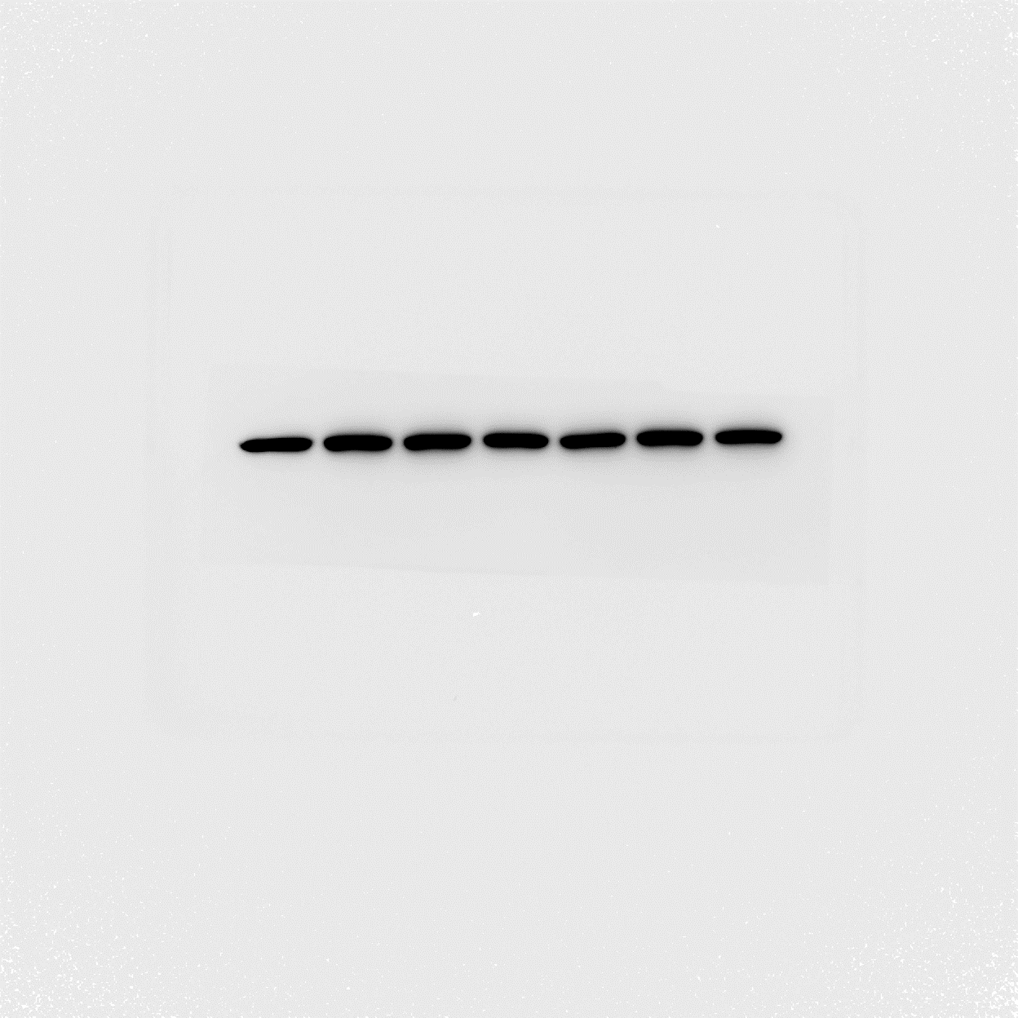  48  35  63  25  β-actin
Exp.3 | 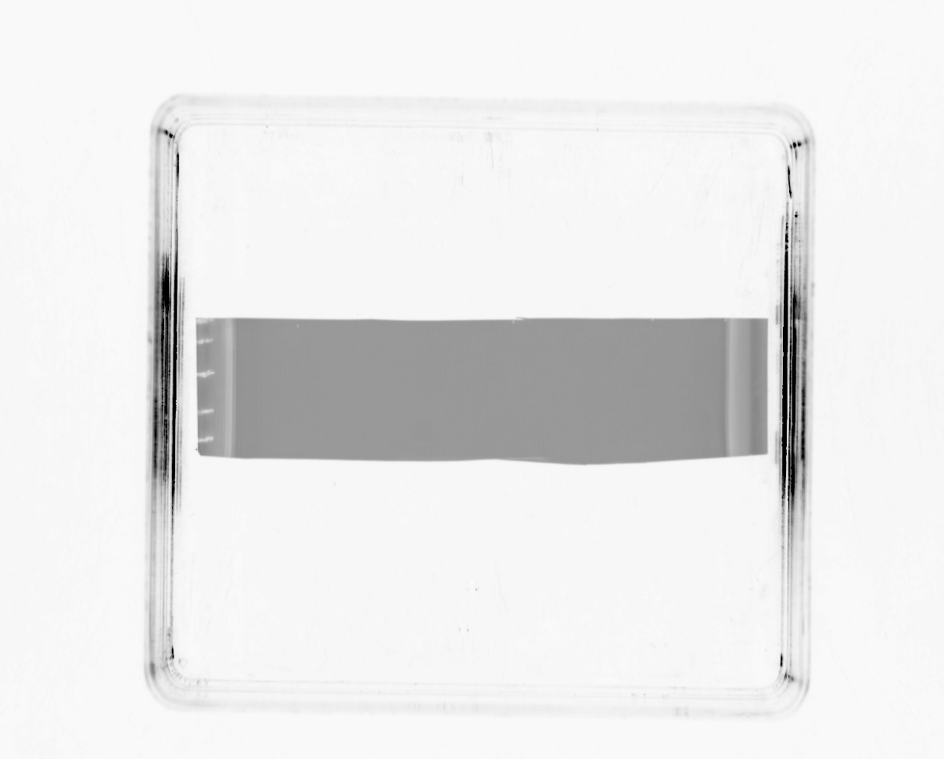  17  20  48  35  25 | 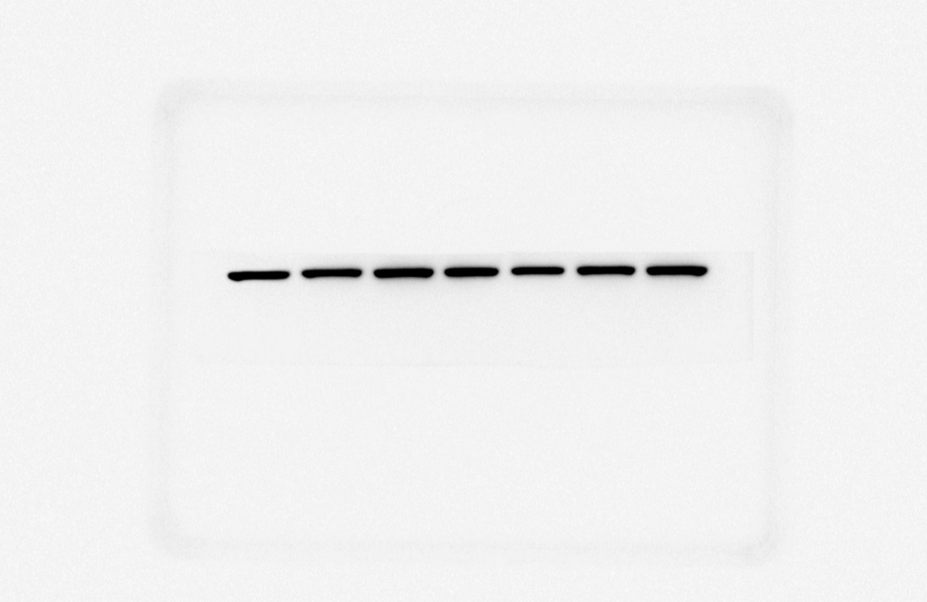  17  20  48  35  25  β-actin

Figure 4
Proteins from Nuclear extraction
48
NF-κB p65 | A: Exposure time 1/100 sec | B: Exposure time 240 sec
Exp.1  48  75  63 | 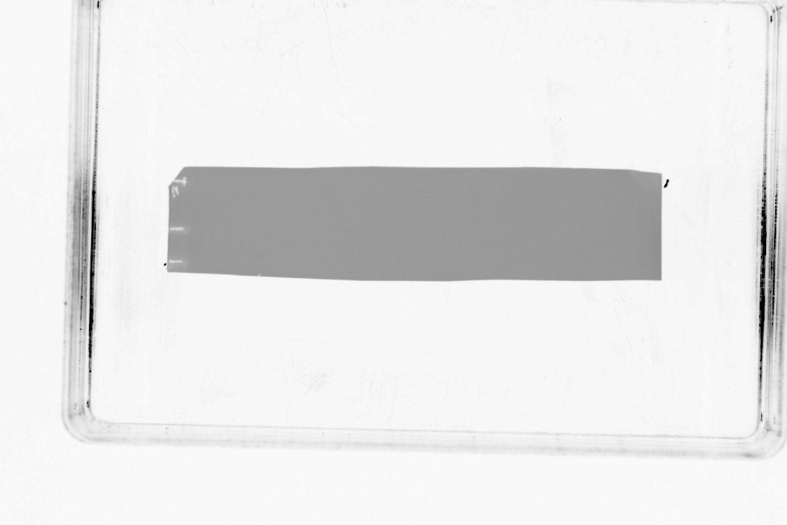 | 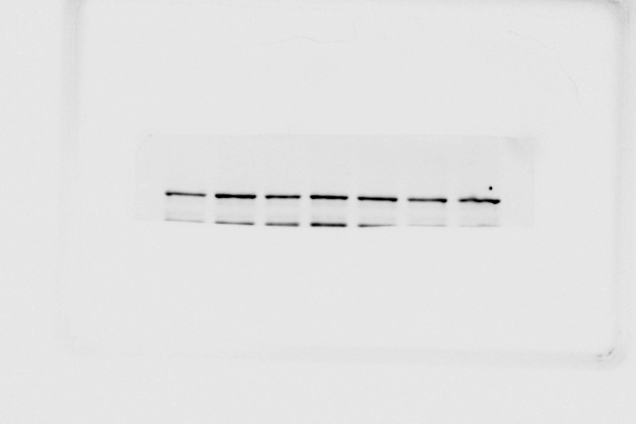  75  63  p65
Exp.2 | 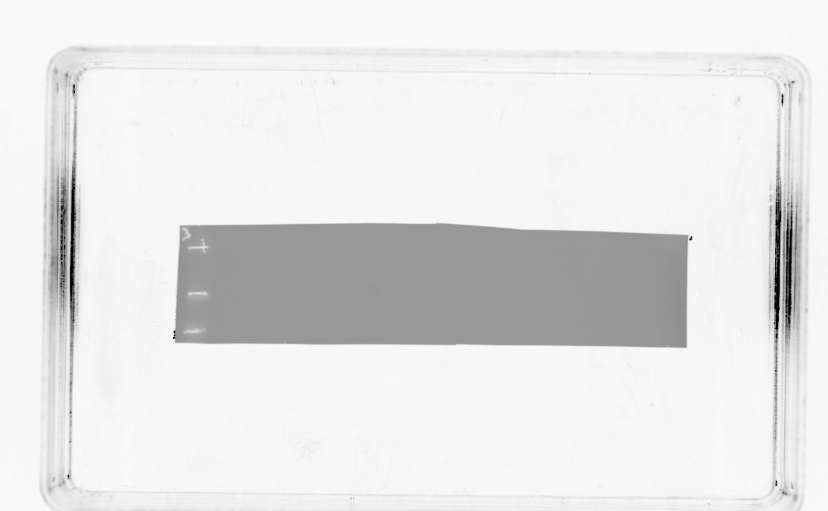  75  63 | 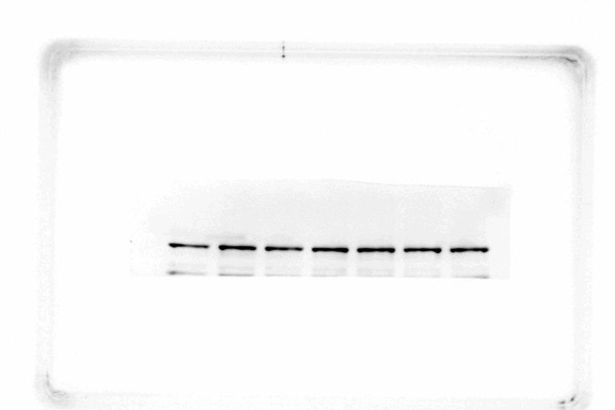  48  75  63  p65
Exp.3  75  63 | 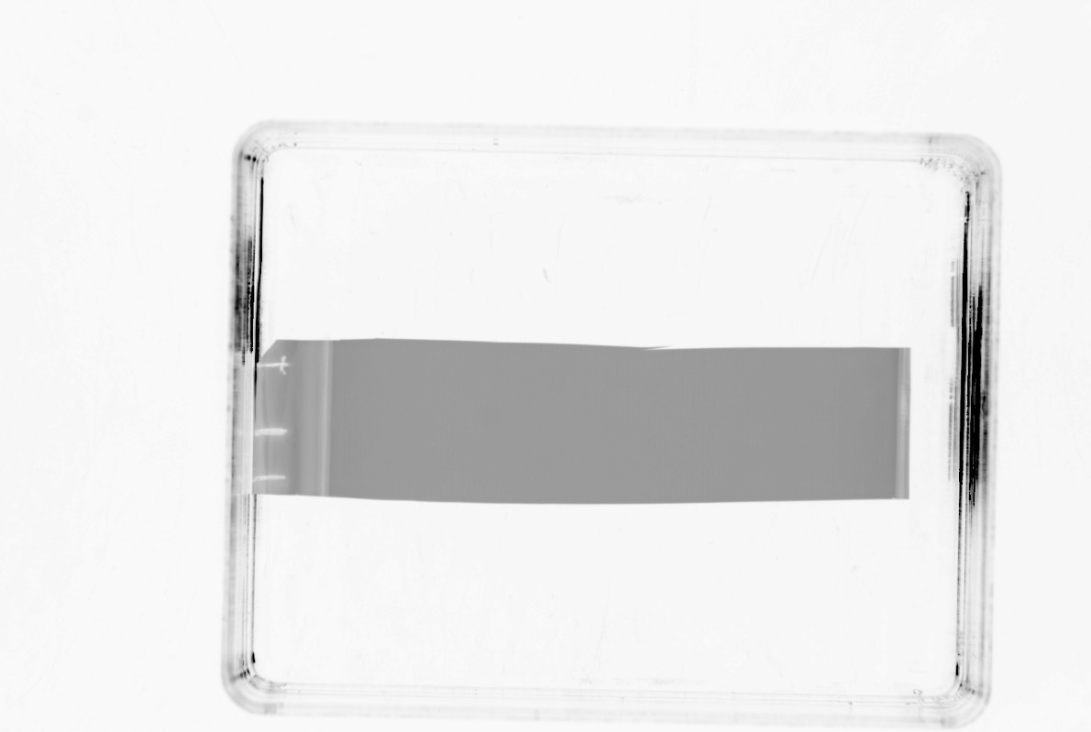  48 | 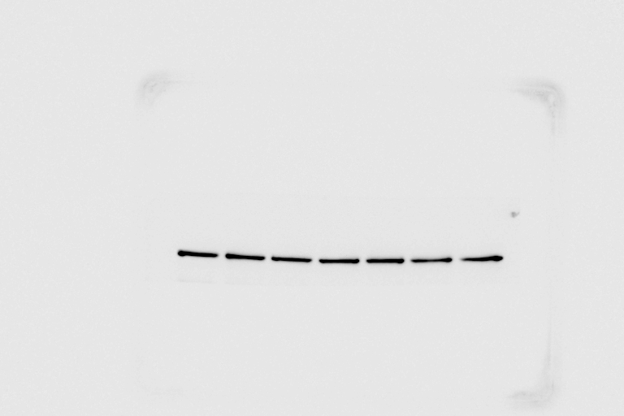  p65  75  63  48  48  48

β-actin | A: Exposure time 1/100 sec | B: Exposure time 20 sec
Exp.1 | 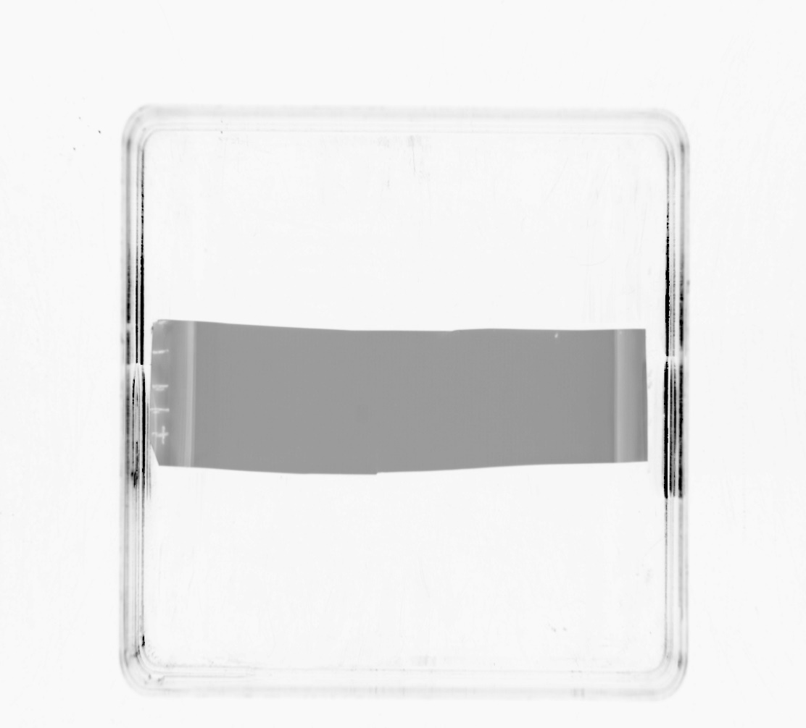  17  35  25  48  20 | 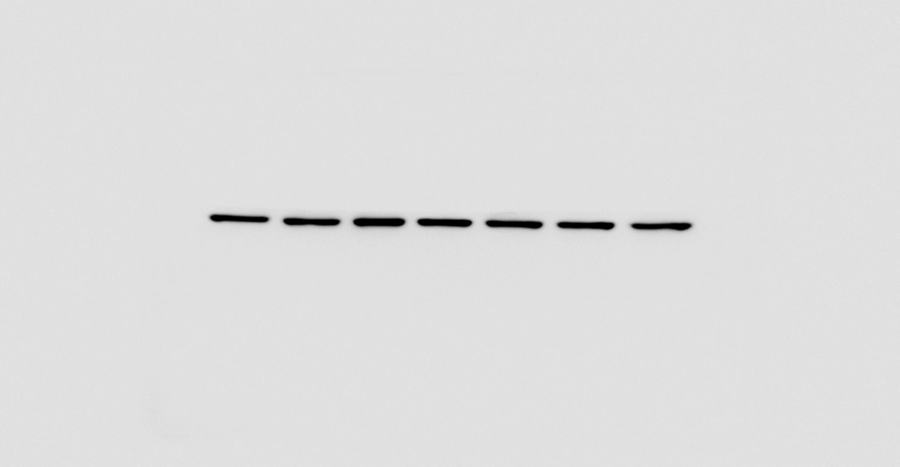  35  25  48  20  17  β-actin
Exp.2 | 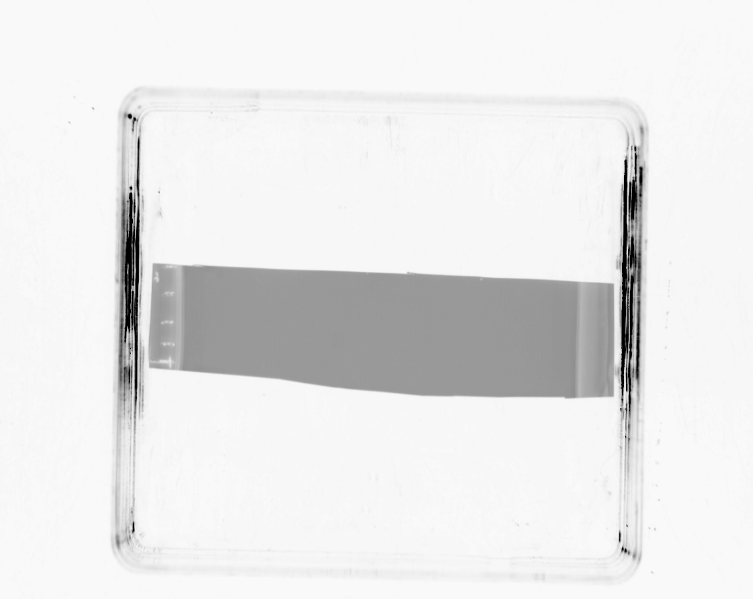  17  35  25  48  20 | 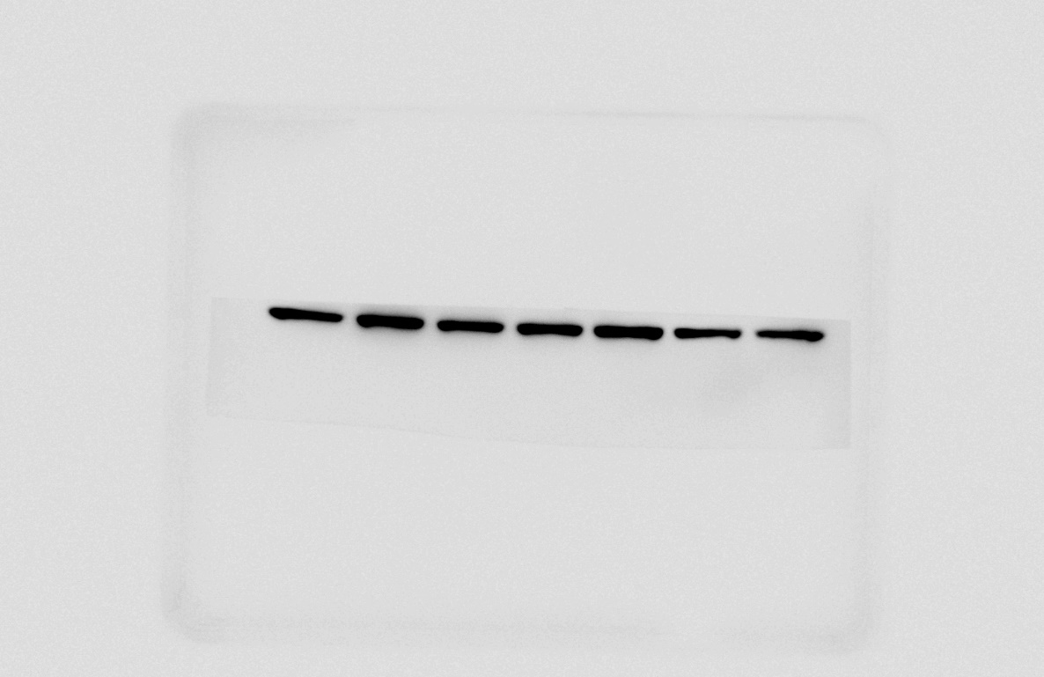  β-actin  35  25  48  20
Exp.3 | 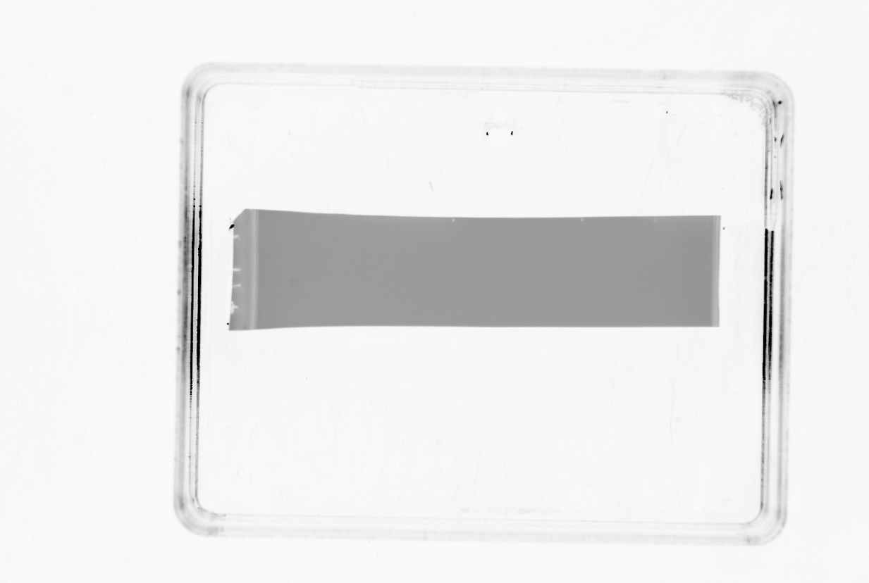  48  35  25  20 | 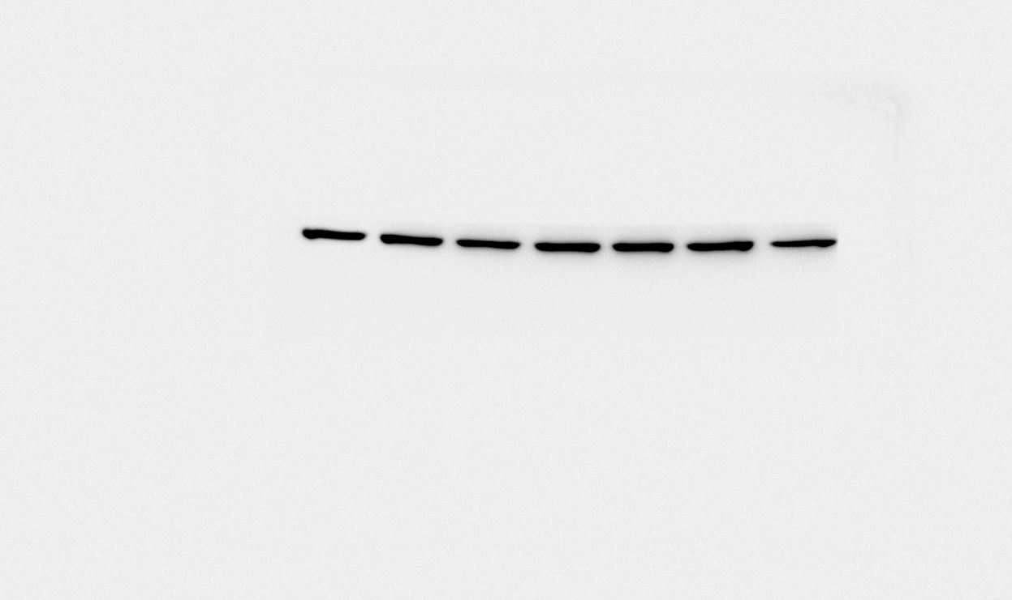  20  48  35  25  β-actin  17

Proteins from Cytoplasmic extraction
p-IκB-α
p-IκB-α | A: Exposure time 1/100 sec | B: Exposure time 100 sec
Exp.1 | 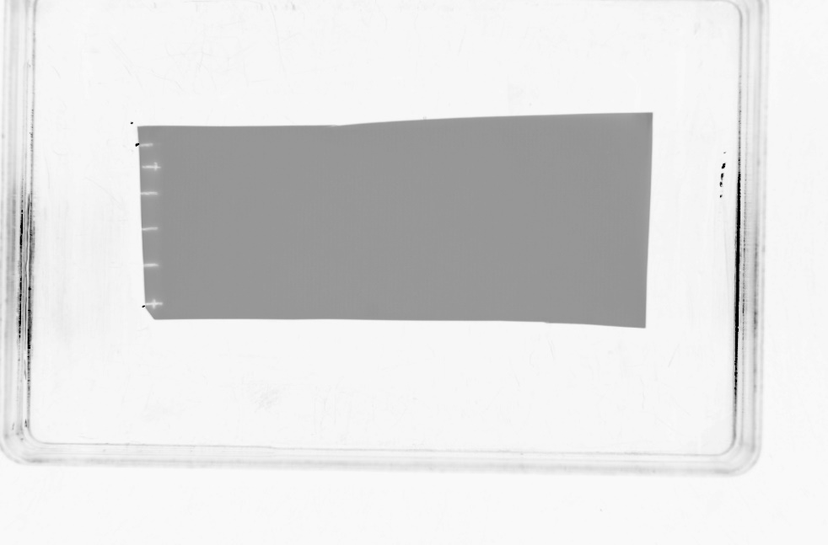  75  48  35  25  63 | 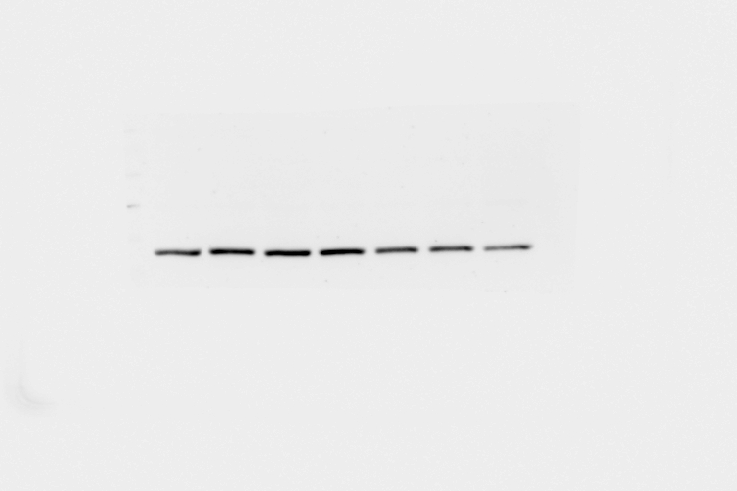  75  48  35  25  63  p-IκB-α
Exp.2 | 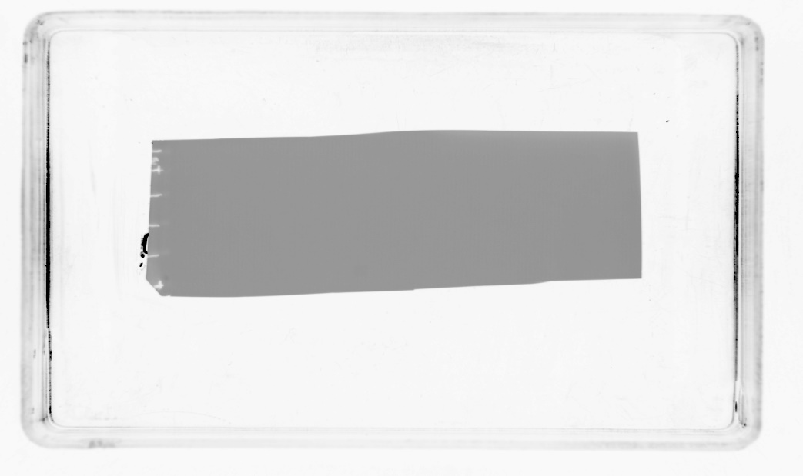  75  48  35  25  63 | 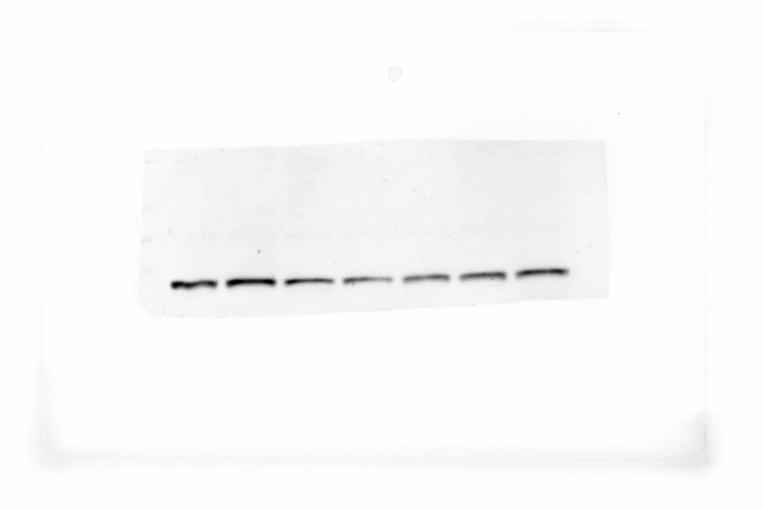  p-IκB-α
Exp.3 | 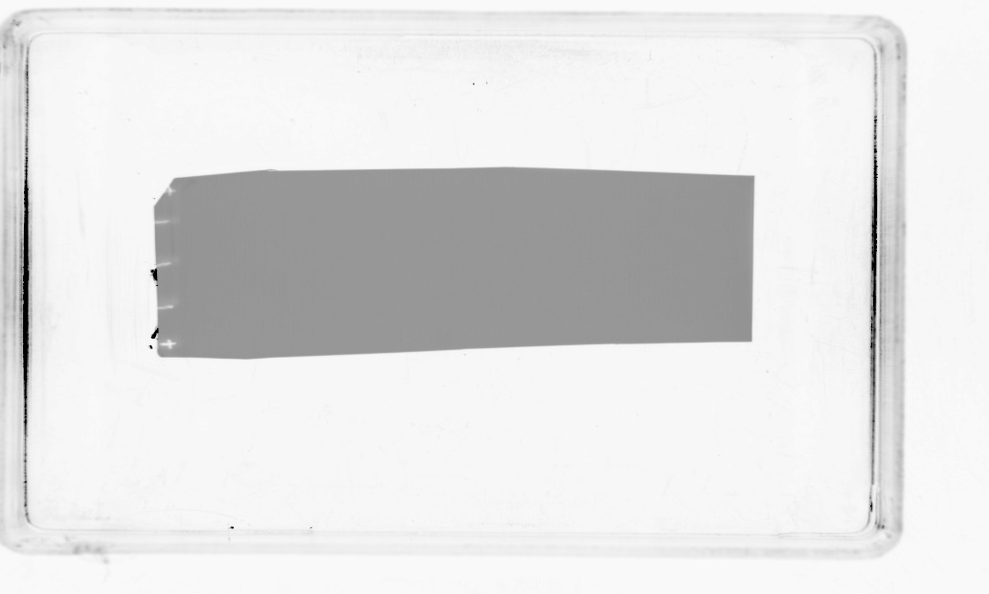  75  48  35  25  63 | 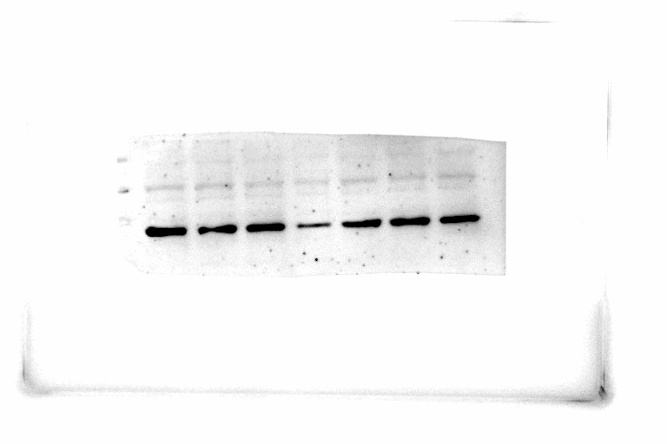  75  48  35  25  63  75  48  35  25  63  48

β-actin | A: Exposure time 1/100 sec | B: Exposure time 20 sec
Exp.1 | 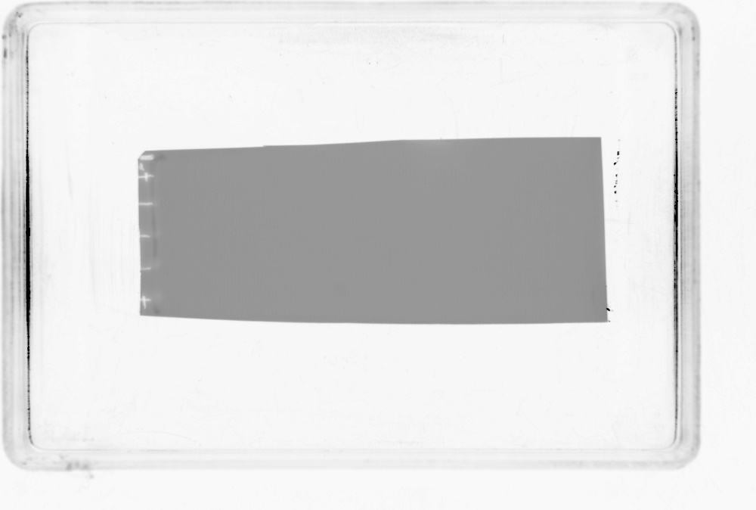  48  35  63  25 | 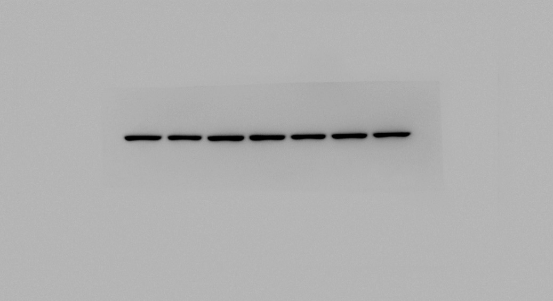  β-actin  48  35  63  25
Exp.2 | 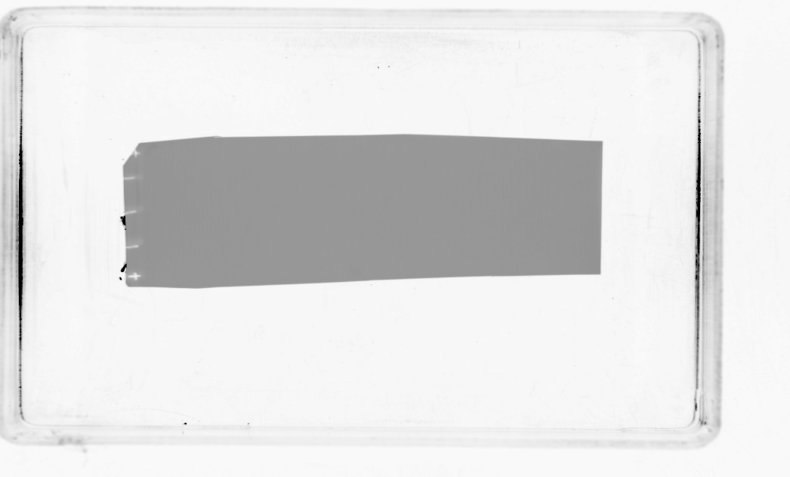  48  35  63  25 | 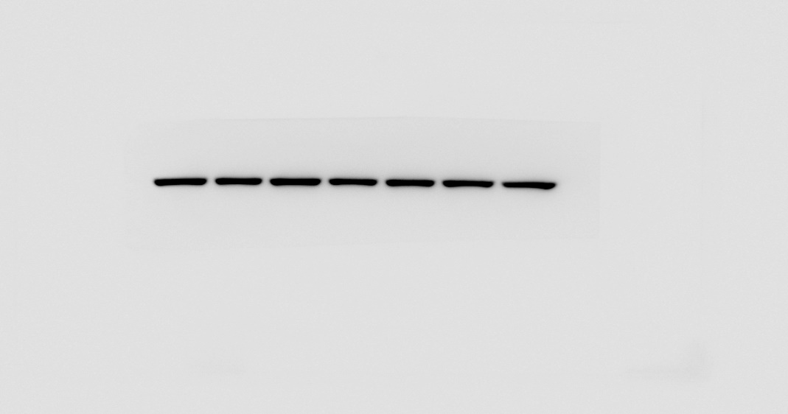  β-actin  48  35  63  25
Exp.3 | 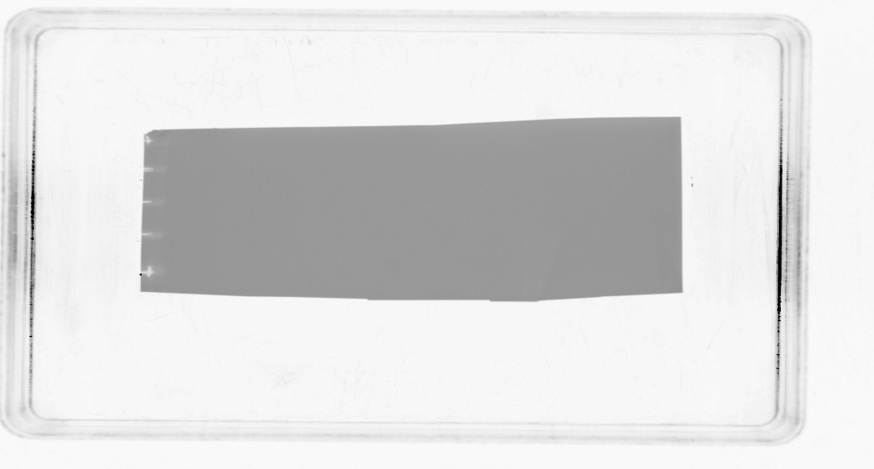  48  35  63  25 | 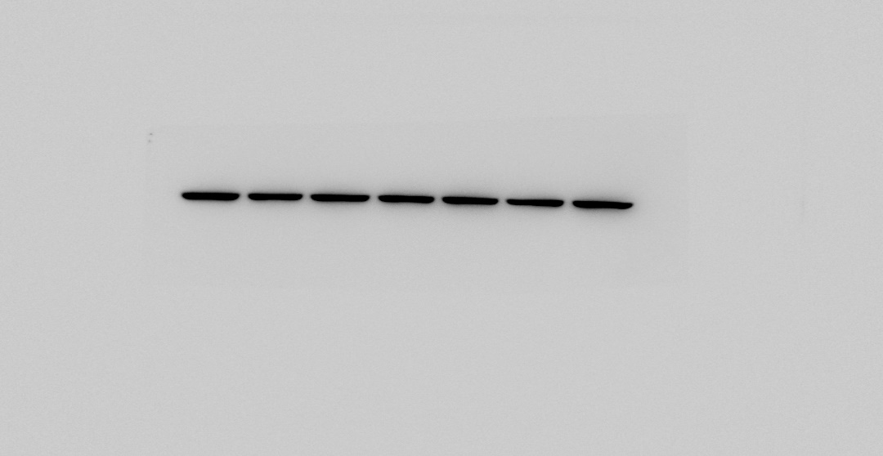  β-actin  48  35  63  25

