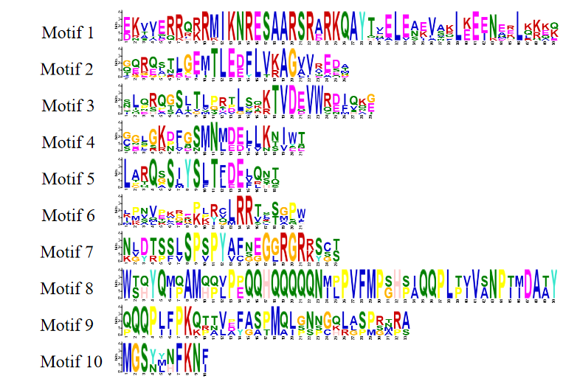
Amino acid sequences of different conserved motifs displayed by stacks of letters at each position.

