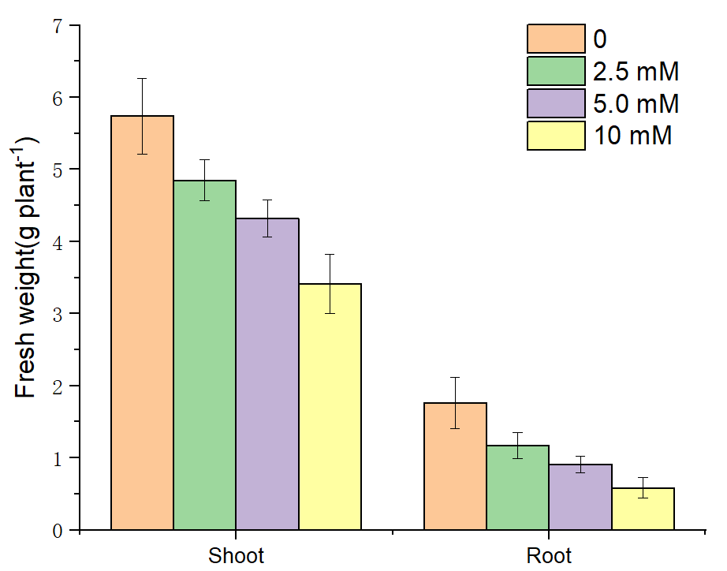
Figure S1 Effects of different Zn concentrations on the growth of watermelon seedlings

