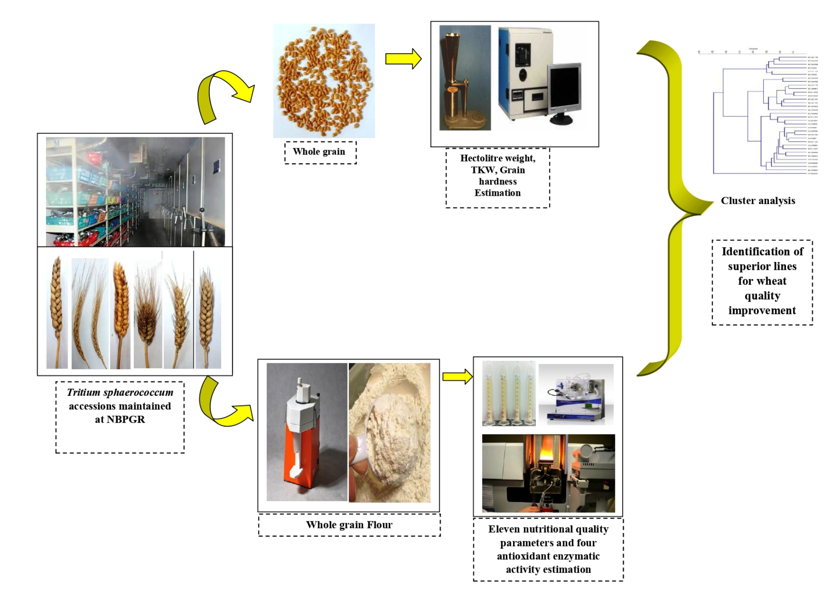

**Supplementary Fig. 1. Flow of work done for grain quality analysis**