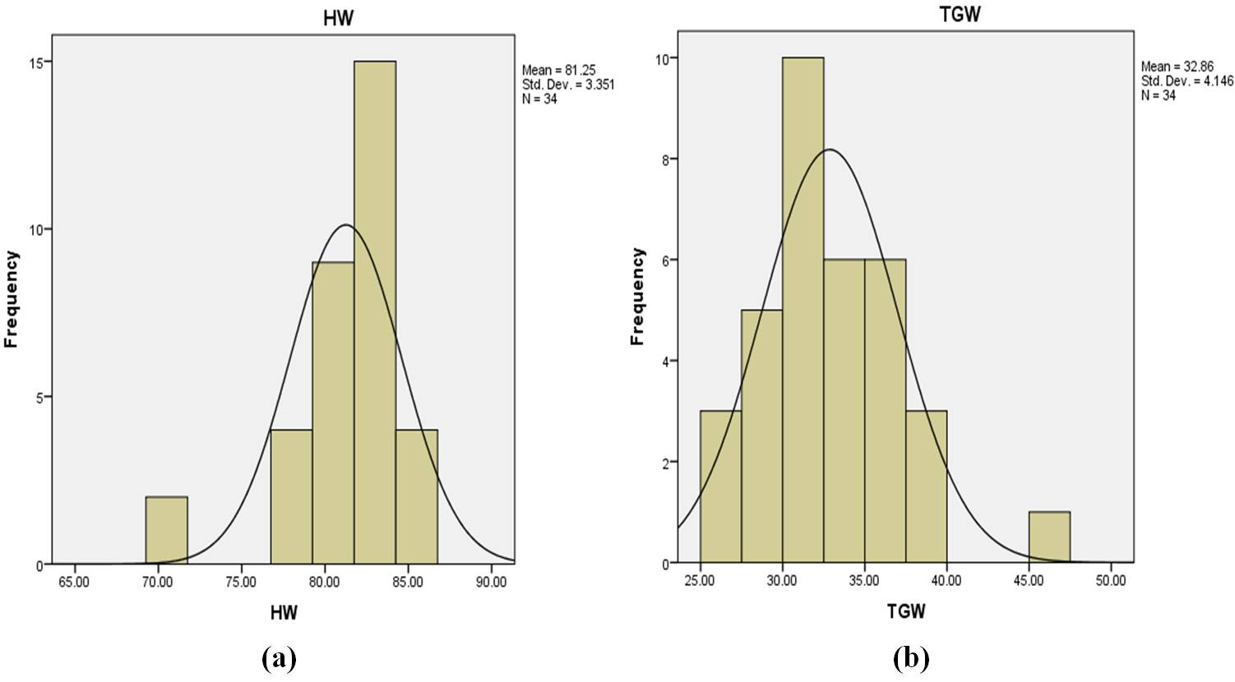

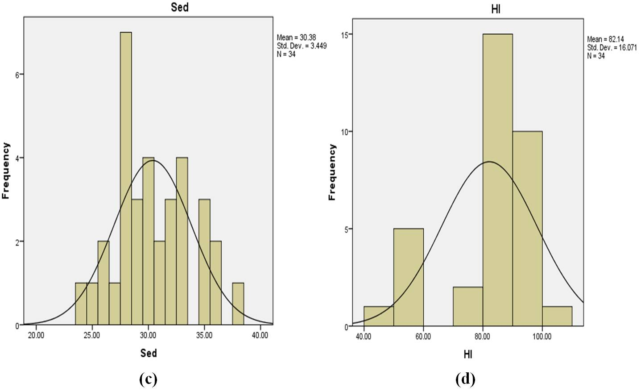

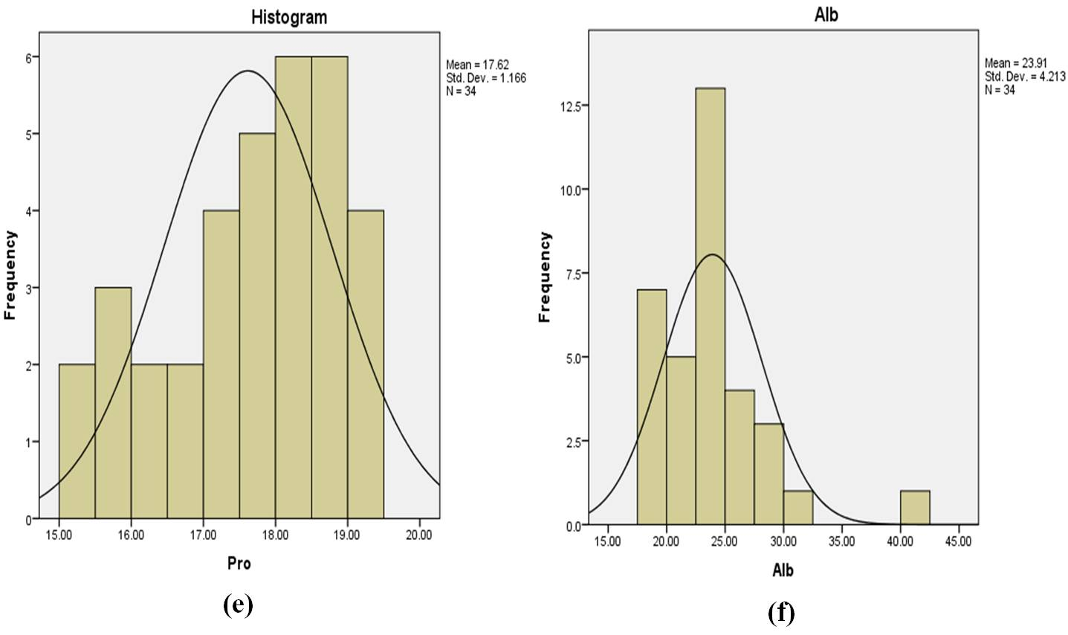

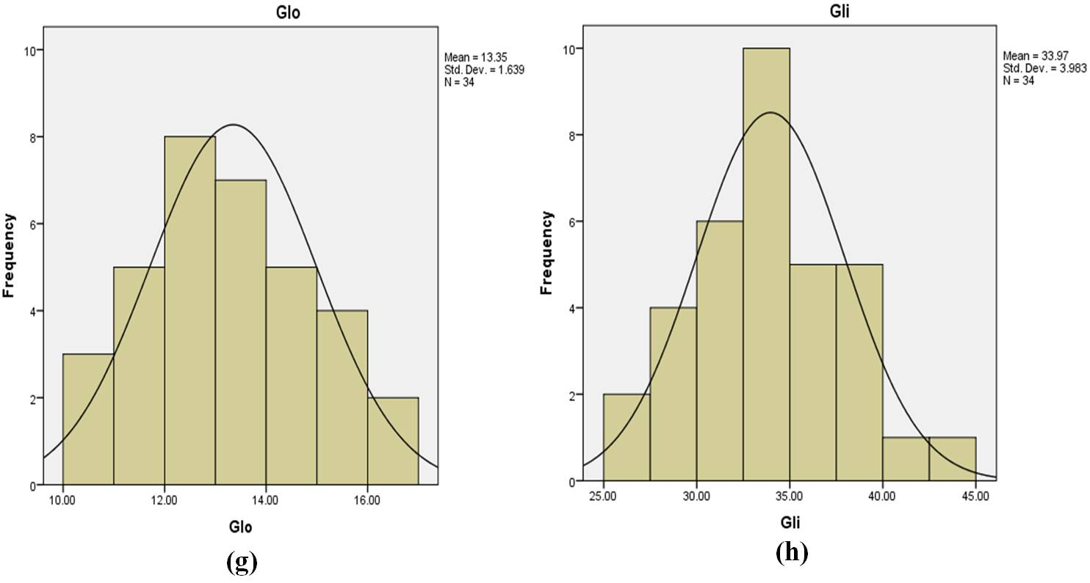

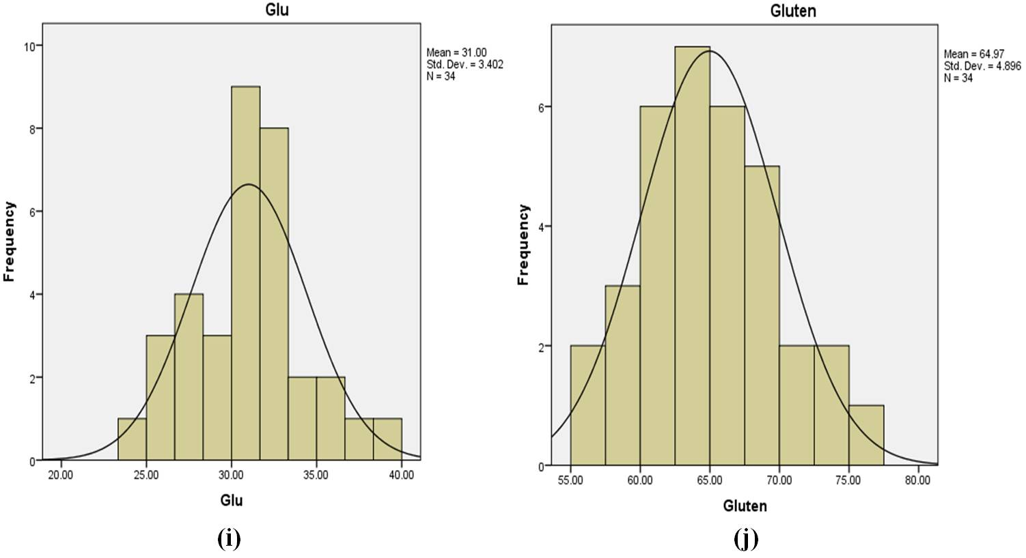

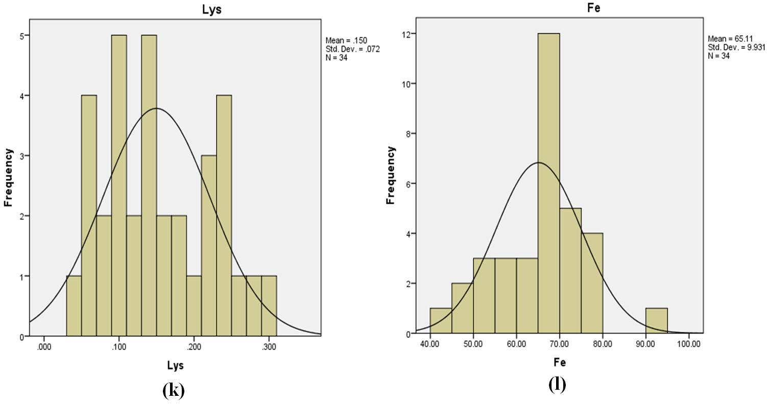

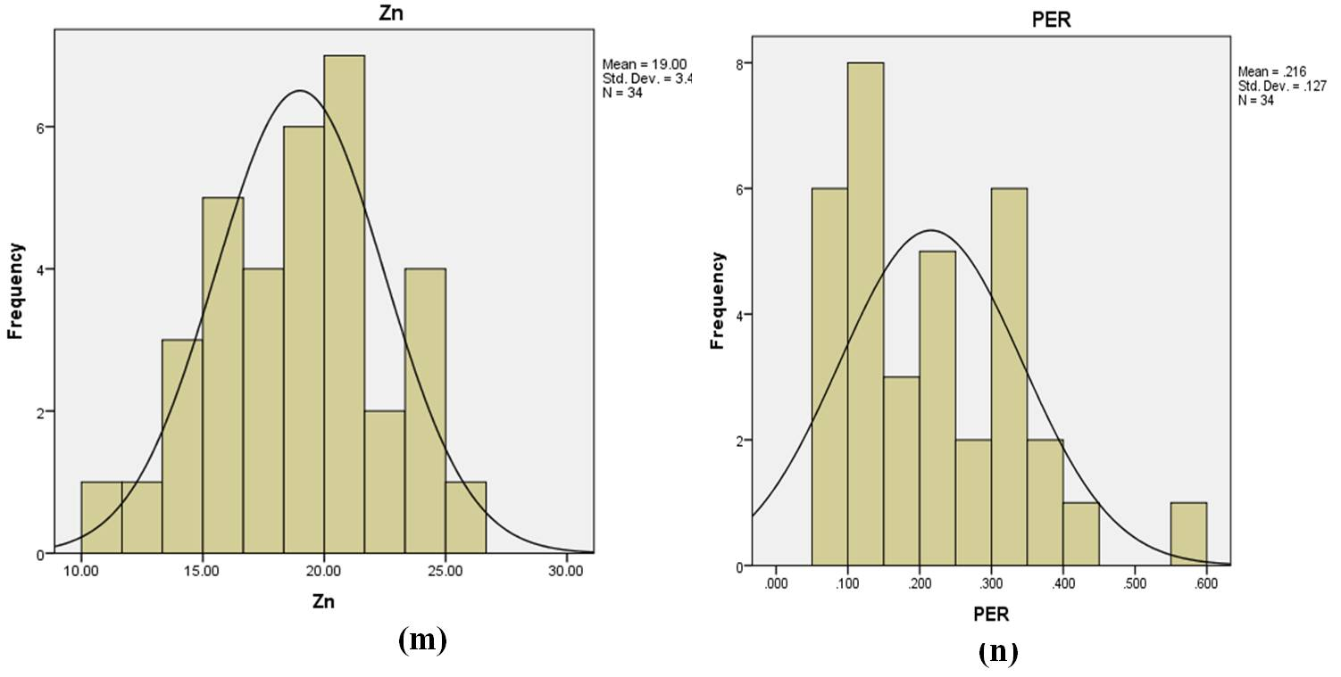

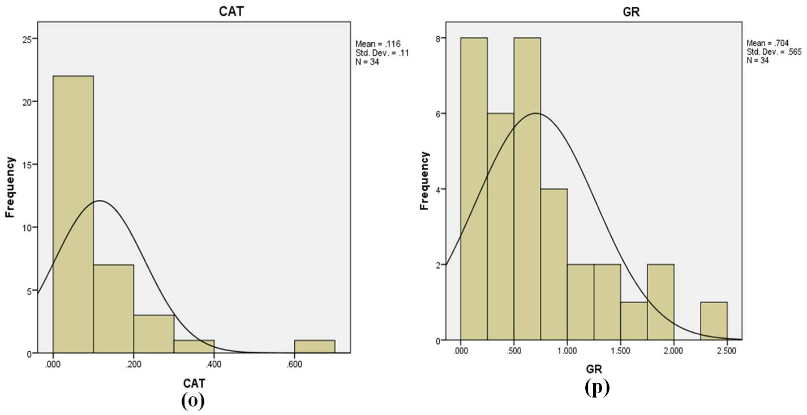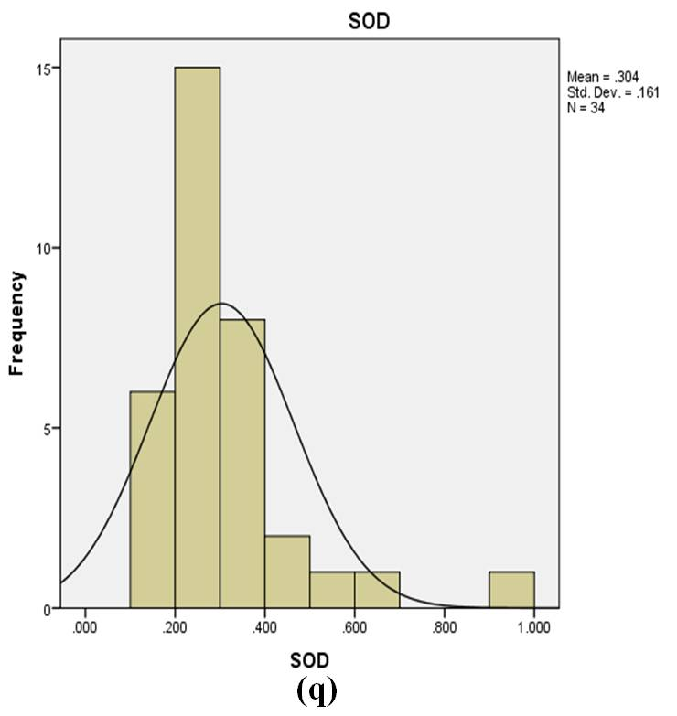

**Supplementary Fig. 2 Histogram depicting variations in different grain quality traits studied a) Hectolitre weight (HW), b)Thousand grain weight (TGW) c) Sedimentation value (Sed), d) Hardness index (HI), e) Protein content (Pro), f)Albumin content (Alb), g) Globulin content (Glo), h) Gliadin content (Gli), i) Glutenin content (Glu), j) Gluten content, k) Lysine content (Lys), l) Fe+2 Content, m) Zn+2 content, n) Peroxidase (POX), o) Catalase (CAT), p) Glutathione reductase (GR), q) Superoxide dismutase (SOD)**