Supporting information

Baseline dynamics of Symbiodiniaceae genera and photochemical efficiency in corals from reefs with different thermal histories

Crystal J. McRae¹, Shashank Keshavmurthy², Hung-Kai Chen¹, Zong-Min Ye¹, Pei-Jie Meng^{1,3}, Sabrina L. Rosset⁴, Wen-Bin Huang⁵, Chaolun Allen Chen², Tung-Yung Fan^{1,6}, Isabelle M. Côté⁷

¹ National Museum of Marine Biology and Aquarium, Pingtung, Taiwan.
² Biodiversity Research Center, Academia Sinica, Taipei, Taiwan.
³ Graduate Institute of Marine Biology, National Dong Hwa University, Pingtung, Taiwan.
⁴ School of Biological Sciences, Victoria University of Wellington, Wellington, New Zealand
⁵ Department of Natural Resources and Environmental Studies, National Dong Hwa University, Hualien, Taiwan.
⁶ Department of Marine Biotechnology and Resources, National Sun Yat-sen University, Kaohsiung, Taiwan
⁷ Department of Biological Sciences, Simon Fraser University, British Columbia, Canada.

Corresponding authors:
Tung-Yung Fan^{1,6}; Crystal J. McRae
Email address: tyfan@nmmba.gov.tw; crystal.j.mcrae@gmail.com

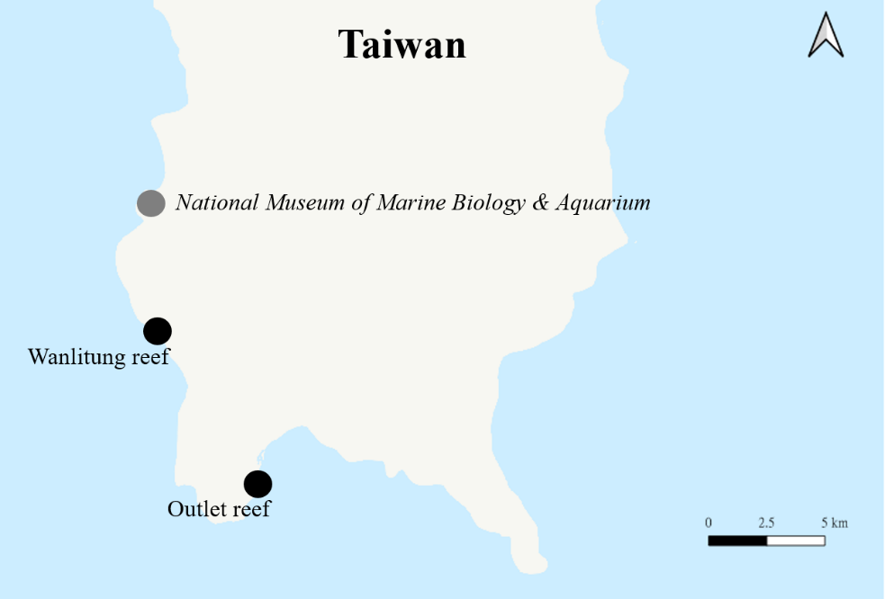
Figure S1. Map of coral collection sites, Wanlitung reef (thermally stable site; 21.955°E, 120.766°N) and Outlet reef (chronically warmed and thermally variable site; 21.931°E, 120745°N), and the research facilities of the National Museum of Marine Biology & Aquarium in southern Taiwan.

Table S1. Summary of individual colony sampling and condition across seasons for Outlet reef from July 2018 to August 2019. Check mark = fragments were sampled from the colony; NA = not sampled; PM = partial mortality; PB = partial bleaching; R = recovery; M = mortality. Mortality and bleaching percentages are reported relative to initial colony condition; recovery percentages are reported relative to previous sampling time point.

Colony ID | Summer  2018 | Fall  2018 | Winter  2019 | Spring  2019 | Summer  2019 | Included in  qPCR analysis | Comments
Pocillopora acuta
PA1
PA2
PA3 |  |  | PM (~20%) | PM (~40%) | R (Spring + ~20%)
PA4
PA5
PA6
PA7
PA8 |  | PM (~30%) | PM (~30%) | PM (~30%) | R (Spring + ~10%)
PA9
PA10
Acropora nana
AN1 |  | NA | NA | NA | NA | NA | not relocated
AN2 |  | NA | NA | NA | NA | NA | not relocated
AN3 | NA | NA | NA | NA | NA | NA | species misidentified
AN4
AN5 |  | PB (~20%) | PM (~60%) | R (Winter + ~5%) | R (Spring +~10%)
AN6 | NA | NA | NA | NA | NA | NA | species misidentified
AN7 | NA | NA | NA | NA | NA | NA | species misidentified
AN8
AN9
AN10
AN11
AN12
AN13
AN14 | NA | NA
AN15 | NA | NA | NA
AN16 | NA | NA | NA
Porites lutea
PL1 |  |  |  |  |  |  | < 5 m from PL2
PL2 |  |  |  |  |  |  | < 5 m from PL1
PL3
PL4
PL5
PL6 |  |  |  |  |  |  | < 5 m from PL7
PL7 |  |  |  |  |  |  | < 5 m from PL6
PL8
PL9
PL10
PL11 | NA

Table S2. Summary of individual colony sampling and condition across seasons for Wanlitung reef from July 2018 to August 2019. Check mark = fragments were sampled from the colony; NA = not sampled; PM = partial mortality; PB = partial bleaching; R = recovery; M = mortality. Mortality and bleaching percentages are reported relative to initial colony condition; recovery percentages are reported relative to previous sampling time point.

Colony ID | Summer  2018 | Fall  2018 | Winter  2019 | Spring  2019 | Summer  2019 | Included in  qPCR analysis | Comments
Pocillopora acuta
PA1 |  | PM (~90%) | M | NA | NA
PA2 |  | M | NA | NA | NA | NA
PA3
PA4 | NA | NA | NA | NA | NA | NA | species misidentified
PA5 |  | NA | NA | NA | NA |  | not relocated
PA6 |  | NA | NA | NA | NA | NA | not relocated
PA7
PA8 |  | NA |  | PB (~10%) |  |  | not relocated in fall
PA9 |  | PM (~75%) | PM (~90%) | M | NA
PA10 |  | PM (~50%) | PM (~80%) | PM (~85%) | R (Spring + ~5%)
PA11 | NA | PB (~5%) | PM (~20%) | PM (~20%) | R (Spring + ~15%)
PA12 | NA |  |  |  | R (Spring + ~10%)
PA13 | NA |  |  | PM (~30%) | PM (~30%)
PA14 | NA | PB (~10%) | PM (~30%) | PM (~60%) | M
PA15 | NA |  | PM (~20%) | PM (~30%) | PM (~80%)
PA16 | NA | NA |  | PM (~10%) | PM (~10%)
Acropora nana
AN1 |  |  | PM (50%) | PM (75%) | PM (75%)
AN2 |  | PM (~90%) |  |  |  |  | < 5 m from AN8
AN3 |  |  |  |  |  |  | < 5 m from AN13
AN4 | NA | NA | NA | NA | NA | NA | species misidentified
AN5 |  |  |  |  | NA |  | not relocated in summer 2019
AN6 |  |  |  |  |  |  | < 5 m from AN11 & 14
AN7 |  |  | PM (80%) | PM (80%) | M |  | < 5 m from AN14
AN8
AN9 |  | PM (~40%) | PM (40%) | PM (50%) | PM (50%)
AN10 |  |  | PM (40%) | PM (60%) | M
AN11 | NA |  |  |  |  |  | < 5 m from AN6 & 14
AN12 | NA | NA | NA | NA | NA | NA | species misidentified
AN13 | NA |  |  |  |  |  | < 5 m from AN3
AN14 | NA |  |  |  |  |  | < 5 m from AN7
AN15 | NA |  |  |  |  |  | < 5 m from AN6 & 11
Porites lutea
PL1
PL2
PL3
PL4
PL5 | PM (~35%) | PM (~35%) | PM (~35%) | PM (~35%) | PM (~35%)
PL6 | PM (~5%) | PM (~5%) | PM (~5%) | PM (~5%) | PM (~5%)
PL7
PL8 | PM (~20%) | PM (~20%) | PM (~20%) | PM (~20%) | PM (~20%)
PL9 | PM (~60%) | PM (~70%) | PM (~80%) | PM (~90%) | R (Spring + ~10%)
PL10

Table S3. Summary of ‘qPCR analysis subset’ colony condition across seasons for Outlet reef from July 2018 to August 2019. Check mark = fragments were sampled from the colony; NA = not sampled; PM = partial mortality; PB = partial bleaching; R = recovery; M = mortality. Mortality and bleaching percentages are reported relative to initial colony condition; recovery percentages are reported relative to previous sampling time point.

Colony ID | Summer  2018 | Fall  2018 | Winter  2019 | Spring  2019 | Summer  2019
Pocillopora acuta
PA1
PA2
PA5
PA7
PA9
PA10
Acropora nana
AN5 |  | PB (~20%) | PM (~60%) | R (Winter + ~5%) | R (Spring +~10%)
AN8
AN9
AN10
AN12
AN13
Porites lutea
PL1
PL4
PL5
PL6
PL8
PL9

Table S4. Summary of ‘qPCR analysis subset’ colony condition across seasons for Wanlitung reef from July 2018 to August 2019. Check mark = fragments were sampled from the colony; NA = not sampled; PM = partial mortality; PB = partial bleaching; R = recovery; M = mortality. Mortality and bleaching percentages are reported relative to initial colony condition; recovery percentages are reported relative to previous sampling time point.

Colony ID | Summer  2018 | Fall  2018 | Winter  2019 | Spring  2019 | Summer  2019
Pocillopora acuta
PA1 |  | PM (~90%) | M / NA | NA | NA
PA3 |  |  |  |  | NA
PA5 |  | NA | NA | NA | NA
PA7
PA9 |  | PM (~75%) | PM (~90%) | M / NA | NA
PA10 |  | PM (~50%) | PM (~80%) | PM (~85%) | R (Spring + ~5%)
PA11 | NA | PB (~5%) | PM (~20%) | PM (~20%) | R (Spring + ~15%)
PA13 | NA |  |  | PM (~30%) | PM (~30%)
PA15 | NA | NA | PM (~20%) | PM (~30%) | PM (~80%)
PA16 | NA | NA |  | PM (~10%) | PM (~10%)
Acropora nana
AN1 |  |  | PM (50%) | PM (75%) | PM (75%)
AN3
AN5 |  |  |  |  | NA
AN6
AN7 |  |  | PM (80%) | PM (80%) | NA
AN8
AN11 | NA | NA | NA | NA
AN14 | NA | NA | NA | NA
Porites lutea
PL1
PL2
PL3
PL4
PL6 | PM (~5%) | PM (~5%) | PM (~5%) | PM (~5%) | PM (~5%)
PL10

Table S5. Nutrient data (mean ± SD) from a warmed and thermally variable reef (Outlet reef) and a thermally stable reef (Wanlitung reef) in southern Taiwan, from May 2018 to June 2019. Parameters measured included 5-day biological oxygen demand (BOD₅), nitrate (NO₃⁻), nitrite (NO₂⁻), phosphate (PO₄³⁻) and ammonia (NH₃); all data are shown in mg/L.

Sampling date | BOD₅ |  | NO₃⁻ |  | NO₂ |  | PO₄³⁻ |  | NH₃
 | Outlet | Wanlitung | Outlet | Wanlitung | Outlet | Wanlitung | Outlet | Wanlitung | Outlet | Wanlitung
May 25, 2018 | 0.6 | 0.6 | 0.002 | 0.002 | 0.006 | 0.008 | 0.003 | 0.002 | 0.01 | 0.015
July 27, 2018 | 1.0 | 1.3 | 0.017 | 0.029 | 0.001 | 0.001 | 0.002 | 0.002 | 0.015 | 0.016
September 5, 2018 | 0.6 | 0.7 | 0.048 | 0.029 | 0.001 | 0.001 | 0.007 | 0.007 | 0.027 | 0.032
October 21, 2018 | 1.5 | 1.2 | <0.002 | <0.002 | 0.052 | 0.017 | 0.011 | 0.006 | 0.015 | 0.018
November 16, 2018 | 0.6 | 0.6 | 0.012 | 0.011 | 0.001 | 0.001 | 0.011 | 0.003 | 0.031 | 0.029
December 20, 2018 | 0.7 | 0.7 | 0.019 | 0.014 | <0.001 | <0.001 | 0.003 | 0.003 | 0.012 | 0.013
January 24, 2019 | 1.5 | 1.6 | 0.023 | 0.016 | 0.001 | 0.001 | 0.017 | 0.095 | 0.019 | 0.013
March. 18, 2019 | 1.5 | 1.2 | 0.019 | 0.019 | 0.001 | 0.001 | 0.003 | <0.002 | 0.012 | 0.015
April 22, 2019 | 1.2 | 0.8 | <0.003 | <0.003 | <0.001 | <0.001 | <0.002 | <0.002 | 0.022 | 0.024
May 23, 2019 | 0.8 | 0.8 | 0.022 | 0.021 | 0.001 | 0.001 | 0.005 | 0.003 | 0.018 | 0.015
June 28, 2019 | 1.2 | 2.6 | 0.021 | 0.016 | 0.001 | 0.001 | 0.003 | <0.003 | 0.01 | 0.01
Mean | 1.0 | 1.1 | 0.017 | 0.014 | 0.006 | 0.003 | 0.006 | 0.011 | 0.017 | 0.018
Standard deviation | 0.4 | 0.6 | 0.014 | 0.010 | 0.015 | 0.005 | 0.005 | 0.028 | 0.007 | 0.007

