Table S1: Collection sites of Sargassum in La Paz Bay, Baja California Sur (BCS), Mexico.
Sargassum species | Site | Date | Number of thalli
Sargassum horridum Setchell & N.L. Gardner | San Juan de la Costa | March 2018 | 1
 |  | July 2021 | 1
 | El Sauzoso | May 2018 | 1
 | Agua de Yepiz | March 2021 | 1
 | El Califin | May 2018 | 3
 | El Cajete | July 2021 | 1
 | Playa Caimancito | April 2018 | 17
 |  | August 2018 | 1
Sargassum lapazeanum Setchell & N.L. Gardner | San Juan de la Costa | March 2018 | 3
 |  | July 2021 | 1

Table S2: PERMANOVA results for each Sargassum trait (habit and region) using Bray-Curtis dissimilarity. df: degrees of freedom; SS: square sum, MS: mean sum of squares, F Model: F value by permutation, *statistical significance with p<0.05 based on 999 permutations.
Source | df | SS | MS | F model | R² | Pr(>F)
Habit | 2 | 1.113 | 0.556 | 1.3694 | 0.110 | 0.04*
Residuals | 22 | 8.943 | 0.406 |  | 0.889
Total | 24 | 10.056 |  |  | 1.000
Region | 6 | 4.557 | 0.759 | 2.486 | 0.453 | 0.01*
Residuals | 18 | 5.499 | 0.305 |  | 0.546
Total | 24 | 10.056 |  |  | 1.000

Table S3: Pairwise adonis test between groups of every Sargassum trait (habit andregion). df: degrees of freedom; SS: square sum, F Model: F value by permutation, *statistical significance with p<0.05. Adjusted p: Bonferroni adjustment. TNA: Temperate Northern Atlantic, TNP: Temperate Northern Pacific, TAS: Temperate Australasia, TA: Tropical Atlantic, TSA: Temperate South America, WIP: Western Indo-Pacific.
Habit
Pairs | df | SS | F model | R² | p value | Ajusted p
Benthic vs drifting | 1 | 0.454 | 1.068 | 0.0484 | 0.350 | 1.000
Benthic vs holopelagic | 1 | 0.671 | 1.667 | 0.0735 | 0.027 | 0.081
Drifting vs holopelagic | 1 | 0.482 | 1.951 | 0.493 | 0.333 | 1.000
Region
TNA vs TNP | 1 | 0.560 | 1.927 | 0.194 | 0.204 | 1.00
TNA vs widespread | 1 | 0.428 | 1.303 | 0.206 | 0.265 | 1.00
TNA vs TAS | 1 | 0.500 | NA | 1.000 | NA | NA
TNA vs TA | 1 | 0.537 | 2.191 | 0.522 | 0.250 | 1.00
TNA vs TSA | 1 | 0.409 | 1.103 | 0.524 | 0.666 | 1.00
TNA vs WIP | 1 | 0.583 | 1.750 | 0.466 | 0.500 | 1.00
TNP vs widespread | 1 | 1.084 | 3.549 | 0.214 | 0.008 | 0.16
TNP vs TAS | 1 | 0.667 | 2.294 | 0.222 | 0.098 | 1.00
TNP vs TA | 1 | 1.275 | 4.526 | 0.311 | 0.001 | 0.02
TNP vs TSA | 1 | 0.644 | 2.151 | 0.192 | 0.096 | 1.00
TNP vs WIP | 1 | 1.168 | 3.903 | 0.281 | 0.007 | 0.14
Widespread vs TAS | 1 | 0.616 | 1.875 | 0.272 | 0.145 | 1.00
Widespread vs TA | 1 | 0.882 | 2.895 | 0.292 | 0.011 | 0.22
Widespread vs TSA | 1 | 0.175 | 0.521 | 0.0799 | 0.955 | 1.00
Widespread vs WIP | 1 | 0.886 | 2.686 | 0.277 | 0.011 | 0.22
TAS vs TA | 1 | 0.627 | 2.558 | 0.561 | 0.250 | 1.00
TAS vs TSA | 1 | 0.542 | 1.460 | 0.593 | 0.333 | 1.00
TAS vs WIP | 1 | 0.921 | 1.750 | 0.466 | 0.500 | 1.00
TA vs TSA | 1 | 0.479 | 1.669 | 0.357 | 0.300 | 1.00
TA vs WIP | 1 | 0.921 | 3.185 | 0.443 | 0.100 | 1.00
TSA vs WIP | 1 | 0.643 | 1.860 | 0.382 | 0.200 | 1.00

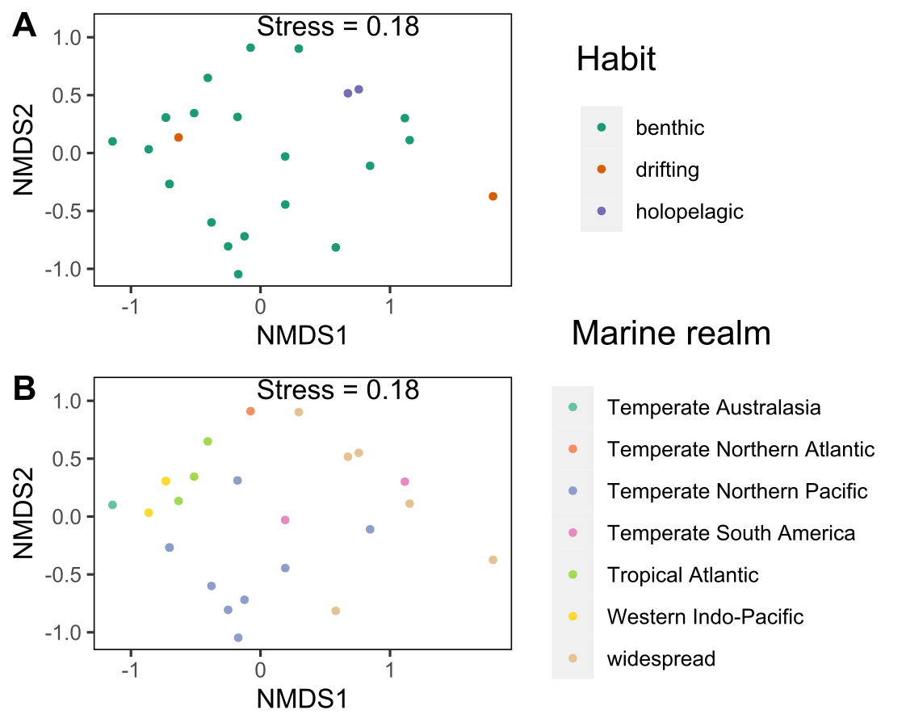

Figure S1: Non-metric multidimensional scaling (NMDS) ordination of the composition of hydrozoan species between Sargassum species colored by Sargassum habit (A) and (B) geographic realm.

