Supplementary Figure 1. The NMR data of compound 1 in CD3OD (500 MHz for 1 H NMR, 125 MHz for 13 C NMR)

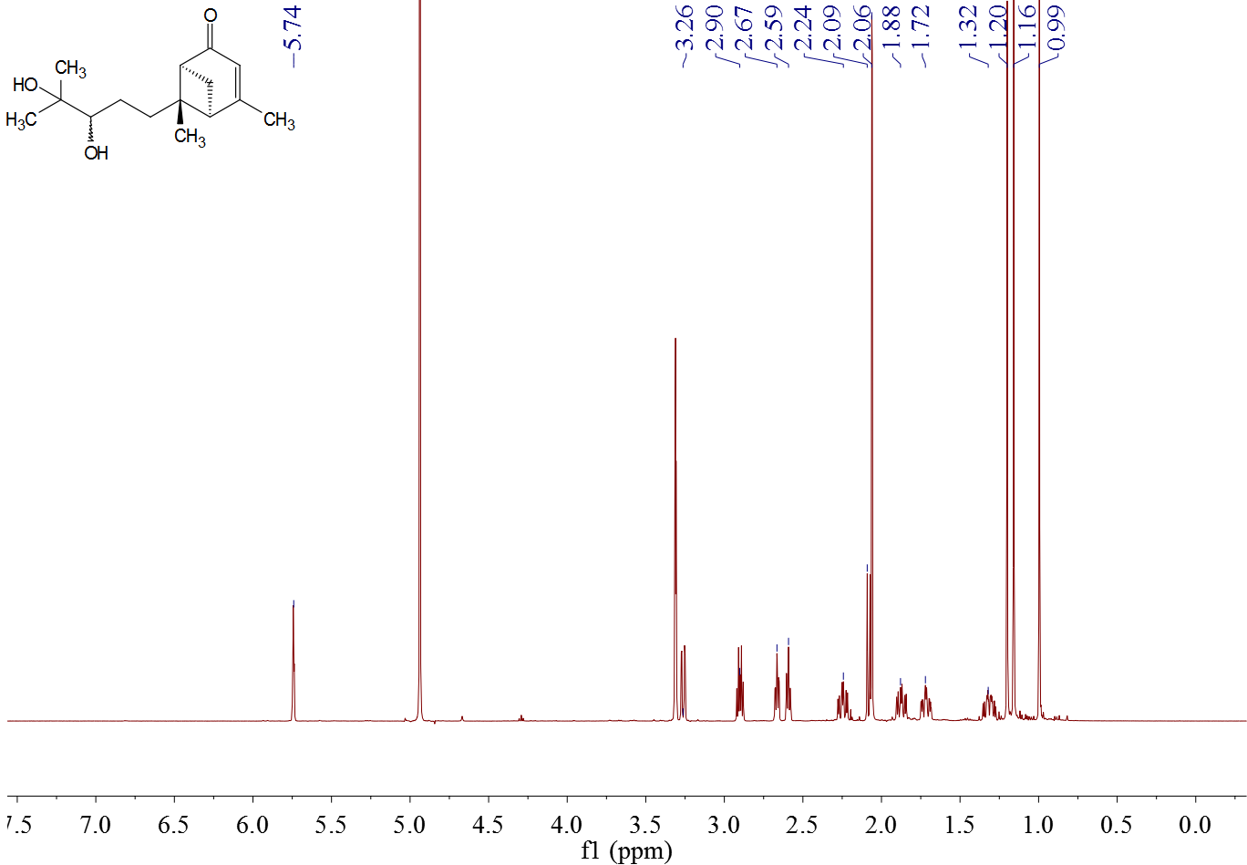

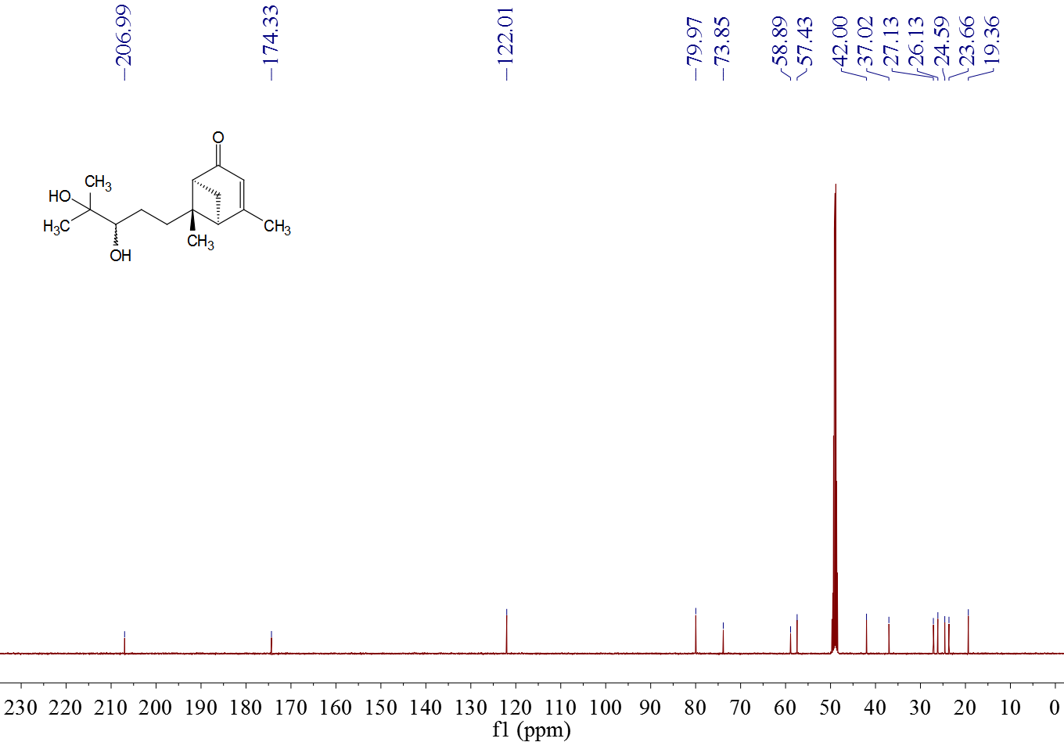

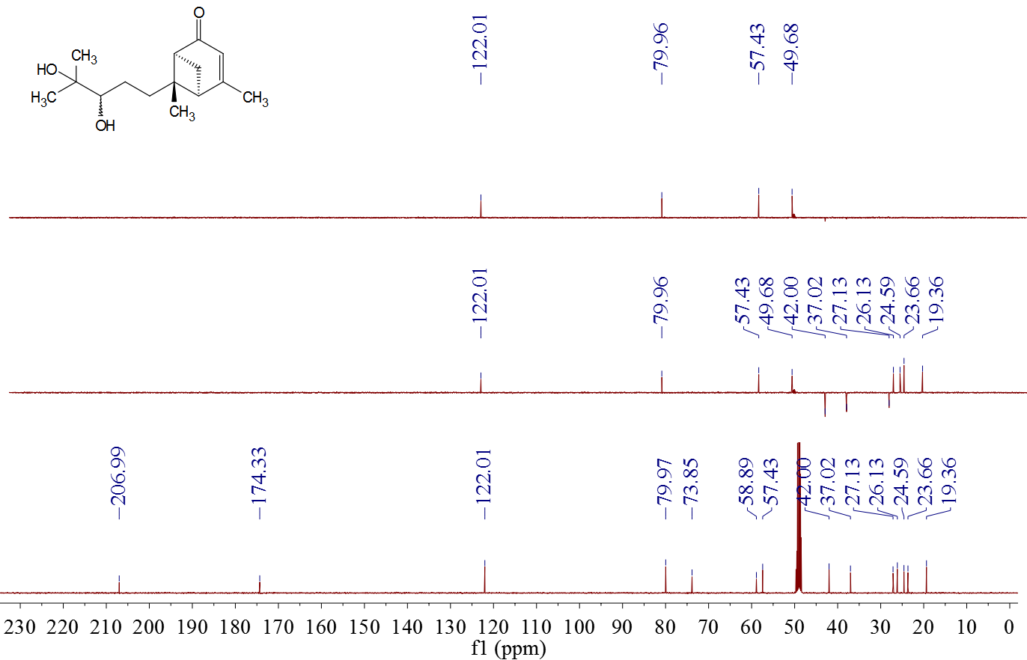

Supplementary Figure 2. The NMR data of compound 2 in CDCl3 (500 MHz for 1 H NMR, 125 MHz for 13 C NMR)

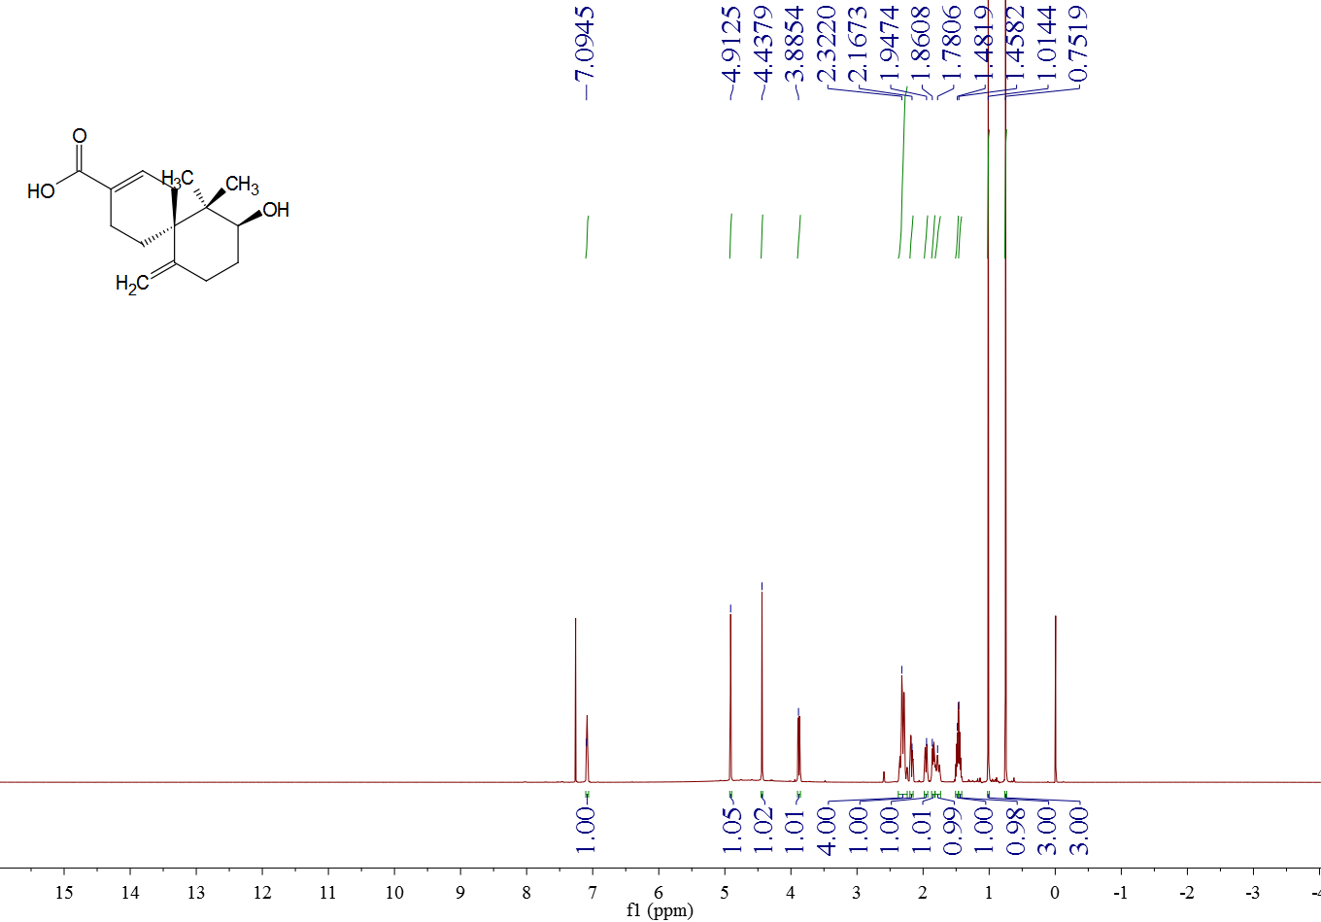

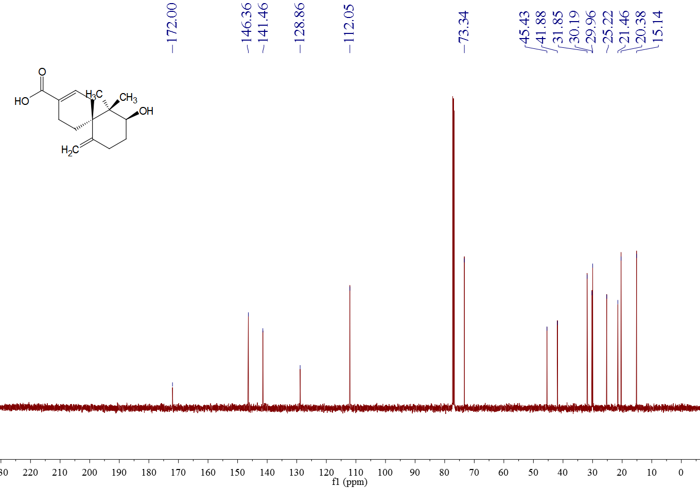

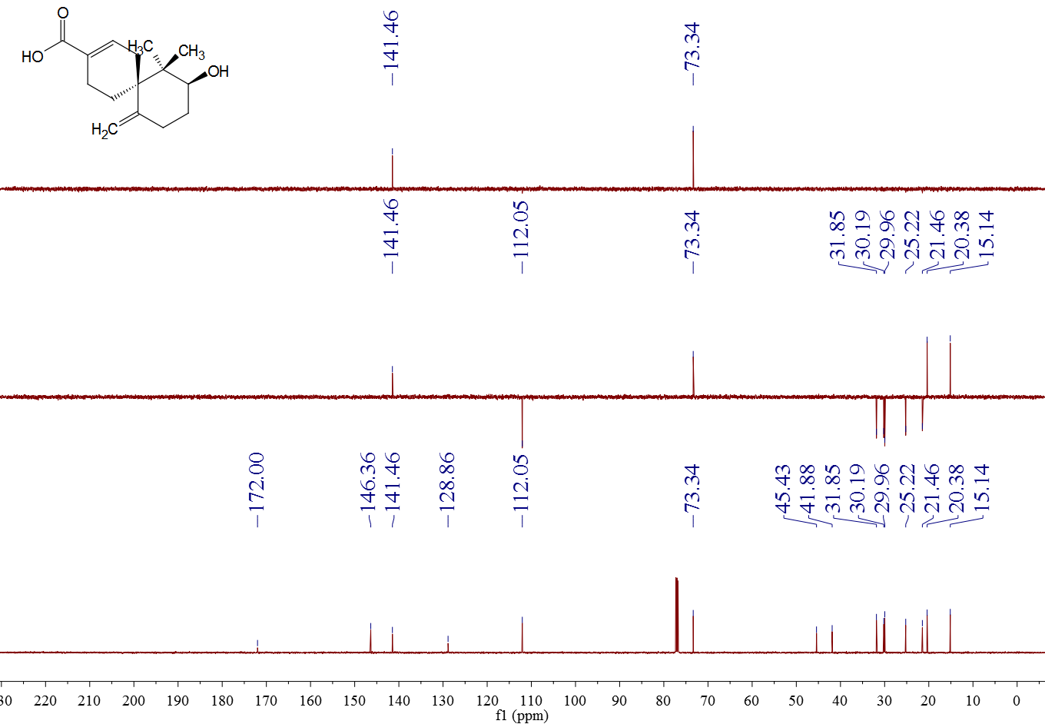

Supplementary Figure 3. The NMR data of compound 3 in CDCl3 (500 MHz for 1 H NMR, 125 MHz for 13 C NMR)

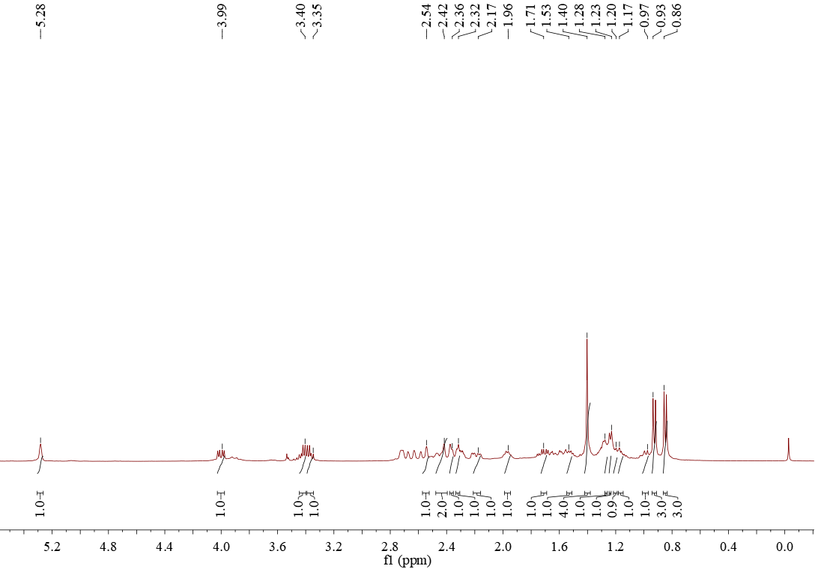

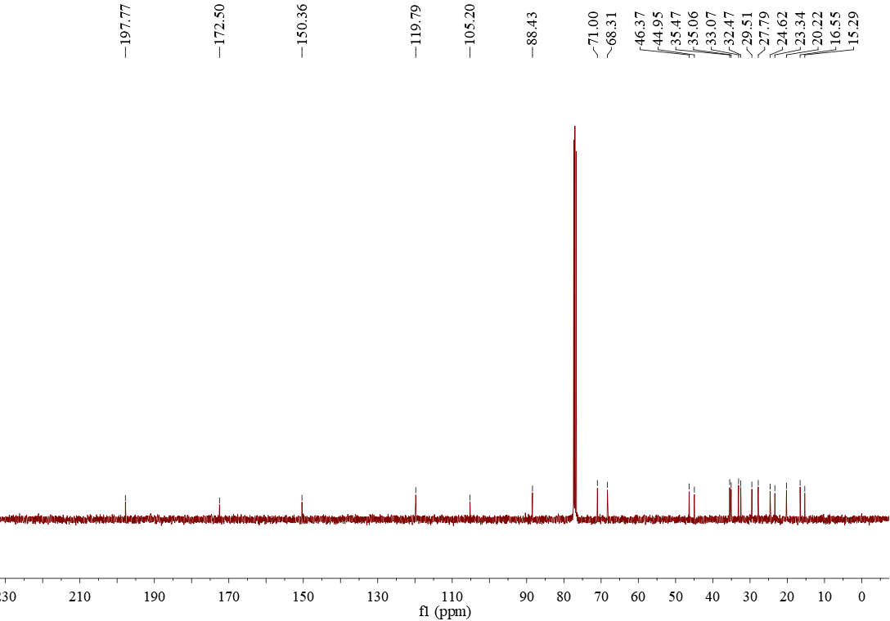

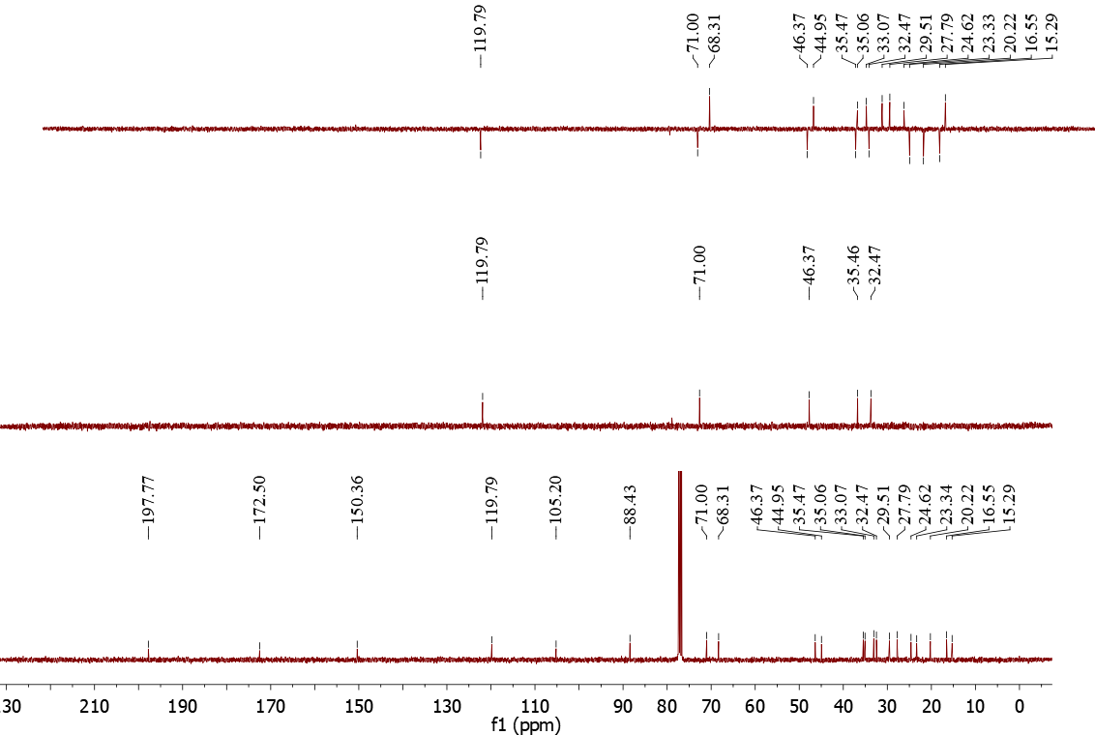

Supplementary Figure 4. The NMR data of compound 4 in CDCl3 (500 MHz for 1 H NMR, 125 MHz for 13 C NMR)

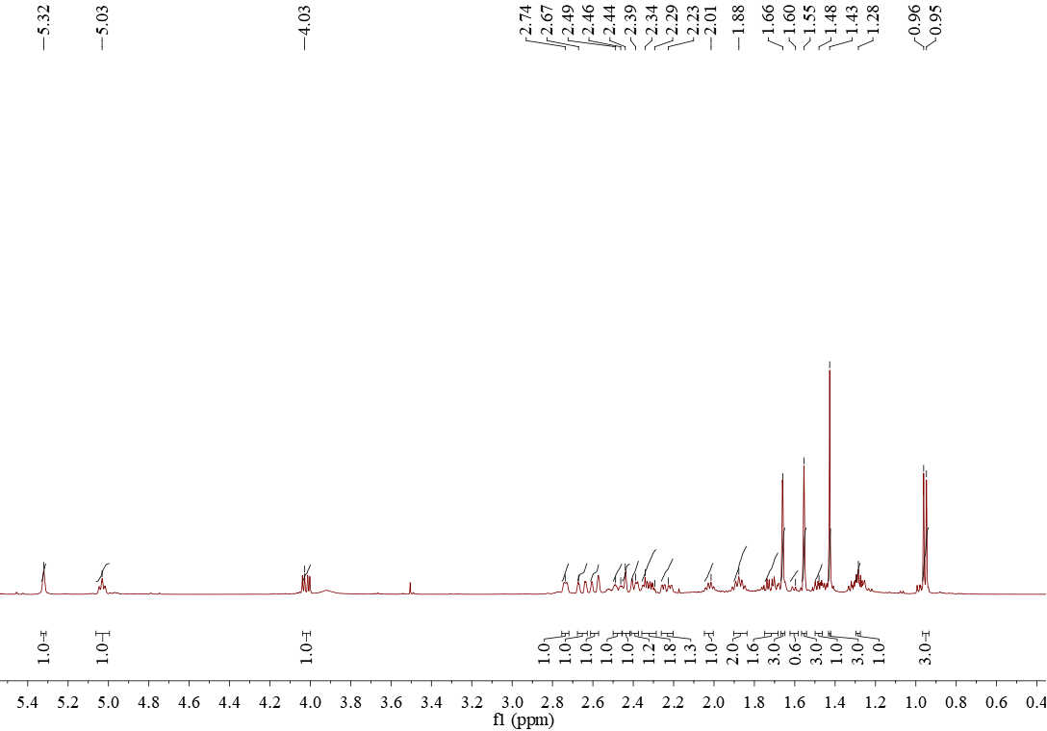



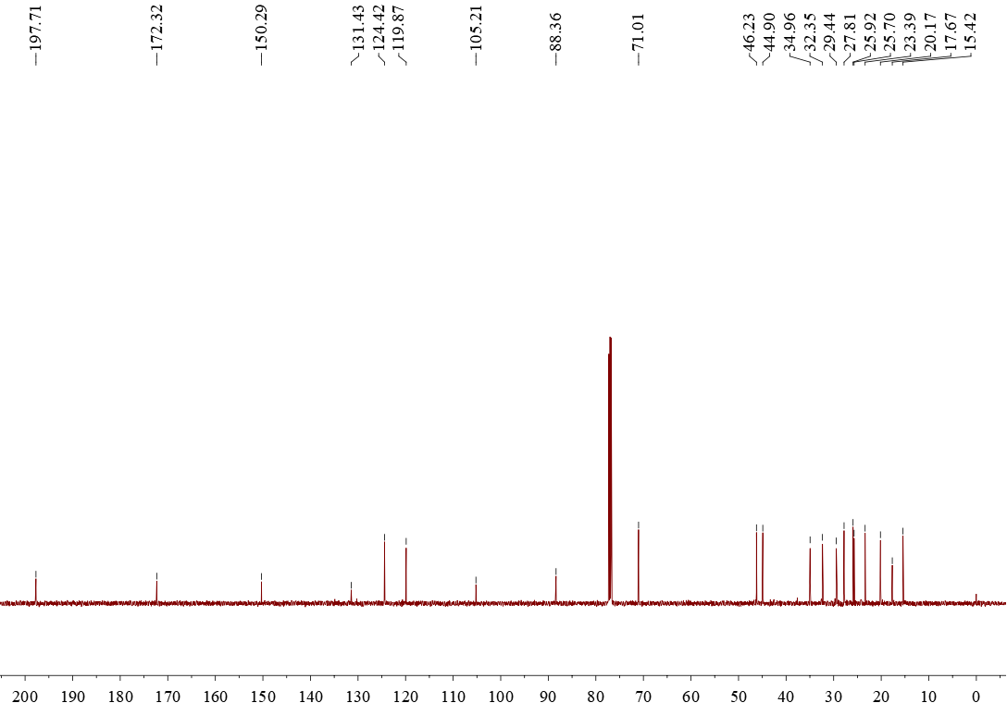



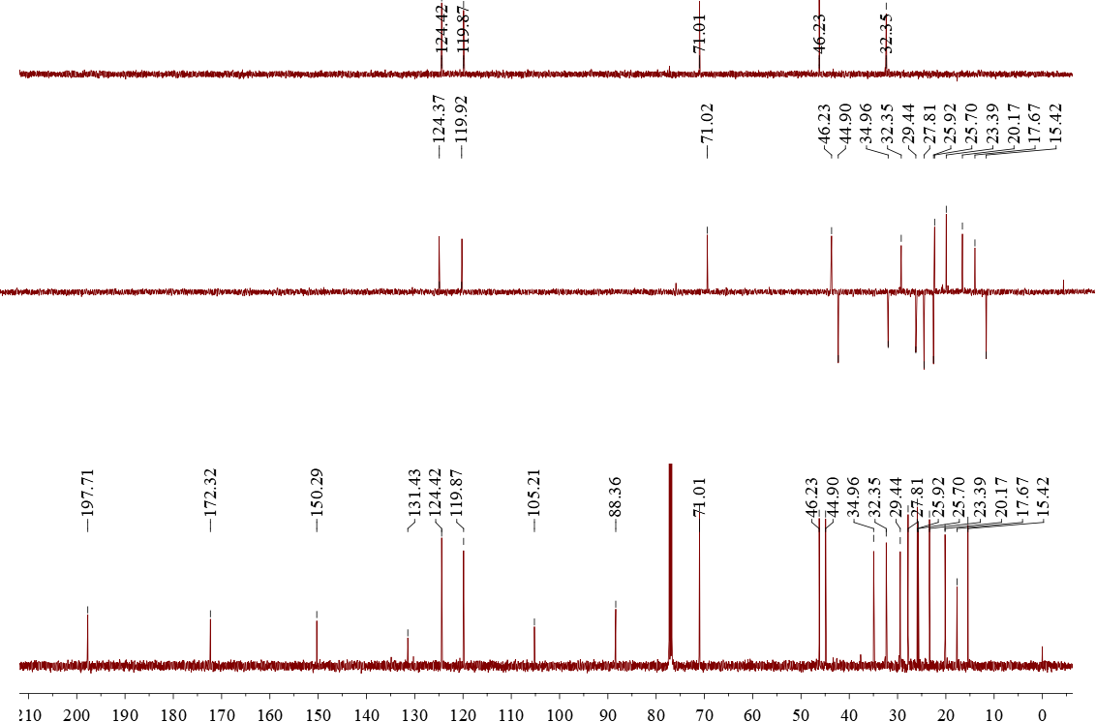

Supplementary Figure 5. The NMR data of compound 5 in CDCl3 (500 MHz for 1 H NMR, 125 MHz for 13 C NMR)

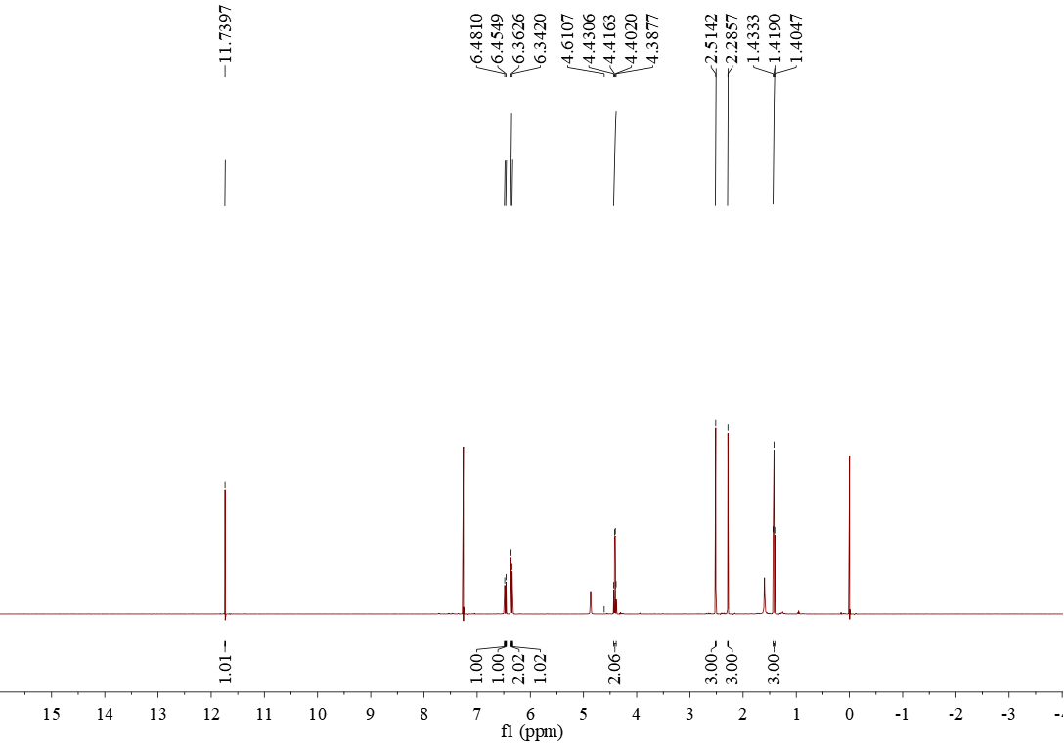

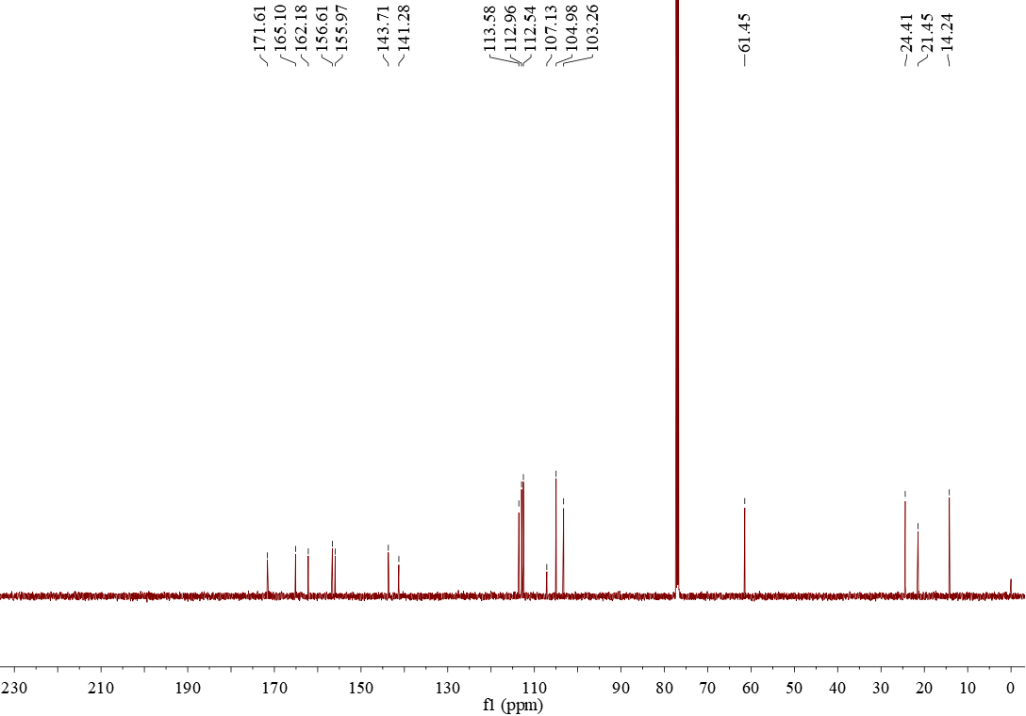



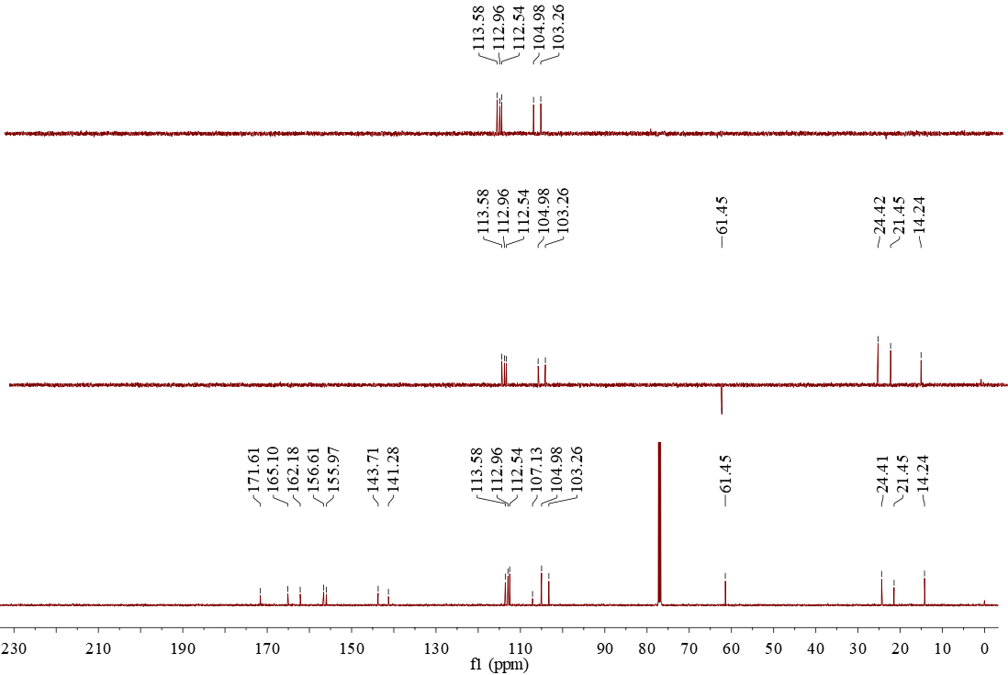

Supplementary Figure 6. The NMR data of compound 6 in DMSO-d6 (500 MHz for 1 H NMR, 125 MHz for 13 C NMR)

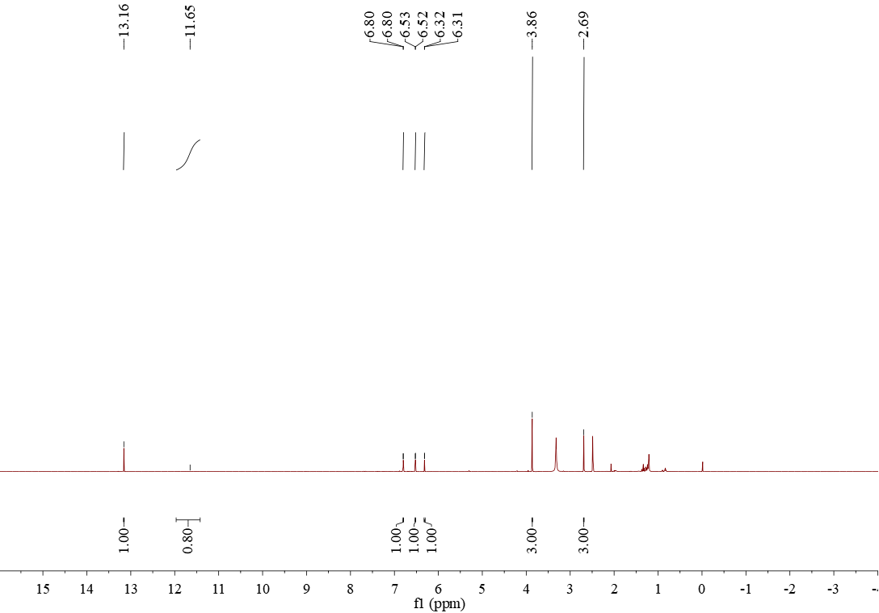

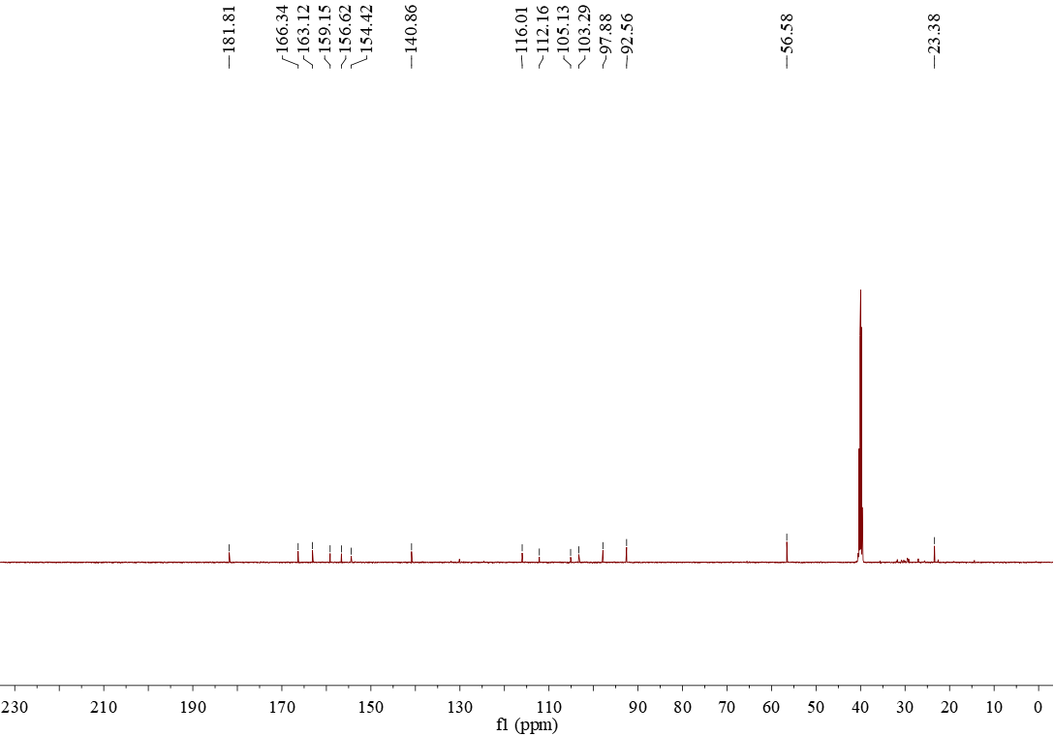

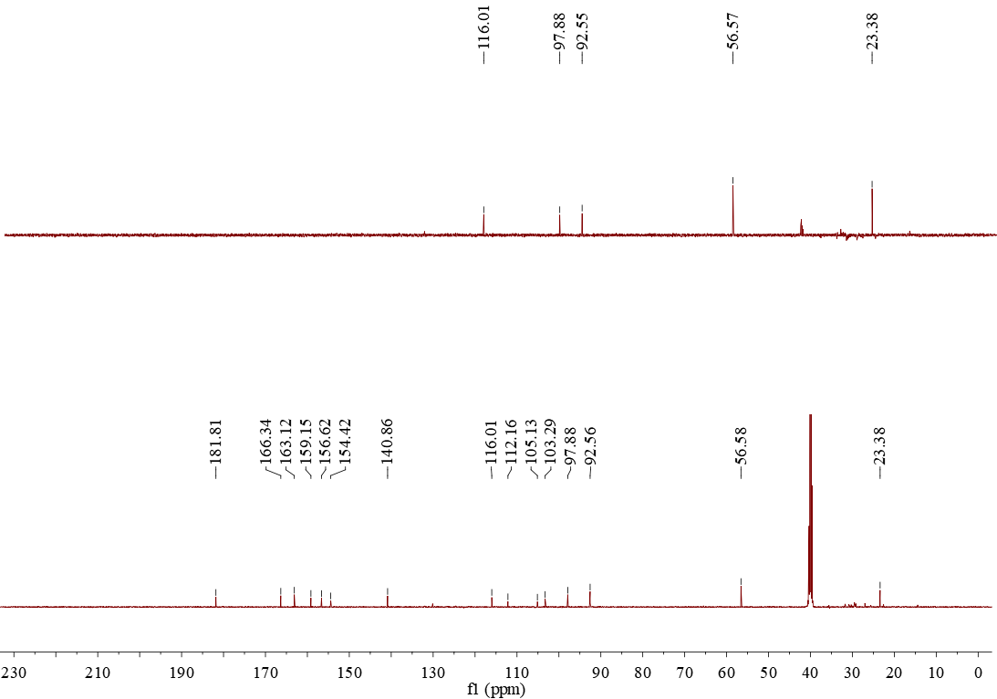

Supplementary Figure 7. The minimum inhibitory concentration (MIC, µg/mL) of the monomeric compounds (1-6) against *S. agalactiae* GBS-1 **(A)**, *S. aureus* SA-1 **(B)** and *E. coli* EC-1 **(C)** respectively.

