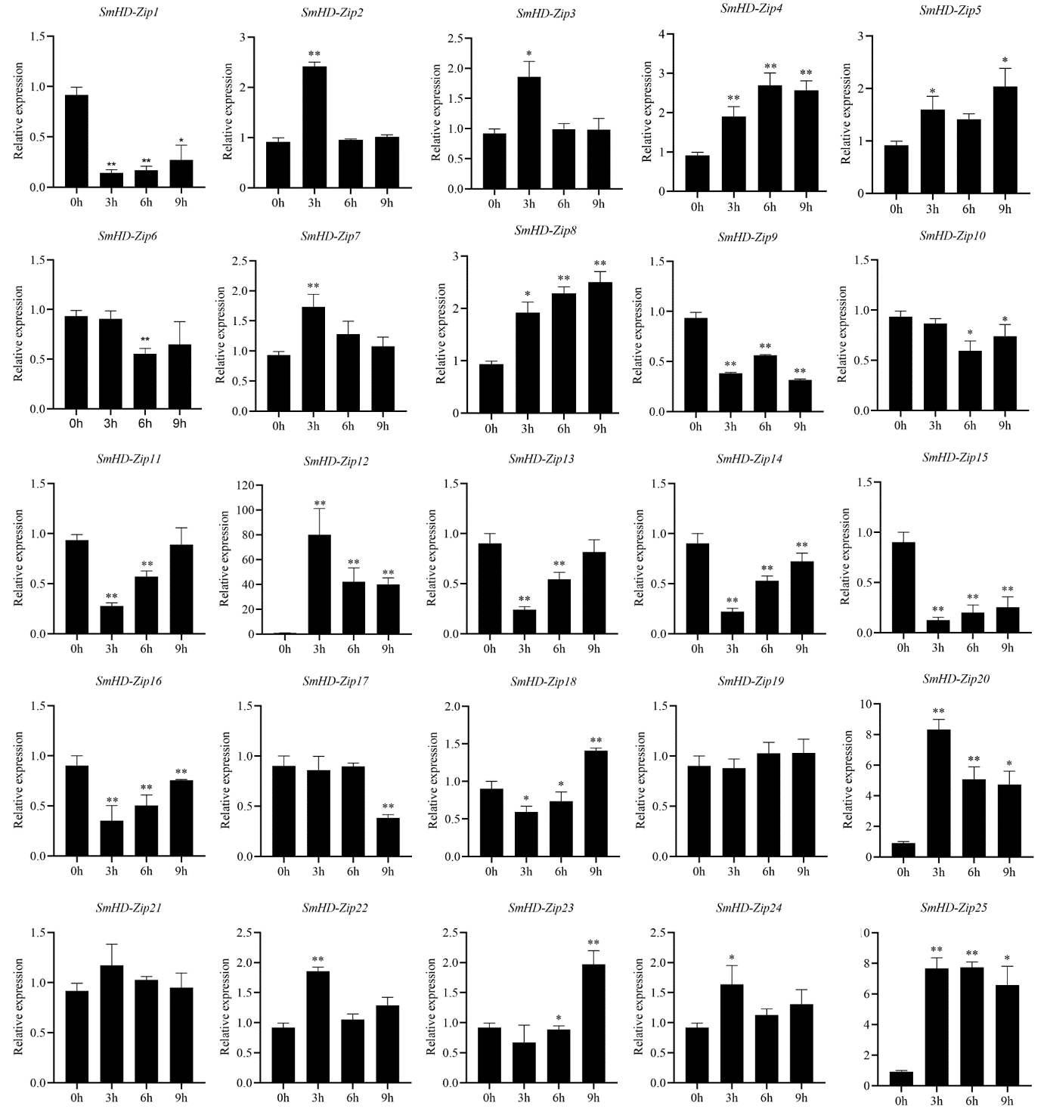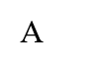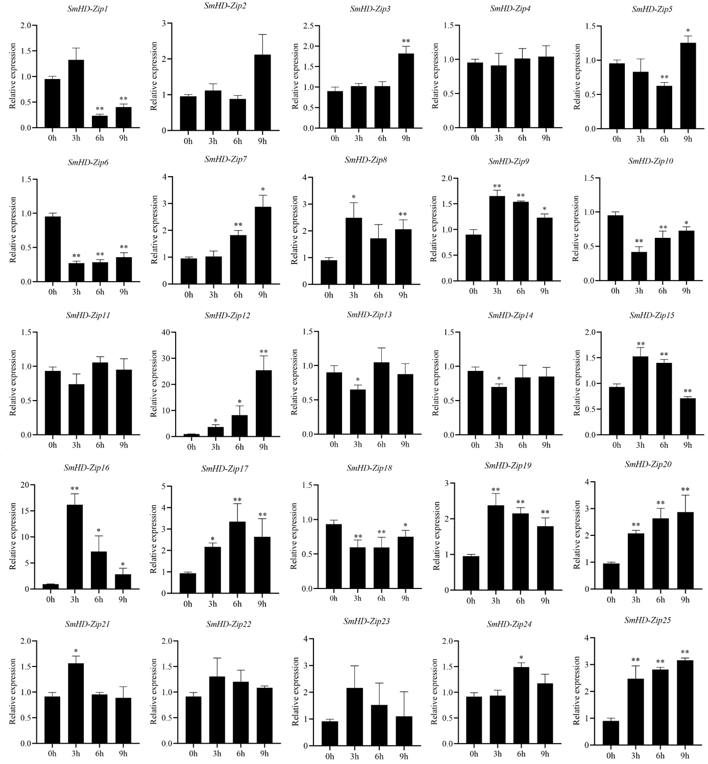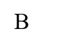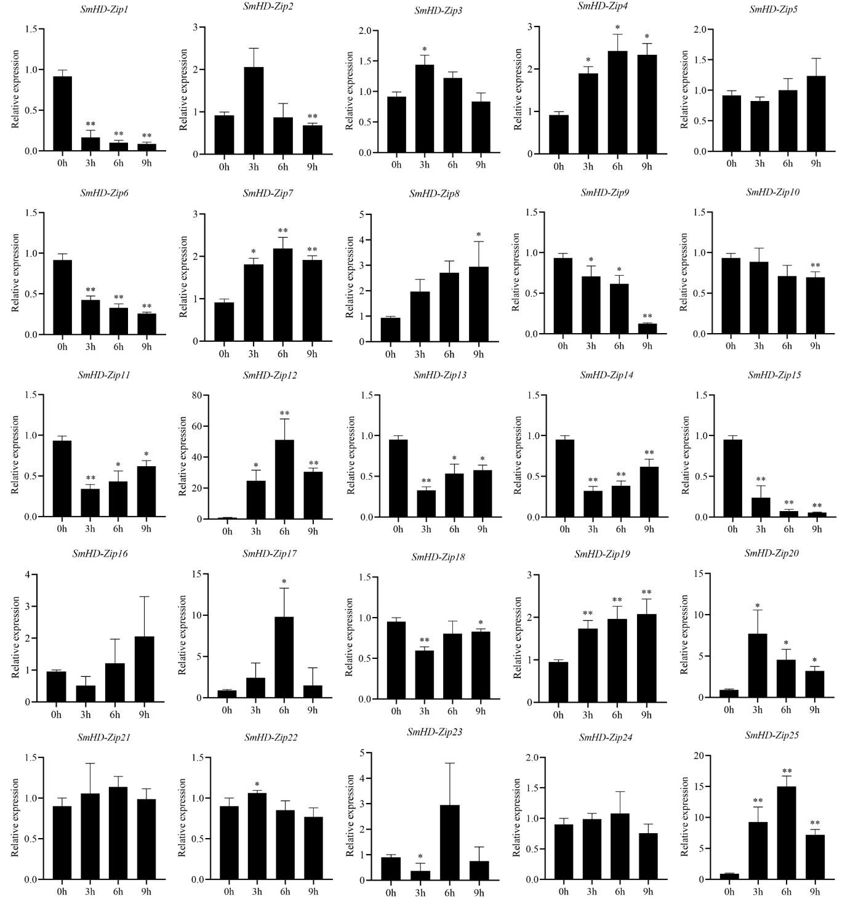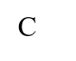

**Figure S1.** The expression patterns of the *SmHD-Zip I* at 0, 3, 6, and 9 h after treated with ABA (A), PEG (B), and NaCl (C). Hairy roots were cultured in a 6,7-V liquid medium for 18 days before being treated. The 2−∆∆CT method was used to be an evaluation of the relative expression. *SmActin* was used as the internal standard. ** and * indicate significant differences compared to the control (0 h) at *p* < 0.01 and *p* < 0.05, respectively.