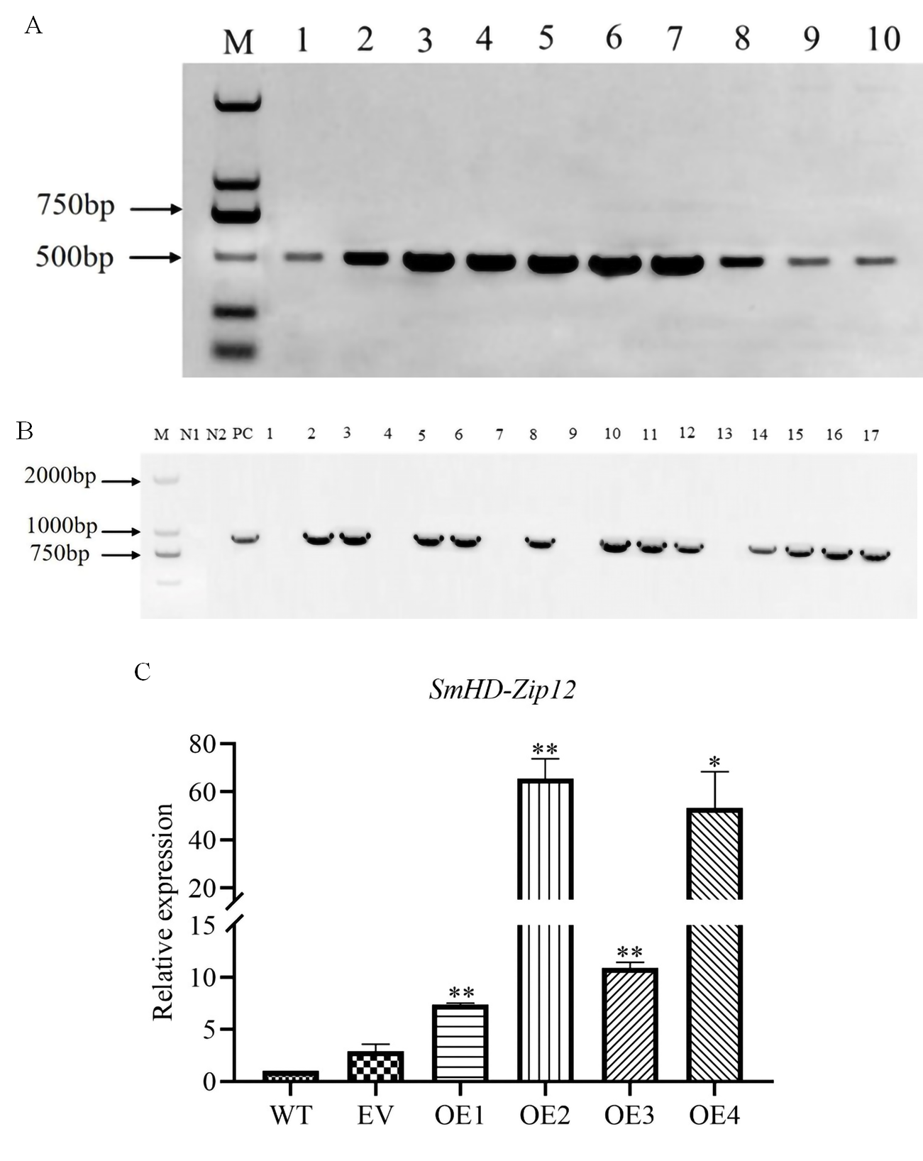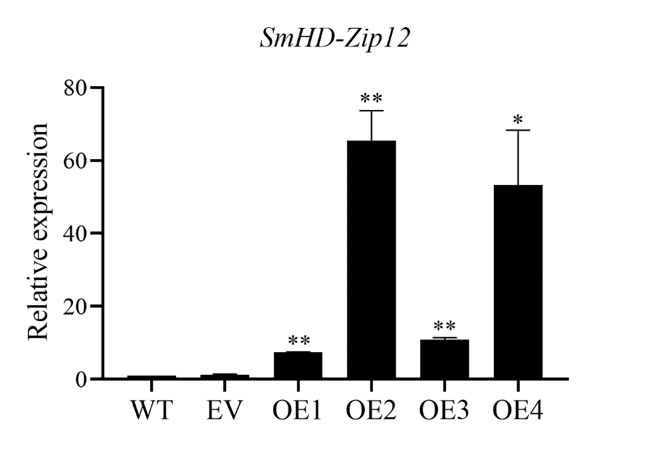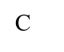

**Figure S2.** Identification of *SmHD-Zip12* overexpression hairy roots.(A)Identification of hairy roots by rolB. M, DL-2000; 1, WT; 2, EV; 3-10, Overexpression of *SmHD-Zip 12.*(B)PCR analyses of transgenic hairy root lines. M, DL-2000; N1: H2O; N2: WT；PC: Recombinant plasmid; 1-17: Overexpression of *SmHD-Zip 12*.(C)Relative expression analysis of *SmHD-Zip 12* genes by qRT-PCR in in transgenic lines and WT of *S. miltiorrhiza* hairy roots. ** and * indicate significant differences compared with the wild type (WT) at p < 0.01 and p < 0.05, respectively.