Table S4. The motif sequence information of SmHD-Zip I
Motif | E-value | Site | Width | logo
1 | 1.1e-737 | 24 | 50 | 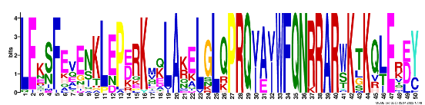
2 | 1.1e-136 | 25 | 21 | 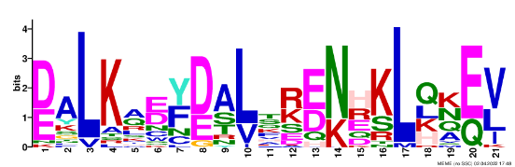
3 | 8.7e-099 | 20 | 20 | 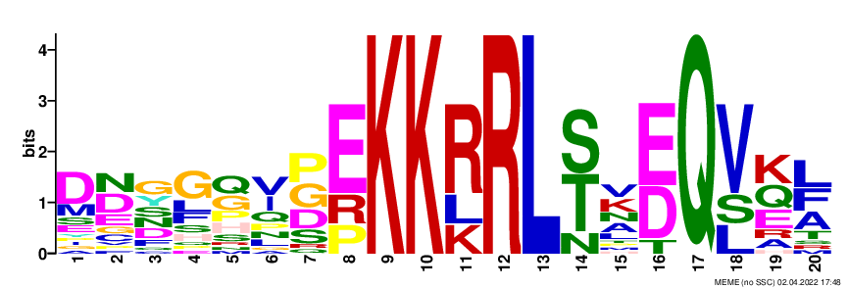
4 | 2.9e-036 | 4 | 49 | 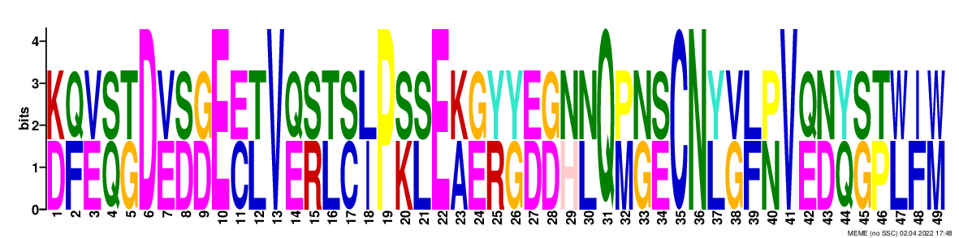
5 | 2.9e-029 | 3 | 29 | 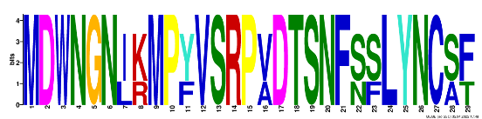
6 | 2.5e-016 | 5 | 14 | 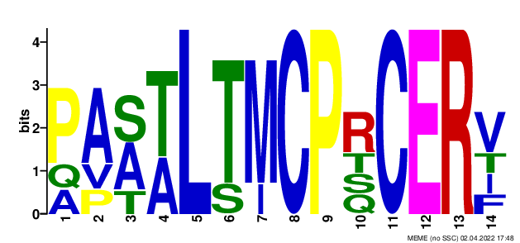
7 | 2.1e-014 | 5 | 11 | 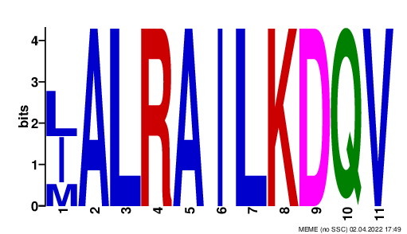
8 | 3.4e-013 | 7 | 15 | 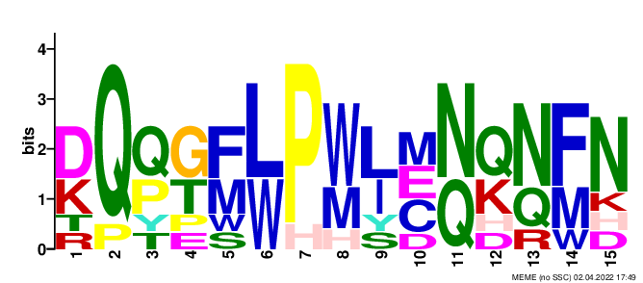
9 | 2.9e-008 | 3 | 28 | 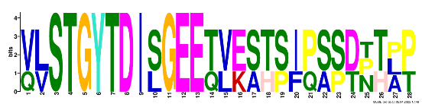
10 | 7.5e-007 | 2 | 25 | 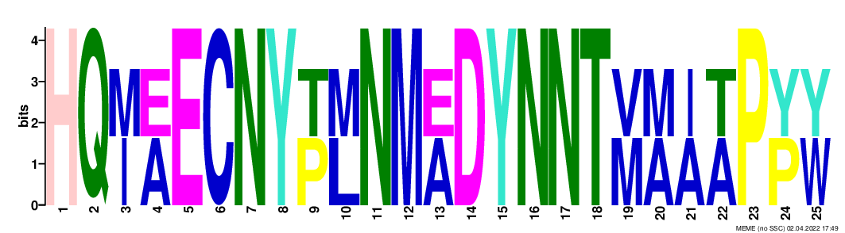
11 | 1.7e-007 | 3 | 23 | 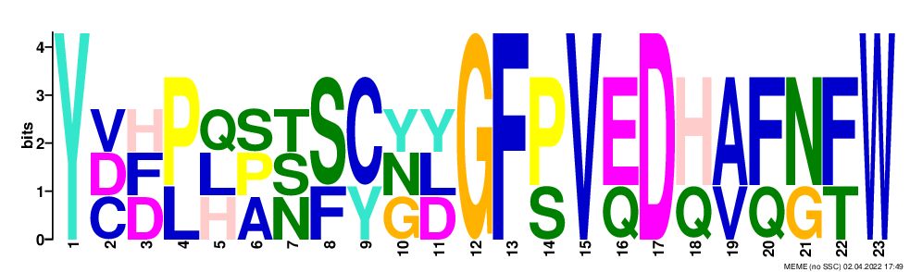
12 | 1.3e-005 | 2 | 14 | 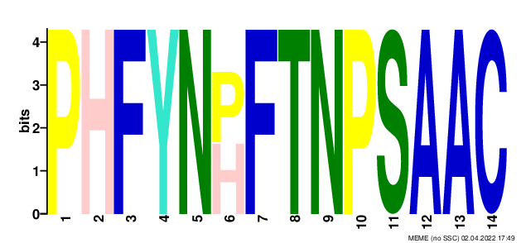
13 | 5.9e-004 | 2 | 25 | 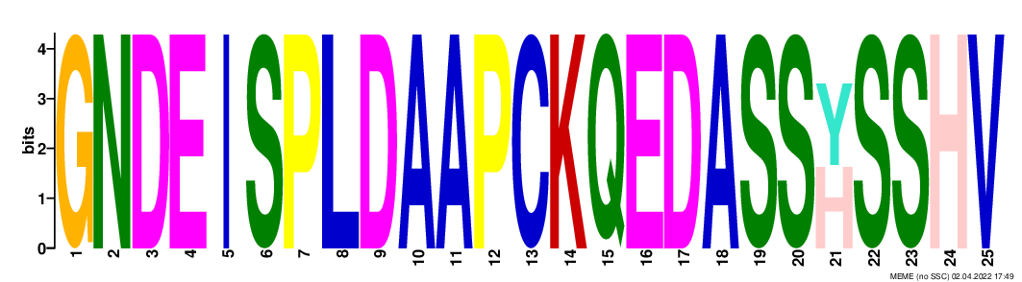
14 | 4.6e-003 | 3 | 12 | 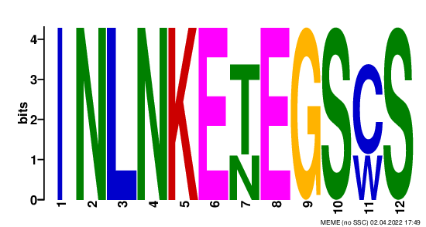
15 | 2.8e-002 | 2 | 11 | 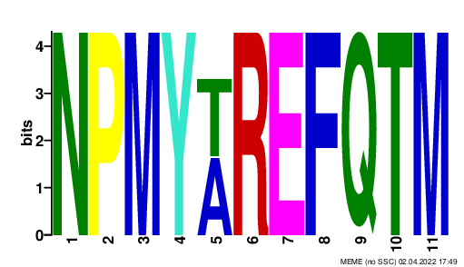
16 | 2.9e-002 | 3 | 15 | 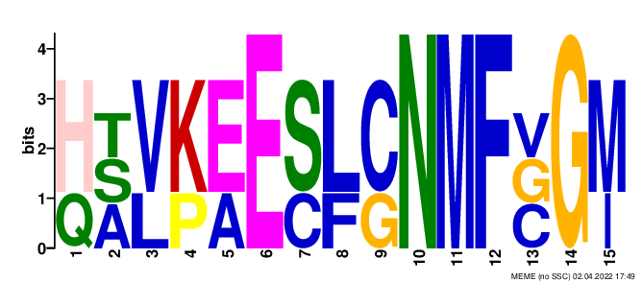
17 | 4.5e-002 | 2 | 21 | 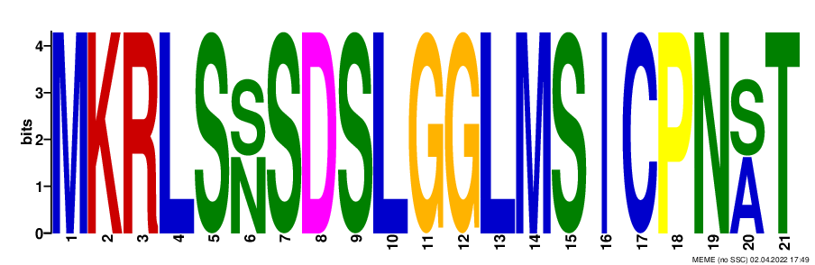
18 | 6.0e-002 | 2 | 21 | 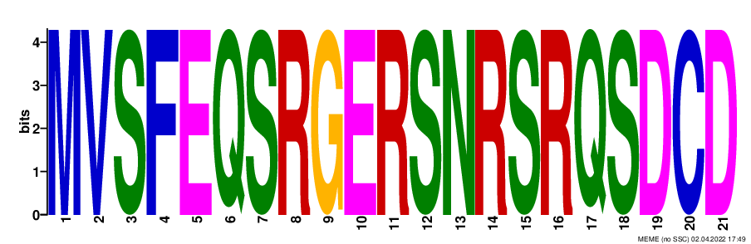
19 | 2.9e-001 | 2 | 11 | 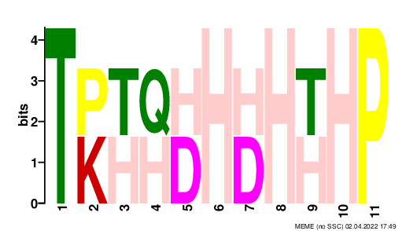
20 | 2.9e+000 | 2 | 10 | 