Table S1 Chemical properties of the samples
Treatments | pH | Available nitrogen (mg/kg) | Total nitrogen (g/kg)
N90 | 7.86±0.05 ª | 2.01±0.03 | 1.35±0.08
N120 | 7.85±0.02 | 2.03±0.05 | 1.38±0.06
N150 | 7.88±0.04 | 1.98±0.04 | 1.36±0.10
ª Two-tailed t-test was used to analyze the variances among groups. The results showed that there was no significant difference (df=2, P>0.05) in all of the three indices.

Table S2 Valid reads obtained from the samples
Samples | Raw reads | Ratio of valid reads | Valid reads
N90_1 | 85436866 | 99.63 | 85120749.6
N90_2 | 100730128 | 99.68 | 100407791.6
N90_3 | 86890742 | 99.67 | 86604002.55
N120_1 | 95538976 | 99.65 | 95204589.58
N120_2 | 92548524 | 99.65 | 92224604.17
N120_3 | 88939526 | 99.6 | 88583767.9
N150_1 | 86687642 | 99.68 | 86410241.55
N150_2 | 94703168 | 99.62 | 94343295.96
N150_3 | 83325472 | 99.61 | 83000502.66

Table S3 Alpha diversity indexes of soil microbes
Treatments | Simpson | Chao1 (×10⁴) | ACE (×10⁴) | Shannon
N90 | 0.62±0.03 ª | 2.79±0.02 | 2.76±0.02 | 4.43±0.21
N120 | 0.59±0.02 | 2.81±0.02 | 2.79±0.02 | 4.09±0.23
N150 | 0.61±0.03 | 2.80±0.02 | 2.78±0.02 | 4.36±0.23
ª Two-tailed t-test was used to analyze the variances among groups. There was no significant difference (df=2, P>0.05) in all of the three indices.

Table S4 Numbers of functions annotated by genes with significantly different relative abundance
Group pairs | KO | eggNOG | CAZyme
N150-N120 | 0 | 0 | 0
N150-N90 | 0 | 0 | 0
N90-N120 | 0 | 2 | 0

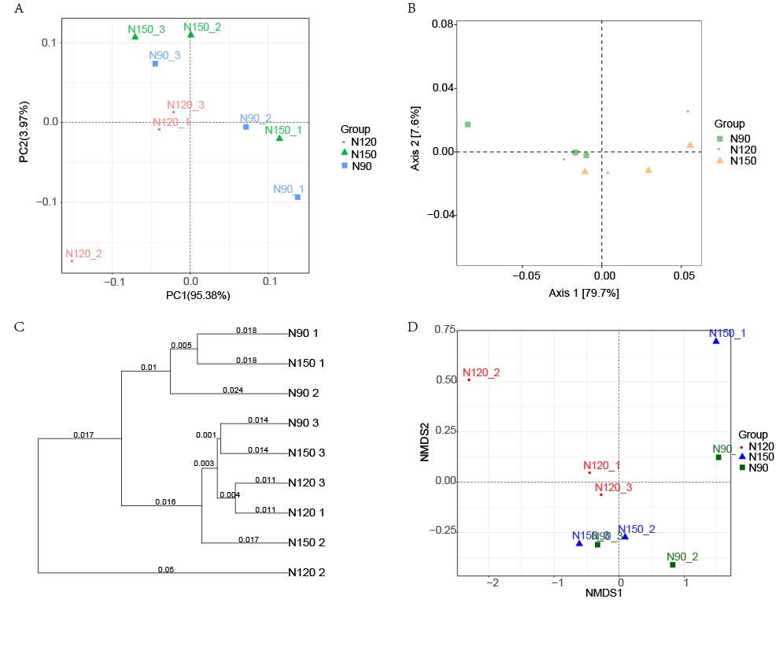
Figure S1 Beta diversity of microorganism in buckwheat rhizosphere. A. PCA analyze. B. Principal coordinates analysis (PCoA) analyze. C. Hierarchical clustering by unweighted pair-group method with arithmetic means (UPGMA). D. Nonmetric multidimensional scaling (NMSD) analyze.

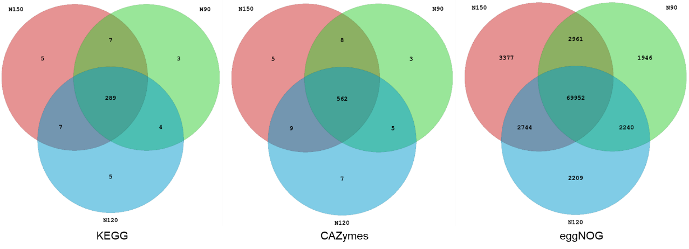
Figure S2 Microbial function numbers in rhizosphere of buckwheat with different nitrogen application rates.

