SUPPLEMENTARY

Figure

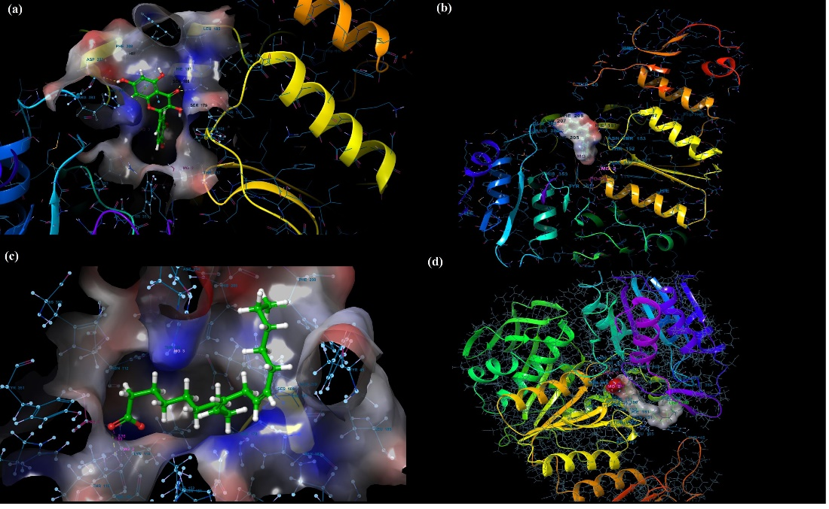
Figure S1. (a) and (b) show the molecular electrostatic potential surface of the binding pocket of the S. aureus MurE receptor and ligands for quercetin (c) and linoleic acid (d)

Tables

Table S1. The docking score energies and probable interaction of major compounds in O. acanthium against S. aureus
Receptor  PdbID: 4C13 | Ligand-1  Quercetin | Ligand-2  Linoleic
Docking Score(Kcal/mol) | -6.770 | -2.734
H.Bond (Angstrom) | ASP207…….....OH(2.03)  ARG187………O(2.14,2.20)  ASN151………OH(2.71)  LYS114………OH(2.12) | THR137……..O(1.83)
Pi-Pi stacking | HIE181 | -
Pi-cation | ARG383 | -
Salt Bridge | - | MG……..O(2.16)
Hydrophobic Residues | TYR45  PHE208  TYR351 | TYR45  PHE208  TYR351  LEU185
Polar Residues | THR137  THR153  THR152  ASN151  SER179  SER180  HIE181  HIS205 | THR137  THR153  THR152  ASN151  SER179  HIE181  THR115  THR111  HIS353  HIS205
Charged (positive) Residues | ARG187  ARG383 | ARG187  ARG383  ARG335
Charged (negative) Residues | ASP207 | ASP207  GLU177

Table S2. The calculated ADME profiles of major compounds in O. acanthium

Principal Descriptors | Ligand-1  Quercetin | Ligand-2  Linoleic | (Range 95% of Drugs)
Solute Molecular Weight | 302.240 | 280.450 | (130.0 /725.0)
Solute Total SASA | 515.586 | 700.154 | (300.0 /1000.0)
Solute Hydrophobic SASA | 0.000 | 561.980 | (0.0 /750.0)
Solute Hydrophilic SASA | 287.589 | 98.729 | (7.0 /330.0)
Solute Carbon Pi SASA | 227.997 | 39.445 | (0.0 /450.0)
Solute Weakly Polar SASA | 0.000 | 0.000 | (0.0 /175.0)
Solute Molecular Volume (A^3) | 863.099 | 1189.403 | (500.0 /2000.0)
Solute vdW Polar SA (PSA) | 143.252 | 48.948 | (7.0 /200.0)
Solute No, of Rotatable Bonds | 5.000 | 14.000 | (0.0 /15.0)
Solute as Donor -Hydrogen Bonds | 4.000 | 1.000 | (0.0 /6.0)
Solute as Acceptor-Hydrogen Bonds | 5.250 | 2.000 | (2.0 /20.0)
Solute Globularity (Sphere = 1) | 0.850 | 0.775 | (0.75/0.95)
Predictions for Properties:
QP Polarizability (Angstroms^3) | 27.354M | 32.833M | (13.0 /70.0)
QP log P for hexadecane/gas | 10.698M | 10.541M | (4.0 /18.0)
QP log P for octanol/gas | 19.589M | 12.348M | (8.0 /35.0)
QP log P for water/gas | 14.394M | 2.690M | (4.0 /45.0)
QP log P for octanol/water | 0.350 | 5.786 | (-2.0 /6.5)
QP log S for aqueous solubility | 2.854 | -6.043 | (-6.5 /0.5)
P log S-conformation independent | -4.043 | -4.070 | (-6.5 /0.5)
QP log K hsa Serum Protein Binding | -0.349 | 0.719 | (-1.5 /1.5)
QP log BB for brain/blood | -2.390 | -1.375 | (-3.0 /1.2)
No, of Primary Metabolites | 5 | 4 | (1.0 /8.0)
Predicted CNS Activity (-- to ++) | -- | --
HERG K+ Channel Blockage: log IC50 | -5.042 | -3.547 | (concern below -5)
Apparent Caco-2 Permeability (nm/sec) | 18 | 290 | (<25 poor, >500 great)
Apparent MDCK Permeability (nm/sec) | 6 | 165 | (<25 poor, >500 great)
QP log Kp for skin permeability | -5.537 | -1.856 | (Kp in cm/hr)
Jm, max transdermal transport rate | 0.001 | 0.004 | (micrograms/cm^2-hr)
Lipinski Rule of 5 Violations | 0 | 1 | (maximum is 4)
Jorgensen Rule of 3 Violations | 1 | 1 | (maximum is 3)
% Human Oral Absorption in GI (+-20%) | 52 | 92 | (<25% is poor)
Qual, Model for Human Oral Absorption | Medium | HIGH | (>80% is high)

