Figure 2B
Original blot file:

Shown is anti-HA immunoblot, which detects both HA-tagged GLUT4-GFP (upper smear) and HA-mVps45 (band at roughly 68 kDa).

Figure 3A
Original autoradiograph:

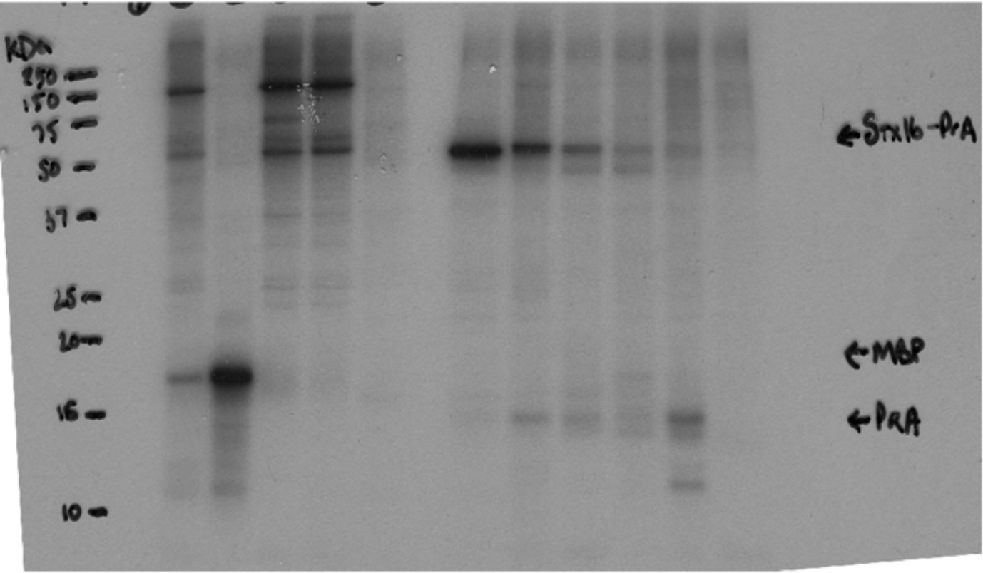

Samples shown in figure are boxed. Other lanes are either controls or experiments using different constructs not used in this study.

Figure 3B:
Original blot file:

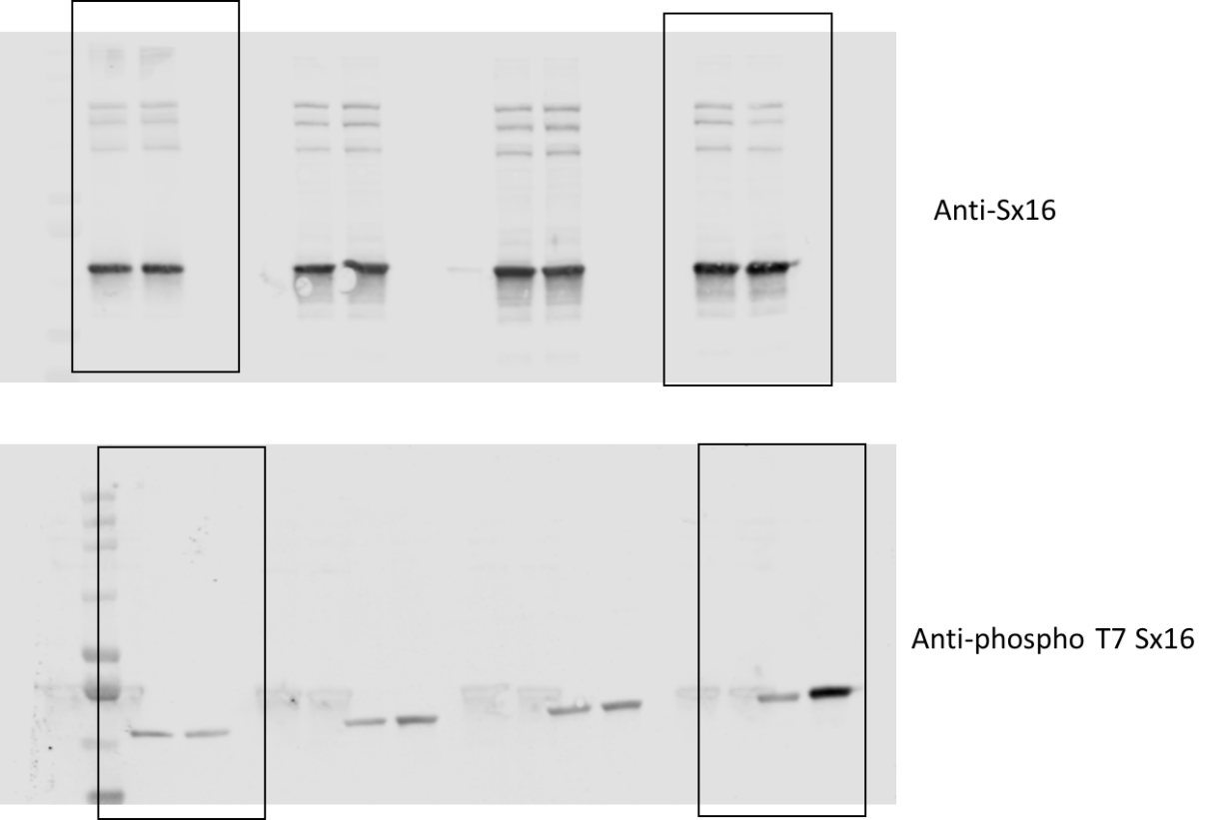

Shown is anti-Sx16 and anti-phospho T7 Sx16 immunoblot. Samples shown in figure are boxed. Other lanes are experiments using different conditions not used in this study.

Figure 3C:
Original blot file:
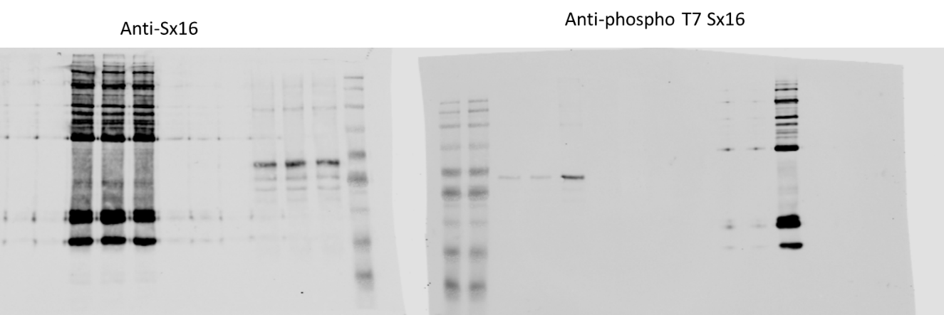
Shown is anti-Sx16 and anti-phospho T7 Sx16 immunoblot.

Figure 4:
Original stain and blot files:

Samples shown in figure are boxed. Images show Coomassie stained gels and anti-HA immunoblots.

Figure 5
Original blot files:

Anti-GLUT4

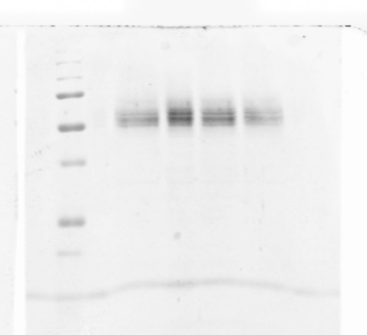

Anti-mVps45

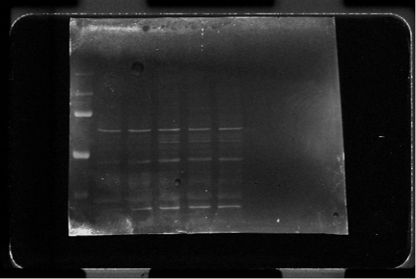

Anti-Sx16
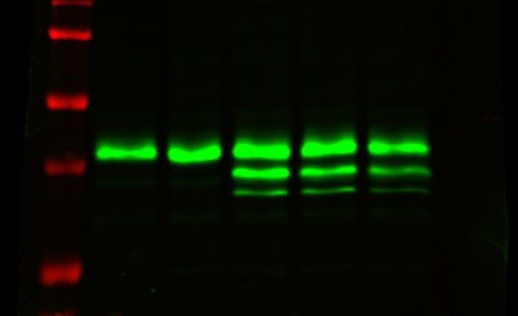

Anti-GAPDH

Shown are anti-Sx16, anti-mVps45, anti-GLUT4 and anti-GAPDH immunoblots. In order, samples are; positive control (present in anti-mVps45,-Sx16 and -GAPDH immunoblots), control cells, WT Sx16,T7A Sx16 and Sx16 T7D. Note for the anti-GAPDH immunoblot there is an empty lane between positive control and experimental samples which was run on a separate gel to those above because of size clashes.

Figure 6
Original Coomassie Blue stained gel and autoradiograph:
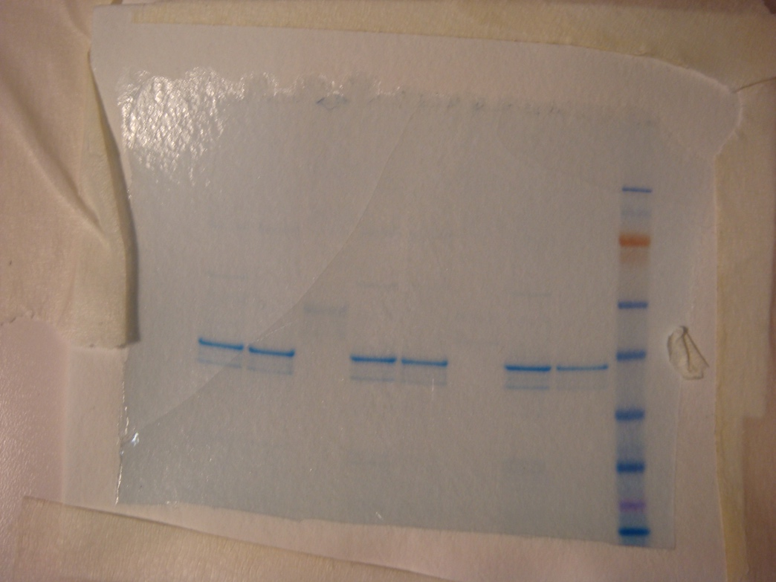

Corresponding Autorad.

Shown is the original Coomassie Blue stained gel and the accompanying autoradiograph.

Figure 7A:
Original blot file:

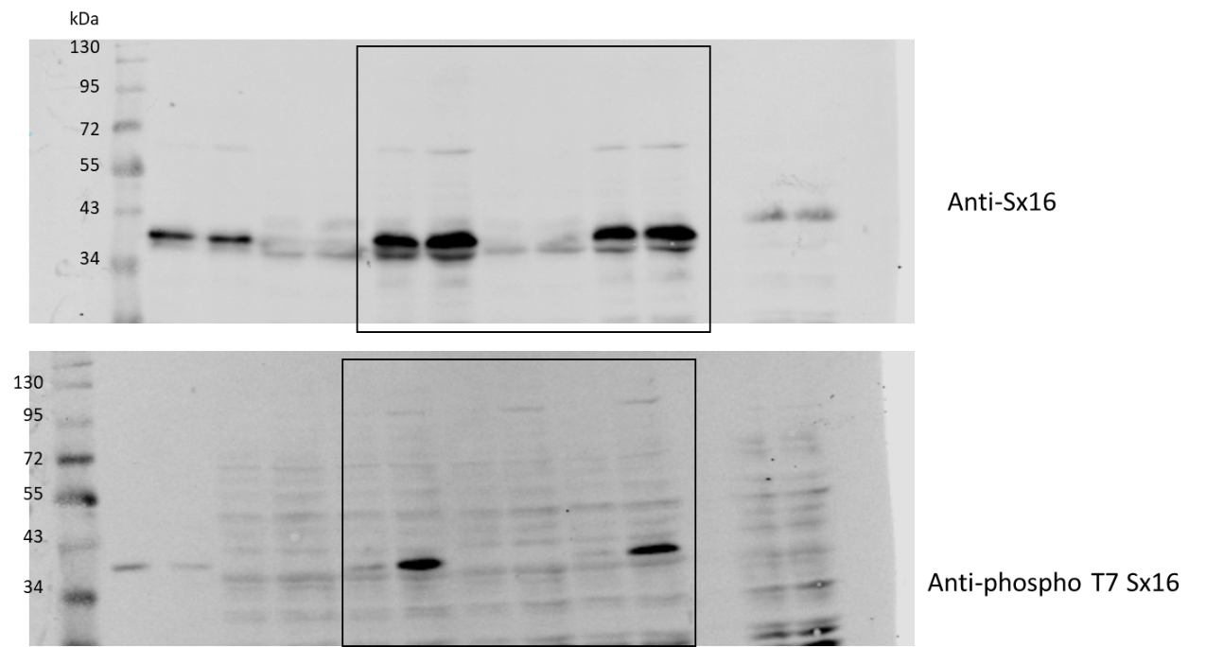

Shown is anti-Sx16 and anti-phospho T7 Sx16 immunoblot. Samples shown in figure are boxed, other lanes are experiments using different conditions not used in this study.

Figure 7B:
Original blot file:
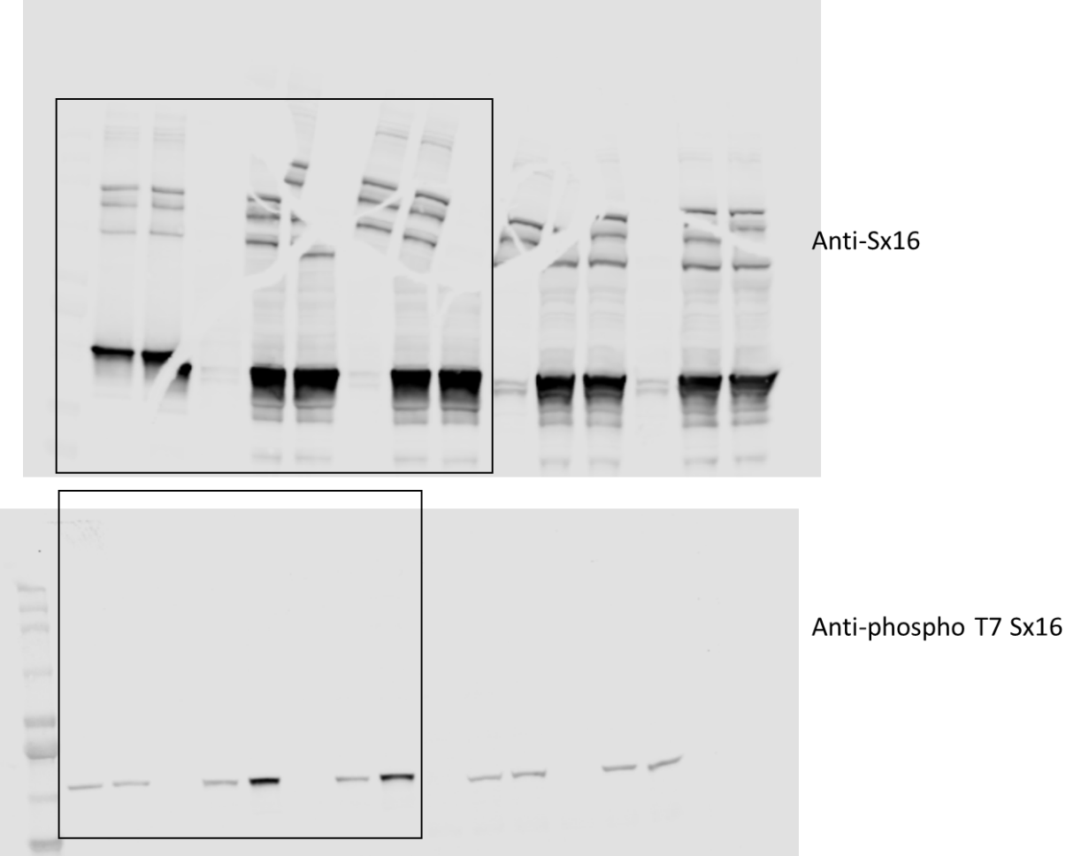
Shown is anti-Sx16 and anti-phospho T7 Sx16 immunoblot. Samples shown in figure are boxed, other lanes are experiments using different conditions not used in this study.

Figure 7C:
Original blot file:
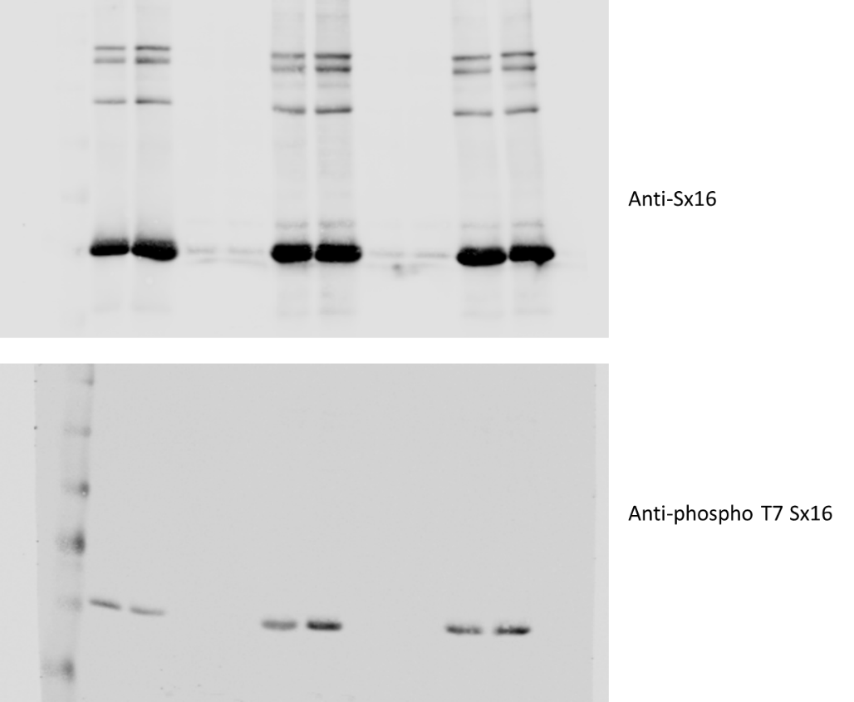
Shown is anti-Sx16 and anti-phospho T7 Sx16 immunoblot.

