Note:

* 0.5-1; 0.5-3; and 0.5-5 represent *D. japonica* exposed to 0.5 mg/L SDS for 1, 3, and 5 days respectively.
* 1-1; 1-3; and 1-5 represent *D. japonica* exposed to 1.0 mg/L SDS for 1, 3, and 5 days respectively.

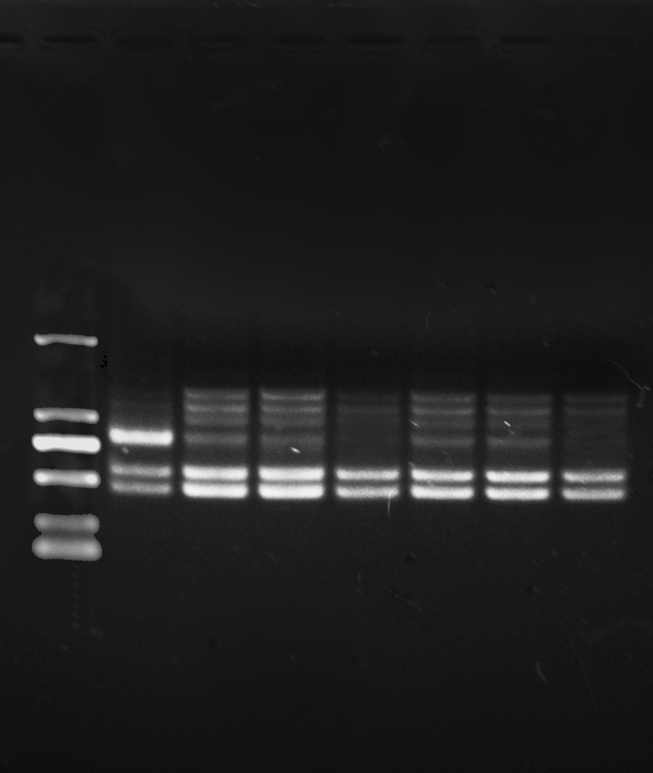

**S5 control 0.5-1 0.5-3 0.5-5 1-1 1-3 1-5**

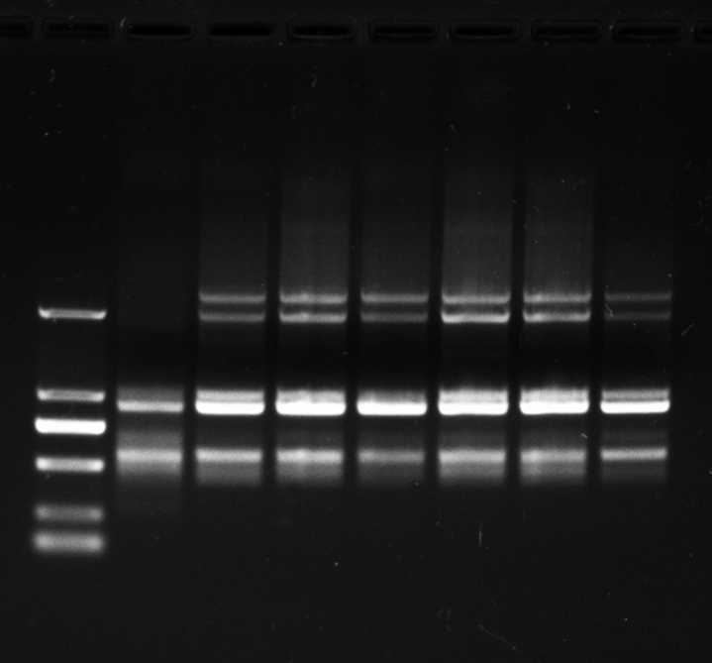

**S8 control 0.5-1 0.5-3 0.5-5 1-1 1-3 1-5**

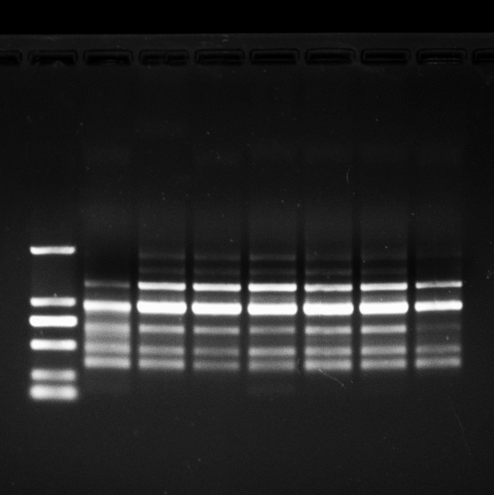

**S10 control 0.5-1 0.5-3 0.5-5 1-1 1-3 1-5**

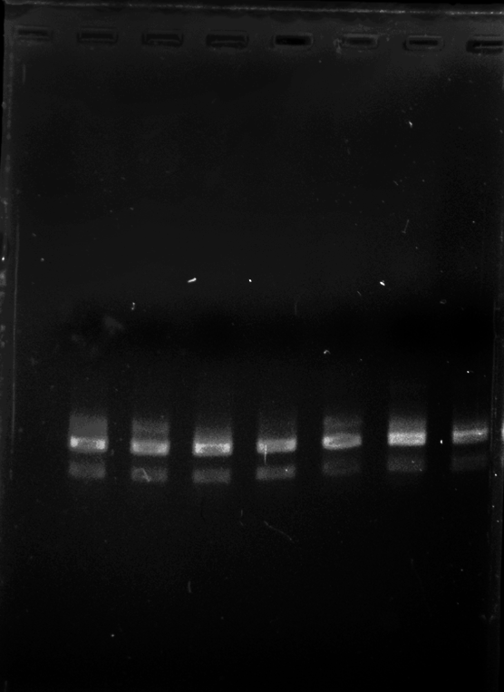

**S15 0.5-1 0.5-3 0.5-5 control 1-1 1-3 1-5**

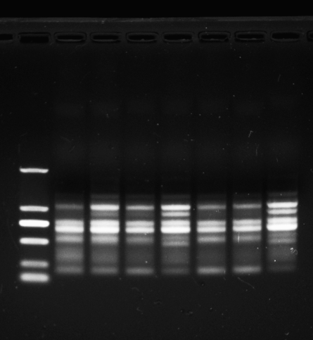

**S17 control 0.5-1 0.5-3 0.5-5 1-1 1-3 1-5**

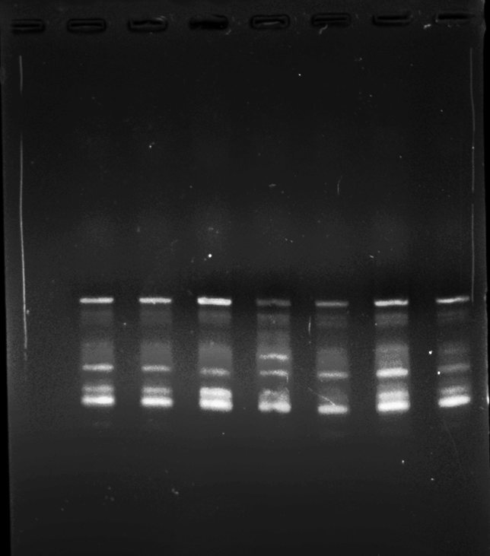

**S18 0.5-1 0.5-3 0.5-5 control 1-1 1-3 1-5**

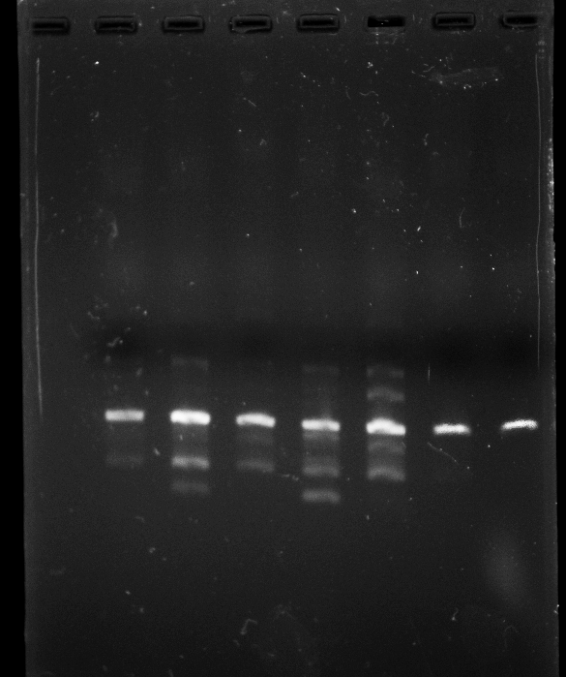

**S20 0.5-1 0.5-3 0.5-5 control 1-1 1-3 1-5**

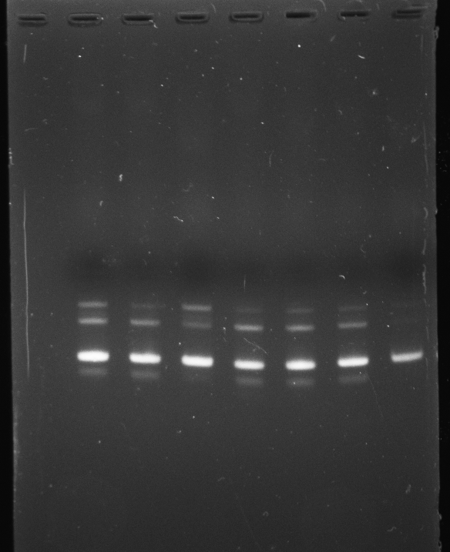

**S64 0.5-1 0.5-3 0.5-5 control 1-1 1-3 1-5**

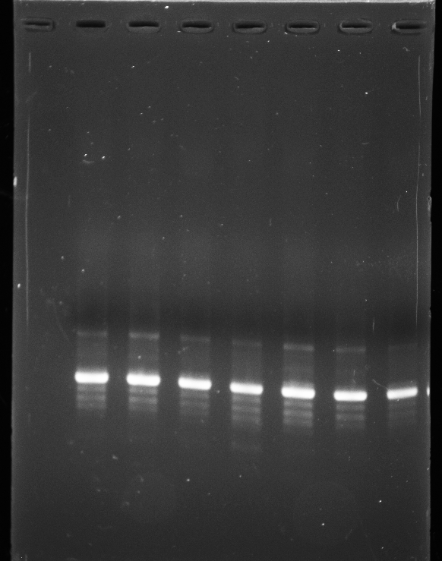

**S75 0.5-1 0.5-3 0.5-5 control 1-1 1-3 1-5**

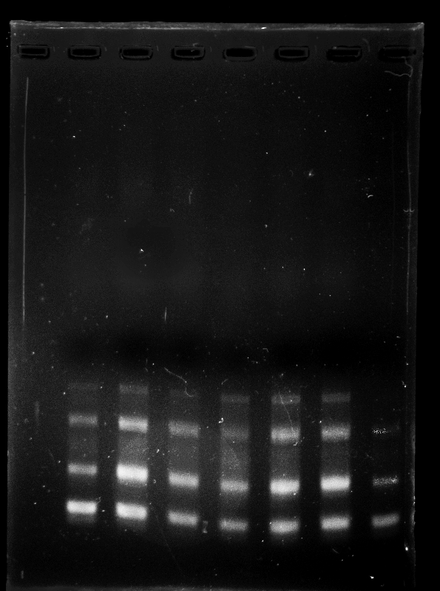

**S78 0.5-1 0.5-3 0.5-5 control 1-1 1-3 1-5**

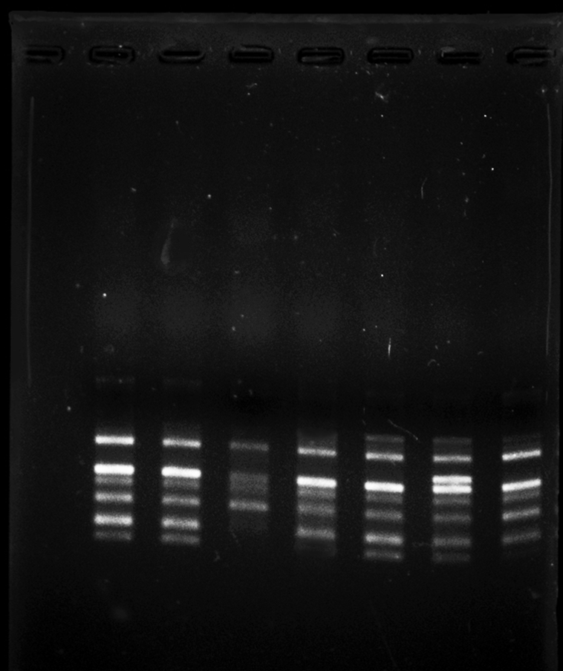

**S80 0.5-1 0.5-3 0.5-5 control 1-1 1-3 1-5**

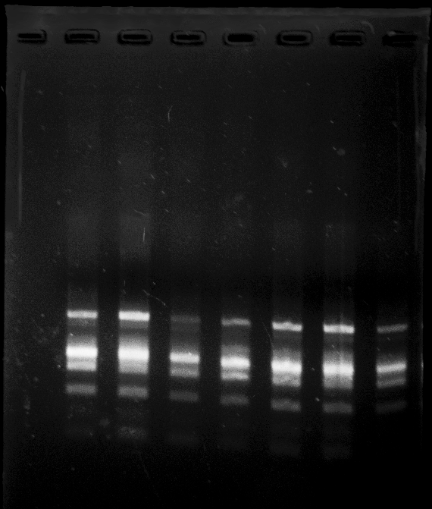

**S83 0.5-1 0.5-3 0.5-5 control 1-1 1-3 1-5**

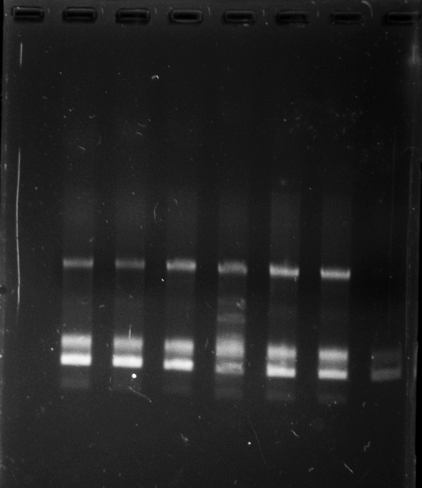

**S84 0.5-1 0.5-3 0.5-5 control 1-1 1-3 1-5**