**Supplementary**

**Hub gene associated with prognosis in bladder cancer is the noval therapeutic target**

Dengpan Fang1,2, Yuanqiao He3,4,5, Yun Yi6, Jiaqi Mei7, Cundong Liu1*

1 Department of Urology, The Third Affiliated Hospital of Southern Medical University, Guangzhou, Guangdong, China

2 Department of Urology, The Sixth Hospital of Wuhan, Affiliated Hospital of Jianghan University, Wuhan, Hubei, China

3 Center of Laboratory Animal Science, Nanchang University, Nanchang, Jiangxi, China

4 Jiangxi Province Key Laboratory of Laboratory Animal, Nanchang, Jiangxi, China

5 Nanchang Royo Biotechnology, Nanchang, Jiangxi, China

6 Biobank center, The Second Affiliated Hospital of Nanchang University, Nanchang, Jiangxi, China

7 The First Clinical Medical College, Nanchang University，Nanchang, Jiangxi, China

* Corresponding author:

Cundong Liu;

Address: No. 183, Zhongshan Avenue West, Tianhe District, Guangzhou, 510630, Guangdong Province, China

E-mail: [cundongliu@163.com](mailto:cundongliu@163.com);



Fig. S1A: KEGG enrichment analysis in high-risk and low-risk groups; S1B: GO enrichment analysis in high-risk and low-risk groups

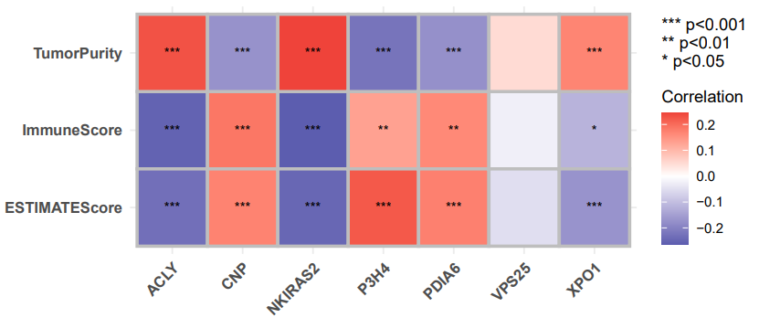

**C**

Fig. S2A: The fraction of 13 subsets of immune cells in bladder cancer; S2B: Correlation between 13 immune cells and 7 genes; S2C: Correlation between immune microenvironment and tumor purity and genes