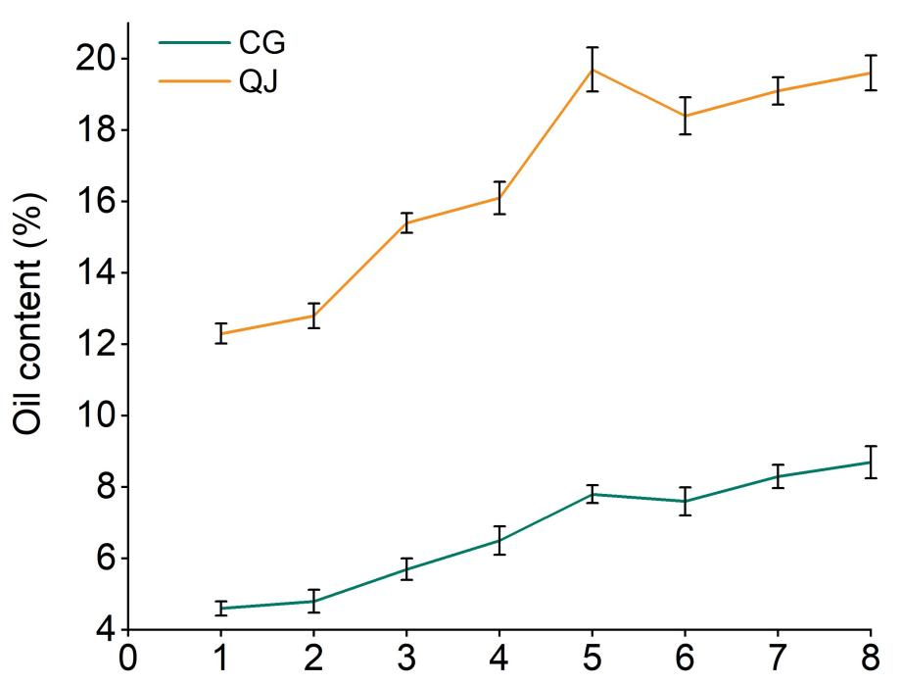

**Supplementary Figure 1.** Oil content of fresh olive fruit at different maturity stages. The data are shown as means of three biology repeats±SD.